# OR 3: Lecture 2 - Normal Form Games

## Recap

In the [previous lecture](Lecture_3-Dominance.html) we discussed:

* Predicting rational behaviour using dominated strategies;
* The CKR;

We did discover certain games that did not have any dominated strategies.

## Best response functions

### Definition

In an $n$ player normal form game. A strategy $s^{*}$ for player $i$ is a best response to some strategy profile $s_{−i}$ if and only if $u_{i}(s^{*},s_{−i})≥u_{i}(s,s_{−i})$ for all $s∈S_{i}$.

We can now start to predict rational outcomes in pure strategies by identifying all best responses to a strategy.

$$\left(\begin{matrix}(1,3) & (4,2) & (2,2) \\ (4,0) & (0,3) & (4,1) \\ (2,5) & (3,4) & (5,6)\end{matrix}\right)$$

We will underline the best responses for each strategy giving:

$$\left(\begin{matrix}(1,\underline{3}) & (\underline{4},2) & (2,2) \\ (\underline{4},0) & (0,\underline{3}) & (4,1) \\ (2,5) & (3,4) & (\underline{5},\underline{6})\end{matrix}\right)$$

We see that $(r_{1},s_{1})$ represented a pair of best responses. What can we say about the long term behaviour of this game?

## Connection between best responses and dominance

## Best responses against mixed strategies

We can identify best responses against mixed strategies. Let us take a look at the matching pennies game:

$$\left(\begin{matrix}(1,−1) & (−1,1) \\ (−1,1) & (1,−1)\end{matrix}\right)$$

If we assume that player 2 plays a mixed strategy $σ_{2}=(x,1−x)$ we have:

$$u_{1}(r_{1},σ_{2})=1−2x$$

and

$$u_{1}(r_{2},σ_{2})=2x−1$$

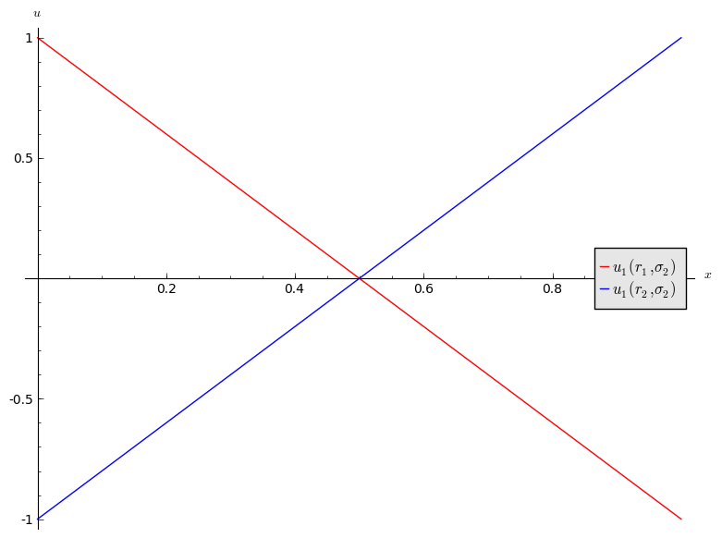

1. If $x<1/2$ then $r_{1}$ is a best response for player 1.
2. If $x>1/2$ then $r_{1}$ is a best response for player 1.
3. If $x=1/2$ then player 1 is indifferent.

Let us repeat this exercise for the battle of the sexes game.

$$\left(\begin{matrix}(3,2) & (0,0) \\ (1,1) & (2,3)\end{matrix}\right)$$

If we assume that player 2 plays a mixed strategy $σ_{2}=(x,1−x)$ we have:

$$u_{1}(r_{1},σ_{2})=3x$$

and

$$u_{1}(r_{2},σ_{2})=2−x$$

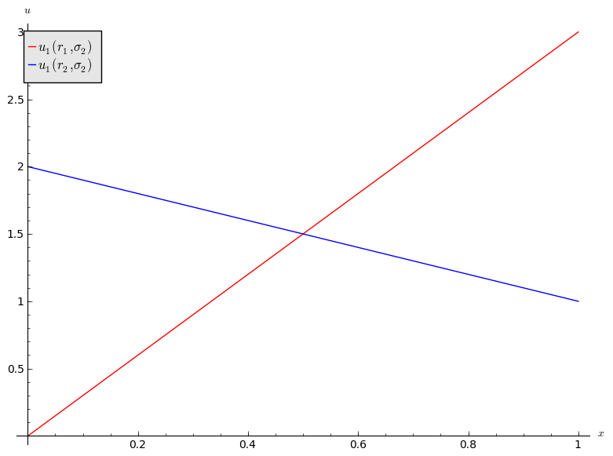

1. If $x<1/2$ then $r_{2}$ is a best response for player 1.
2. If $x>1/2$ then $r_{1}$ is a best response for player 1.
3. If then player 1 is indifferent.