# OR 3: Lecture 2 - Normal Form Games

## Recap

In the [previous lecture](Lecture_1-Introduction.html) we discussed:

* Interactive decision making;
* Normal form games;
* Normal form games and representing information sets.

We did this looking at a game called "the battle of the sexes":

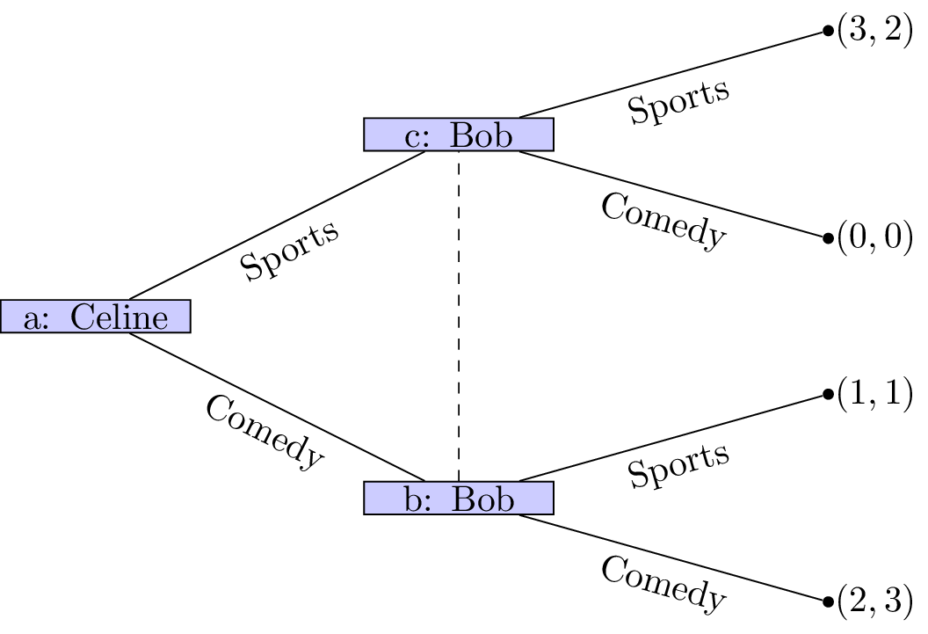

Celine and Bob with Information Set

Can we think of a better way of representing this game?

## Normal form games

One other representation for a game is called the **normal form**.

### Definition

A player **normal form game** consists of:

1. A finite set of players;
2. Strategy spaces for the players: ;
3. Payoff functions for the players:

The convention used in this course (unless otherwise stated) is that all players aim to choose from their strategies in such a way as to maximise their utilities.

A natural way of representing a two player normal form game is using a **bi-matrix**. If we assume that and then the following is a **bi-matrix** representation of the game considered:

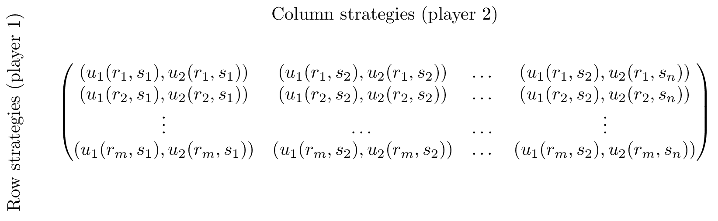

A bi matrix

### Some examples

#### The battle of the sexes

This is the game we've been looking at between Bob and Celine:

#### Prisoners' Dilemma

Assume two thieves have been caught by the police and separated for questioning. If both thieves cooperate and don't divulge any information they will each get a short sentence. If one defects he/she is offered a deal while the other thief will get a long sentence. If they both defect they both get a medium sentence.

#### Hawk-Dove/Chicken

Suppose...

#### Coordination

Suppose...

#### Pareto Coordination

Suppose...

#### Pigs

Suppose...

## Mixed Strategies

So far we have only considered so called **pure strategies**. We will now allow players to play **mixed strategies**.

### Definition

In an player normal form game a **mixed strategy** for player denoted by is a probability distribution over the pure strategies of player .

For example in the matching pennies game discussed previously. A strategy profile of and implies that player 1 plays heads with probability .2 and player 2 plays heads with probability .6.

We can extend the utility function which maps from the set of pure strategies to using *expected payoffs*. For a two player game we have:

(where we relax our notation to allow )

## Matching pennies revisited.

In the previously discussed strategy profile of and the expected utilities can be calculated as follows:

### Example

If we assume that player 2 always plays tails, what is the expected utility to player 1?

Let and we have which gives:

Similarly if player 1 always plays tails the expected utility to player 2 is:

A plot of this is shown here:

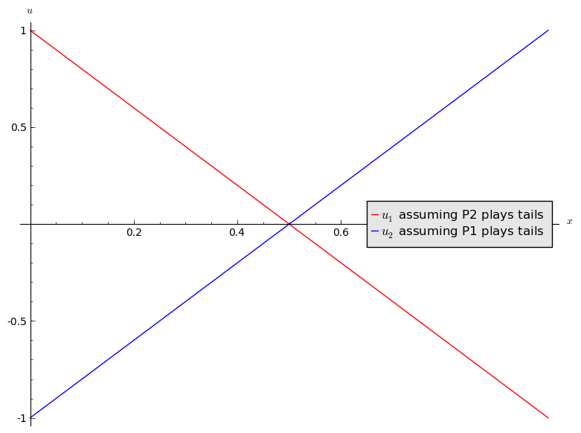

Add to this plot by assuming that the players independently both play heads.