# Homework sheet 3 - Extensive form games, subgame perfect equilibrium and repeated games

1. Obtain the Nash equilibrium for the following games using backward induction:

* 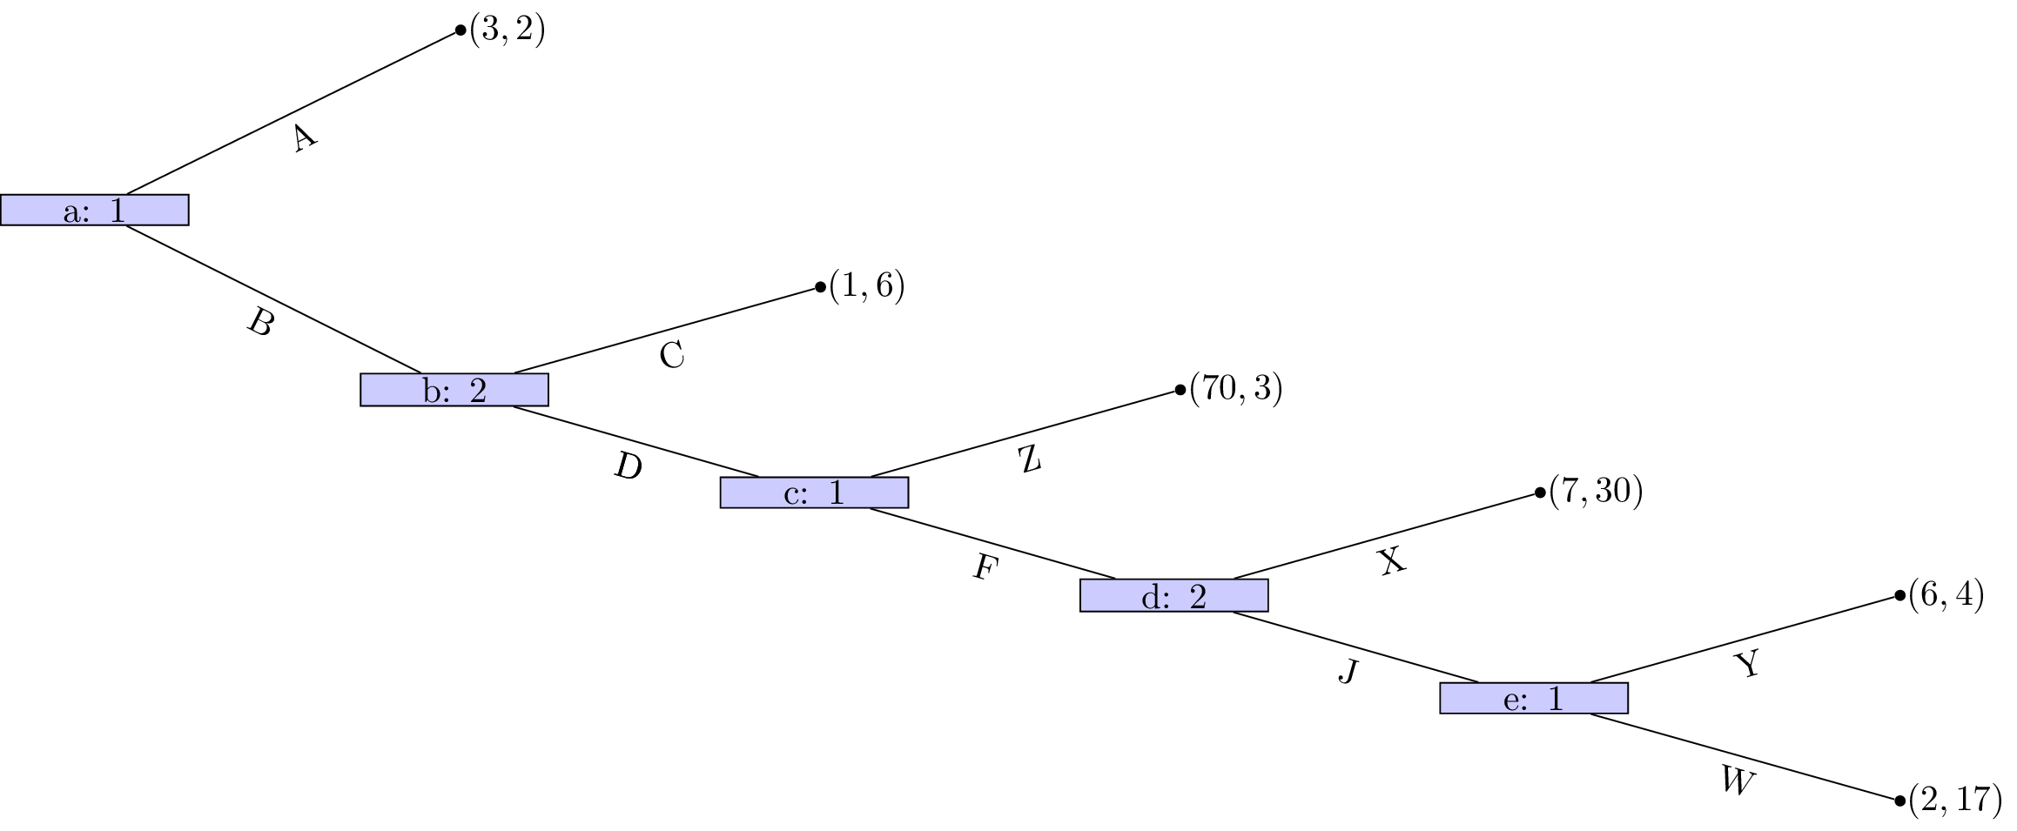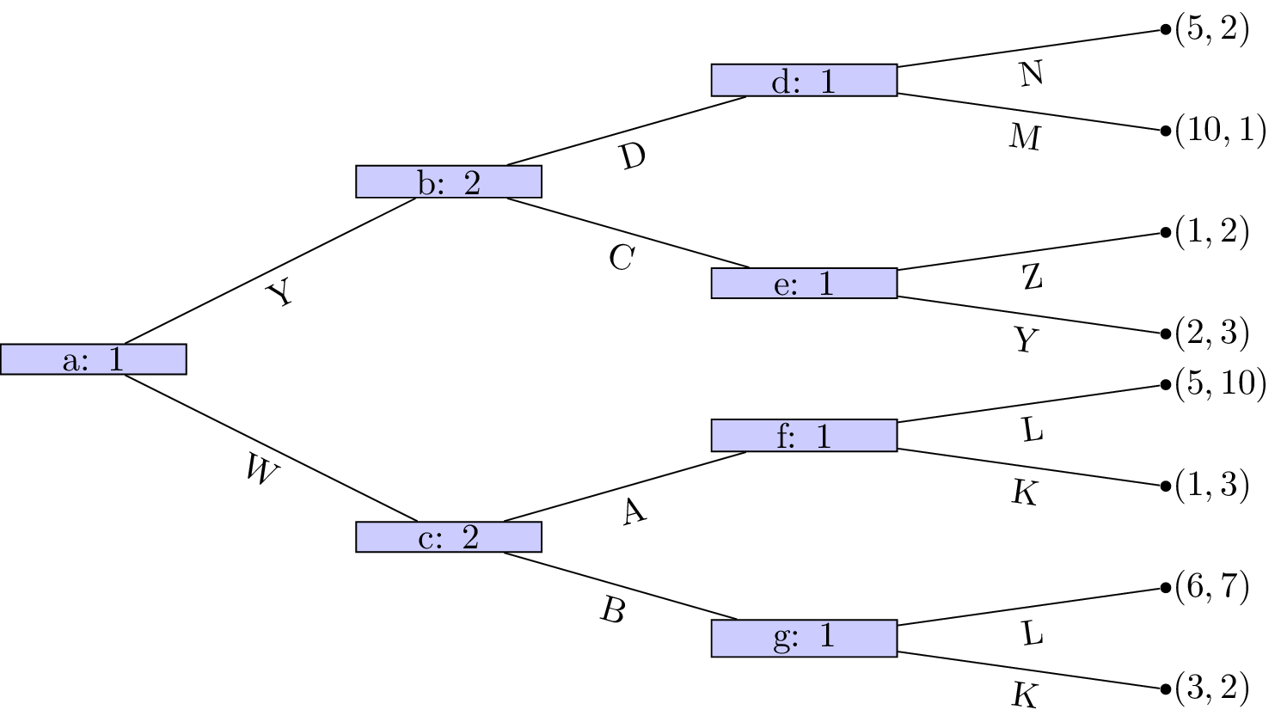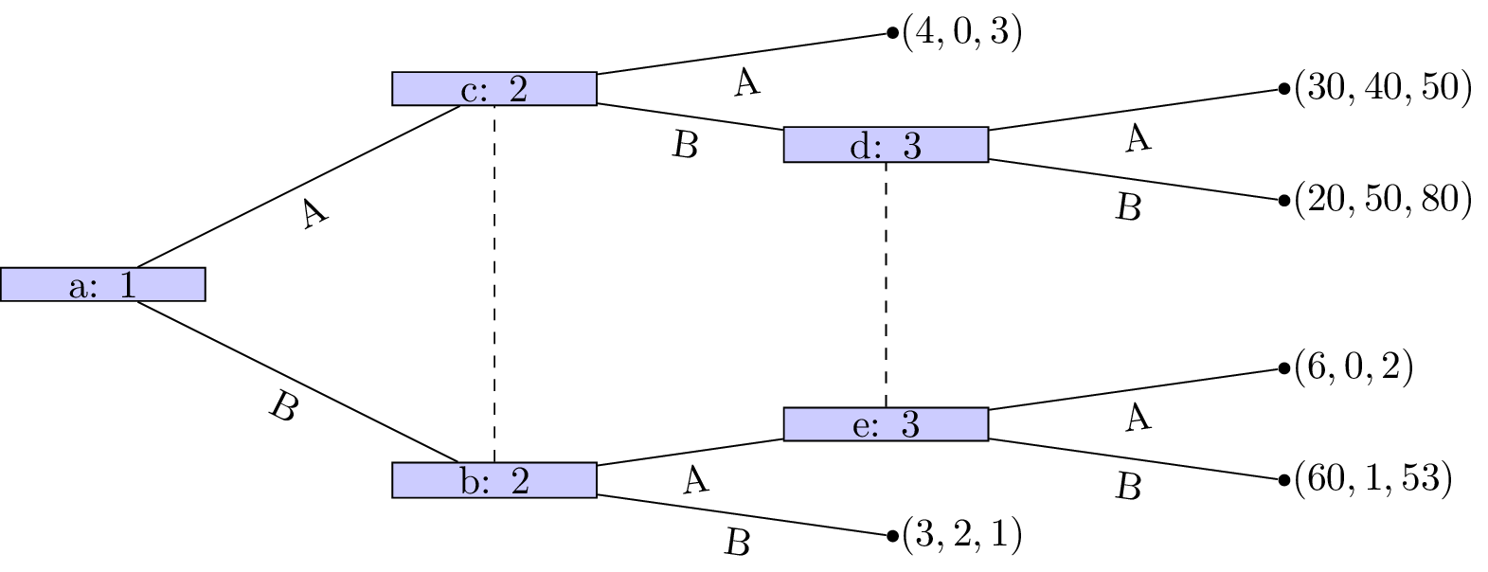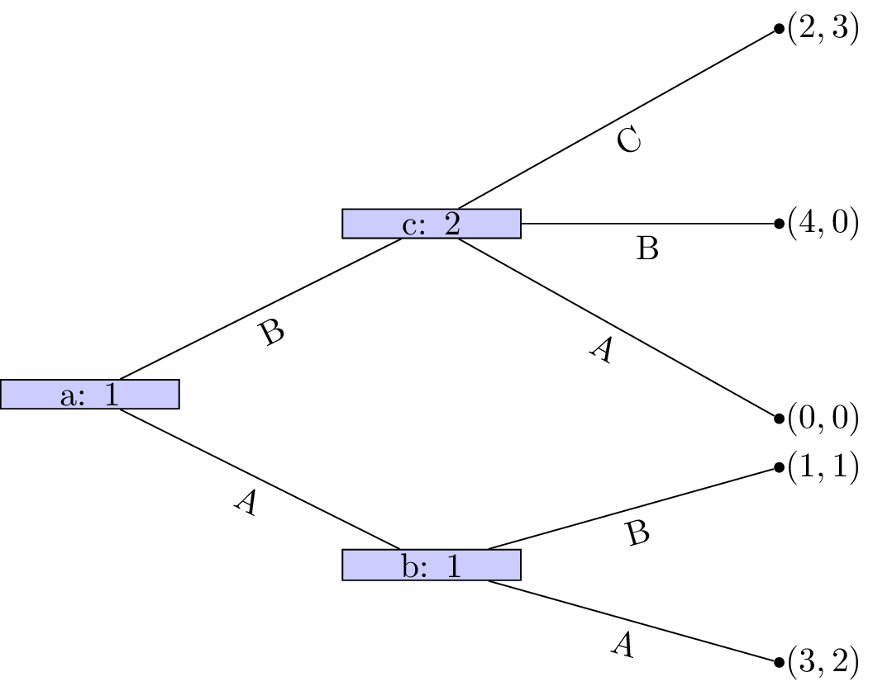

1. Obtain the Nash equilibrium for the following game:

* *Player 1 chooses a number , which player 2 observes. After this simulataneously and independatly player 1 and player 2 choose respectively. The utility to player 1 is given by and the utility to player 2 is given by .*

1. For each of the following games:
   1. Identify all subgames.
   2. Identify the corresponding normal form representations and hence obtain all Nash equilibrium.
   3. Identify which Nash equilibrium are also subgame perfect Nash equilibrium.

* 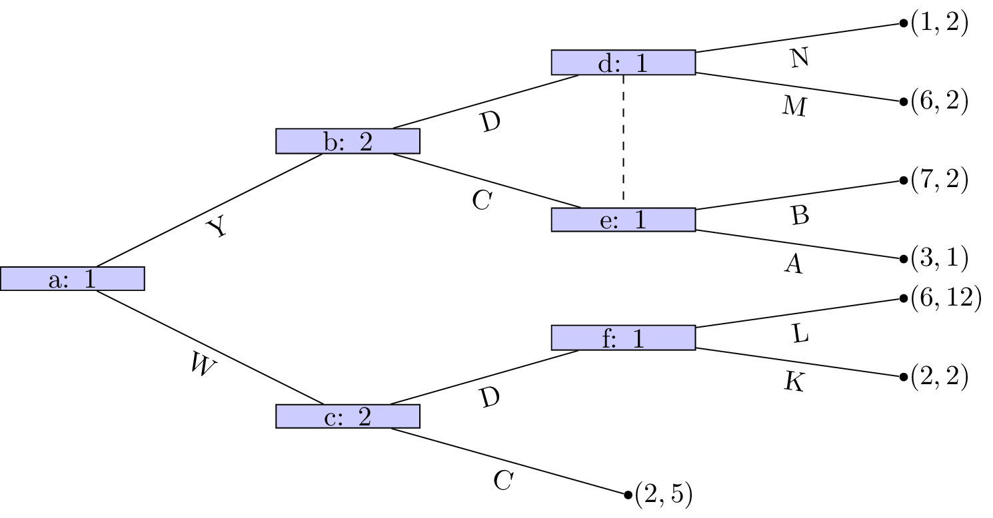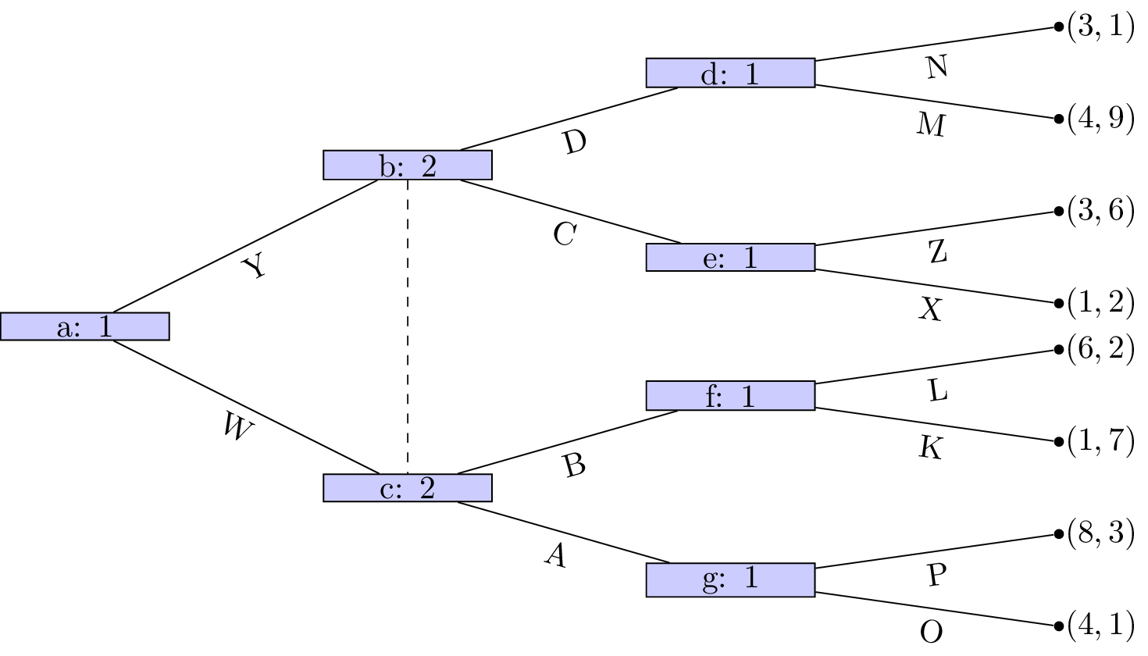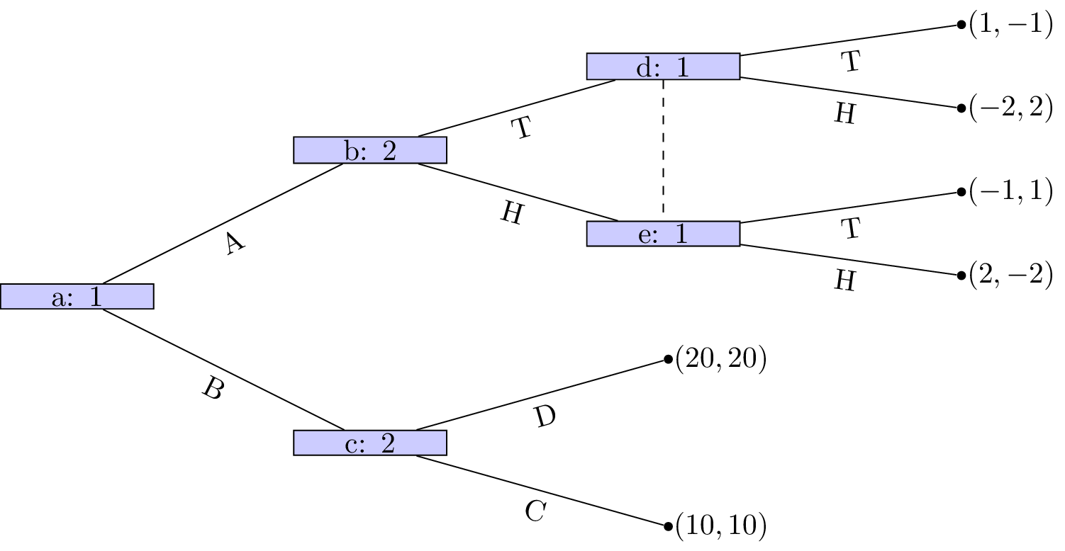

1. For the following stage games:
   1. Plot all possible utility pairs for ;
   2. Recalling that subgame perfect equilibrium for the repeated game must play a stage Nash equilibrium in the final stage attempt to identify a subgame perfect Nash equilibrium for the repeated game that is not a sequence of stage Nash profiles.
2. Consider the following stage game:
   1. For obtain the utilities for the infinitely repeated game for the strategies : "play the first strategy throughout" and : "play the second strategy throughout".
   2. Plot the space of feasible average payoffs and the space of individually rational payoffs.
   3. Obtain that ensures that a strategy profile exists that would give a subgame perfect Nash equilibrium with average payoffs: , , and .