# Homework sheet 4 - Evolutionary games, games with incomplete information and stochastic games

1. Consider the pairwise contest games with the following associated two player games:

* (Assume and )
* Identify all evolutionary stable strategies.

1. Consider the following game:

* In a mathematics department, researchers can choose to use one of two systems for typesetting their research papers: LaTeX or Word. We will refer to these two strategies as and respectively. A user of receives a basic utility of 1 and as is more widely used by mathematicians out of the department and is in general considered to be a better system a user of gets a basic utility of . Members of the mathematics department often collaborate and as such it is beneficial for the researchers to use the same typesetting system. If we let represent the proportion of users of we let:
* What are the evolutionary stable strategies?

1. Consider the simple game with two players: an insurer and a driver. The insurer sets a premium price , once that is done the driver can choose to buy insurance or not. It is assumed that the driver will have an accident with probability , if the driver has an accident the financial cost is . Represent this game in extensive form and obtain the Nash equilibrium for the game as a function of the parameters. Modify your analysis assuming that the utility function to the driver is given by and the utility to the insurer is given by .
2. Repeat the analysis of the principal agent game assuming that is the probability of the project being successful in case of a high level of effort by the employee.
   1. What are the expected utilities to the employer and the employee?
   2. Obtain a condition for which the employer should offer a bonus.
3. Obtain the Markov Nash equilibrium for the following games assuming .

* 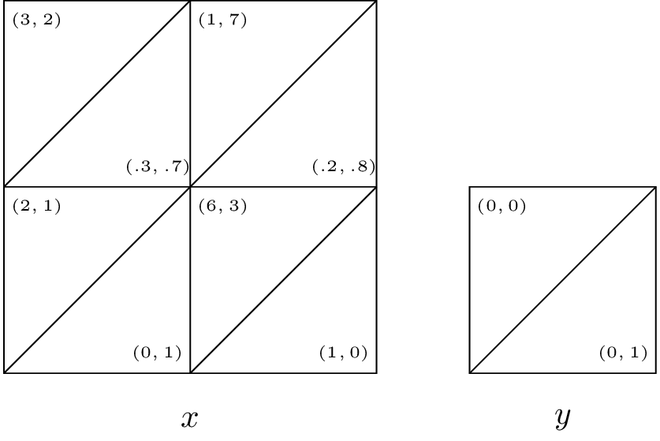  
  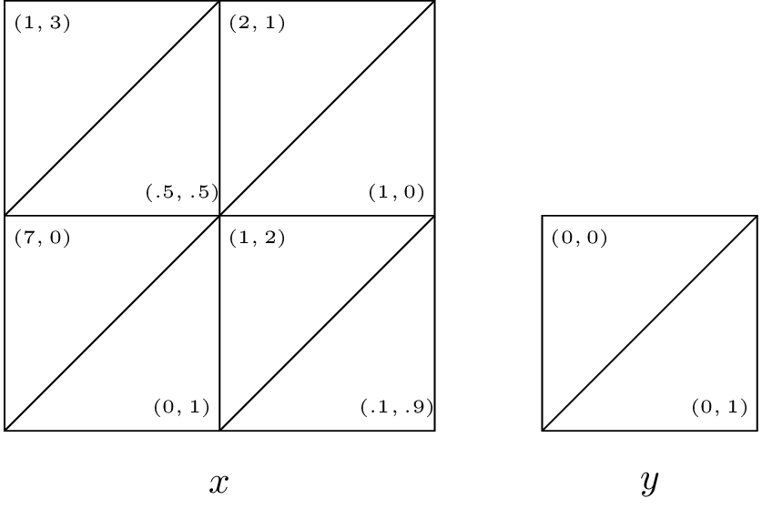  
  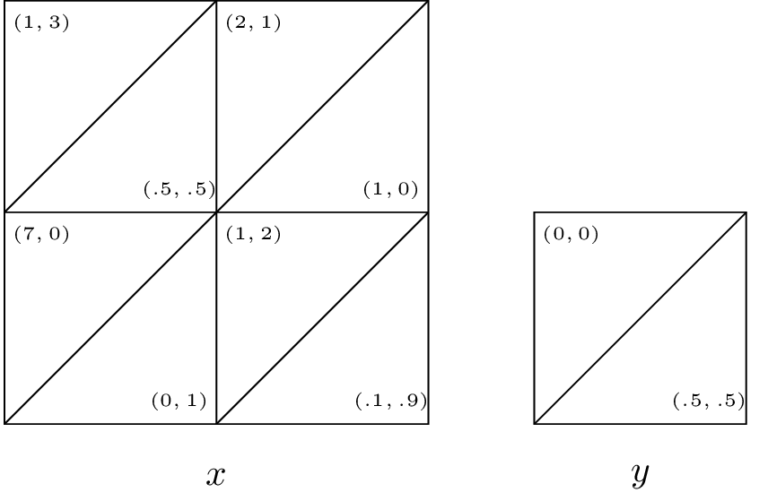

1. Construct a two state stochastic game corresponding to an infinitely repeated game with the following stage game:

* Show that the strategy ("player the first strategy until either player plays the second strategy") can be represented as a Markov strategy. For what values of is both players playing this strategy a Markov Nash equilibrium?