# Homework sheet 2 - Nash equilibrium in normal form games

1. Compute the Nash equilibrium (if they exist) in pure strategies for the following games:

* **Solution**

1. For what values of does a Nash equilibrium exist in pure strategies for the following game:

* **Solution**
  + is a pure strategy Nash equilibrium if:
  + and
  + Thus is a Nash equilibrium iff .
  + is a pure strategy Nash equilibrium if:
  + and
  + This is not possible.
  + is a pure strategy Nash equilibrium if:
  + and
  + Thus is a Nash equilibrium iff
  + is a pure strategy Nash equilibrium if:
  + and
  + Thus is a Nash equilibrium iff

1. Consider the following game:

* Suppose two vendors (of an identical product) must choose their location along a busy street. It is anticipated that their profit is directly related to their position on the street.
* If we allow their positions to be represented by a points on the line segment then we have:
* and
* By considering best responses of each player, identify the Nash equilibrium for the game.
* **Solution**
* Consider , if then . However for some (arbitrarily) small . Thus for arbitrarily small , . If a similar argument gives . If , considering we see that neither player has an incentive to move.
* Thus we conclude:
* So the Nash equilibrium for this problem is .

1. Consider the following game:

* Plot the expected utilities for each player against mixed strategies and use this to obtain the Nash Equilibria.
* **Solution**
* We have:
* Here is a plot of this:
* 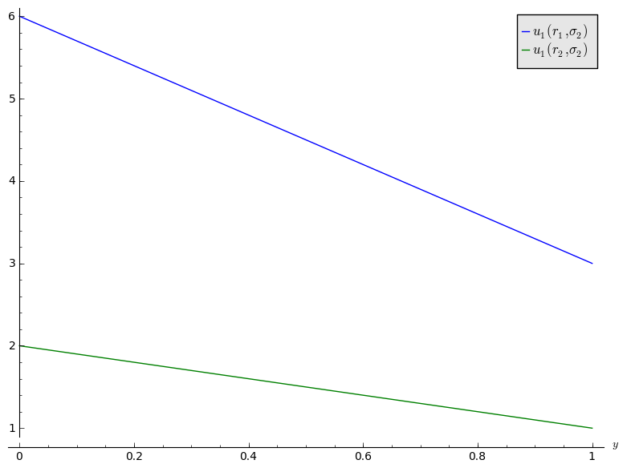
* We see that is dominated by . For player 2, we have:
* Here is a plot of this:
* 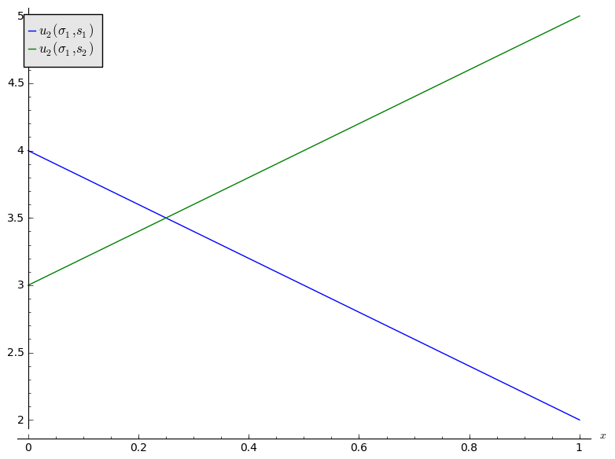
* As is dominated, we see from the plot that the Nash equilibrium is .

1. Assume a soccer player (player 1) is taking a penalty kick and has the option of shooting left or right: . A goalie (player 2) can either dive left or right: . The chances of a goal being scored are given below:
   1. Assume the utility to player 1 if the probability of scoring and the utility to player 2 the probability of a goal not being scored. What is the Nash equilibrium for this game?

* **Solution**
* We see that this is a zero sum game with bi-matrix:
* There are no pure Nash equilibria. To obtain the NE, we use the Equality of Payoffs theorem:
* So the Nash Equilibrium is .
  1. Assume that player 1 now has a further strategy available: to shoot in the middle: the probabilities of a goal being scored are now given:
* Obtain the new Nash equilibrium for the game.
* **Solution**
* There are various approaches to this game, one is to apply the equality of payoffs theorem to all possible supports. Another is to plot the utilities:
* 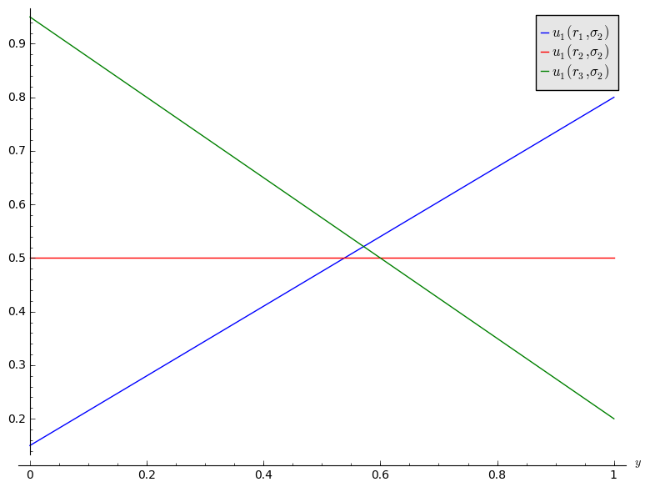
* We see that , by the equality theorem this gives and so the Nash equilibria is the same as before.

1. In the notes the following theorem is given:

* Every normal form game with a finite number of pure strategies for each player, has at least one Nash equilibrium.
* Prove the theorem for 2 player games with . I.e. prove the above result in the special case of games.
* **Solution**
* Let us consider the game:
* There is no pure strategy Nash equilibrium if either:
  1. and and and or
  2. and and and
* In each of these cases we use the Euqality of payoffs theorem:
* which gives:
* Similarly:
* In both cases the as required.