# Homework sheet 3 - Extensive form games, subgame perfect equilibrium and repeated games

1. Obtain the Nash equilibrium for the following games using backward induction:

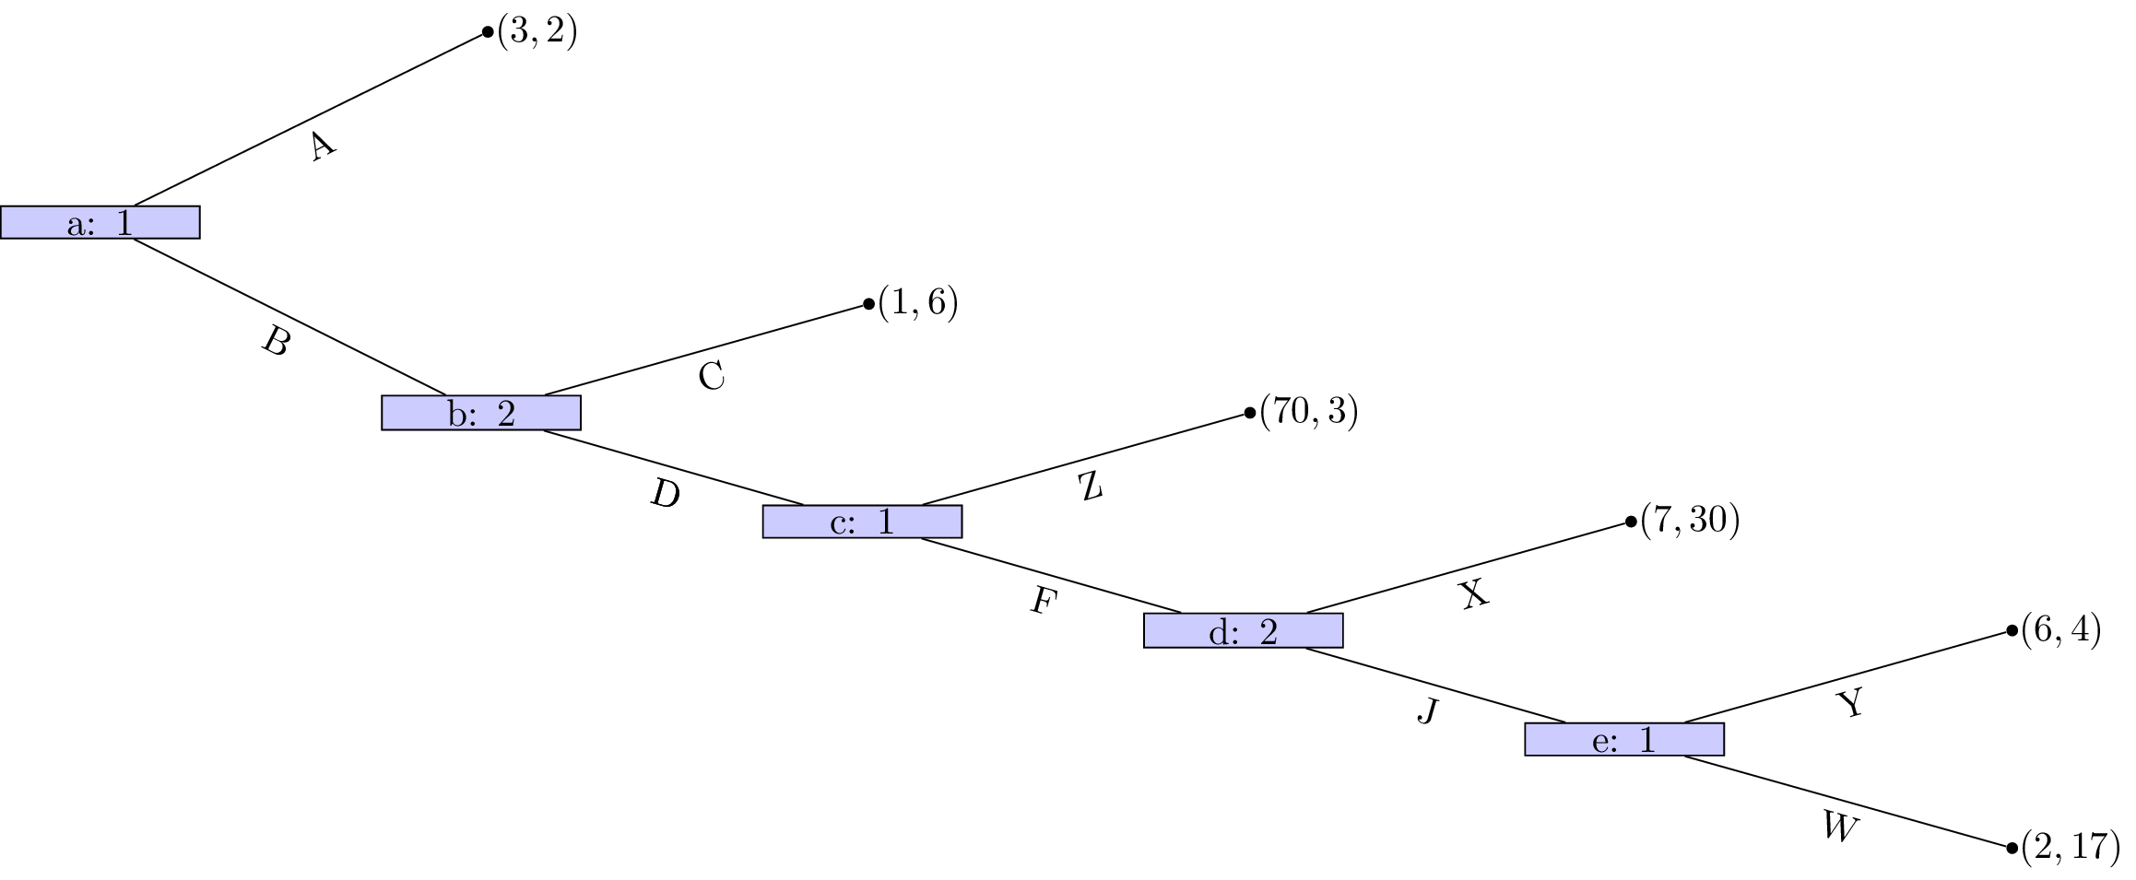 **Solution**

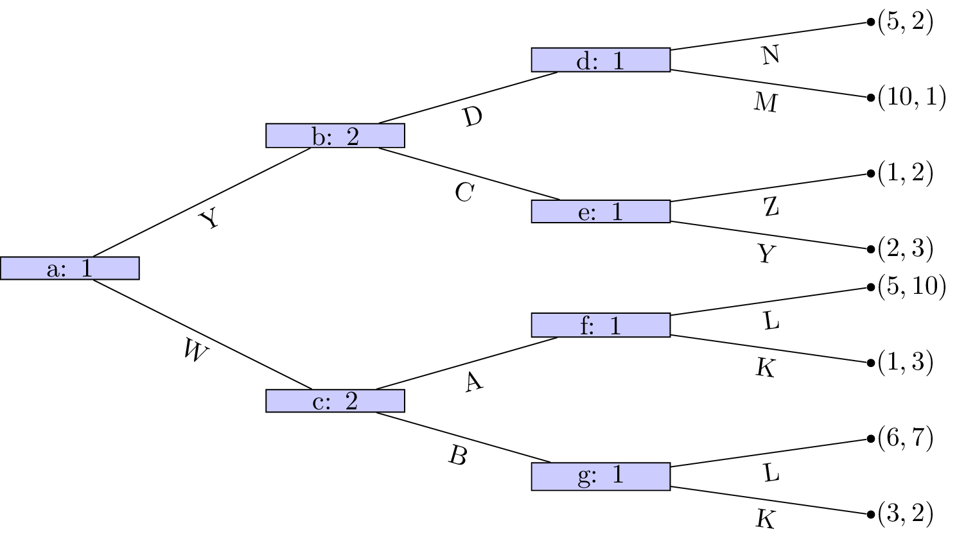 **Solution**

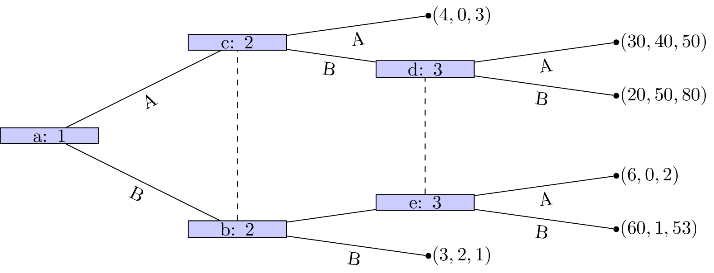 For , dominates , for , dominates , finally dominates for :

**Solution**

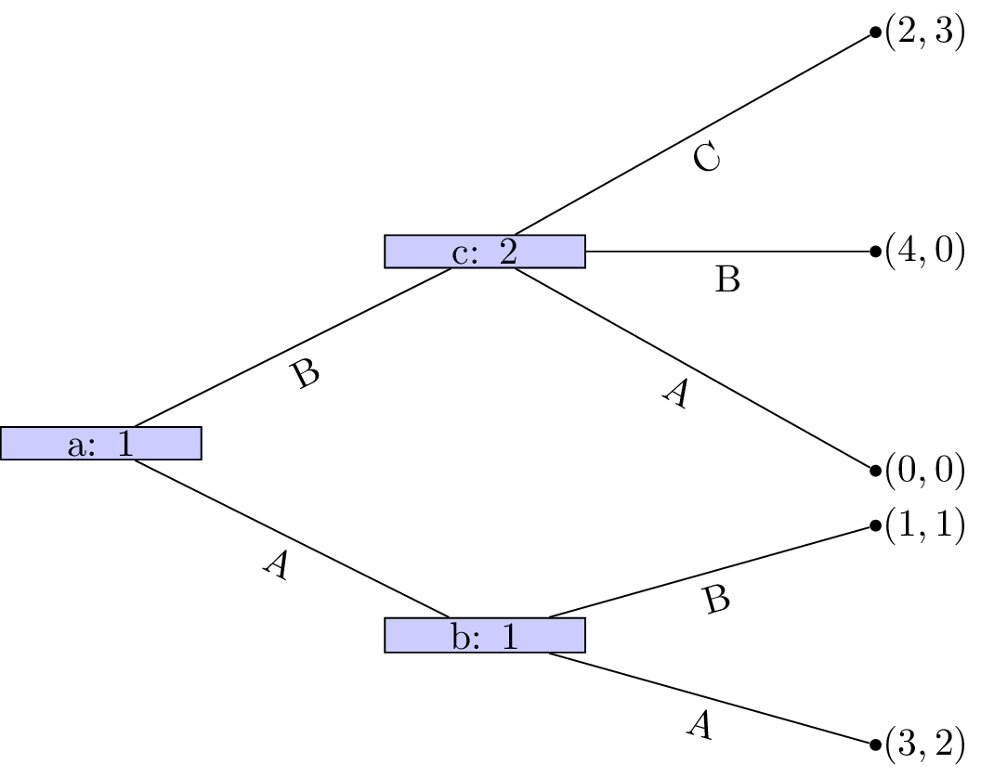 **Solution**

1. Obtain the Nash equilibrium for the following game:

*Player 1 chooses a number , which player 2 observes. After this simulataneously and independatly player 1 and player 2 choose respectively. The utility to player 1 is given by and the utility to player 2 is given by .*

**Solution**

For given : maximises , thus is a solution to:

(As the function has a local maxima which is global)

so:

Similarly:

Thus solve the following system of equations:

Thus:

This gives which has a maxima at for . This gives:

1. For each of the following games:
2. Identify all subgames.
3. Identify the corresponding normal form representations and hence obtain all Nash equilibrium.
4. Identify which Nash equilibrium are also subgame perfect Nash equilibrium.

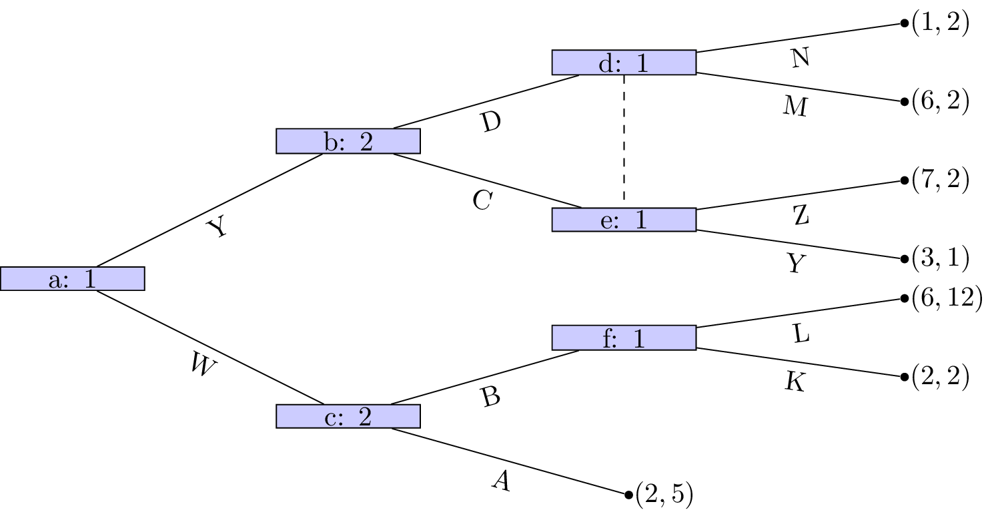 **Solution**

Not a valid game (node d and e are in same information set but have different action sets).

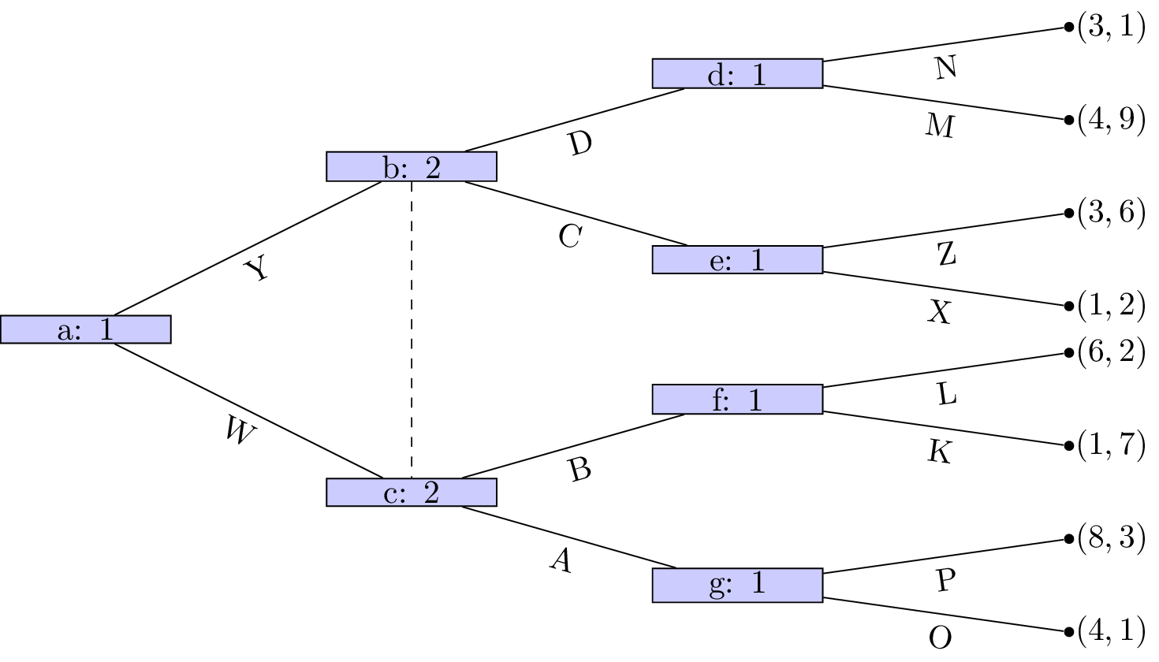 **Solution**

Not a valid game (node b and c are in same information set but have different action sets) 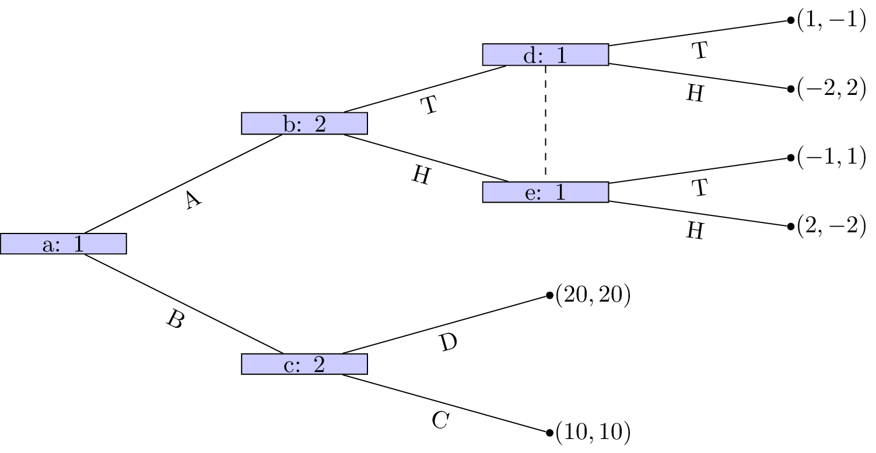 There are two subgames:

* Generated by node (trivial)
* Generated by node

The strategy sets are:

Here is the corresponding normal form representation:

By examining best responses we identify the following 4 pure Nash equilibria:

Looking at the subgame initiated at (with and ):

None of the above strategy pairs are Nash equilibria!

However (using the Equality of Payoffs theorem) we see that:

and

is a NE, and in fact is also a NE for the entire game (again using the Equality of Payoffs theorem). 5. For the following stage games:

1. Plot all possible utility pairs for ;
2. Recalling that subgame perfect equilibrium for the repeated game must play a stage Nash equilibrium in the final stage attempt to identify a Nash equilibrium for the repeated game that is not a sequence of stage Nash profiles.

**Solution**

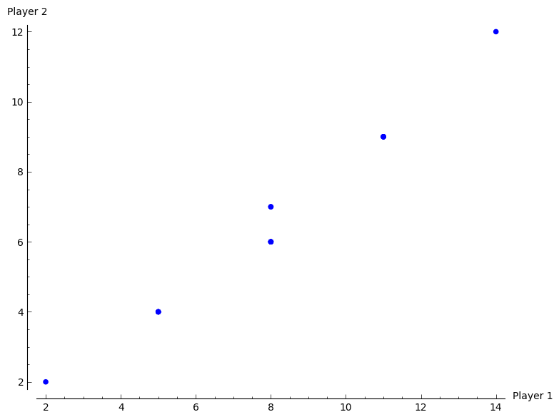 No other strategy is subgame perfect.

**Solution**

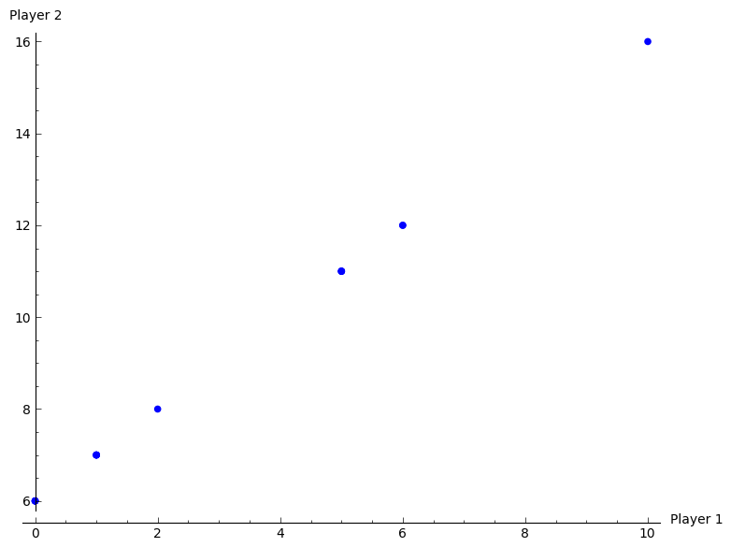 "Play in first round and in second round unless P1 deviates in which case play ."

Outcome: .

Deviate?

* P2: No incentive;
* P1: Gain 2 in 1st round but lose 4 in second round.

**Solution**

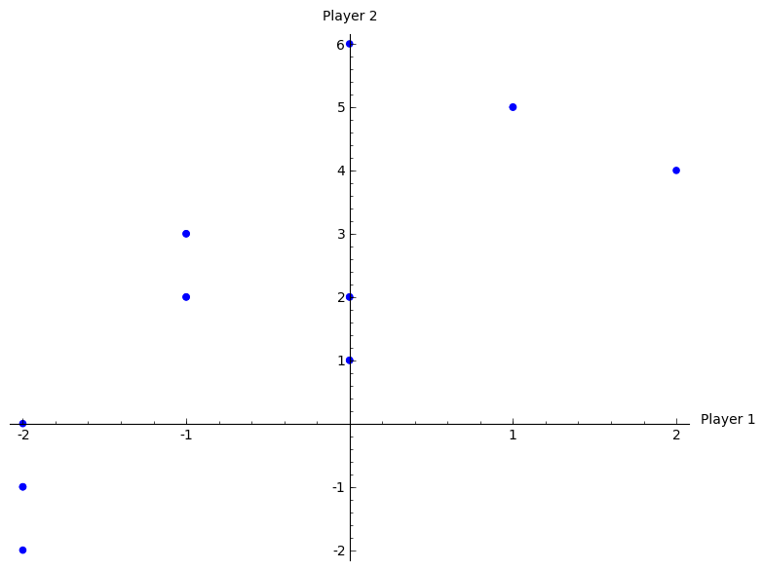 "Play in first round and in second round unless P2 deviates in which case play ."

Outcome: .

Deviate?

* P1: No incentive;
* P2: Gain 1 in 1st round but lose 2 in second round.

1. Consider the following stage game:
2. For obtain the utilities for the infinitely repeated game for the strategies : "play the first strategy throughout" and : "play the second strategy throughout".
3. Plot the space of feasible average payoffs and the space of individually rational payoffs.
4. State whether or not it is possible according to the Folk theorem to obtain that ensures that a strategy profile exists that would give a subgame perfect Nash equilibrium with average payoffs: , , and .

**Solution**

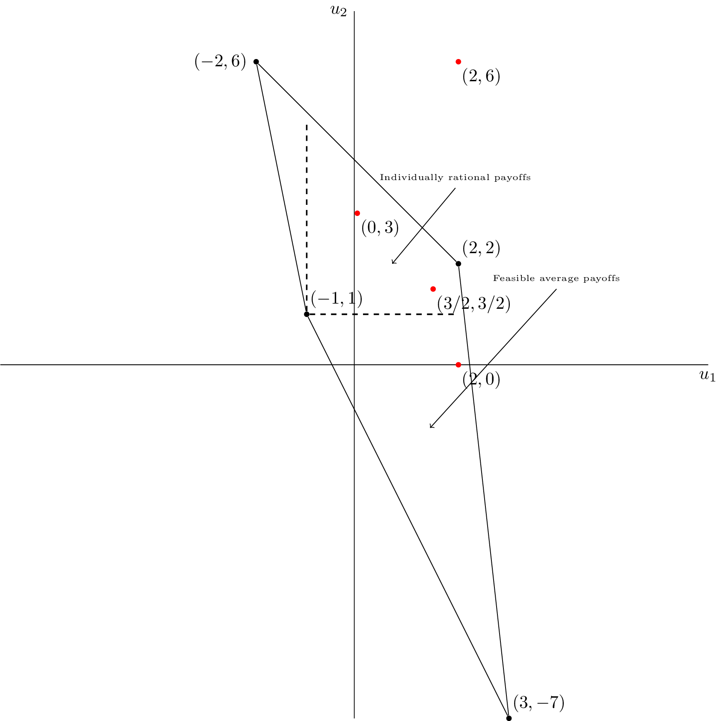 We see that it is possible to find a for and .