# Homework sheet 4 - Evolutionary games, games with incomplete information and stochastic games

1. Consider the pairwise contest games with the following associated two player games:

* **Solution**
* Using the Equality of payoffs theorem we obtain the Nash equilibria:
* The two pure Nash equilibria are ESS (because of the first condition of the theorem relating an evolutionary stable strategy to the Nash equilibrium of the associated game).
* for :
* and:
* thus (after some algebraic manipulation):
* which is negative for so this mixed strategy is not an ESS.
* **Solution**
* Using the Equality of payoffs theorem we obtain the Nash equilibria:
* The two pure Nash equilibria are ESS (because of the first condition of the theorem relating an evolutionary stable strategy to the Nash equilibrium of the associated game).
* As before:
* and:
* so not an ESS.
* Identify all evolutionary stable strategies.

1. Consider the following game:

* In a mathematics department, researchers can choose to use one of two systems for typesetting their research papers: LaTeX or Word. We will refer to these two strategies as and respectively. A user of receives a basic utility of 1 and as is more widely used by mathematicians out of the department and is in general considered to be a better system a user of gets a basic utility of . Members of the mathematics department often collaborate and as such it is beneficial for the researchers to use the same typesetting system. If we let represent the proportion of users of we let:
* What are the evolutionary stable strategies?
* **Solutions**
* Using the theorem for necessity of stability we have the following candidate ESS:
  1. : everyone uses , thus (we have .
  2. : everyone uses , thus (we have .
  3. : some use and some use , by the theorem we have which implies giving .
* Now we consider the post entry population (where is the base strategy and is the entry population). We denote and and . We have:
* which gives:
* We now consider each potential ESS in turn, if for all for some then we have an ESS (this is by definition):
  1. : for all and . Thus is an ESS.
  2. : . If then for all values of , thus if is 3 times better than is not an ESS. If for all . Thus is an ESS for .
  3. : for all and for all so is not an ESS.

1. Consider the following two normal form games:

* Assume both players play either game or game with probability , neither player knows which game is played. Obtain the Nash equilibrium for this game.
* **Solution**
* The described game is akin to the following game:
* We see that is dominated and sole the game using the equality of payoffs theorem to give the following Nash equilibrium:

1. Repeat the analysis of the principal agent game assuming that is the probability of the project being successful in case of a high level of effort by the employee.
   1. What are the expected utilities to the employer and the employee?

* **Solution**
* Repeating the analysis, we see that the employee will carry out a high effort iff:
* Following the same argument as in the notes we arrive at:
* thus:
* The utilities are then:
* Employer:
* Employee:
  1. Obtain a condition for which the employer should offer a bonus.
* **Solution**
* If no bonus is offered the employee has no incentive for a high effort thus , thus the employer should offer a bonus iff:

1. Obtain the Markov Nash equilibrium (in pure strategies if it exists) for the following games assuming .

* 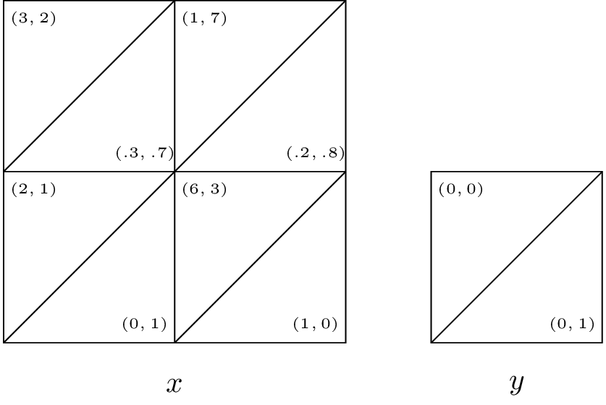 **Solution**
* State gives no value to either player so we only need to consider state . Let the future gains to player 1 in state be and the future gains to player 2 in state be . Thus the players are facing the following game:
* There are four possible equilibria:
  1. which requires: and and . However if this is the equilibria then and which contradicts the constraints.
  2. which requires: and and . However if this is the equilibria then and which contradicts the constraints.
  3. which requires: and and . However if this is the equilibria then and which contradicts the constraints.
  4. which requires: and and . However if this is the equilibria then and which **does not** contradict the constraints.
* Thus is the unique pure strategy equilibrium.
* 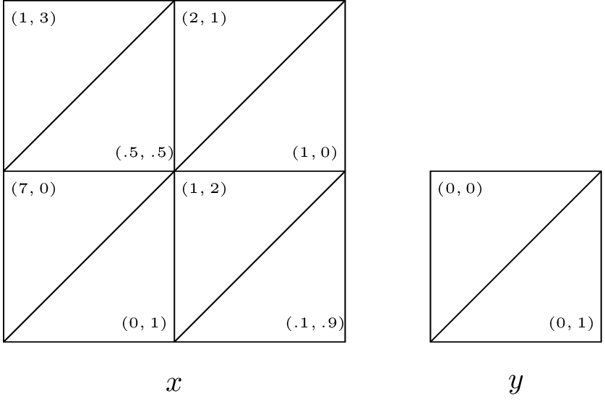 **Solution**
* State gives no value to either player so we only need to consider state . Let the future gains to player 1 in state be and the future gains to player 2 in state be . Thus the players are facing the following game:
* There are four possible equilibria:
  1. which requires: and and . However if this is the equilibria then and which contradicts the constraints.
  2. which requires: and and . However if this is the equilibria then and which contradicts the constraints.
  3. which requires: and and . However if this is the equilibria then and which contradicts the constraints.
  4. which requires: and and . However if this is the equilibria then and which contradicts the constraints.
* Thus no Nash equilibrium exists in pure strategies.
* 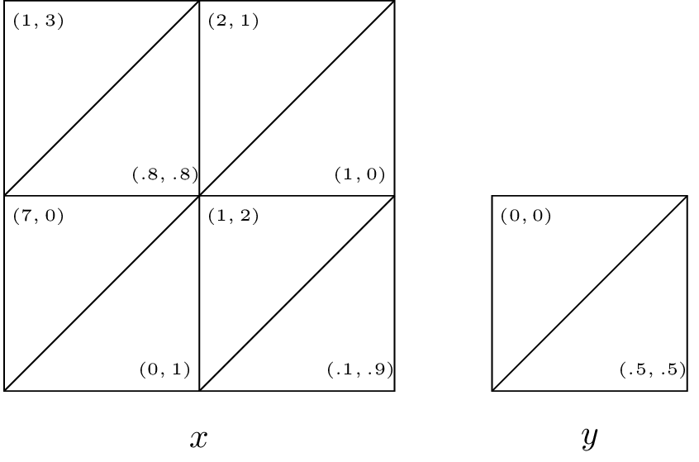 **Solution**
* State gives no value to either player so we only need to consider state . Let the future gains to player 1 in state be and the future gains to player 2 in state be . Thus the players are facing the following game:
* There are four possible equilibria:
  1. which requires: and and . However if this is the equilibria then and which contradicts the constraints.
  2. which requires: and and . However if this is the equilibria then and which does not contradict any constraints.
  3. which requires: and and . However if this is the equilibria then and which contradicts the constraints.
  4. which requires: and and . However if this is the equilibria then and which contradicts the constraints.
* Thus is the unique pure strategy equilibrium.