Header Files in C:

In C language, header files contain a set of predefined standard library functions. The .h is the extension of the header files in C and we request to use a header file in our program by including it with the C preprocessing directive “#include”.

C Header files offer the features like library functions, data types, macros, etc by importing them into the program with the help of a preprocessor directive “#include”.

Syntax of Header Files in C:

We can include header files in C by using one of the given two syntax whether it is a pre-defined or user-defined header file.

#include <filename.h> // for files in system/default directory
or
#include "filename.h" // for files in same directory as source file

The “#include” preprocessor directs the compiler that the header file needs to be processed before compilation and includes all the necessary data types and function definitions.

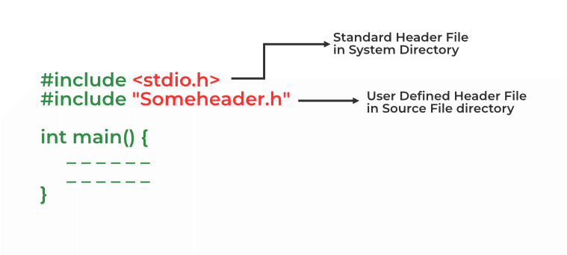

Example:

// C program to demonstrate the use of header files
// standard input and output stdio.h header file
#include <stdio.h>

int main()
{
printf(
"Printf() is the function in stdio.h header file");
return 0;
}

Output
Printf() is the function in stdio.h header file

Types of C Header Files:

There are two types of header files in C:

Standard / Pre-existing header files:

Standard header files contain the libraries defined in the ISO standard of the C programming language. They are stored in the default directory of the compiler and are present in all the C compilers from any vendor.

There are 31 standard header files in the latest version of C language. Following is the list of some commonly used header files in C:

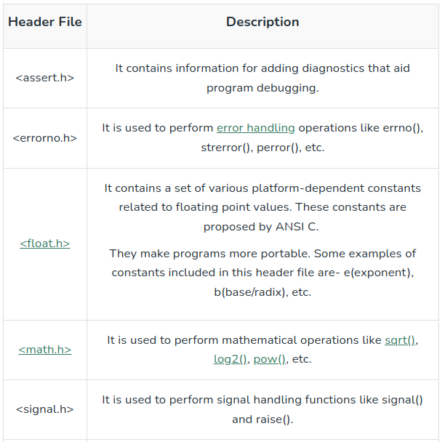

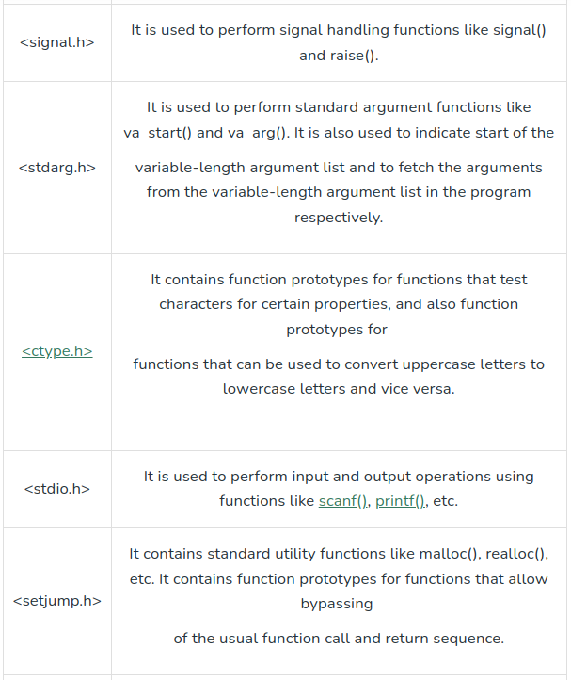

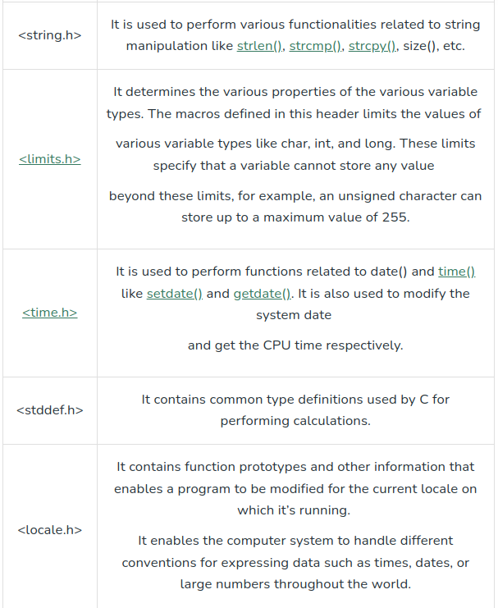

Non-standard / User-defined header files:

Non-standard header files are not part of the language’s ISO standard. They are generally all the header files defined by the programmers for purposes like containing custom library functions etc. They are manually installed by the user or maybe part of the compiler by some specific vendor.

There are lots of non-standard libraries for C language. Some commonly used non-standard/user-defined header files are listed below:
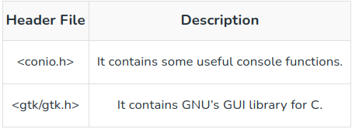
Example:

#include <stdio.h>
#include <conio.h>

// Function to display a welcome message
void displayMessage() {
printf("Hello! Geek\n");
}

int main() {
// Using conio.h functions
printf("Press any key to print message \n");
getch(); // Wait for a key press

// Call the additional function after a key press
displayMessage();

return 0;
}

Output:

Press any key to print message
Hello! Geek

Create your own Header File in C:

Instead of writing a large and complex code, we can create our own header files and include them in our program to use whenever we want. It enhances code functionality and readability. Below are the steps to create our own header file:

Step 1: Write your own C code and save that file with the “.h” extension. Below is the illustration of the header file:

// Function to find the sum of two
// numbers passed
int sumOfTwoNumbers(int a, int b)
{
return (a + b);
}

Step 2: Include your header file with “#include” in your C program as shown below:

// C++ program to find the sum of two
// numbers using function declared in
// header file
#include "iostream"

// Including header file
#include "sum.h"
using namespace std;

// Driver Code
int main()
{

// Given two numbers
int a = 13, b = 22;

// Function declared in header
// file to find the sum
printf("Sum is: %d", sumoftwonumbers(a, b));
}

Output:

Sum is: 35

Including Multiple Header Files:

You can use various header files in a program. When a header file is included twice within a program, the compiler processes the contents of that header file twice. This leads to an error in the program. To eliminate this error, conditional preprocessor directives are used.

Syntax:

#ifndef HEADER_FILE_NAME
#define HEADER_FILE_NAME
the entire header file
#endif

Explanation:

- #ifndef HEADER_FILE_NAME: Checks if HEADER_FILE_NAME is not defined.
- #define HEADER_FILE_NAME: Defines HEADER_FILE_NAME if it is not already defined.
- Header File Contents: The actual content of the header file.
- #endif: Ends the conditional directive.

This construct is called wrapper “#ifndef” (if not defined). When the header is included again, the conditional will become false, because HEADER_FILE_NAME is defined. The preprocessor will skip over the entire file contents, and the compiler will not see it twice.

Sometimes it’s essential to include several diverse header files based on the requirements of the program. For this, multiple conditionals are used.

Syntax:

#if SYSTEM_ONE
#include "system1.h"
#elif SYSTEM_TWO
#include "system2.h"
#elif SYSTEM_THREE
....
#endif

Macros and its types in C:

In C, a macro is a piece of code in a program that is replaced by the value of the macro. Macro is defined by #define directive. Whenever a macro name is encountered by the compiler, it replaces the name with the definition of the macro. Macro definitions need not be terminated by a semi-colon(;).

Example:
// C program to illustrate macros
#include <stdio.h>

// Macro definition
#define LIMIT 5

// Driver Code
int main()
{
// Print the value of macro defined
printf("The value of LIMIT"
" is %d",
LIMIT);

return 0;
}

Output:

The value of LIMIT is 5

Example 2:
// C program to illustrate macros
#include <stdio.h>

// Macro definition
#define AREA(l, b) (l * b)

// Driver Code
int main()
{
// Given lengths l1 and l2
int l1 = 10, l2 = 5, area;

// Find the area using macros
area = AREA(l1, l2);

// Print the area
printf("Area of rectangle"
" is: %d",
area);

return 0;
}

Output
Area of rectangle is: 50

Explanation:
From the above program, we can see that whenever the compiler finds AREA(l, b) in the program it replaces it with the macros definition i.e., (l*b). The values passed to the macro template AREA(l, b) will also be replaced by the statement (l*b). Therefore, AREA(10, 5) will be equal to 10*5.

Types Of Macros in C:
There are two types of macros in C language:

1. Object-Like Macros:

An object-like macro is a simple identifier that will be replaced by a code fragment. It is called object-like because it looks like an object in code that uses it. It is popularly used to replace a symbolic name with a numerical/variable represented as a constant.

Example:
// C program to illustrate macros
#include <stdio.h>

// Macro definition
#define DATE 31

// Driver Code
int main()
{
// Print the message
printf("Lockdown will be extended"
" upto %d-MAY-2020",
DATE);

return 0;
}

Output:

Lockdown will be extended upto 31-MAY-2020

2. Chain Macros:
Macros inside macros are termed chain macros. In chain macros first of all parent macro is expanded then the child macro is expanded.

Example:

// C program to illustrate macros
#include <stdio.h>

// Macro definition
#define INSTAGRAM FOLLOWERS
#define FOLLOWERS 138

// Driver Code
int main()
{
// Print the message
printf("Geeks for Geeks have %dK"
" followers on Instagram",
INSTAGRAM);

return 0;
}

Output:
Geeks for Geeks have 138K followers on Instagram

Explanation:
INSTAGRAM is expanded first to produce FOLLOWERS. Then the expanded macro is expanded to produce the outcome as 138K. This is called the chaining of macros.

3. Multi-Line Macros:
An object-like macro could have a multi-line. So to create a multi-line macro you have to use backslash-newline.

Example:

// C program to illustrate macros
#include <stdio.h>

// Multi-line Macro definition
#define ELE 1, \
2, \
3

// Driver Code
int main()
{

// Array arr[] with elements
// defined in macros
int arr[] = { ELE };

// Print elements
printf("Elements of Array are:\n");

for (int i = 0; i < 3; i++) {
printf("%d ", arr[i]);
}
return 0;
}

Output
Elements of Array are:
1 2 3

4. Function-Like Macros:

These macros are the same as a function call. It replaces the entire code instead of a function name. Pair of parentheses immediately after the macro name is necessary. If we put a space between the macro name and the parentheses in the macro definition, then the macro will not work.
A function-like macro is only lengthened if and only if its name appears with a pair of parentheses after it. If we don’t do this, the function pointer will get the address of the real function and lead to a syntax error.

Example:
// C program to illustrate macros
#include <stdio.h>

// Function-like Macro definition
#define min(a, b) (((a) < (b)) ? (a) : (b))

// Driver Code
int main()
{

// Given two number a and b
int a = 18;
int b = 76;

printf("Minimum value between %d and %d is %d\n", a, b, min(a, b));

return 0;
}
Output:
Minimum value between 18 and 76 is 18

Here is one example that will give more understanding of Macros:
- Problem: We need to find the area of a circle by defining AREA(r) Macros.

#include <stdio.h>
#define PI 3.1416
#define AREA(r) (PI*(r)*(r))

int main() {
float r = 7; // radius of circle

printf("Area of Circle with radius %.0f: %.3f", r, AREA(r));
return 0;
}

Output
Area of Circle with radius 7: 153.938

