Title: Deepfake Detection Using Convolutional Neural Networks: A Comparative Study
Authors: Student A, Student B, Student C

Abstract:
This paper presents a deepfake detection system using transfer learning with MobileNetV2. We trained and evaluated two model versions on a subset of FaceForensics++ dataset consisting of 2000 frames. Our baseline model (V1) achieved 71.25% test accuracy, while the improved model (V2) achieved 74.50%. Robustness testing revealed sensitivity to both JPEG compression and Gaussian noise. A web-based demo was developed using Gradio for real-time inference.

1. Introduction
The proliferation of deepfake technology poses serious threats to digital media integrity. Detecting AI-generated facial manipulations has become a critical research area. In this work, we present a binary classification pipeline using MobileNetV2 pretrained on ImageNet, fine-tuned on FaceForensics++ data.
Our contributions are:
- A lightweight CNN-based deepfake detector
- Comparative analysis of two training configurations
- Robustness evaluation under image degradation
- A web-based inference interface
- 2. Related Work
- Rossler et al. introduced FaceForensics++, a benchmark dataset for facial manipulation detection containing thousands of manipulated videos. Afchar et al. proposed MesoNet, a shallow CNN targeting mesoscopic image properties. Chollet's XceptionNet demonstrated state-of-the-art performance on deepfake detection by leveraging depthwise separable convolutions. Our work differs by prioritizing lightweight inference using MobileNetV2, making it suitable for resource-constrained environments.

- 3. Methodology
- 3.1 Dataset
- We used a subset of FaceForensics++ consisting of 400 videos — 200 real and 200 fake. Five frames were extracted per video at equal intervals, yielding 2000 images total (1000 real, 1000 fake). All frames were resized to 224×224 pixels.
- 3.2 Preprocessing
- Two preprocessing pipelines were used. For V1, standard normalization was applied using ImageNet statistics. For V2, additional augmentation was applied during training including random horizontal flipping, random rotation up to 10 degrees, and color jitter. Both pipelines normalize using mean=[0.485, 0.456, 0.406] and std=[0.229, 0.224, 0.225].
- 3.3 Model Architecture
- MobileNetV2 pretrained on ImageNet was used as the backbone. The final classification layer was replaced with a binary linear layer outputting real/fake probabilities. The model contains approximately 3.4 million parameters.
- 3.4 Training Configuration
Setting | V1 | V2
Epochs | 5 | 10
Learning Rate | 0.001 | 0.0001
Optimizer | Adam | Adam
Loss | CrossEntropy | CrossEntropy
Batch Size | 32 | 32

4. Experiments and Results
4.1 Training Performance
V1 training results:
Epoch | Loss | Train Accuracy
1 | 0.6302 | 63.44%
2 | 0.5163 | 73.44%
3 | 0.4955 | 76.19%
4 | 0.4619 | 77.56%
5 | 0.4191 | 79.75%
V2 training results:
Epoch | Loss | Train Accuracy
1 | 0.2881 | 86.94%
2 | 0.2117 | 91.25%
3 | 0.1780 | 92.88%
4 | 0.1348 | 94.88%
5 | 0.1029 | 95.94%
6 | 0.0896 | 96.38%
7 | 0.0812 | 96.94%
8 | 0.0557 | 98.00%
9 | 0.0481 | 98.00%
10 | 0.0558 | 98.19%
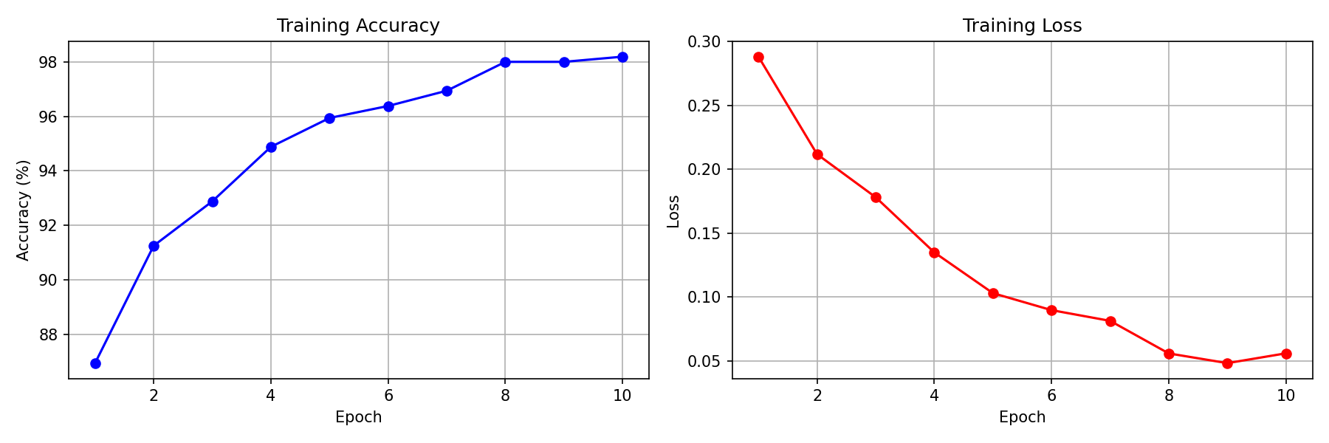
4.2 Test Performance
Model | Test Accuracy
V1 (Baseline) | 71.25%
V2 (Improved) | 74.50%

4.3 Classification Report (V2)
Class | Precision | Recall | F1-Score
Fake | 0.71 | 0.78 | 0.74
Real | 0.74 | 0.66 | 0.70
Accuracy |  |  | 0.72
4.4 Robustness Testing
Condition | V1 | V2
No degradation | 71.25% | 73.00%
JPEG Quality 50 | 70.50% | 65.75%
JPEG Quality 20 | 65.75% | 55.50%
Noise level 10 | 56.00% | 61.00%
Noise level 25 | 58.25% | 48.50%

5. Discussion
Several observations can be drawn from our experiments. First, reducing the learning rate from 0.001 to 0.0001 significantly improved training accuracy from 79.75% to 98.19%, though test accuracy improved modestly from 71.25% to 74.50%, indicating overfitting due to the limited dataset size.
Second, robustness testing revealed that V1 generalizes better under JPEG compression while V2 shows higher sensitivity, likely due to overfitting to clean training images. Gaussian noise remains a challenge for both models, suggesting that noise-based augmentation during training could improve robustness.
Third, the model shows limitations in detecting deepfakes outside the FaceForensics++ distribution, as demonstrated during real-world testing with the Gradio interface.

6. Conclusion and Future Work
This paper presented a deepfake detection system using MobileNetV2 transfer learning. Our best model achieved 74.50% test accuracy on FaceForensics++ subset. Robustness testing revealed sensitivity to image degradation, particularly Gaussian noise.
Future work includes:
- Training on larger and more diverse datasets
- Applying noise augmentation to improve robustness
- Experimenting with deeper architectures such as XceptionNet
- Deploying the model as a permanent web service

References
[1] Rossler, A., et al. "FaceForensics++: Learning to Detect Manipulated Facial Images." ICCV, 2019.
[2] Afchar, D., et al. "MesoNet: a Compact Facial Video Forgery Detection Network." WIFS, 2018.
[3] Sandler, M., et al. "MobileNetV2: Inverted Residuals and Linear Bottlenecks." CVPR, 2018.
[4] Chollet, F. "Xception: Deep Learning with Depthwise Separable Convolutions." CVPR, 2017.
[5] Goodfellow, I., et al. "Generative Adversarial Networks." NeurIPS, 2014.

