**Introduction**

The introduction highlights the significance of LSAT structures in achieving reprogrammable mechanical responses through localized snapping and auxetic behavior, which is beneficial for various advanced materials applications.

Key points discussed in the introduction include:

* The need for materials with tunable mechanical properties.
* The concept of auxetic materials, which exhibit a negative Poisson's ratio.
* The innovation of LSAT structures that combine the benefits of localized snapping and auxetic behavior to enhance mechanical performance.

**Main Objectives**

The primary objectives of the study are:

1. Develop and Characterize LSAT Structures: To create LSAT structures that exhibit reprogrammable mechanical properties and to characterize their performance.

2. Investigate Prestrain Effects: To study how prestrain can transform regular chiral systems into LSAT structures.

3. Optimize Design for Shear Stiffness: To perform a parametric analysis aimed at maximizing the shear stiffness of LSAT structures.

4. Characterize Auxetic and Dynamic Properties: To analyze the auxetic behavior and dynamic properties of the LSAT system.

**Experimentation**

To achieve these objectives, several experiments and analyses were conducted:

1. Material Characterization:

- Chiral specimens were fabricated using a composite material composed of silicone elastomer and glass fibers.

- Uniaxial tension tests were performed to determine the mechanical properties of these specimens.

- The data obtained from these tests were used to calibrate a hyperelastic model, specifically the Yeoh model, for finite element analysis (FEA). The Yeoh model equation used was:

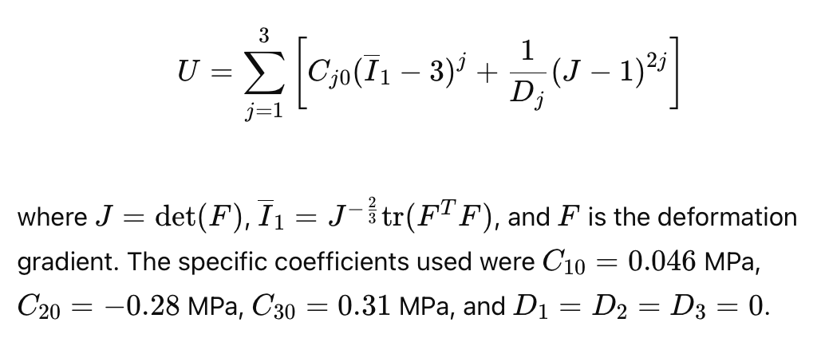

2. LSAT Fabrication:

- LSAT structures were fabricated using a mold casting method with silicone elastomer reinforced with glass fibers.

- Prestrain was applied using wire frames to transform regular chiral structures into LSAT systems, a crucial step in achieving the desired mechanical properties.

3. Structural Design by Parametric Analysis:

- Finite element analysis (FEA) was employed to study the response of LSAT structures under shear loading.

- The analysis focused on optimizing geometric parameters to maximize the reprogrammability of shear stiffness.

- Both experimental and numerical results were compared to evaluate shear stiffness in unsnapped and snapped configurations.

4. Auxetic Analysis:

- The auxetic behavior of the LSAT structure was studied by applying vertical compression and analyzing in-plane deformations using digital image correlation.

- Poisson's ratio was calculated based on local strain values.

- Dynamic tests were conducted to characterize the system's response to harmonic excitation, providing insights into the LSAT system's potential for responsive applications.

**Results**

The study produced significant findings across the various objectives:

1. Shear Stiffness:

- Experimental and numerical results indicated a significant increase in shear stiffness when LSAT cells were in the snapped configuration compared to the unsnapped state.

- The snapped configuration resulted in a 20-fold increase in shear stiffness due to contact and frictional interactions within the structure.

2. Parametric Analysis:

- The parametric study revealed that certain geometric ratios maximize the reprogrammability of shear stiffness.

- Some configurations achieved over a 40-fold increase in stiffness, demonstrating the effectiveness of the design optimization.

3. Auxetic and Dynamic Properties:

- LSAT structures exhibited notable auxetic behavior, characterized by a negative Poisson's ratio during vertical compression.

- Dynamic tests indicated that the LSAT system could effectively respond to harmonic excitation, suggesting its potential for applications in sensors, actuators, and mechanical computers.

**Conclusion**

The research demonstrates the innovative potential of LSAT structures in various advanced materials applications. The ability to rapidly and reversibly tune mechanical properties without changing the overall volume or shape of the material offers significant advantages for developing responsive and reprogrammable material systems. This study provides a foundation for future developments in multifunctional materials, including applications in sensors, actuators, and mechanical computing.