1. Web-Based Mobile App hoti kya hai?
Web-Based Mobile App ek aisi application hoti hai jo mobile phone par app ki tarah use hoti hai, lekin asal mein web technologies se banti hai aur browser ke through chal sakti hai.
For example, tum apne mobile par Chrome open karte ho, kisi website par jate ho, aur woh website mobile ki screen ke mutabiq app jaisa interface show karti hai.
Is tarah ki application ki 3 common forms hoti hain.
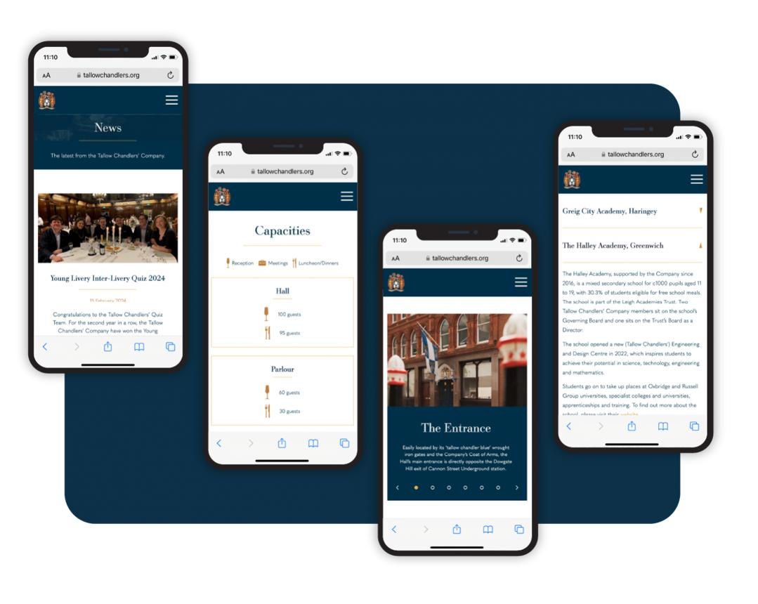
1. Responsive Web App
Website browser mein open hoti hai aur mobile, tablet aur desktop ki screen ke mutabiq adjust ho jati hai.
Example: Mobile browser mein Gmail ya kisi shopping website ko use karna.
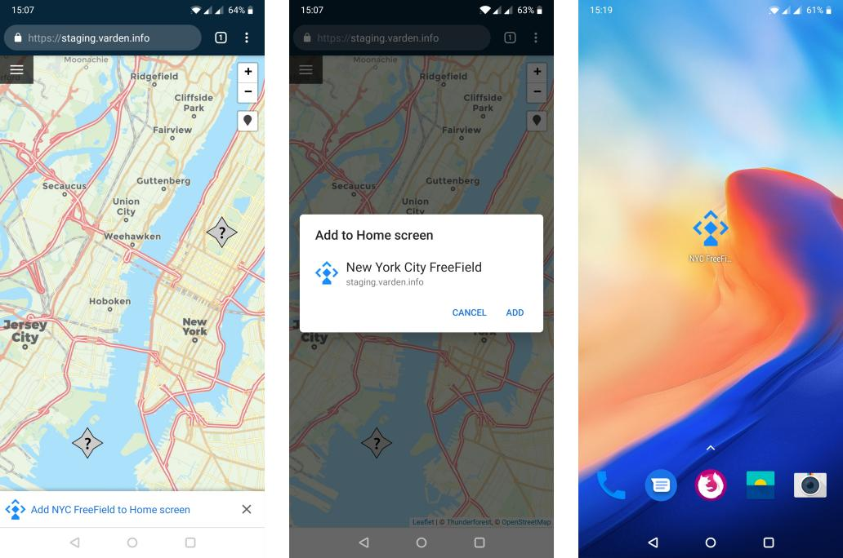
2. PWA (Progressive Web App)
Website ko mobile ki home screen par install kiya ja sakta hai. Supported devices aur browsers par yeh standalone app ki tarah open hoti hai aur kuch offline features bhi provide kar sakti hai.
Example: Aisi task-management app jo home screen se open ho aur notifications support kare.
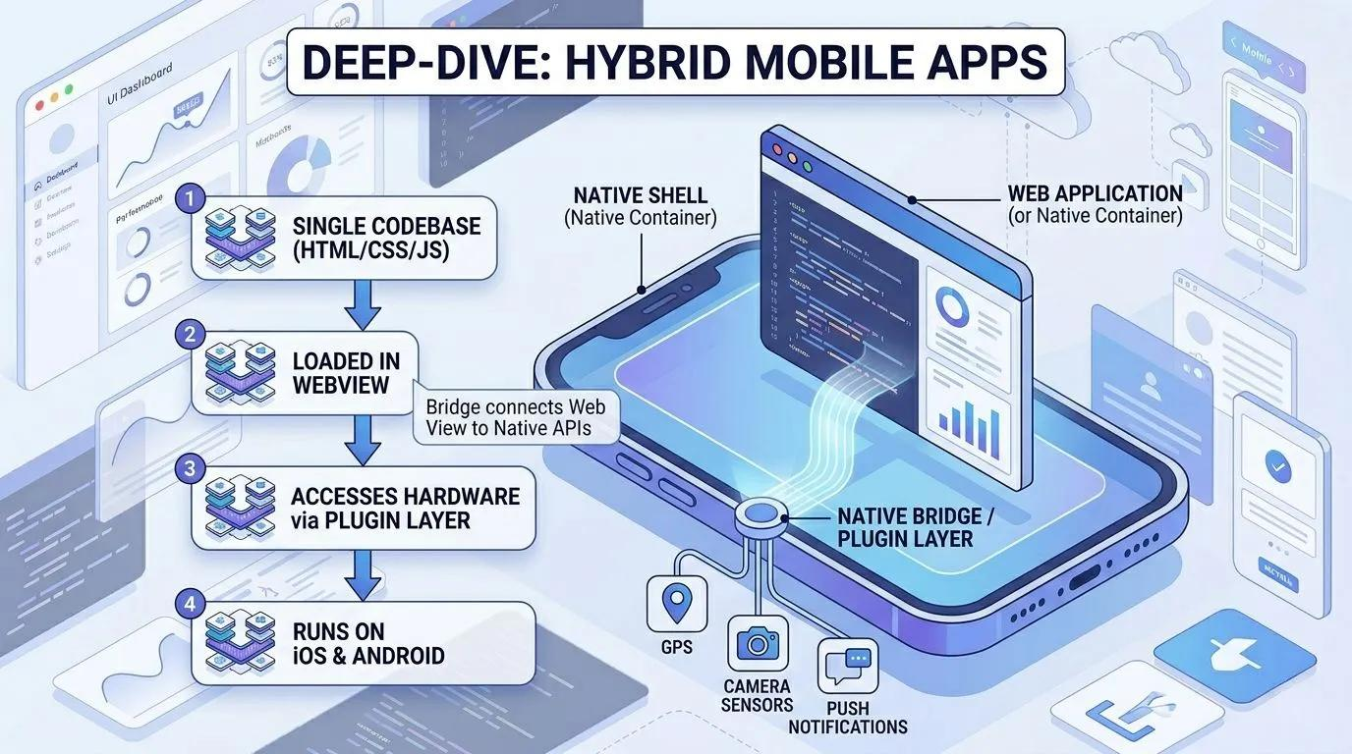
3. Hybrid Mobile App
Is mein web technologies se banaya gaya interface native mobile application ke andar run karta hai. Ise mobile app package, jaise Android APK, ke taur par distribute kiya ja sakta hai.
Example: Ionic aur Capacitor se banayi gayi app.
Important: Ye teenon related concepts hain, lekin bilkul ek hi cheez nahi hain.
2. Web app aur normal mobile app mein kya difference hai?
Web-Based App
- Browser se access hoti hai.
- Installation zaroori nahi.
- Update karne ke liye aam tor par website ka code update karte hain.
- HTML, CSS, JavaScript aur React se ban sakti hai.
Native Mobile App
- Android ke liye Kotlin/Java aur iOS ke liye Swift jaise technologies use ho sakti hain.
- App aam tor par store se install hoti hai.
- Camera, Bluetooth, background tasks aur doosre device features ka deeper access mil sakta hai.
- Updates aksar app release ke through distribute ki jati hain.
3. Web-Based Mobile App asal mein kaise kaam karti hai?
Suppose tum ek Task Manager App banana chahte ho jahan user tasks add kare, edit kare aur delete kare.
Mobile Phone
User app ko open karta hai
Frontend — React + CSS
Buttons, screens, forms aur user interface
Backend — Node.js + Express
Requests process karta hai aur business logic handle karta hai
Database — MongoDB
User aur tasks ka data save karta hai
Yeh ek common architecture hai; har web app ke liye backend aur database lazmi nahi hote.
Example: User mobile par Add Task button press karta hai.
- React task ka form show karta hai.
- User task ka naam enter karta hai.
- React API request Node.js backend ko bhejta hai.
- Backend task ko validate karta hai aur MongoDB mein save karta hai.
- Backend response bhejta hai.
- React screen par naya task show kar deta hai.
Yani mobile app jaisa experience dene ke liye zaroori nahi ke tum Android Studio mein native app hi banao.
4. Is app ko banane ke liye kaunsi technologies use karni chahiye?
Tumhari existing web-development knowledge ko dekhte hue, ek practical stack yeh ho sakta hai:
Part | Technology | Kaam
Frontend | React.js | UI aur app ki functionality
Styling | CSS ya Tailwind CSS | Mobile-friendly design
Routing | React Router | Different screens navigate karna
Backend | Node.js + Express | APIs aur server logic
Database | MongoDB | Data store karna
Authentication | JWT ya session-based auth | Login aur user access
Installation | PWA features | Supported devices par home screen installation
Hosting | Frontend + backend hosting | App ko internet par available karna
Ek important baat: Responsive design aur PWA support do alag cheezein hain. Responsive design screen ko adjust karta hai; PWA installation aur additional app-like capabilities provide kar sakti hai.
5. Mobile app jaisa interface kaisa dikhta hai?
My Tasks
TUESDAY, OCTOBER 13
Stay productive.
You have 3 tasks to complete.
Today's tasks
Complete assignment
University
Practice React
Learning
Plan next project
Personal
Add new task
Illustrative mobile interface concept — not a working application.
Notice karo ke is interface mein mobile ki full screen use ho rahi hai, buttons touch-friendly hain, aur bottom navigation bhi hai. React aur CSS se aisa interface banaya ja sakta hai.
6. Tumhein kaunsa approach choose karna chahiye?
- Sirf browser mein chalani hai: Responsive Web App.
- Mobile ki home screen par install bhi karwani hai: Responsive Web App + PWA.
- Play Store par publish karna hai aur native device features bhi chahiye: PWA ya React Native/Capacitor jaise approach ko requirements ke mutabiq choose karo.
Meri recommendation: agar tumhara goal ek mobile-first application banana hai aur tum React jaante ho, to React + responsive CSS + Node.js/Express + MongoDB se start karo, aur zaroorat ho to baad mein PWA features add kar lo.
Ab mujhe bas ek baat batao
Tum jo web-based mobile app banana chahte ho, uska main purpose kya hai?
1. Kis type ki app hai?
Meri apni idea wali app (custom project)
E-commerce / online shopping
Chatting / social media
Task manager / dashboard / productivity
Koi aur type ki app
2. Mobile par kaise chalani hai?
Sirf browser mein
Browser mein bhi aur home screen par install bhi
Play Store par bhi publish karni hai
Continue with my app
acha mujy asay module banany hai jesy auth ofc real time notification real time chatting app ai booking system in which user talk with ai and ask for booking of specific service he will apply for boking Sending the report system ... >>>> in which automatically the system send report of user to whatsap in 7 days it must be a magement system yai sab main nay example di hia but it must contain all of these and ypu have to give me more module like that which are appricated t presentaable in hackathon module must be like high tech and appreaciated for presented in hackathon hackthon is very big and also i have to apply in redis for caching nigx for load balancer and ai models integarttion and it must be serives based project each servisec must have its own folder and as it is PWA so it must have seperate folder so give me a full clear concept
Wasay, tum jo project banana chahte ho, woh simple management system nahi hona chahiye. Agar hackathon bara hai aur tum Redis, Nginx, AI models, real-time communication aur PWA sab integrate karna chahte ho, to project ko AI-Powered Smart Service Management Platform ke concept par design karna chahiye.
Meri recommendation hai ke hum ek aisa platform banayein jo services ki booking, staff aur resource management, real-time communication, automated reporting aur AI-based decision-making ko ek hi system mein combine kare.
Is mein tum sirf features present nahi karoge, balkay judges ko system architecture, independent services, real-time workflows, AI integration, caching aur load balancing bhi practically demonstrate kar sakoge.
1. Project concept
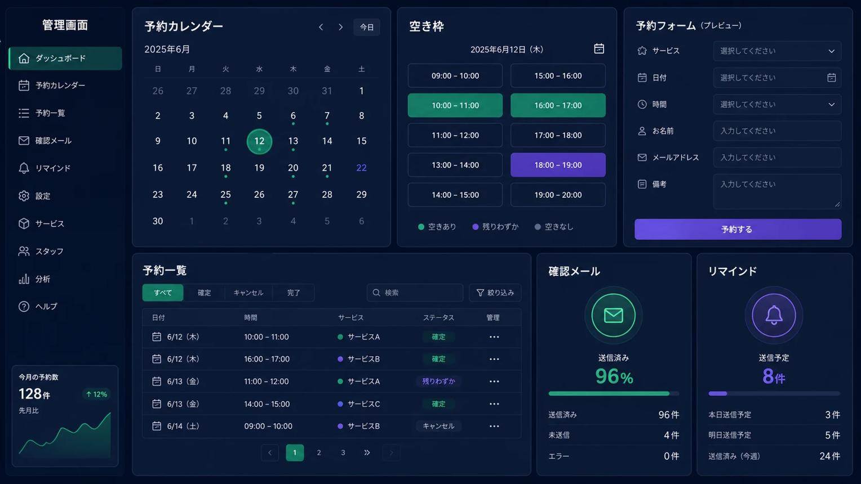
symvance-tech.com
NEXUS — AI-Powered Smart Service Management Platform
Proposed project name · AI + Microservices + PWA + Real-Time Systems
Core idea: NEXUS ek intelligent management platform hoga jahan customers services discover aur book kar sakenge, AI se natural language mein baat karke booking karwa sakenge, service providers apna kaam manage karenge, managers live operations monitor karenge aur system automatically reports aur alerts deliver karega.
For example, kisi customer ko AC maintenance, medical appointment, equipment rental, IT support ya kisi doosri supported service ki zaroorat hai.
Woh likh sakta hai:
“I need an AC maintenance service tomorrow after 4 PM. Find an available technician and book it for me.”
AI user ki requirement samjhega, available slots check karega, price aur details confirm karwayega, aur user ki approval ke baad booking create karega.
Usi booking ke baad system notification bhejega, relevant staff ko assign karega, chat enable karega, aur completed service ko reporting aur analytics mein include karega.
Important: Yeh sirf booking website nahi hogi. Iska central concept service operations ko end-to-end intelligently manage karna hoga.
2. Complete module list — hackathon-level features
Main modules ko 3 levels mein divide kar raha hoon: core modules, advanced AI modules aur standout features. Is tarah project ka scope impressive bhi rahega aur implementation ke liye clear bhi.
A. Core management modules
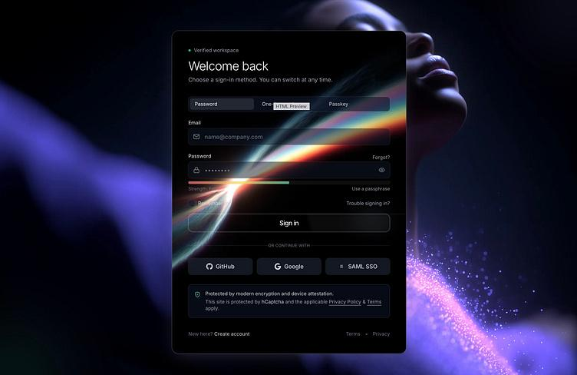
01. Identity & Access Management
- Signup, login, logout, email verification, password reset.
- JWT access tokens with refresh-token rotation.
- Role-based permissions and organization-level access.
- Optional MFA, OAuth and login-session management.
- Audit logs for sensitive actions.
Security foundation
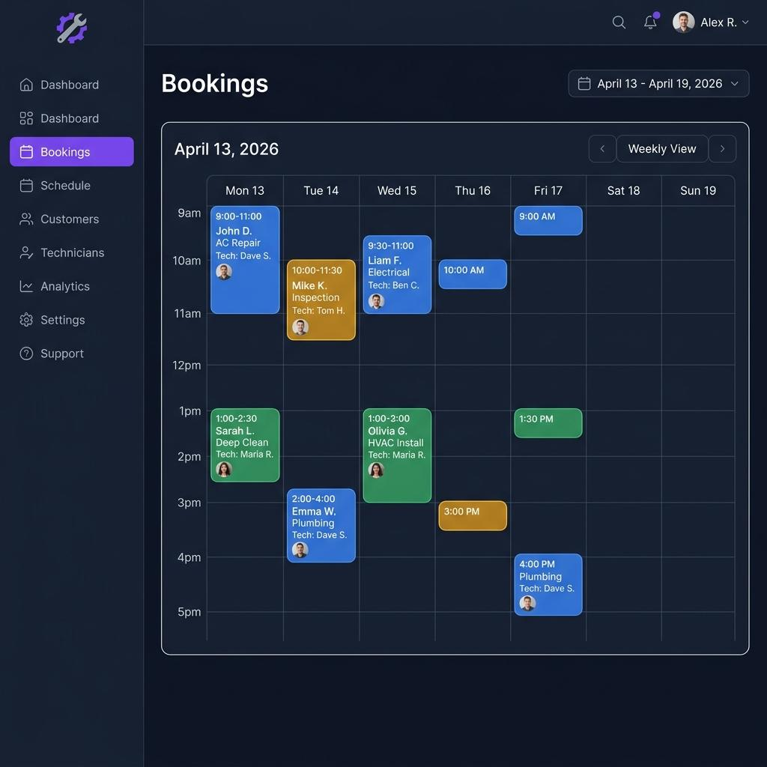
02. Smart Service & Booking Management
- Service catalog, pricing, duration and availability.
- Booking, rescheduling, cancellation and waitlists.
- Staff assignment and conflict detection.
- Booking status: pending, confirmed, in progress, completed or cancelled.
- Optional deposits, invoices and payment integration.
The central business module of the platform.
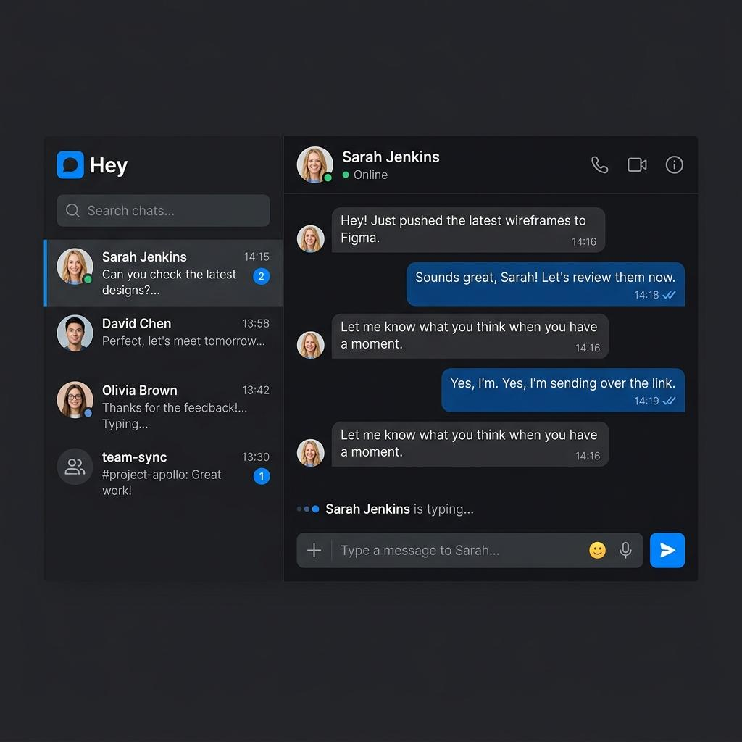
03. Real-Time Chat & Collaboration
- Customer-to-provider and staff-to-staff chat.
- Online/offline presence, typing indicators and read receipts.
- Booking-linked conversations and attachments.
- Unread counters and message history.
- Role-aware access to conversations.
Technology: Socket.IO, WebSockets and persistent message storage.
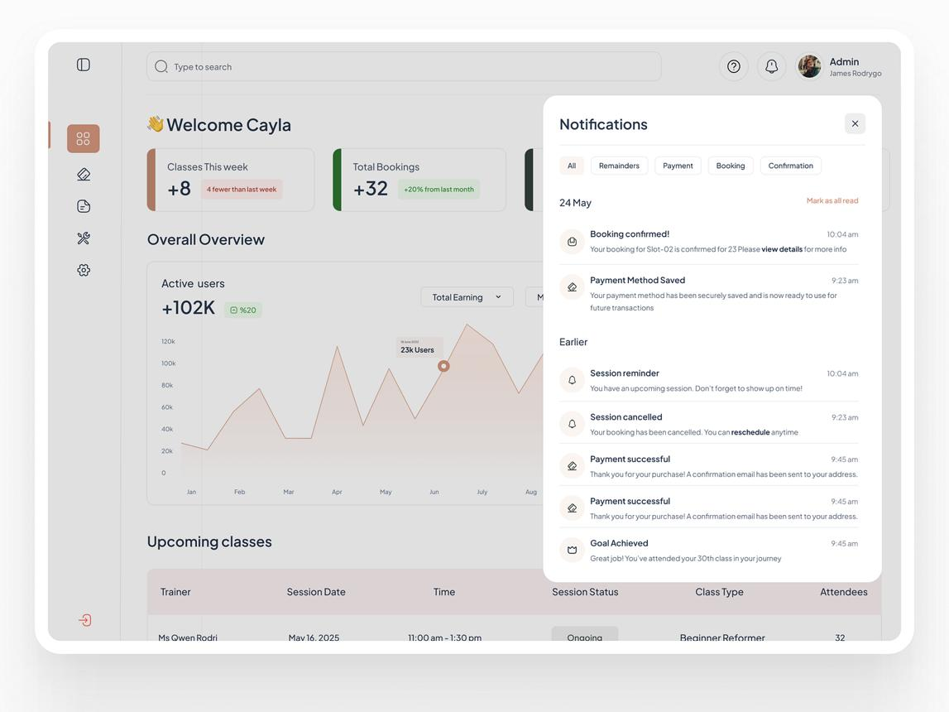
04. Real-Time Notification Service
- In-app live notifications.
- Booking confirmations, cancellations and reminders.
- Staff assignment alerts and deadline warnings.
- Push notifications through supported PWA browsers.
- Email and WhatsApp delivery through separate notification channels.
Include delivery status, retries and notification preferences.
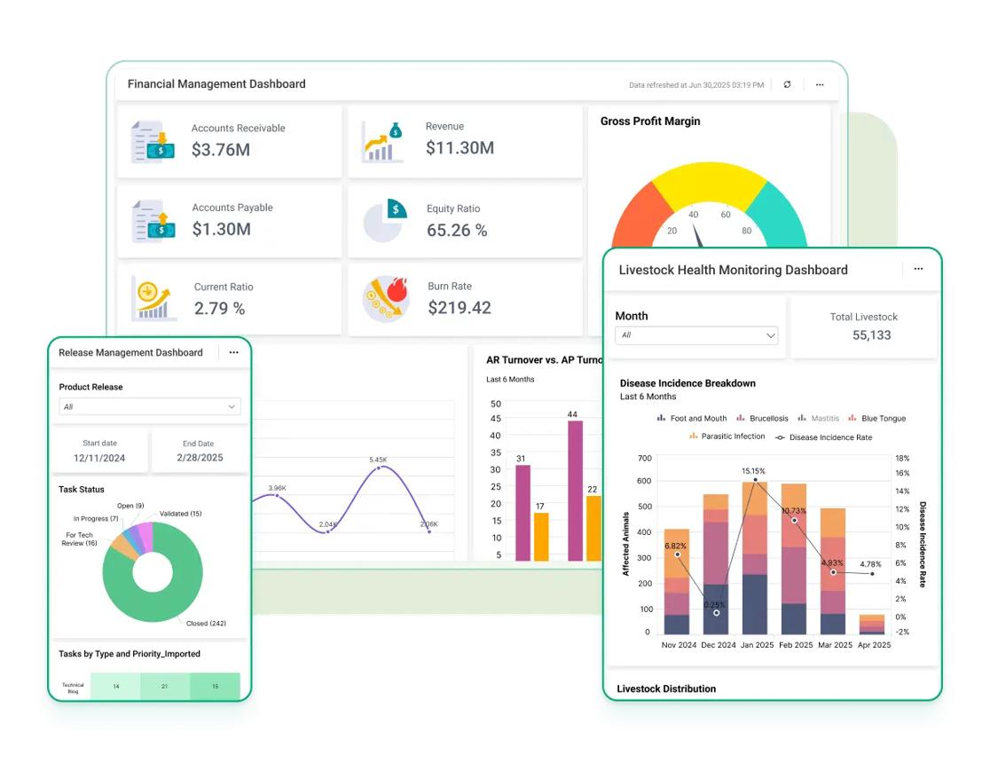
05. Automated Reporting System
- Daily, weekly and monthly performance reports.
- Every seven days, generate and send each eligible user's configured report.
- WhatsApp report delivery with a PDF or secure report link.
- Booking volume, completed services, revenue and response-time metrics.
- Delivery logs, failed-send retries and report history.
Technology: scheduled workers, database aggregation, PDF generation and WhatsApp Business Platform integration.
B. Advanced AI modules
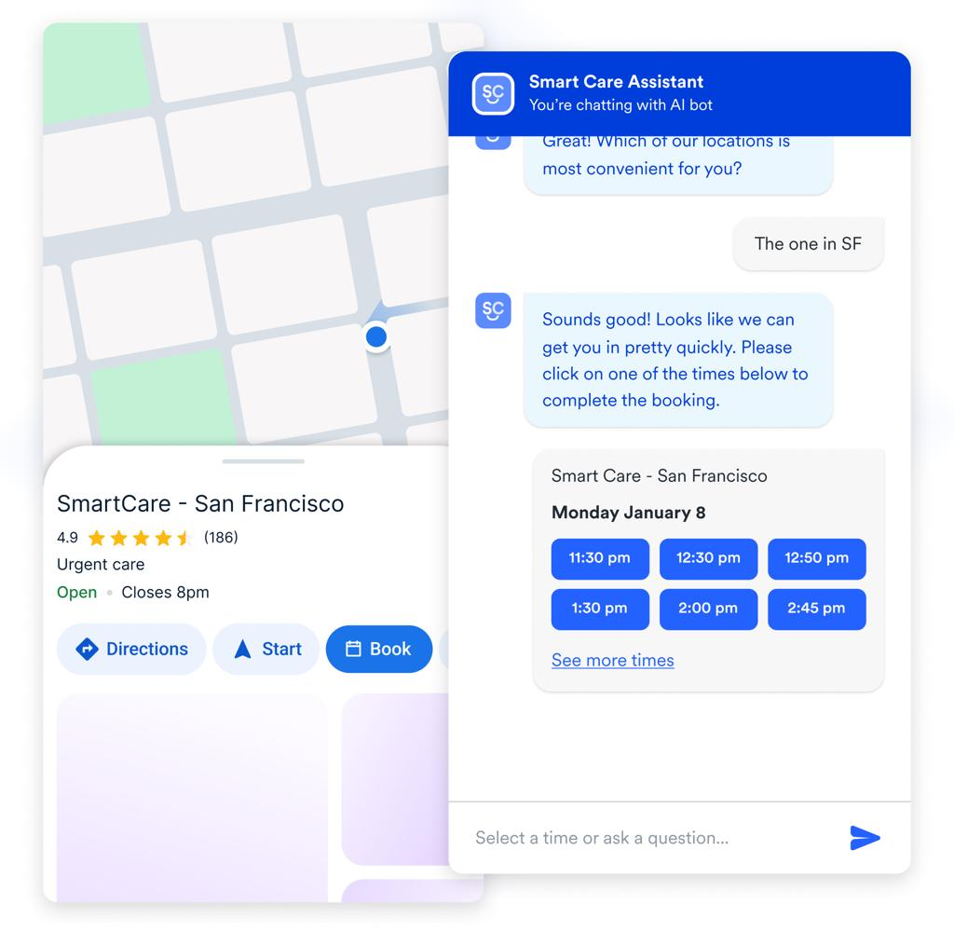
06. AI Booking Agent
User normal language mein request karega. AI service identify karega, missing details poochega, available slots fetch karega aur booking ka proposal banayega.
- Natural-language booking and rescheduling.
- Service recommendations and FAQs.
- Tool/function calling to real booking APIs.
- Explicit user confirmation before creating or cancelling a booking.
- Human handoff when the AI cannot safely resolve a request.
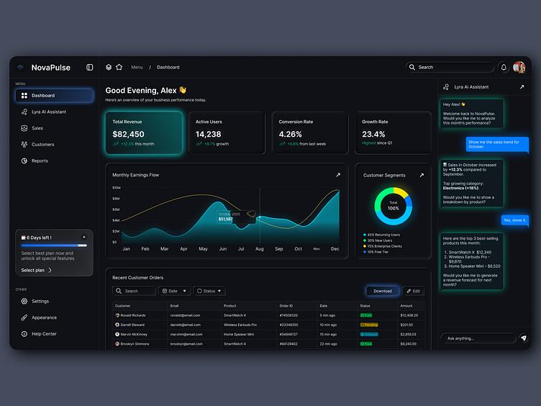
07. AI Management Copilot
Manager pooch sakega:
- “Which services had the most cancellations this week?”
- “Which staff members are overloaded tomorrow?”
- “Summarize this week's operational performance.”x
- “Which bookings require immediate attention?”
AI authorized data aur analytics tools use karke answers, summaries aur recommended actions dega.
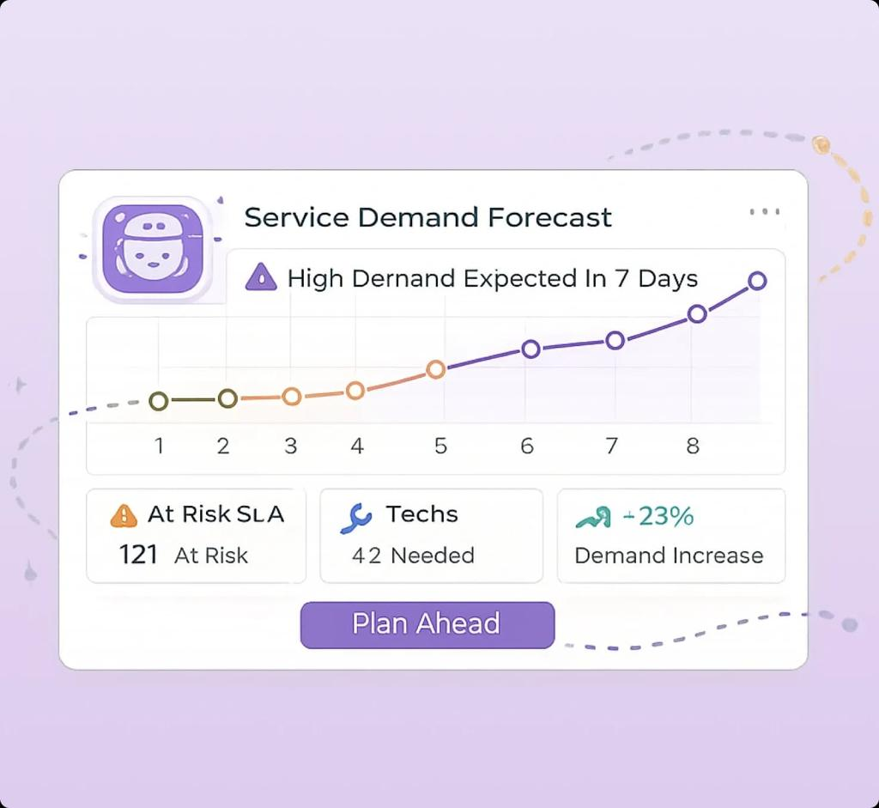
08. Predictive Analytics & Anomaly Detection
- Forecast service demand from historical bookings.
- Detect unusual cancellation spikes or delayed jobs.
- Identify peak hours and resource shortages.
- Recommend staffing or scheduling adjustments.
Start with statistical baselines; add a forecasting model only when you have enough meaningful data.
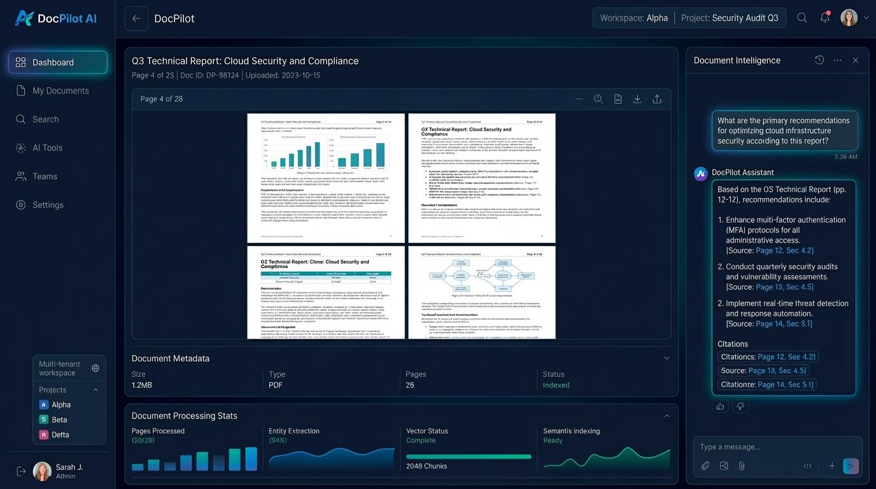
09. AI Document & Knowledge Assistant
- Upload service policies, manuals and FAQs.
- Search documents using semantic retrieval.
- Answer questions with citations to the source document.
- Summarize long reports and service histories.
- Respect document permissions so users only access authorized content.
Optional RAG pipeline for a more technically distinctive demonstration.
C. High-impact differentiator modules
10. Live Operations Command Center
A manager dashboard showing active bookings, staff availability, queue length, delayed jobs, service health and live activity. Use live event updates instead of repeatedly refreshing the page.
11. Smart Queue & Resource Optimization
Prioritize urgent requests, identify scheduling conflicts, maintain a waitlist and recommend suitable staff based on availability, skills and workload.
12. Audit, Security & Compliance Center
Track who changed a booking, when a report was sent, which AI action was approved and whether access was denied. Include rate-limit events and suspicious activity alerts.
13. Installable PWA & Offline Experience
Install the app from a supported browser, receive supported push notifications, cache the app shell and show previously loaded data offline. Queue safe user actions for later synchronization when connectivity returns.
14. System Health & Performance Monitoring
Display API response times, error rates, service availability, queue backlog and cache hit ratio. Demonstrate what happens when one service is slow or unavailable.
3. Is project ko unique kaise banana hai?
Sirf AI chatbot, notifications aur CRUD modules banana kaafi nahi hoga. Hackathon mein strong demonstration ke liye modules ko ek connected workflow mein operate karna chahiye.
Example: One request, complete automation
- Customer sends a request
“Book a technician tomorrow at 5 PM.”
- AI understands the request
Missing details poochta hai, service identify karta hai aur available slots check karta hai.
- Booking service validates the request
Availability, conflicts, pricing aur customer confirmation verify karta hai.
- Event-driven automation begins
Booking confirm hone par event publish hota hai. Notification aur staff-assignment workflows trigger hote hain.
- Chat and live dashboard update
Customer aur assigned staff ko relevant information milti hai; manager ko live operational update dikhai deta hai.
- Background reporting runs
Scheduled worker weekly metrics calculate karta hai aur eligible users ko WhatsApp par report bhejta hai.
- AI management copilot learns from permitted operational data
Aggregated history ki bunyaad par workload, cancellations aur demand ke insights deta hai. Sensitive data ki access permissions maintain rehti hain.
Yeh connected workflow tumhari presentation ka strongest part ban sakta hai: judges ek hi request ke through AI, backend services, Redis, real-time events, reporting aur PWA sab dekh sakte hain.
4. Recommended architecture — service-based project
Tumhari sab se important requirement hai ke har service ka apna folder ho aur PWA ka folder alag ho.
Is ke liye main ek monorepo recommend karunga. Monorepo ka matlab hai ke frontend, backend services aur infrastructure ek hi main Git repository mein honge, lekin unke code aur responsibilities separate hongi.
Initially, har service ko independent module aur API boundary ke saath develop karo. Phir important services ko independently run aur deploy kar sakte ho. Is se unnecessary complexity se bachoge aur architecture bhi defend kar paoge.
PWA Frontend
React · Responsive UI · Service Worker · Web Push
Nginx — Reverse Proxy & Load Balancer
TLS · Routing · Rate limits · Multiple API instances
Backend API & Service Layer
Auth Service
Booking Service
Chat Service
AI Service
Notification Service
Report Service
Plus service catalog, staff, analytics, audit and scheduling services.
MongoDB
Persistent application data
Redis
Cache, Pub/Sub and queues
Background Workers & Event Processing
Scheduled reports · Retries · Notifications · Async jobs
External AI Models & Messaging Providers
LLM API · Embeddings (optional) · WhatsApp Business Platform · Email provider
This is a logical architecture, not a claim that every service must run as a separate server from day one. Chat/WebSocket connections and external integrations can follow dedicated routes through Nginx.
5. Complete folder structure
Neeche proposed production-oriented structure hai. Is mein PWA, backend services, shared libraries, workers aur infrastructure clearly separate hain.

nexus-platform/
│
├── apps/
│ └── pwa/ # Separate mobile-first PWA
│ ├── public/
│ │ ├── icons/
│ │ ├── manifest.webmanifest
│ │ └── offline.html
│ ├── src/
│ │ ├── app/
│ │ │ ├── router/
│ │ │ ├── providers/
│ │ │ └── layouts/
│ │ ├── components/
│ │ ├── pages/
│ │ │ ├── auth/
│ │ │ ├── dashboard/
│ │ │ ├── bookings/
│ │ │ ├── ai-assistant/
│ │ │ ├── chat/
│ │ │ ├── notifications/
│ │ │ └── reports/
│ │ ├── features/
│ │ ├── services/
│ │ │ ├── api-client/
│ │ │ ├── socket-client/
│ │ │ └── push-client/
│ │ ├── hooks/
│ │ ├── store/
│ │ ├── styles/
│ │ └── main.jsx
│ ├── tests/
│ ├── vite.config.js
│ └── package.json
│
├── services/
│ ├── api-gateway/ # Backend entry / API routing
│ │ └── src/
│ │ ├── routes/
│ │ ├── middleware/
│ │ └── app.js
│ │
│ ├── auth-service/
│ │ └── src/
│ │ ├── controllers/
│ │ ├── services/
│ │ ├── models/
│ │ ├── routes/
│ │ ├── middleware/
│ │ └── app.js
│ │
│ ├── user-service/
│ ├── organization-service/
│ ├── service-catalog-service/
│ ├── booking-service/
│ ├── staff-service/
│ ├── chat-service/
│ ├── notification-service/
│ ├── report-service/
│ ├── ai-service/
│ ├── analytics-service/
│ ├── audit-service/
│ └── integration-service/
│
├── workers/
│ ├── report-worker/
│ ├── notification-worker/
│ ├── booking-reminder-worker/
│ └── ai-job-worker/
│
├── packages/
│ ├── contracts/ # Shared API/event schemas
│ ├── logger/
│ ├── observability/
│ ├── validation/
│ └── test-utils/
│
├── infrastructure/
│ ├── nginx/
│ │ ├── nginx.conf
│ │ └── conf.d/
│ ├── redis/
│ ├── mongodb/
│ ├── docker/
│ └── monitoring/
│
├── docs/
│ ├── architecture/
│ ├── api/
│ └── event-contracts/
│
├── .env.example
├── docker-compose.yml
├── package.json
└── README.md
Folder structure ko samajhne ke liye important distinction:
- apps/pwa/ sirf user interface aur PWA functionality ke liye hai.
- services/ mein business capabilities aur unki APIs hain.
- workers/ long-running ya scheduled background jobs handle karte hain.
- packages/ reusable code aur contracts ke liye hai.
- infrastructure/ Nginx, Redis, Docker aur monitoring configuration rakhta hai.
Har service mein ek jaisa internal structure rakhna zaroori nahi, lekin controllers, business logic, models aur routes ko clear separation dena maintainability ke liye useful hai.
6. Har service ki responsibility kya hogi?
Service-based architecture mein sab se important rule yeh hai ke har service ki clear responsibility honi chahiye. Sirf folders ko alag kar dena microservices architecture nahi hota.
Service | Main responsibility
auth-service | Authentication, token validation, sessions and roles
user-service | Profiles, preferences and user settings
organization-service | Organizations, teams and tenant isolation
service-catalog-service | Available services, pricing, categories and rules
booking-service | Booking lifecycle, availability, conflicts and confirmation
staff-service | Staff profiles, skills, shifts and assignments
chat-service | Messages, conversation history and real-time presence
notification-service | In-app, push, email and WhatsApp notification orchestration
report-service | Report generation, report schedules and delivery records
ai-service | AI conversations, tool calling, model integration and safety checks
analytics-service | Aggregations, KPIs, trends and demand forecasting
audit-service | Security logs and traceable business actions
integration-service | External providers, webhooks and third-party API adapters
api-gateway | Backend entry point, route forwarding and shared request policies
Aik example samjho: AI service khud database mein direct booking insert na kare. Woh booking service ko authorized API/tool call kare, aur booking service availability, permission aur confirmation verify karke booking create kare.
Isi tarah report worker khud WhatsApp API logic har jagah duplicate nahi karega. Woh notification/integration layer ke through message delivery request karega.
7. Redis ka actual use kahan hoga?
Tumhare project mein Redis sirf caching ke liye nahi, balkay multiple useful purposes ke liye use ho sakta hai.
A. API Caching
Frequently requested service catalog, public service details aur dashboard summary cache karo.
Example: GET /api/services ka response Redis mein 60 seconds ke liye rakhna.
Invalidation: jab service ki price ya availability-related information update ho, relevant cache expire ya invalidate karo.
B. Real-Time Presence
Online users, temporary typing indicators aur short-lived presence information ko Redis mein manage kar sakte ho.
Socket.IO ke multiple instances ke darmiyan event distribution ke liye Redis adapter bhi use ho sakta hai.
C. Background Job Queue
BullMQ + Redis se weekly reports, reminder notifications aur retryable jobs queue karo.
Agar WhatsApp provider temporarily unavailable ho, failed delivery ko retry schedule par process kar sakte ho.
D. Rate Limiting & Temporary State
Login attempts, AI requests per user, verification codes aur temporary conversation state ko appropriate TTL ke saath manage kar sakte ho.
Sensitive tokens aur verification codes ke liye expiration aur access controls zaroori hain.
Hackathon demonstration: Redis cache ko pehli request par miss aur subsequent request par hit show karwao. Saath hi response time aur cache hit ratio display karo. Is se Redis ka practical benefit visible hoga.
Ek technical distinction: Redis Pub/Sub messages durable nahi hote. Important booking aur report jobs ke liye BullMQ ya durable event processing use karo; booking events ke liye MongoDB transactional outbox pattern bhi consider karo.
8. Nginx load balancer ka use
Nginx tumhare backend ke aage reverse proxy ka kaam karega. Agar ek API service ke multiple instances run ho rahe hon, Nginx requests ko configured upstream instances mein distribute kar sakta hai.
Incoming Requests
Mobile PWA · Browser · API clients
Nginx Load Balancer
HTTPS termination · Routing · Upstream balancing
API Instance A
Port 5001
API Instance B
Port 5002
Illustrative deployment topology; actual routing and health checks must be configured.
Is ke benefits:
- Traffic ko multiple API instances mein distribute karna.
- HTTPS aur reverse-proxy configuration centralize karna.
- API routes aur WebSocket connections ko correct upstream par forward karna.
- Load test ke zariye performance compare karna.
- Appropriate health checks aur failure handling configure karna.
Important: Sirf Nginx install karne se app automatically scalable nahi ban jati. Multiple application instances, compatible session handling, shared state aur database capacity bhi matter karte hain. Local hackathon demo mein Docker Compose ke through do API instances chala kar load balancing demonstrate ki ja sakti hai.
9. AI models ka integration kaise hoga?
AI service ko model provider se separate rakho, taake baad mein OpenAI-compatible API, doosre hosted models ya local models switch karna easy ho.
User's Message
“Book a technician for tomorrow.”
AI Orchestrator
Prompt · Context · Permissions · Tool selection
Approved Business Tools
Search services
Check availability
Quote pricing
Request booking
Booking Service
Validates and executes the confirmed operation
AI integration mein yeh features add karna useful hoga:
- LLM: User intent samajhne aur natural-language responses ke liye.
- Structured outputs: Service ID, preferred date, time aur requirements ko predictable schema mein convert karne ke liye.
- Tool/function calling: Real APIs ko invoke karne ke liye.
- Embeddings + RAG: Service manuals aur policy documents search karne ke liye, agar yeh feature include karte ho.
- AI evaluation logs: Correctness, tool-call failures, latency aur estimated model cost track karne ke liye.
AI ko booking ka final authority mat banana. Availability aur pricing backend se aani chahiye, aur booking create ya cancel karne se pehle user ki explicit confirmation honi chahiye.
10. Seven-day automatic reporting system — complete workflow
Tumhare project ka yeh feature judges ke saamne achha impact create kar sakta hai, kyun ke is mein scheduling, background processing, report generation aur third-party API integration ek saath demonstrate hote hain.
- User report preferences set karta hai
User weekly report enable karta hai, WhatsApp number verify karta hai aur report categories select karta hai.
- Scheduler due reports identify karta hai
Background scheduler har din check karta hai ke kis user ki report due hai.
- Report worker data collect karta hai
Report service relevant seven-day period ke bookings, completed tasks, cancellations aur performance metrics calculate karti hai.
- Report generate hoti hai
Worker summary aur optional PDF generate karta hai. Report mein sirf woh data hota hai jise recipient access kar sakta hai.
- WhatsApp notification send hoti hai
Notification service approved WhatsApp Business Platform integration ke through message ya secure report link deliver karti hai.
- Delivery status save hota hai
System message ID, scheduled time, sent/failed/delivered status aur retry attempts record karta hai.
Recommended technologies:
- BullMQ + Redis — scheduled and retryable background jobs.
- report-service — report data and generation.
- report-worker — processing and PDF generation.
- integration-service — WhatsApp provider integration.
- notification-service — message orchestration and delivery tracking.
WhatsApp par automated reports ke liye official Business Platform/API aur applicable approved message templates ki requirements follow karni hongi. User ki opt-in consent lo, number verify karo, aur sensitive reports ko public links mein expose mat karo. Secure, expiring access links use karna behtar hai.
11. PWA ko separate rakhne ka faida
Tumne kaha ke PWA ka separate folder hona chahiye. Yeh bilkul reasonable architectural decision hai.
Tumhari PWA mein yeh features honge:
PWA feature | Purpose
Web App Manifest | App name, icons, theme aur installation configuration
Service Worker | App shell caching aur selected offline capabilities
Responsive UI | Mobile, tablet aur desktop support
Push notifications | Supported browsers/devices par notifications
Offline screen | Internet unavailable hone par useful interface
Safe action queue | Non-sensitive, retryable actions ko reconnect hone par sync karna
Install prompt | Supported browsers par installation guidance
Ek zaroori distinction: PWA install hone ka matlab yeh nahi ke har browser mein saare native features mil jayenge. Push notifications aur background behavior platform-dependent hain. Offline booking ko bhi tab tak confirmed mat dikhana jab tak server usay accept na kar le.
12. Security aur reliability — hackathon mein yeh bhi demonstrate karna
High-tech project mein security sirf login page tak limited nahi honi chahiye.
Authentication and authorization
JWT/session security, role-based access, organization isolation aur backend par har protected operation ki permission checks.
Booking consistency
Double booking rokne ke liye server-side availability checks, appropriate unique constraints/locking strategy aur idempotency keys.
Reliable notifications
Retries, duplicate prevention, delivery tracking aur failed-job visibility.
Secrets management
API keys, JWT secrets aur WhatsApp credentials environment variables ya secret manager mein; frontend bundle mein kabhi nahi.
Observability
Centralized structured logs, request IDs, error rates, latency, worker failures aur service health.
13. Implementation roadmap
Project impressive zaroor hona chahiye, lekin har module ko ek saath build karna risk hoga. Main isay phases mein develop karunga.
Phase 1 — Working foundation
Must-have
- PWA frontend and responsive dashboard.
- Authentication, roles and organization setup.
- Service catalog and booking lifecycle.
- MongoDB models and API validation.
- Nginx routing and initial Redis caching.
Phase 2 — Real-time system
- Socket.IO chat and live notifications.
- Staff assignment and operations dashboard.
- Redis adapter where multiple WebSocket instances require it.
- Notification preferences and activity history.
Phase 3 — AI and automation
- AI booking assistant with real tool calling.
- Confirmation and validation workflow.
- Weekly report scheduler, worker and PDF generation.
- WhatsApp integration and delivery tracking.
Phase 4 — Hackathon differentiators
- AI management copilot.
- Predictive analytics or document RAG.
- Monitoring dashboard and performance tests.
- Docker Compose deployment with multiple API instances.
- Offline PWA demonstration and fault-handling scenarios.
14. Hackathon demo mein judges ko kya dikhana chahiye?
Main presentation ko is sequence mein arrange karunga:
- Customer AI ko natural-language request deta hai.
- AI actual service availability check karta hai aur confirmation ke baad booking create hoti hai.
- Staff ko real-time notification milti hai aur chat open ho jati hai.
- Manager ke live dashboard par booking aur workload update hota hai.
- Redis cache hit/miss aur Nginx ke through multiple API instances ka load test show hota hai.
- Weekly report worker execute hota hai aur WhatsApp sandbox/test recipient par report deliver hoti hai.
- AI management copilot booking data ke basis par operational insight deta hai.
Is demo ke liye real integrations ya controlled test environments use karna zaroori hai. Agar kisi external API ka access available na ho, to uski mocked demonstration ko clearly label karna chahiye.

