COMSATS University Islamabad
Abbottabad Campus
Department of Computer Science
PROJECT PROPOSAL
Plumb
A Lightweight Domain-Specific Language for Data Pipelines, with Compiler Diagnostics and a Developer Dashboard
Submitted by
Student Name | Registration No. | Role
Abdul Wasay | FA23-BCS-004 | Project Lead
Fauzan Gauhar | FA23-BCS-037 | Team Member
Hasnain Ali | FA23-BCS-027 | Team Member
Supervisor: ______________________________
Submission Date: 30 September 2026
Planned Duration: 3 Weeks

Table of Contents
1. Executive Summary 3
2. Introduction 3
3. Problem Statement 3
4. Proposed Solution 4
5. Project Objectives 4
6. Project Scope 5
7. The Plumb Language 5
8. Compiler Architecture 6
9. Compiler Phases in Detail 7
10. Compiler Diagnostics 9
11. Compilation Telemetry 10
12. Developer Dashboard 11
13. System Modules 12
14. Technology Stack 12
15. Requirements 12
16. Testing Strategy 13
17. Team and Module Distribution 13
18. Project Plan (Three Weeks) 14
19. Risks and Mitigation 16
20. Expected Outcomes 16
21. Learning Outcomes 17
22. Future Enhancements 17
23. Conclusion 17
Appendix A: Gantt Chart 18

1. Executive Summary
Plumb is a small Domain-Specific Language (DSL) made to describe simple data pipelines. A pipeline is a short list of steps, such as reading a file, filtering rows, choosing columns and writing the result. With Plumb, a user writes these steps in a few clear lines instead of writing a long program in a general-purpose language.
The main purpose of this project is to learn and show how a compiler works. The Plumb compiler will have a lexer, a parser, an Abstract Syntax Tree (AST), semantic analysis, a symbol table and a code generator. A valid Plumb program will be converted into JavaScript code.
The project also includes a web-based Developer Dashboard. The dashboard lets a user write Plumb code, compile it, and see the compilation time, token count, AST, errors, warnings and generated code in one place.
The project will be completed by a team of three students in three weeks. The work is divided into ten modules. Abdul Wasay is the project lead and is responsible for the language core (language design, lexer, parser and AST). The other modules are shared between Fauzan Gauhar and Hasnain Ali.

2. Introduction
A compiler is a program that reads source code and converts it into another form. It does this in stages. First, the source code is split into small pieces called tokens. This stage is called lexical analysis. Next, the parser checks whether the tokens follow the grammar of the language and builds an Abstract Syntax Tree (AST). After that, the compiler checks the meaning of the program (semantic analysis) and finally produces the output code.
Plumb is a small language built to practise all of these stages on a language that is small enough to finish in three weeks. Plumb programs describe a data pipeline. A simple Plumb program looks like this:
pipeline process_data
read "users.csv"
filter age > 18
transform name
output "result.csv"

Each line is one command. The user only says what should happen. The compiler checks the program and produces the code that does the work. Plumb source files use the extension .plb.

3. Problem Statement
Three problems are addressed by this project:
- Too much code for small tasks. General-purpose languages need extra syntax and setup even for a simple job such as filtering a CSV file.
- Compilers are hard to see. In most compiler projects, everything happens inside the program or in a command line. A beginner gets an error message but cannot see how the code was split into tokens or how the syntax tree was built.
- Poor error messages. Many student compilers only print a short message such as “syntax error”, which does not tell the user where the problem is or how to fix it.
Therefore, a small educational language is needed that has simple syntax, demonstrates each phase of a compiler, gives clear error messages, and shows its internal results through a simple visual interface.

4. Proposed Solution
Plumb solves these problems with a small language, its compiler, and a web dashboard. The system has three main components, shown in Figure 1.
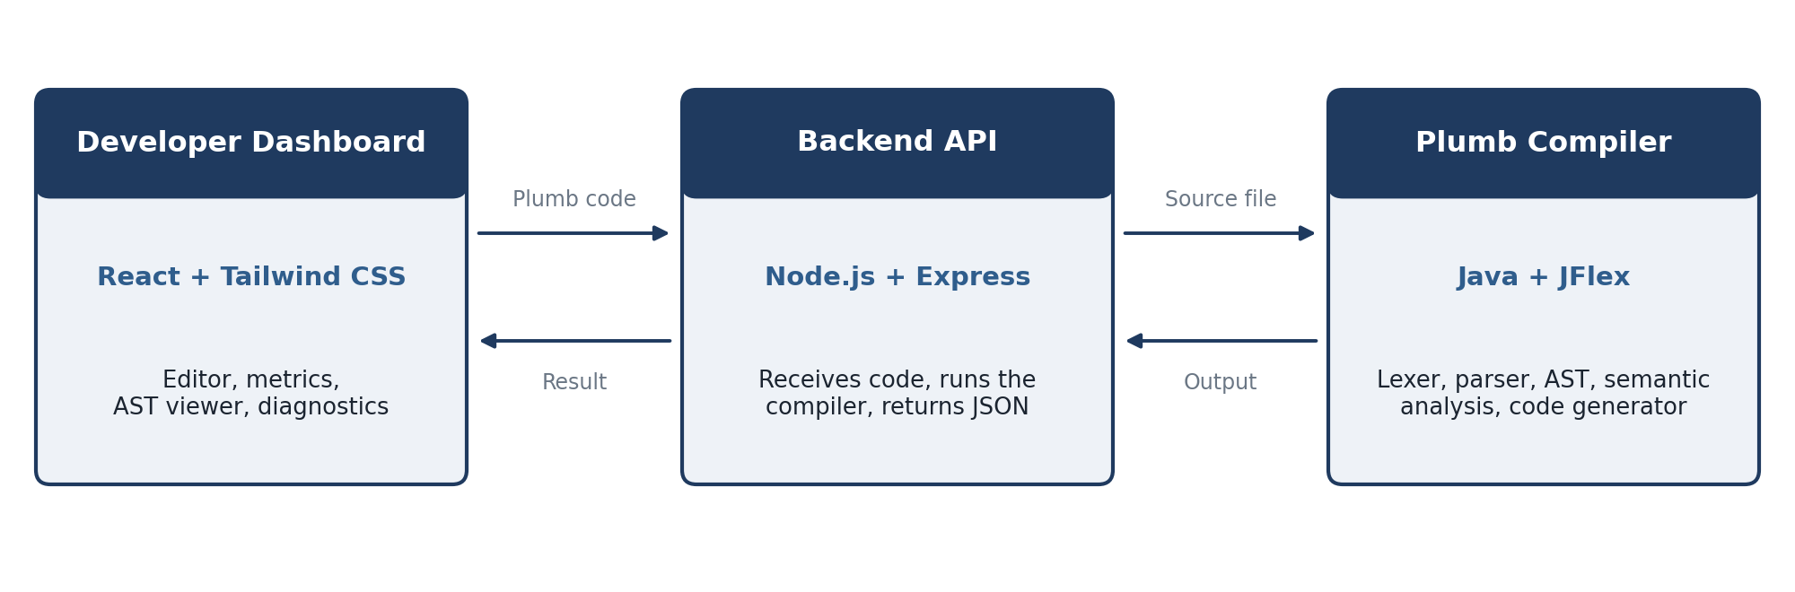
Figure 1: Main components of the Plumb system

4.1 Plumb Compiler
- Written in Java, with JFlex for the lexer and a recursive descent parser.
- Processes the source code through lexer, parser, AST, semantic analysis and code generation.
- Produces errors, warnings and statistics for every compilation.

4.2 Backend API
- A lightweight Node.js and Express server.
- Receives Plumb code from the dashboard, runs the compiler, and sends the results back as JSON.

4.3 Developer Dashboard
- A React web page where the user writes Plumb code and presses Compile.
- Shows the status, token information, AST, errors, warnings, telemetry and generated code.

5. Project Objectives
The main objective is to build a small but working Domain-Specific Language and, at the same time, learn the basic concepts of compiler construction in practice. The specific objectives are:
- Design a simple syntax for the Plumb language.
- Define the grammar of the language in EBNF.
- Implement lexical analysis.
- Implement syntax analysis using a recursive descent parser.
- Generate an Abstract Syntax Tree.
- Implement basic semantic checking.
- Implement a simple Symbol Table.
- Generate JavaScript code from valid Plumb programs.
- Give clear error messages with line and column numbers.
- Collect basic compilation statistics.
- Build a simple web-based developer dashboard.
- Connect the compiler and the dashboard through a backend API.

6. Project Scope

6.1 Included in the Project
- Plumb language syntax and grammar
- Lexer, parser and AST
- Basic semantic analysis and Symbol Table
- Code generation (Plumb to JavaScript)
- Compiler diagnostics with suggestions
- Basic telemetry (time and counts)
- Backend API
- React developer dashboard

6.2 Not Included in the Project
- Advanced AI features
- Code optimization
- User login and accounts
- Cloud deployment
- Distributed compilation
- Type inference beyond simple checks
- Large standard library
- Running generated code in a secure sandbox
Plumb is not meant to replace Python or JavaScript. It stays small and focused on a limited set of pipeline commands. In this version, a file contains one pipeline, and data files are CSV files only.

7. The Plumb Language

7.1 Commands
Plumb has six commands. The language is kept small on purpose so that every part of the compiler stays easy to understand.
Command | Meaning
pipeline name | Starts a pipeline and gives it a name.
read "file.csv" | Reads input data from a CSV file.
filter column op value | Keeps only the rows that match a condition.
transform column, ... | Keeps the listed columns of the data.
output "file.csv" | Writes the result to a CSV file.
log "message" | Prints a message while the pipeline runs.

7.2 Language Rules
- Keywords are written in lowercase.
- Text values are written inside double quotes.
- Commands inside a pipeline are indented by four spaces.
- A line that starts with # is a comment and is ignored.
- Comparison operators are >, <, >=, <=, == and !=.

7.3 Grammar (EBNF)
program = pipeline ;
pipeline = "pipeline" IDENTIFIER NEWLINE { command } ;
command = INDENT ( read | filter | transform | output | log ) NEWLINE ;
read = "read" STRING ;
filter = "filter" IDENTIFIER operator value ;
transform = "transform" IDENTIFIER { "," IDENTIFIER } ;
output = "output" STRING ;
log = "log" STRING ;
operator = ">" | "<" | ">=" | "<=" | "==" | "!=" ;
value = NUMBER | STRING ;

The grammar will be frozen at the end of Day 2. Later changes need the approval of the project lead so that the lexer, parser and semantic analyzer stay consistent.

8. Compiler Architecture
The compiler works as a pipeline of stages. The output of one stage is the input of the next stage (Figure 2). The Symbol Table supports the semantic analyzer, and the diagnostics and telemetry parts collect errors and statistics from all stages.
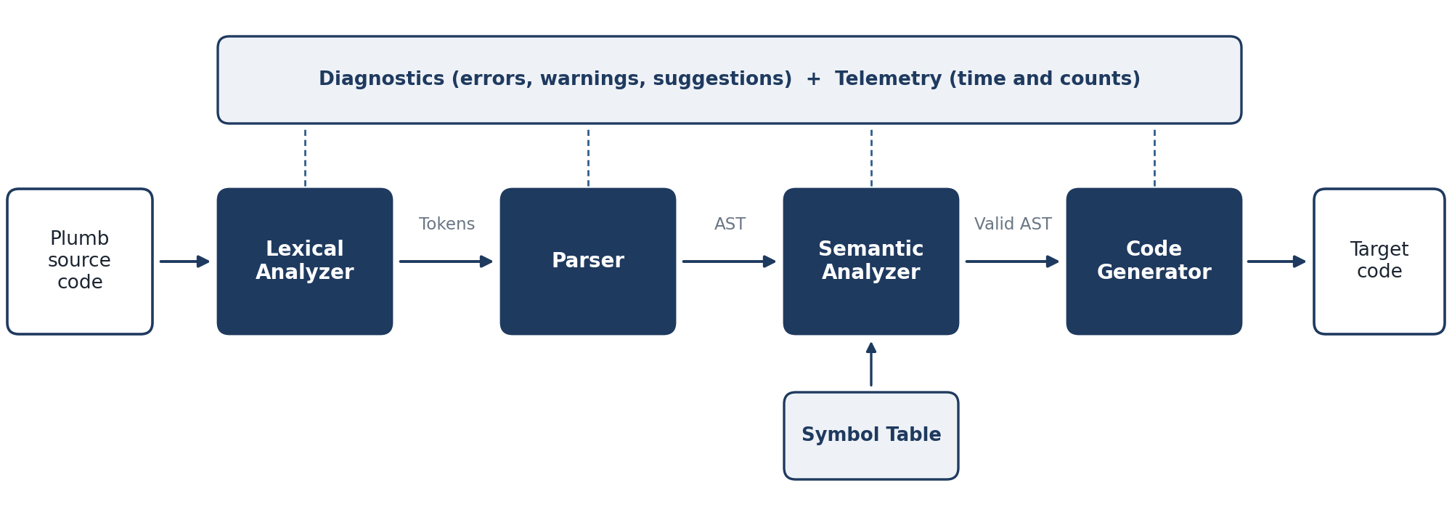
Figure 2: Stages of the Plumb compiler
Stage | Input | Output | Main job
Lexical Analyzer | Source text | Tokens | Splits the code into tokens and finds invalid characters.
Parser | Tokens | AST | Checks the grammar and builds the syntax tree.
Semantic Analyzer | AST | Checked AST | Checks that the program makes sense.
Code Generator | Checked AST | JavaScript | Converts the tree into target code.

9. Compiler Phases in Detail

9.1 Lexical Analysis
The lexer reads the source code and produces tokens. It will be written with JFlex. It also reports basic lexical errors such as an unknown character or a string that is not closed.
Token type | Examples | Description
Keyword | pipeline, read, filter, transform, output, log | Reserved words of the language.
Identifier | process_data, age, name | Names of pipelines and columns.
String | "users.csv", "result.csv" | Text inside double quotes.
Number | 18, 2.5 | Numeric values.
Operator | >, <, >=, <=, ==, != | Comparison symbols.
Separator | comma, new line, indentation | Marks the structure of the code.

9.2 Syntax Analysis
The parser receives the tokens and checks them against the grammar. A recursive descent parser will be used: each grammar rule becomes one method. Figure 3 shows the simplified states that a valid Plumb program goes through.
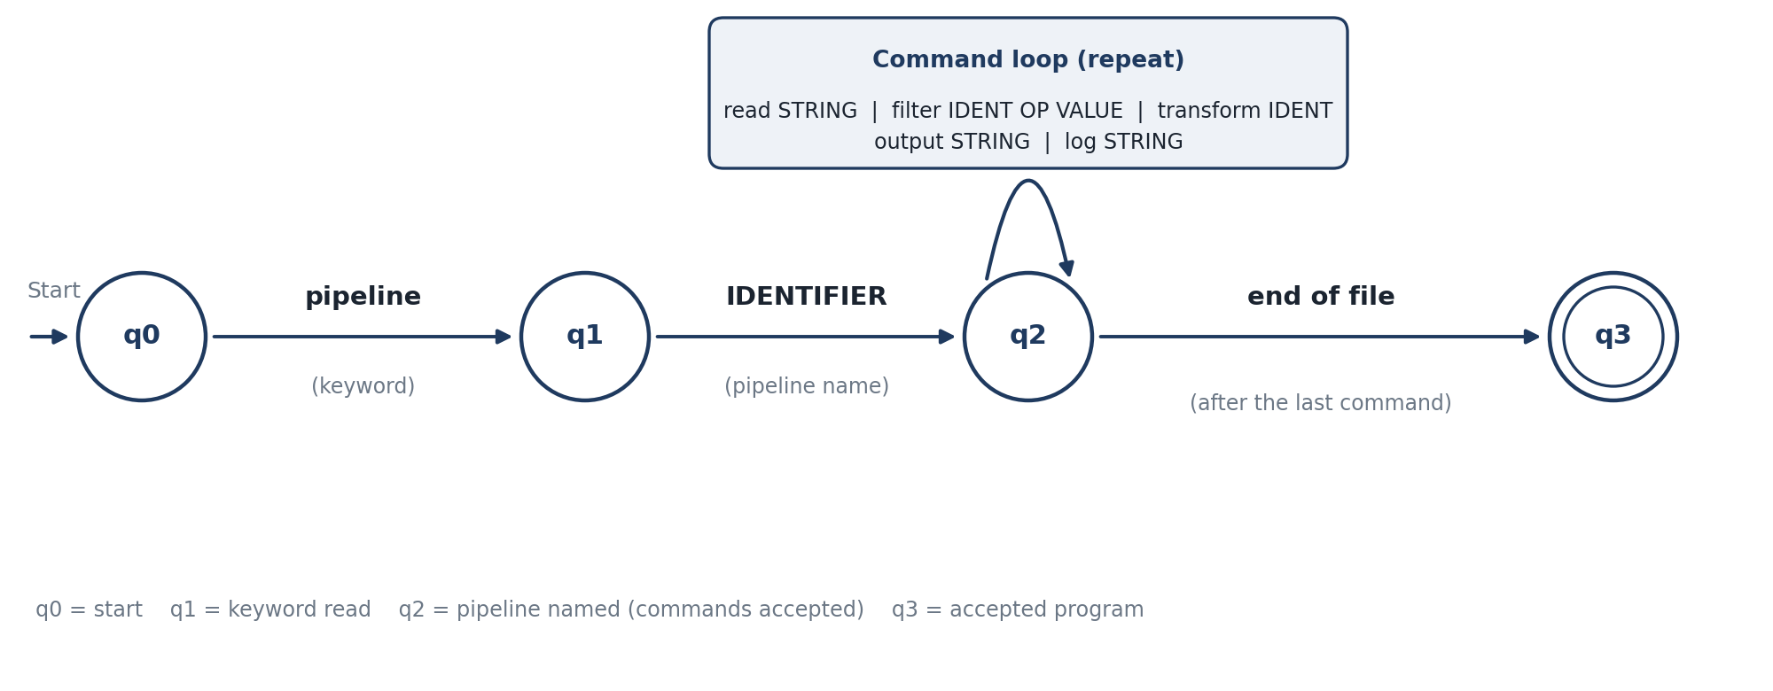
Figure 3: Simplified state diagram of a Plumb program
For example, the following program is valid:
pipeline process
read "users.csv"
output "result.csv"

The next program gives a syntax error because the pipeline has no name and the read command has no file:
pipeline
read

9.3 Abstract Syntax Tree
The AST shows the logical structure of the program. Each command becomes a node class (PipelineNode, ReadNode, FilterNode, TransformNode, OutputNode and LogNode). The sample program from Section 2 produces this tree with 9 nodes:
Pipeline: process_data
|-- Read
| `-- "users.csv"
|-- Filter
| `-- age > 18
|-- Transform
| `-- name
`-- Output
`-- "result.csv"

9.4 Semantic Analysis
After parsing, the compiler checks whether the program follows the rules of Plumb.
Rule | Example of a violation
A pipeline must have exactly one read command, and it must come first. | output placed before read
A pipeline must have exactly one output command, and it must come last. | a command written after output
File paths must be strings that end with .csv. | read "users.txt"
Operators >, <, >= and <= need a number value. | filter age > "ten"
A column name must be a valid identifier. | filter 2age > 18

The analyzer also gives warnings. A warning does not stop the compilation. Examples are a pipeline that has no filter or transform command, and an empty log message.

9.5 Symbol Table
A simple Symbol Table stores the names used in a program. It is used to find repeated names and to check the type of a column. To keep the project short, only one pipeline scope is used instead of a complex scope system.
Name | Kind | Type | Scope | Line
process_data | Pipeline | - | Global | 1
age | Column | Number | process_data | 3
name | Column | Text | process_data | 4

9.6 Code Generation
The code generator walks through the checked AST and writes JavaScript. JavaScript is chosen as the target because the backend also uses Node.js. Two small helper functions, readCSV and writeCSV, are provided in a helper file.
Plumb command | Generated JavaScript
read "users.csv" | const data = readCSV("users.csv");
filter age > 18 | const filtered = data.filter(r => r.age > 18);
transform name | const result = filtered.map(r => ({ name: r.name }));
output "result.csv" | writeCSV(result, "result.csv");
log "done" | console.log("done");

10. Compiler Diagnostics
Plumb will give clear messages instead of a generic error. Every message has an error type, a line number, a column number, a short explanation, and a suggestion when possible. Suggestions are found by comparing the word with the known commands (edit distance of two or less).
Error: Invalid command
Line: 3 Column: 5
Unknown command: "filtr"
Did you mean: "filter"?

Type | Example | Message
Lexical error | Unknown character @ | Invalid character '@' at line 2, column 7.
Syntax error | pipeline with no name | Expected a pipeline name after 'pipeline'.
Semantic error | output before read | The first command must be 'read'.
Warning | No filter or transform | Pipeline does not change the data.

11. Compilation Telemetry
A lightweight telemetry part records useful facts about each compilation and sends them to the dashboard. Advanced real-time or distributed monitoring is outside the scope of this project.
Metric | Meaning
Compilation time | Total time taken by the compiler, in milliseconds.
Token count | Number of tokens found by the lexer.
AST node count | Number of nodes in the syntax tree.
Errors and warnings | Number of errors and warnings found.
Status | Success or failed.

The backend sends the result to the dashboard in JSON format, for example:
{
"status": "success",
"compilationTime": 24,
"tokenCount": 12,
"errors": 0,
"warnings": 0,
"astNodes": 9
}

12. Developer Dashboard
The dashboard is a React web page with four areas, shown in Figure 4.
- Code Editor: the user writes Plumb code.
- Compilation Panel: the Compile button sends the code to the backend.
- Metrics Panel: compile time, token count, AST nodes, errors, warnings, status and token distribution.
- AST and Diagnostics Panel: the syntax tree, errors, warnings and the generated code.
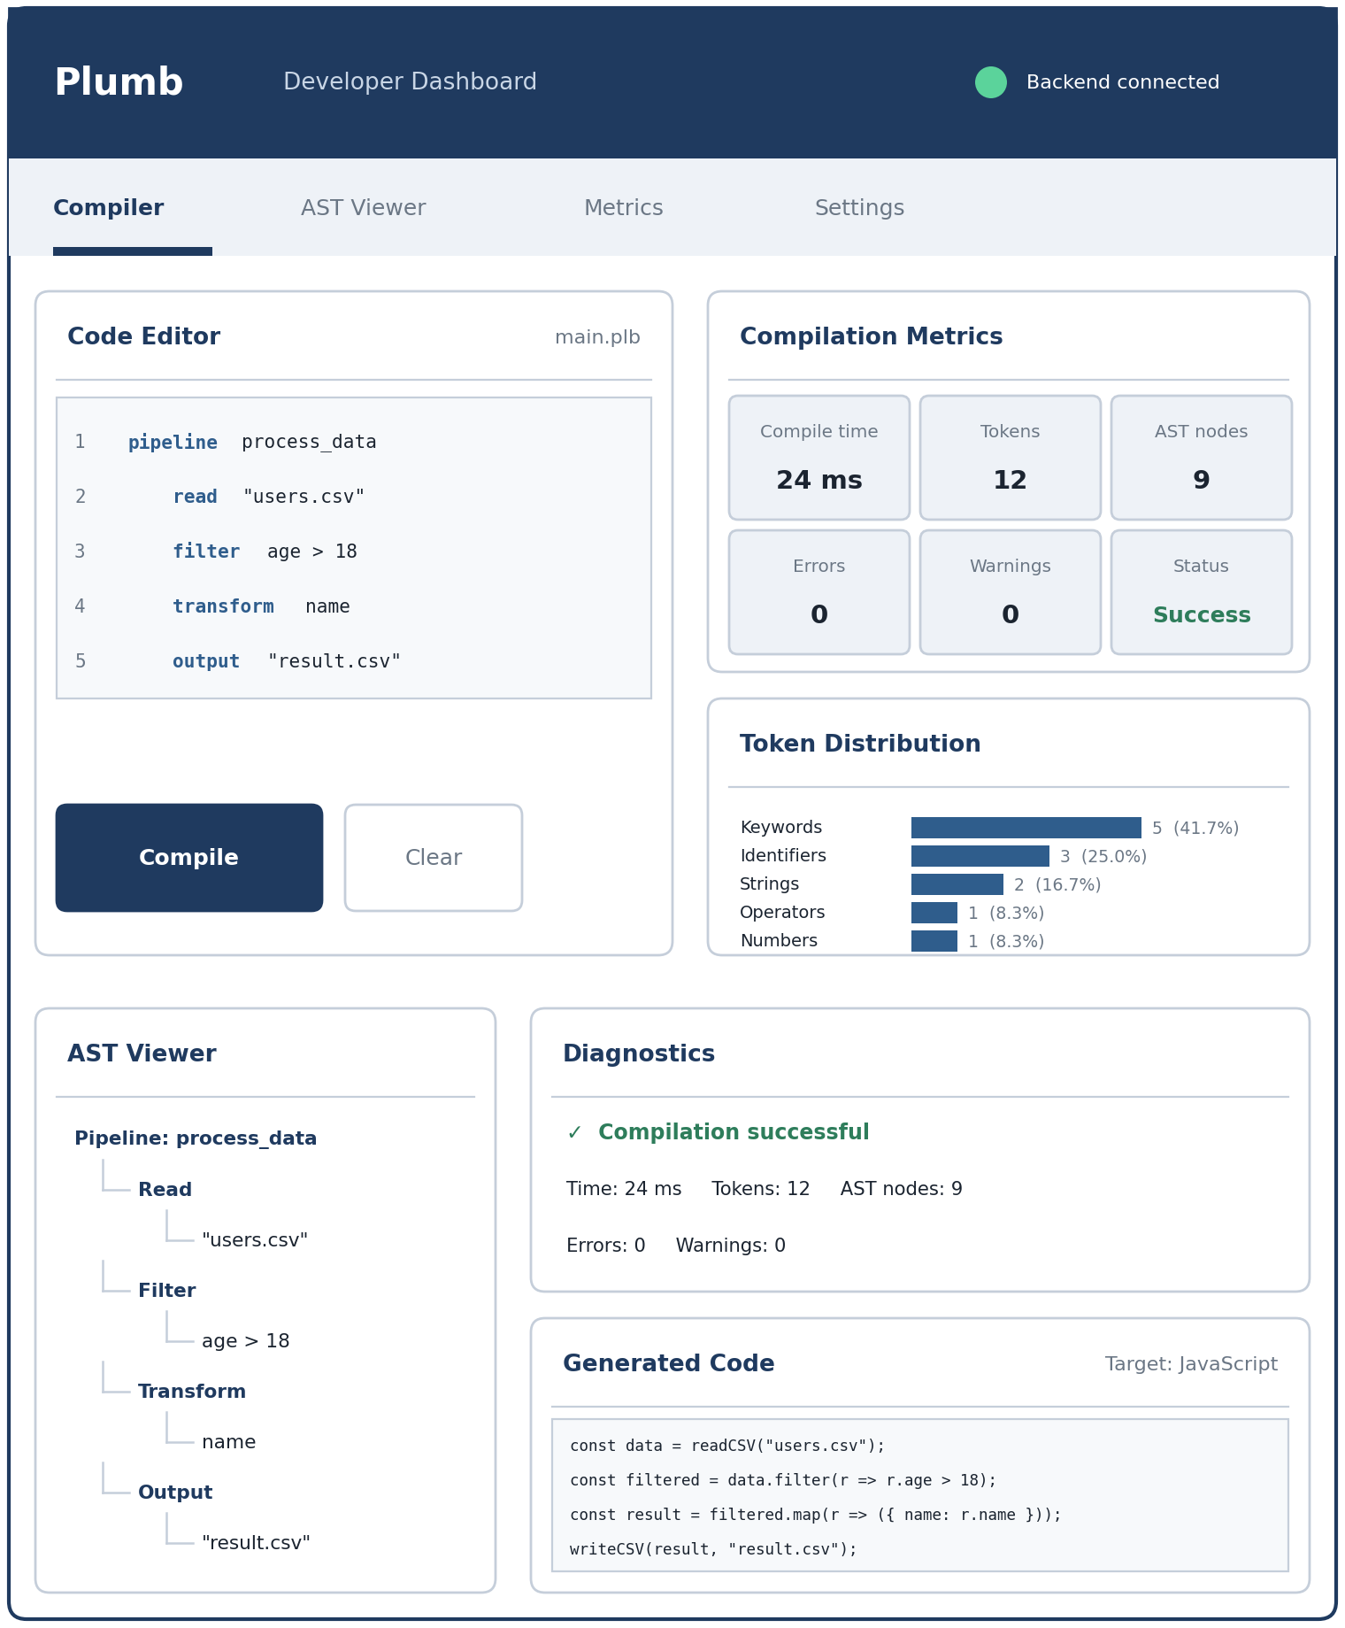
Figure 4: Planned layout of the Plumb Developer Dashboard

13. System Modules
No. | Module | Contents
M1 | Language Design and Grammar | Keywords, commands, operators, data types, EBNF grammar, sample programs.
M2 | Lexer | Token definitions, JFlex rules, lexical error handling.
M3 | Parser and AST | Recursive descent parser, AST classes, syntax errors.
M4 | Semantic Analyzer | Command checks, identifier checks, basic type checks, warnings.
M5 | Symbol Table | Storing names, types and scope; duplicate and lookup checks.
M6 | Code Generator | AST walker that produces JavaScript code.
M7 | Diagnostics and Telemetry | Error messages, suggestions, compile time and counts.
M8 | Backend API | Express server, compile route, compiler execution, JSON results.
M9 | Developer Dashboard | Editor, compile button, metrics, AST viewer, diagnostics, generated code.
M10 | Testing and Documentation | Test programs, system testing, report, screenshots, presentation.

14. Technology Stack
Part | Tools | Use
Compiler | Java, JFlex | Lexer and compiler code
Parsing method | Recursive descent, EBNF grammar | Syntax analysis
Backend | Node.js, Express.js | API between dashboard and compiler
Frontend | React.js, Tailwind CSS | Dashboard pages and styling
Charts | Recharts or simple components | Token distribution display
Tools | Visual Studio Code, Git, GitHub, Postman | Development, teamwork and API testing

15. Requirements

15.1 Functional Requirements
The system should:
- Allow users to write Plumb code.
- Recognize valid Plumb tokens.
- Detect invalid tokens.
- Parse valid Plumb programs.
- Generate an AST.
- Perform basic semantic checks.
- Maintain a Symbol Table.
- Generate JavaScript code.
- Display compiler errors and warnings.
- Calculate compilation statistics.
- Send the code to the backend and return the results.
- Display the results, AST and telemetry on the dashboard.

15.2 Non-Functional Requirements
Requirement | Description
Usability | A student should be able to use the dashboard without long instructions.
Performance | Small Plumb programs should compile in well under one second.
Maintainability | Each compiler phase is a separate module with a clear interface.
Reliability | Invalid programs give meaningful errors and never crash the compiler.
Simplicity | No extra features that do not support the learning goals.

16. Testing Strategy
Test type | What is tested | Responsible
Lexer tests | Every token type and invalid characters | Abdul Wasay
Parser tests | Valid programs and syntax errors | Abdul Wasay
Semantic tests | Each rule and warning in Section 9.4 | Fauzan Gauhar
Code generator tests | Generated JavaScript for each command | Fauzan Gauhar
API tests | Compile route using Postman | Hasnain Ali
Dashboard tests | Editor, buttons and result panels | Hasnain Ali
End-to-end tests | Full path from editor to result | All members

The team will prepare at least 10 valid and 15 invalid sample programs. They will be used again and again during development to make sure that old features keep working.

17. Team and Module Distribution

17.1 Team Members
Name | Registration No. | Role
Abdul Wasay | FA23-BCS-004 | Project Lead
Fauzan Gauhar | FA23-BCS-037 | Team Member
Hasnain Ali | FA23-BCS-027 | Team Member

17.2 Division of Modules
Abdul Wasay, as project lead, takes the language core, because every other module depends on the grammar, tokens and AST. The remaining modules are divided between Fauzan Gauhar (compiler back half) and Hasnain Ali (backend and dashboard).
No. | Module | Responsible | Main deliverable
M1 | Language Design and Grammar | Abdul Wasay | Frozen grammar and sample programs
M2 | Lexer | Abdul Wasay | Working JFlex lexer
M3 | Parser and AST | Abdul Wasay | Parser that builds the AST
M4 | Semantic Analyzer | Fauzan Gauhar | Semantic checks and warnings
M5 | Symbol Table | Fauzan Gauhar | Symbol Table class
M6 | Code Generator | Fauzan Gauhar | Plumb to JavaScript generator
M7 | Diagnostics and Telemetry | Fauzan Gauhar | Error messages and statistics
M8 | Backend API | Hasnain Ali | Express server with compile route
M9 | Developer Dashboard | Hasnain Ali | React dashboard
M10 | Testing and Documentation | Hasnain Ali (all help) | Test results and final report

17.3 Responsibilities
Abdul Wasay (Project Lead). Modules M1, M2 and M3. Also manages the plan, the GitHub repository, code reviews, final integration and the final demo.
Fauzan Gauhar. Modules M4, M5, M6 and M7. Builds the semantic analysis, symbol table, code generator, diagnostics and telemetry.
Hasnain Ali. Modules M8, M9 and M10. Builds the backend API and dashboard and leads system testing and documentation.

17.4 Working Method
- A short team meeting every day to share progress and problems.
- GitHub is used for all code. Each member works on a separate branch and uses pull requests.
- The JSON format between the compiler and the backend is agreed on Day 3 so both sides can work at the same time.
- A small demo is shown at the end of each week.

18. Project Plan (Three Weeks)
The project is planned for three weeks (21 days). Each week has one theme. The full schedule is shown as a Gantt chart in Appendix A.
Week | Theme | Goal
Week 1 | Foundation | Grammar, lexer, parser, AST, symbol table, backend skeleton and dashboard design.
Week 2 | Compiler and integration | Complete semantic analysis, code generator and diagnostics; connect backend and start dashboard.
Week 3 | Dashboard, telemetry and testing | Telemetry, dashboard panels, full testing, documentation and final demo.

Week 1: Foundation (Days 1–7)
Days | Task | Responsible
Day 1–2 | M1: Define commands, syntax and EBNF grammar; write sample programs. | Abdul Wasay
Day 3–4 | M2: Write JFlex rules, token classes and lexical error handling. | Abdul Wasay
Day 5–7 | M3: Build the recursive descent parser and AST classes. | Abdul Wasay
Day 3–5 | M5: Build the Symbol Table (insert, lookup, duplicate check). | Fauzan Gauhar
Day 6–7 | M4: Semantic checks for commands (first part). | Fauzan Gauhar
Day 1–3 | M9: Dashboard wireframes and page layout design. | Hasnain Ali
Day 4–7 | M8: Express server, compile route skeleton and JSON format. | Hasnain Ali

Week 2: Compiler and Integration (Days 8–14)
Days | Task | Responsible
Day 8–10 | Syntax error handling; compiler command-line runner that returns JSON. | Abdul Wasay
Day 11–14 | Compiler integration testing with valid and invalid programs. | Abdul Wasay
Day 8–9 | M4: Semantic checks for identifiers, types and command order. | Fauzan Gauhar
Day 10–12 | M6: Code generator (Plumb to JavaScript). | Fauzan Gauhar
Day 13–14 | M7: Diagnostics with line, column and “Did you mean” suggestions. | Fauzan Gauhar
Day 8–10 | M8: Connect the backend to the Java compiler and return results. | Hasnain Ali
Day 11–14 | M9: Code editor, Compile button and API call. | Hasnain Ali

Week 3: Dashboard, Telemetry and Testing (Days 15–21)
Days | Task | Responsible
Day 15–18 | End-to-end integration and bug fixing. | Abdul Wasay
Day 19–21 | Final review, demo preparation and submission. | Abdul Wasay
Day 15–16 | M7: Telemetry (time, token count, node count, error count). | Fauzan Gauhar
Day 17–19 | Unit tests for the semantic analyzer and code generator. | Fauzan Gauhar
Day 15–18 | M9: Metrics panel, AST viewer and diagnostics panel. | Hasnain Ali
Day 19–21 | M10: System testing and UI polishing. | Hasnain Ali
Day 19–21 | Report, screenshots and presentation. | All members

Milestones
Day | Milestone
Day 7 | Grammar, lexer and parser working; Symbol Table ready; backend skeleton ready.
Day 14 | All compiler phases working and connected to the backend.
Day 18 | Dashboard shows metrics, AST, errors and generated code; full workflow works.
Day 21 | Testing finished; report, screenshots and final demo ready.

19. Risks and Mitigation
Risk | Effect | Plan
Grammar changes late | Lexer and parser must be rewritten | Freeze grammar on Day 2; changes only with lead approval.
Java and Node.js connection problems | Dashboard cannot compile code | Run the compiler as a child process with JSON output; test by Day 10.
A member is busy or absent | Work is delayed | Keep modules small, share progress daily, lead reviews the plan.
Scope grows | Deadline is missed | Follow the exclusion list in Section 6.2; extra ideas only after Day 18.
Late integration bugs | Not enough time to fix | Integrate in Week 2 and show a demo every week.
Unclear error messages | Poor user experience | Test with invalid programs and review messages as a team.

20. Expected Outcomes
At the end of the project, a working prototype is expected to provide:
- A custom lightweight DSL with its grammar
- A working lexer, parser and AST generator
- Basic semantic analysis with a Symbol Table
- JavaScript code generation
- Clear compiler errors and warnings
- Compilation telemetry
- A backend API
- A React dashboard with metrics, AST viewer, diagnostics and generated output
The final demo will show the full path: Plumb code, lexer, tokens, parser, AST, semantic analysis, code generation, result and dashboard.

21. Learning Outcomes
- Compiler construction: lexical analysis, grammars, parsing, ASTs, semantic analysis, symbol tables and code generation.
- Software development: backend API, frontend development, JSON communication, error handling and testing.
- Developer tools: code editor integration, diagnostics, performance metrics and dashboard design.
- Teamwork: dividing work, using Git and GitHub, reviewing code and meeting deadlines.

22. Future Enhancements
- More Plumb commands (join, sort, group)
- Stronger type checking
- Syntax highlighting and autocomplete
- A VS Code extension
- More target languages such as Python
- AI-assisted error explanations
- Cloud-based compilation
These ideas are outside the three-week plan and can be added in a later version.

23. Conclusion
Plumb is a small Domain-Specific Language that shows the main ideas of compiler construction in a practical way. It covers lexical analysis, parsing, AST generation, semantic analysis, symbol table management and code generation, and it adds a dashboard so that every step can be seen.
The project is divided into ten modules, shared fairly between three team members under the lead of Abdul Wasay, and planned in three clear weeks. By keeping the scope small and focused, the team can finish a complete and working system while gaining strong practical knowledge of compilers, backend development and frontend development.
Approval
Supervisor Name: | Signature: | Date:

Appendix A: Gantt Chart
The Gantt chart below shows the tasks of all three members over the 21 days of the project. Each colour belongs to one team member.
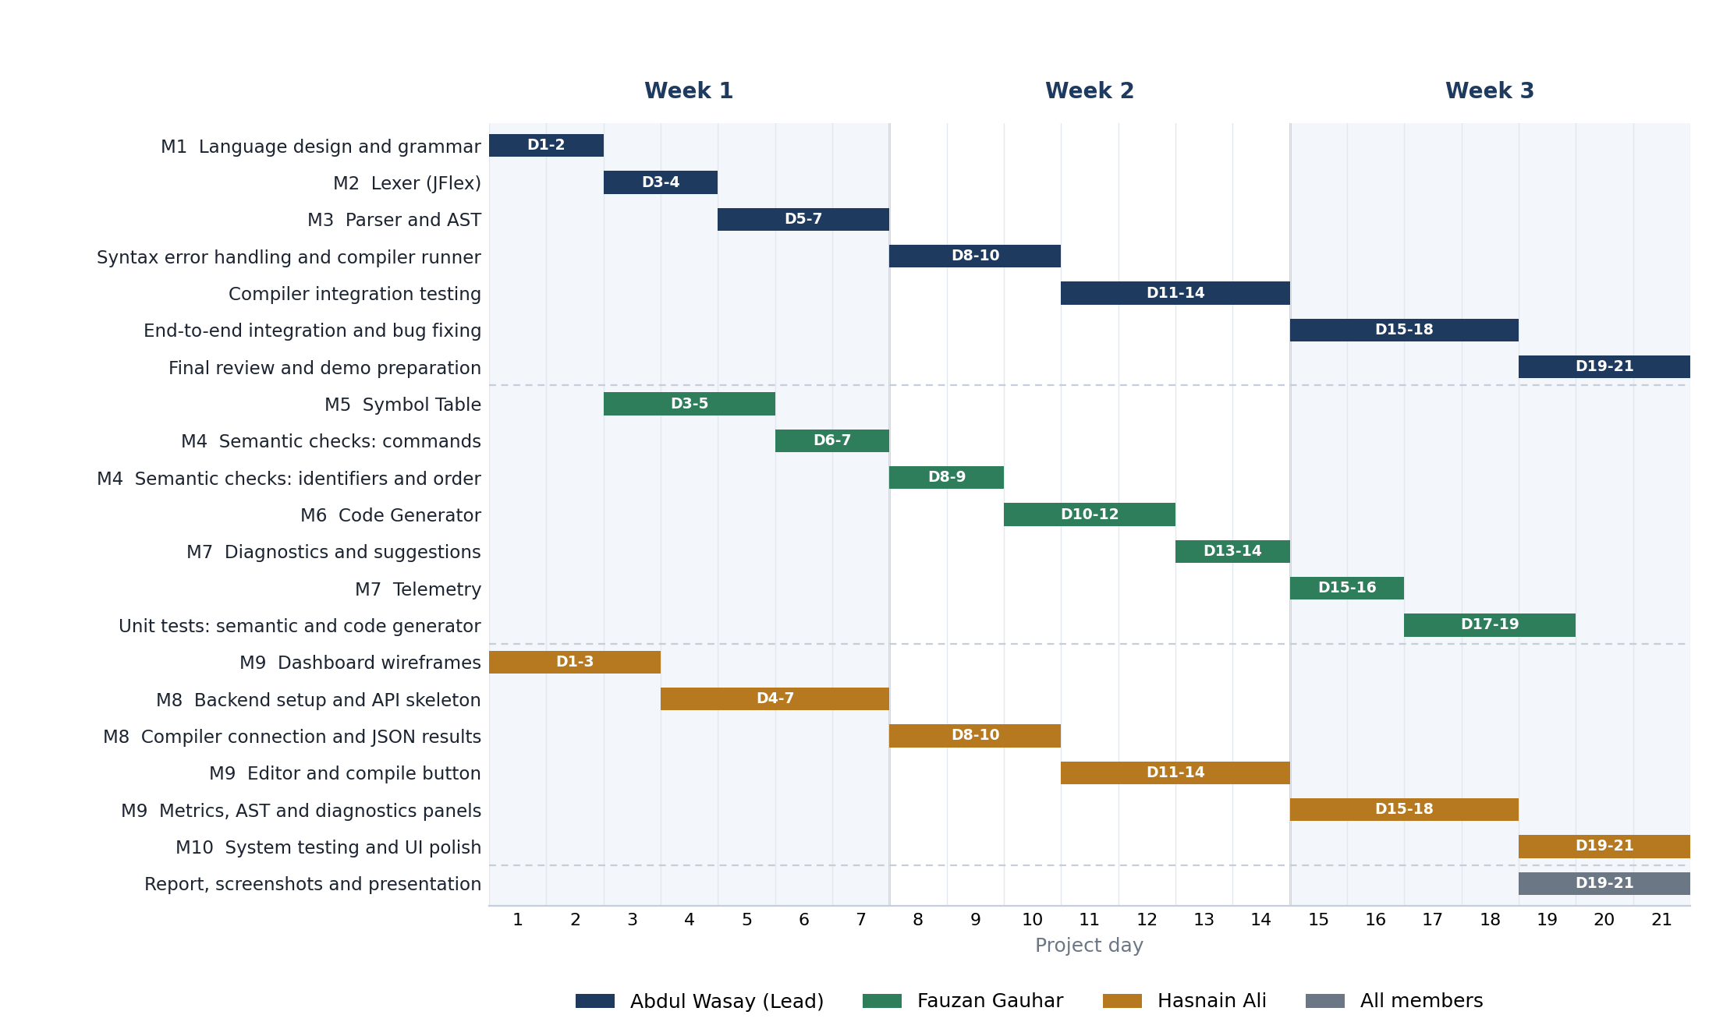
Figure 5: Gantt chart of the three-week project plan

