Types Of Invoice

- Proforma Invoice
- Sales Invoice
- Retainer Invoice
- Interim Invoice
- Final Invoice
- Reccuring Invoice
- Overdue Invoice

The following types of invoices are not used for sales but to make corrections to past transactions via credit and debit.

- Credit Note
- Debit Note

Proforma Invoice

- A proforma invoice is a preliminary invoice that is sent to a customer(buyer) by the tenant(seller) before a sale is confirmed.

- After reviewing the proforma invoice, the buyer gives the green light to the seller. The seller starts working on their part of the deal manufacturing the products or providing the service.

- To let the buyer know what to expect from the sale and allow room for negotiation.

- This invoice cannot be used for accounting purposes.

Sales Invoice

- A sales invoice is sent to a customer(buyer) to request payment after providing product or service.

- This invoice can be used for accounting purposes.

Retainer Invoice

- Retainer invoice s are invoices which is used to record the advance payments made by customer(buyer).
- After the product is delivered or service is provided, the advance payment is deducted from the final invoice.

Interim Invoice

- Interim invoices are also used for larger, more expensive projects because the total amount can be broken down into smaller invoices to make it more affordable for the customer.
- Interim invoices are partial invoices that contain only a portion of the final invoice’s amount.
Final Invoice
- A final invoice is the last invoice sent at the end of a project that highlights the total amount of the product or provided service.
- This total amount of final invoice is calculated by deducting the retainer invoice amount and interim invoices amount of the project.

Reccuring Invoice
- A recurring invoice is an invoice that is sent on a recurring basis for products or services offered repeatedly. Recurring invoices are generally sent on a weekly, monthly, or yearly basis.
- The Recurring Invoices feature is to auto-send invoices to the customers(buyer) from the tenant (seller) at a particular interval or else automatically generate the invoices as pdf and saved in draft, then the user from the tenant verifies and send to the customer.

OverDue Invoice

- Overdue invoice is nothing but all the invoices for which are beyond the payment due date and are yet to be paid by the customer.

Credit Note

- Credit Note is a document given by the seller to their customer to denote the amount of money the seller owes to that particular customer.
- For Example:If the goods supplied to the customer are damaged the seller owes some amount of money to the customer.So the seller will issue a credit note to the customer.
- Credit Note remains as open status until its refunded or substracted from the next invoice.
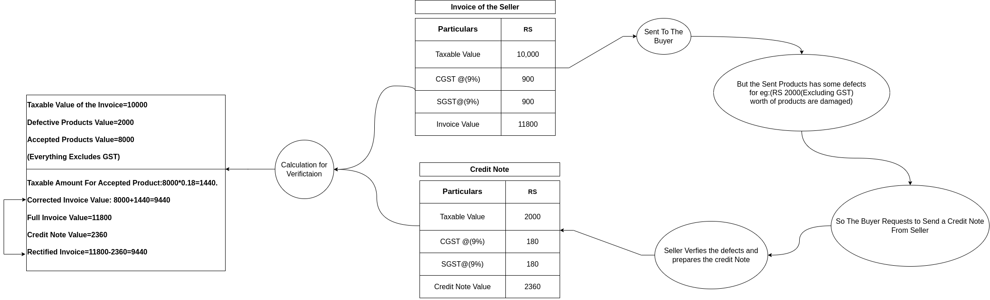

Debit Note

- Debit Note is a document given by the seller to their customer to denote the amount of money the customer owes to the seller.

Life cycle

LifeCycle of Invoice

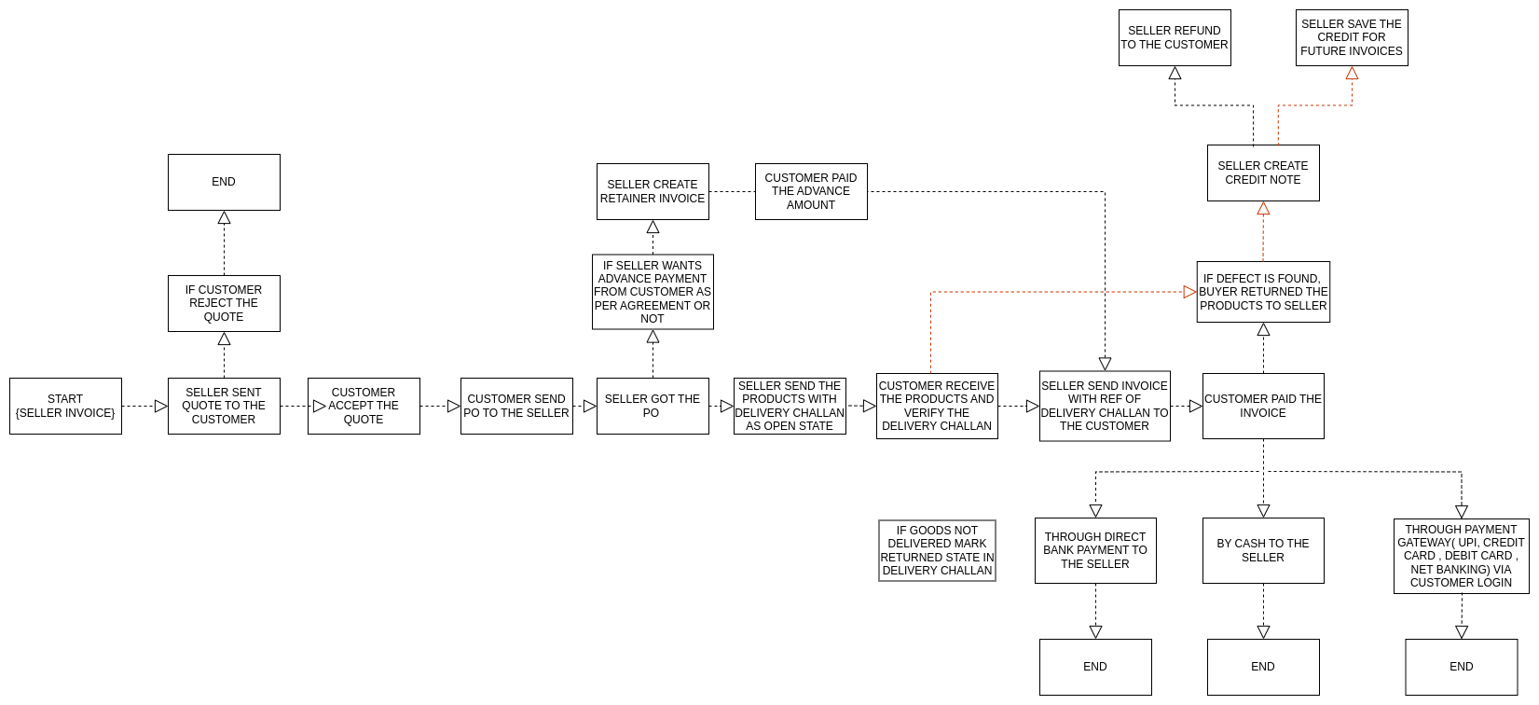
LifeCycle of Quote
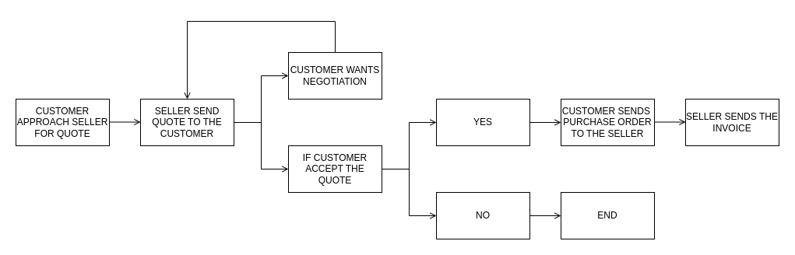
LifeCycle of Retainer Invoice
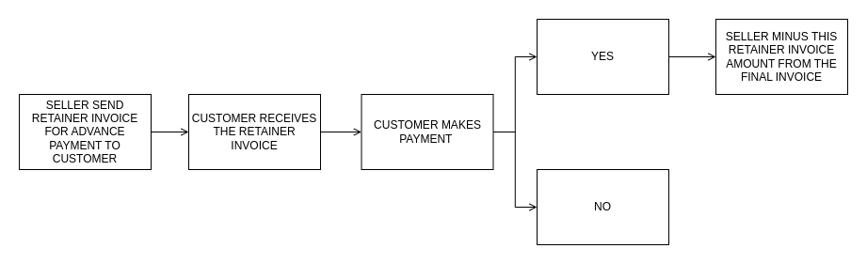
LifeCycle of Recurring Invoice

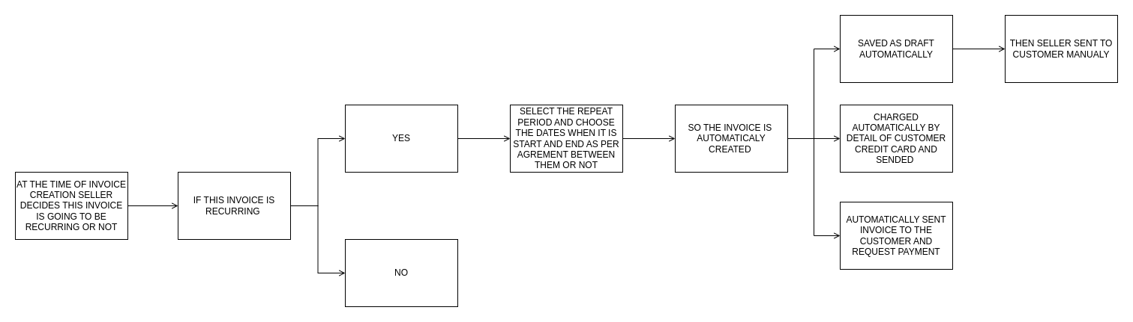
LifeCycle of Expense
