ANA 515 Assignment 1

Mohammed Abdul Bari

2022-05-27

## R Markdown

This is an R Markdown document. Markdown is a simple formatting syntax for authoring HTML, PDF, and MS Word documents. For more details on using R Markdown see <http://rmarkdown.rstudio.com>.

When you click the **Knit** button a document will be generated that includes both content as well as the output of any embedded R code chunks within the document. You can embed an R code chunk like this:

summary(cars)

## speed dist   
## Min. : 4.0 Min. : 2.00   
## 1st Qu.:12.0 1st Qu.: 26.00   
## Median :15.0 Median : 36.00   
## Mean :15.4 Mean : 42.98   
## 3rd Qu.:19.0 3rd Qu.: 56.00   
## Max. :25.0 Max. :120.00

## Including Plots

You can also embed plots, for example:



Note that the echo = FALSE parameter was added to the code chunk to prevent printing of the R code that generated the plot.

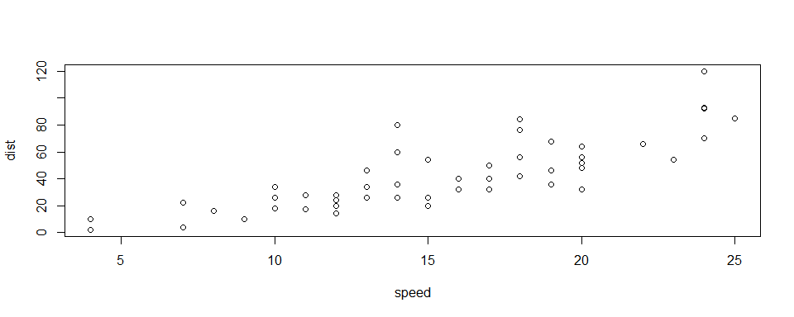

This is a long long long long caption.

plot(1) # high-level plot  
abline(0, 1) # low-level change

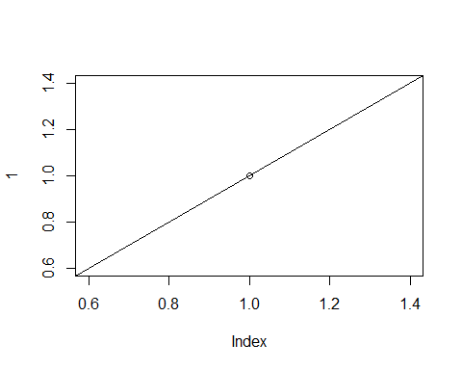

plot(rnorm(10)) # high-level plot  
# many low-level changes in a loop (a single R expression)  
for(i in 1:10) {  
 abline(v = i, lty = 2)  
}

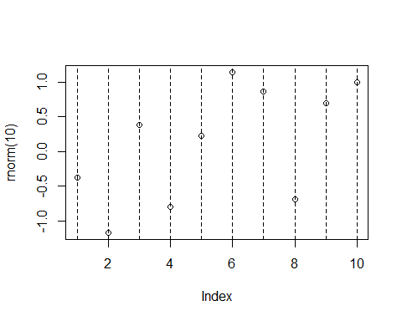

library(dplyr)  
youth <- filter(all_data, age<=65)  
summary(youth)

## ...1 year month intent   
## Min. : 1 Min. :2012 Length:85111 Length:85111   
## 1st Qu.: 24944 1st Qu.:2012 Class :character Class :character   
## Median : 50035 Median :2013 Mode :character Mode :character   
## Mean : 50203 Mean :2013   
## 3rd Qu.: 75512 3rd Qu.:2014   
## Max. :100798 Max. :2014   
## police sex age race   
## Min. :0.00000 Length:85111 Min. : 0.00 Length:85111   
## 1st Qu.:0.00000 Class :character 1st Qu.:25.00 Class :character   
## Median :0.00000 Mode :character Median :36.00 Mode :character   
## Mean :0.01612 Mean :37.89   
## 3rd Qu.:0.00000 3rd Qu.:51.00   
## Max. :1.00000 Max. :65.00   
## hispanic place education   
## Min. :100.0 Length:85111 Length:85111   
## 1st Qu.:100.0 Class :character Class :character   
## Median :100.0 Mode :character Mode :character   
## Mean :115.6   
## 3rd Qu.:100.0   
## Max. :998.0

library(dplyr)  
nrow(all_data) - nrow(youth)

## [1] 15687

youth %>%  
 ggplot(aes(age))+  
 geom_freqpoly(binwidth=1)

