Diamond sizes

Mohammed Abdul Bari

2021

output of diamonds data smaller than 2.5 carats.

## # A tibble: 53,814 × 10  
## carat cut color clarity depth table price x y z  
## <dbl> <ord> <ord> <ord> <dbl> <dbl> <int> <dbl> <dbl> <dbl>  
## 1 0.23 Ideal E SI2 61.5 55 326 3.95 3.98 2.43  
## 2 0.21 Premium E SI1 59.8 61 326 3.89 3.84 2.31  
## 3 0.23 Good E VS1 56.9 65 327 4.05 4.07 2.31  
## 4 0.29 Premium I VS2 62.4 58 334 4.2 4.23 2.63  
## 5 0.31 Good J SI2 63.3 58 335 4.34 4.35 2.75  
## 6 0.24 Very Good J VVS2 62.8 57 336 3.94 3.96 2.48  
## 7 0.24 Very Good I VVS1 62.3 57 336 3.95 3.98 2.47  
## 8 0.26 Very Good H SI1 61.9 55 337 4.07 4.11 2.53  
## 9 0.22 Fair E VS2 65.1 61 337 3.87 3.78 2.49  
## 10 0.23 Very Good H VS1 59.4 61 338 4 4.05 2.39  
## # … with 53,804 more rows

We have data about 53940 diamonds. Only 126 are larger than 2.5 carats. The distribution of the remainder is shown below:

all diamonds count

## [1] 53940

smaller diamonds count; smaller or equal to 2.5 carats

## [1] 53814

count of diamond larger than 2.5 carats

## [1] 126

distribution of diamonds larger than 2.5 carats 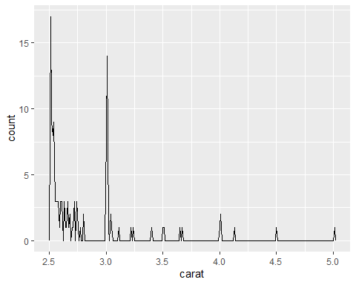

distribution of diamonds smaller or equal to 2.5 carats 