Data Visualization

Mohammed Abdul Bari

2022-06-24

## R Markdown

#reading data from github repository  
read_data <- read.csv(url("https://raw.githubusercontent.com/fivethirtyeight/police-settlements/main/atlanta_ga/final/atlanta_edited.csv"))

#histogram showing Number of police misconduct incidences  
hist(data$sum_calendar_year, main ="Number of incidences per year",  
 xlab ="Number of incidences",  
 xlim =c(0,35000), col ="blue",  
 freq = FALSE)

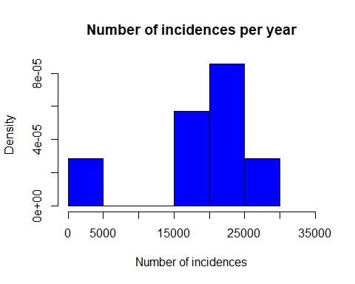

# scatterplot visualization showing the Number of police misconduct incidences per year  
plot(data$calendar_year,data$sum_calendar_year,  
 main = 'Number of police misconduct incidences per year',  
 xlab ="year of incidence",  
 ylab ="Number of incidences")

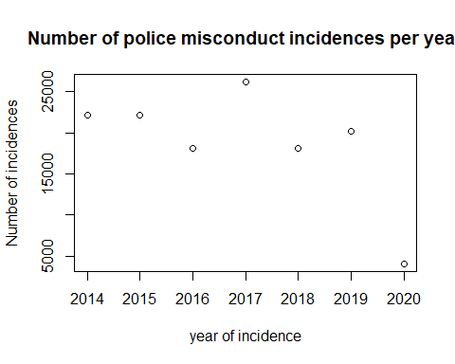

#scatterplot showing relationship between amount of money demanded to compensate police misconduct victims and amount awarded.  
plot(x = read_data$amount_awarded,  
 y = read_data$amount_demanded,  
 xlab = "amount awarded",  
 ylab = "amount demanded",  
 col = "green",  
 main = "amount awarded vs amount demanded")

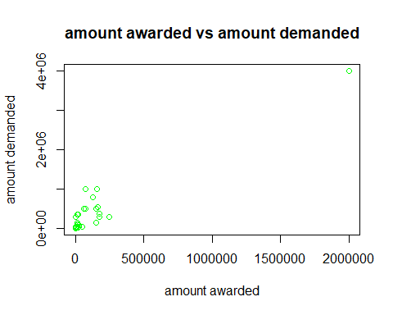

#bar chart: Number of police misconduct incidences per year  
barplot(data$sum_calendar_year,  
 names.arg=data$calendar_year,  
 main = 'Number of police misconduct incidences per year',  
 xlab ="year of incidence",  
 ylab ="Number of incidences")

