Game Design Document

Fill up the following document

1. Write the title of your project.

Space invaders

1. What is the goal of the game?

Shoot as many ships as you can to save Earth

1. Write a brief story of your game.

An evil alien has attacked earth.He has sent spaceships to invade earth, the caracter in the game tries to take down as many ships as he can

1. Which are the playing characters of this game?

* Playing characters are the ones who respond to the user based on the input from the user.
* Cars, monkeys, dinos, wizards, etc., are the playing characters in the game.

|  |  |  |
| --- | --- | --- |
| Number | Character Name | What can this character do? |
| 1 | Player SpaceShip | Shoot bullets |
| 2 |  |  |
| 3 |  |  |
| 4 |  |  |
| 5 |  |  |
| 6 |  |  |
| 7 |  |  |
| 8 |  |  |

1. Which are the Non-Playing Characters of this game?

* Non-Playing characters are the ones that don't have an action or behavior when the user interacts with the game.
* Hurdles, stones, bananas, coins, etc., are non-playing characters in the game.

|  |  |  |
| --- | --- | --- |
| Number | Character Name | What can this character do? |
| 1 | Space invader1 | Destroy Earth |
| 2 | Space invader2 | Destroy Earth |
| 3 | Space invader3 | Destroy Earth |
| 4 | Space invader4 | Destroy Earth |
| 5 |  |  |
| 6 |  |  |
| 7 |  |  |
| 8 |  |  |

Draw your imagination of this game. What does this game look like?

* Draw the game either on your computer or on paper.
* Add images of the game scenes to show each of the playing and non-playing characters at least once.

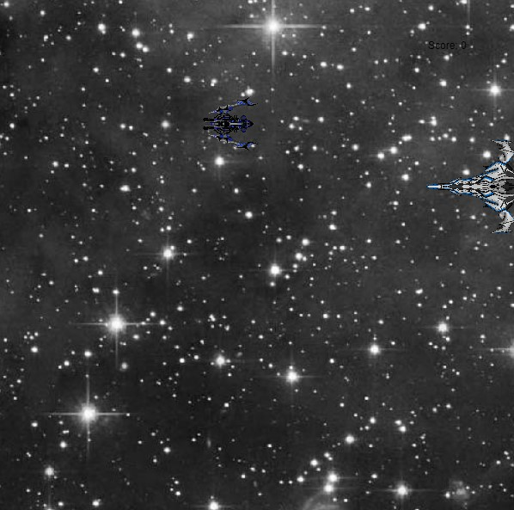

How do you plan to make your game engaging?

By adding scores and speed up the game to make it harder as the player get ahead in the game.the game can be played on pc.