

ProdPilot Task Management and Project Planning Using Critical Path Method
Project report
by
Abdulkalam A (24MIS0245)
Harshid Giriver SV (24MIS152)
Dinesh G (24MIS0453)
Under the guidance of
Dr. SWETA BHATTACHARYA
School of Computer Science Engineering and Information Systems
VIT Vellore
October 2026

EXECUTIVE SUMMARY
ProdPilot extends an existing task-management application with project planning and Critical Path Method calculations. Users can create projects, maintain activities and teams, assign responsibility and inspect a dependency network. The existing Dashboard, My tasks and JWT sign-in flow remain part of the same application.
The planning engine validates the activity graph, runs a forward pass and backward pass, and calculates ES, EF, LS, LF and total float. It supports fractional durations, branching, merging and several critical paths. The SVG view shows these values on nodes and highlights tight critical connections. A timing table provides the same results in a readable tabular form.
The team model records names, email addresses, roles and skills. Managers can assign activities manually or review deterministic role and skill suggestions. CSV and JSON imports support small team datasets. No external AI API or heavy graph library is needed.
The saved CampusPay showcase has thirteen activities and nine members. Its duration is thirty-seven days, with two critical paths ending through parallel activities K and M. The original six-activity example gives sixteen days and two paths; the decimal example gives 8.75 days. Local verification on 10 October 2026 passed twenty-two backend tests with no failures or skips, and the frontend production build succeeded.
The report covers requirements, technical specifications, design, algorithms, implementation, test results, screenshots, deployment and limitations. The schedule uses numeric days and finish-to-start relationships. It does not account for working calendars, resource limits or uncertain duration estimates.

TABLE OF CONTENTS
Executive summary ii
Table of contents iii
List of figures iv
List of tables v–vi
Abbreviations vii
Symbols and notations viii
1 Introduction 1
2 Technical Specification 8
3 Architecture And Design 16
4 Schedule Tasks And Milestones 34
5 Implementation 40
6 Implementation Results And Screenshots 49
7 Cost Analysis And Deployment 67
8 Findings Discussion And Conclusion 73
9 References 75
Appendix A Operation and verification guide —

LIST OF FIGURES
Fig. 3.1 Application Architecture 16
Fig. 3.2 Logical Data Model 17
Fig. 3.3 Activity Update Sequence 19
Fig. 6.1 ProdPilot Login Screen 51
Fig. 6.2 Authenticated Dashboard 52
Fig. 6.3 My Tasks All Filter with Three Tasks 53
Fig. 6.4 New Task Form Before Submission 54
Fig. 6.5 My Tasks Pending Filter with Two Tasks 55
Fig. 6.6 My Tasks Completed Filter with One Task 56
Fig. 6.7 CampusPay Project Overview 57
Fig. 6.8 CampusPay Activities and Predecessors 58
Fig. 6.9 Activity Editing Form 59
Fig. 6.10 CampusPay Project Team 60
Fig. 6.11 CPM Network and Summary View 61
Fig. 6.12 Project Network Download PNG Control 62
Fig. 6.13 Complete CampusPay Network Exported as PNG 63

LIST OF TABLES
Table 1.1 Objective 1
Table 1.2 Understanding the background concepts 3
Table 1.3 Problem definition 4
Table 1.4 Scope 5
Table 1.5 Acceptance criteria 6
Table 2.1 Existing stack 8
Table 2.2 Local runtime and ports 9
Table 2.3 Project data specification 10
Table 2.4 Activity data specification 11
Table 2.5 Member data specification 12
Table 2.6 API input and response contract 13
Table 2.7 Nonfunctional requirements 14
Table 2.8 Assumptions and operational limits 15
Table 3.1 Use cases and permissions 18
Table 3.2 Graph validation 21
Table 3.3 Forward pass 23
Table 3.4 Project duration and final activities 24
Table 3.5 Backward pass 25
Table 3.6 Float and decimal precision 26
Table 3.7 Network layout 28
Table 3.8 Connections and accessibility 29
Table 3.9 Manual assignment 30
Table 3.10 Deterministic assignment design 31
Table 3.11 Alternatives and tradeoffs 33
Table 4.1 Development work breakdown 34

LIST OF TABLES CONTINUED
Table 4.2 Proposed milestone sequence 35
Table 4.3 Task dependencies in implementation 36
Table 4.4 Agile workflow 37
Table 4.5 Risks and mitigation 38
Table 4.6 Showcase preparation 39
Table 5.1 Backend module organization 40
Table 5.2 Project and activity endpoints 41
Table 5.3 Team and assignment endpoints 42
Table 5.4 Validation and error handling 43
Table 5.5 Frontend organization 44
Table 5.6 Activity editor behavior 45
Table 5.7 Consistency and concurrency 46
Table 5.8 Preserving task functionality 47
Table 6.1 Verification method and results 49
Table 6.2 Test coverage 50
Table 6.3 CampusPay numerical result 64
Table 6.4 Integer and decimal CPM examples 65
Table 6.5 Assignment and invalid input results 66
Table 7.1 Cost analysis 67
Table 7.2 Continuous integration 69
Table 7.3 Security constraints 70
Table 7.4 Scheduling and assignment limitations 71
Table 7.5 Maintenance and extension plan 72
Table 8.1 Findings 73

ABBREVIATIONS
API Application Programming Interface
CPM Critical Path Method
CRUD Create Read Update Delete
CSV Comma-Separated Values
DAG Directed Acyclic Graph
EF Earliest Finish
ES Earliest Start
HTTP Hypertext Transfer Protocol
JSON JavaScript Object Notation
JWT JSON Web Token
LF Latest Finish
LS Latest Start
QA Quality Assurance
REST Representational State Transfer
SVG Scalable Vector Graphics
UAT User Acceptance Testing
UI User Interface
URL Uniform Resource Locator

SYMBOLS AND NOTATIONS
i An activity in the project network
p An immediate predecessor of activity i
s An immediate successor of activity i
t A final activity with no successors
duration(i) Estimated duration of activity i in days
ES(i) and EF(i) Earliest start and finish as day offsets
LS(i) and LF(i) Latest start and finish preserving project duration
Float(i) LS(i) minus ES(i), also LF(i) minus EF(i)
max Largest value among the relevant predecessors
min Smallest value among the relevant successors
START and FINISH Display endpoints with no added duration
u → v Activity v depends on activity u
Day 0 The project start date
— No predecessor, not applicable or no printed page number

CHAPTER 1
INTRODUCTION

1.1 Objective
ProdPilot is a web application for personal task management and project planning. The project extends the existing application with activity dependencies, team assignments and Critical Path Method calculations. It keeps the original React, Express and MongoDB structure and adds a Projects section beside Dashboard and My tasks.
The main objective is to help a project manager answer a practical question: which activities control the planned finishing time? A task list can show work that is pending, but it does not show how a delay affects dependent work. ProdPilot records predecessor links and calculates the early and late timing of every activity.
The completed feature supports decimal durations, branching, merging and more than one critical path. A project manager can assign work manually or review suggestions based on member roles and skills. The network view shows these results through activity nodes, arrows and a timing table. The software is a planning tool; it does not carry out the work represented by an activity.
Table 1.1 Objective
Objective | Delivered capability
Plan dependent work | Activities with multiple predecessors
Calculate schedule | ES, EF, LS, LF and float
Show schedule risk | All critical activities and tight critical edges
Allocate responsibility | Manual assignment and reviewable suggestions
Retain existing work | Dashboard and personal task APIs remain separate

1.2 Motivation
A project normally has work that can run in parallel and work that must wait for an earlier result. For example, mobile development can follow design while database development follows backend work. Integration cannot start until both required branches are ready. A simple list does not make this waiting time clear.
Manual CPM calculation becomes difficult when a manager changes a duration or adds a predecessor. The forward pass and backward pass must be repeated, and a change in one branch can alter float elsewhere. A visual network helps users check whether the stored relationships match the intended plan.
ProdPilot already provides authentication, forms, navigation and task storage. Extending that base avoids a second account system and an unnecessary new stack. The resulting project demonstrates how a scheduling method can become a working feature in an existing application.
The CampusPay example is used as a demonstration plan. Its activity names represent software delivery work across design, backend, mobile, security and testing. CampusPay is not a payment application built by this project. It is a dataset used to explain the planning and assignment features.

1.3 Understanding the background concepts
Critical Path Method uses a directed activity network. Each activity has a duration and a set of immediate predecessors. The graph must be acyclic because an activity cannot require its own completion before it starts. The order used for calculation is based on dependencies, not on the order in which records were entered.
Kelley and Walker's paper on critical-path planning and scheduling is a foundational reference for coordinating dependent project activities (Kelley & Walker, 1959). ProdPilot implements a small activity-on-node scheduling model for the requirements of this project.
The forward pass finds the earliest times at which activities can start and finish. The backward pass finds the latest times that still preserve the calculated project duration. The difference between the late and early start is total float. An activity with zero float is critical under the current assumptions.
ProdPilot uses an activity on node representation. A node represents a task, and an arrow means that the successor depends on the predecessor. START and FINISH are display endpoints. They are not user-created activities and do not add duration.
CPM results depend on the entered durations and relationships. They are not promises about delivery. Resource shortages, weekends, uncertain estimates and changes in scope can affect real completion. The current system calculates a deterministic dependency schedule and leaves those wider decisions to the project manager.
Table 1.2 Understanding The Background Concepts
Term | Meaning in ProdPilot
Predecessor | An activity that must finish before another starts
Successor | An activity that depends on the current activity
Critical activity | An activity whose calculated total float is zero
Critical path | A complete tight zero-float route from START to FINISH

1.4 Problem definition
The existing application manages personal tasks with details such as priority, due date and completion state. These fields are useful for daily work, but they do not describe a project network. There is no way to calculate when a dependent activity can begin using only a personal task due date.
The project addresses this gap by storing a separate project plan. It must accept fractional durations, support several immediate predecessors and reject networks that cannot be calculated. Invalid inputs must produce readable errors rather than a broken graph or a partly saved project.
Assignment is another requirement. Team members need names, email addresses, roles and skills. The manager must be able to select a member for an activity without depending on a paid external service. Automatic assignment should explain its matching basis and remain a suggestion until it is applied.
The implementation must protect project access on the server. Hiding an edit button alone is not sufficient. Every project lookup must be limited to the authenticated user's accessible projects, and every change must also pass the manager permission check.
Table 1.3 Problem Definition
Existing gap | Required response
No dependency structure | Separate activities and predecessor graph
No computed schedule | Server-side CPM service
No project team | Project-specific member records
Unclear allocation | Manual selection and deterministic matching
Potential invalid links | Validation before persistence

1.5 Scope
The scope covers authenticated project creation, project editing, activity management, project team management, assignment and network calculation. A project includes a name, description and start date. Each activity stores a stable ID, descriptive fields, duration, predecessors, assignment and status.
The Network / CPM tab is the main visual output. It presents project duration, activity count, critical activity count, all critical connections and a readable table of calculated timings. Decimal values are retained rather than converted to whole days.
Team information can be entered in a form or imported from CSV and JSON. Suggestions compare role and skill phrases with activity requirements. Existing assignments are left unchanged. The manager can review and change suggested members before saving them.
The scope excludes notifications, chat, billing, calendars, Gantt charts and external AI calls. It also excludes resource-constrained scheduling and working-day calendars. These limits keep the implementation suitable for the existing application and make the demonstrated results easier to verify.
Table 1.4 Scope
Included | Not included
JWT-protected project planning | External AI services
Dependency-based CPM | Resource leveling
SVG network and timing table | Gantt chart or calendar
Manual and suggested assignment | Employee performance scoring
CSV and JSON team import | TXT import and organization directory

1.6 Acceptance criteria
A successful result must work through both the API and the user interface. Project data must persist, dependent activities must produce correct timing values, and the graph must show the same relationships as the calculated output. Errors should not remove or overwrite a valid saved plan.
The numerical checks include the six-activity example with two critical paths, a decimal-duration example and the larger CampusPay plan. These checks are useful because a straight chain cannot expose errors in merging or in the backward pass.
Assignment checks cover both manual changes and deterministic suggestions. Access checks include the owner, a Project Manager, an ordinary member and an unrelated account. Existing tasks must still belong to their authenticated user.
The final verification combines automated tests, a frontend production build and screenshots from the running local application. Automated checks provide repeatable assertions; screenshots show the interface and saved demonstration data. A screenshot alone is not evidence for every API permission or validation rule.
Table 1.5 Acceptance Criteria
Check | Expected outcome
Six-activity CPM | Duration 16 and two critical paths
Decimal CPM | Duration 8.75 and C float 2.25
CampusPay CPM | Duration 37 and two final critical branches
Invalid dependency | HTTP 400 and useful message
Project permissions | Server-side access and edit restrictions
Existing tasks | CRUD and statistics continue to work
Build and tests | Production build and backend tests pass

1.7 Literature survey
Kelley and Walker (1959) describe critical-path planning and scheduling as a way to represent the order and duration of project work. This is the scheduling foundation used in ProdPilot. The report applies dependency-based forward and backward passes to the activity network rather than deriving a schedule from a task list or due dates.
The official React documentation explains components and state for interactive interfaces (React, n.d.). Express routing documentation describes request handlers and middleware (Express, n.d.), while Mongoose schema documentation describes how application records and validation rules are defined (Mongoose, n.d.). These sources support reuse of the existing stack; they do not establish that ProdPilot itself has passed testing.
RFC 7519 defines JSON Web Tokens (Jones et al., 2015). ProdPilot retains its existing token-based authentication, then applies ownership and project membership checks in the API. A token identifies a signed-in account; access to each planning record still requires a separate authorization decision.
The Scrum Guide describes backlog management and regular inspection of work (Schwaber and Sutherland, 2020). It provides process context, while CPM answers a different question: which dependency routes control the planned finish? ProdPilot keeps personal task status separate from activity timing for this reason.
The design need is a small extension that combines activity dependencies, visible timing values and team assignment in the existing application. The selected references support the scheduling and software concepts. This survey does not claim a measured comparison with commercial tools or a new scheduling algorithm. Complete source details are listed in Chapter 9.

CHAPTER 2
TECHNICAL SPECIFICATION

2.1 Existing stack
The implementation keeps the existing client and server folders. The client uses React and React Router, with Vite for development and production bundling. The server uses Express and Mongoose. MongoDB stores users, personal tasks and project documents.
React components handle forms and tab content. The API client adds the authentication token to protected requests. Express routes connect requests to controllers, while service functions perform CPM and assignment work without depending on the browser.
The container setup builds the client and serves its static files with Nginx. The server runs on Node.js, and MongoDB runs as a separate service with a persistent volume. This arrangement keeps the project consistent with its existing deployment pattern.
No graph library or external AI dependency was added for project planning. The network is drawn with SVG, and role matching is ordinary JavaScript. The official React documentation describes component-based UI construction; the application applies that model through reusable forms and screens (React, n.d.).
Table 2.1 Existing Stack
Layer | Technology | Project use
Client | React 18 and React Router | Authenticated screens and forms
Client build | Vite 5 | Development server and bundle
API runtime | Node.js 22 and Express 4 | JSON HTTP API
Persistence | MongoDB 7 and Mongoose 8 | Schemas and saved records
Web container | Nginx 1.27 | Static client and API proxy
Packaging | Docker Compose and pnpm | Local services and workspace scripts

2.2 Local runtime and ports
The local showcase runs at http://localhost:8040. Docker maps host port 8040 to port 80 in the client container. Changing the host mapping avoids the previously occupied port 8080 without changing the port on which Nginx listens inside the container.
The client, API and database communicate through the Compose service network. The browser uses the web application address, while Nginx forwards API requests to the server service. The database connection used by the server refers to the MongoDB service rather than to the browser's localhost.
The API and database also have local published ports for development and verification. A port conflict on another host port should be resolved in the relevant mapping. It does not justify deleting database volumes or stopping unrelated projects.
Docker Compose describes multi-container services and their configuration in one file (Docker, n.d.). The repository's compose file follows this pattern. For the faculty demonstration, start the existing services, confirm their state and open the browser URL.
Table 2.2 Local Runtime And Ports
Service | Host port | Container port | Purpose
Client | 8040 | 80 | Showcase web address
Server | 5000 | 5000 | API and health checks
MongoDB | 27017 | 27017 | Local database access

docker compose up -d
docker compose ps
# Open http://localhost:8040

2.3 Project data specification
A project document is the main storage boundary for planning. It stores descriptive information and the owner's user reference together with embedded members and activities. Mongoose timestamps record creation and last update time.
The name and start date are required. The description can be empty. The start date explains the meaning of day zero in the UI, but it is not used to exclude weekends or calculate working shifts. CPM values remain numeric offsets in days.
The owner field is set from the authenticated user rather than accepted from a user-controlled request body. The controller selects only permitted project fields for updates. This prevents a normal project edit from changing ownership.
An index on owner supports owner lookups, and an index on member email supports accessible-project queries. Embedding the bounded planning network allows a change to be validated against the complete project before saving it. The model enables optimistic concurrency to detect competing edits.
Table 2.3 Project Data Specification
Field | Type | Rule
name | String | Required, trimmed, up to 120 characters
description | String | Default empty, up to 2000 characters
startDate | Date | Required project reference date
owner | ObjectId | Authenticated creator, references User
members | Array | Embedded project members
activities | Array | Embedded activities
createdAt and updatedAt | Date | Managed by Mongoose timestamps

2.4 Activity data specification
Activity IDs are stable references within one project. The ID is different from the displayed name: a name can change, but changing an existing ID would also affect predecessor links. The normal edit endpoint therefore keeps the ID fixed.
Duration is a JavaScript and MongoDB numeric value. It may include fractions such as 2.5 or 4.75. The service accepts finite values from zero to one billion and rejects negative values. Zero-duration milestones are valid when their dependencies are valid.
Predecessors contain activity IDs from the same project. The assigned member refers to an embedded member ID. The controller checks that this member is still part of the project before saving.
Status and optional dates describe work but do not change CPM. An activity marked completed still participates in the dependency plan. Optional start and end dates must be valid, and an end date cannot be earlier than its start date.
Table 2.4 Activity Data Specification
Field | Meaning
id and name | Stable ID and readable activity title
description | Optional work details
duration | Non-negative finite decimal days
predecessors | Immediate predecessor IDs
assignedMember | Project member ID or null
status | pending, in-progress or completed
requiredRole and requiredSkills | Matching requirements
startDate and endDate | Optional descriptive dates

2.5 Member data specification
Team members are stored inside the project. A member record describes someone who may be assigned work. It does not automatically create an application login or send an invitation. The same person can have different project-specific role or skill information in different projects.
Name, email and role are required. Skills are an array of short strings. Email is trimmed and converted to lowercase, which supports consistent matching with the authenticated user's email. Duplicate emails within one project are rejected.
The owner can manage the project even without an embedded member record. A signed-in user whose email matches a member record can access the project. If that record's role is Project Manager, the user can also make changes. An ordinary member has read-only access under the current design.
The model is intentionally small because the existing system has no global organization directory. Member emails should be reviewed carefully. The current design does not provide invitation approval, identity verification or a detailed organizational permission hierarchy.
Table 2.5 Member Data Specification
Field | Format | Validation
name | Text | Required, trimmed, maximum 100 characters
email | Email-like string | Required, normalized, unique in project
role | Text | Required, maximum 100 characters
skills | String array | Each skill up to 100 characters
_id | ObjectId | Generated embedded member identifier

2.6 API input and response contract
Project routes use JSON requests and responses. The client sends the JWT through the existing authenticated API helper. The server returns the saved project together with permissions and newly calculated CPM results after successful changes.
A detailed response includes project, canManage, isOwner and cpm. The browser uses the permission flags to show appropriate controls. These flags improve the interface, but server middleware remains responsible for enforcing access.
Unknown fields are not copied directly into models. The controller uses a permitted-field list for project, activity and member updates. Assignment requests use activity IDs and member IDs so that names do not become relationship keys.
The route design reuses the existing Express controller pattern. Express supports handlers attached to HTTP methods and route paths (Express, n.d.). ProdPilot applies that mechanism to the project resource rather than adding a second transport or a new service framework.
Table 2.6 Api Input And Response Contract
Response item | Purpose
project | Saved project including members and activities
canManage | Whether the user can edit this project
isOwner | Whether the user can delete the whole project
cpm.duration | Calculated total project duration
cpm.activities | Timing and float per activity
cpm.edges | Predecessor and endpoint connections
cpm.criticalPaths | Bounded text preview of critical paths
cpm.criticalPathCount | Exact total path count as a string

2.7 Nonfunctional requirements
The planning feature must be understandable and repeatable. The same saved activity graph should produce the same CPM output. Suggestions should use visible role and skill information, with no hidden remote service or unpredictable model response.
The project uses existing UI styles, spacing and form controls. Wide graphs scroll rather than compressing every node into unreadable text. A timing table gives a second way to inspect the numbers, including on screens where the network cannot fit at once.
Integrity is more important than accepting every edit. Invalid relationships are rejected before the saved network changes. Concurrent changes produce a reload message rather than silently accepting an outdated document version.
The implementation places limits on project size and import size. These bounds suit a student demonstration and reduce uncontrolled processing. They are not measured performance guarantees. Large-team use would need profiling, stronger access controls, backups and wider operational testing.
Table 2.7 Nonfunctional Requirements
Quality | Implemented measure
Correctness | Dependency validation and numerical tests
Consistency | Server-calculated response after save
Usability | Tabs, forms, network legend and timing table
Access control | JWT plus project and manager checks
Maintainability | Small services and existing API patterns
Bounded workload | 200 activities, 200 members and limited import size

2.8 Assumptions and operational limits
Every predecessor relation is finish to start with zero lag. Durations use a single unit: days. The software does not currently model start-to-start links, lead times or different work calendars. This makes the equations clear and consistent across all activities.
The entered network must form one connected activity component. Several roots or final activities are allowed when the activity network is connected through branches. Two unrelated chains are rejected even though both could be joined artificially through START and FINISH.
Empty projects are valid drafts, and one activity is a valid initial plan. A manager can grow a plan in dependency order or replace a complete activity graph through the bulk API. A save cannot leave a reference to an activity that does not exist.
Resource availability is not part of the calculation. Assigning one member to several parallel activities does not delay their early starts. The manager should review these overlaps separately. The output is therefore a precedence-based schedule, not a staffing-feasible promise.
Table 2.8 Assumptions And Operational Limits
Assumption | Effect
Finish-to-start links | Successor ES waits for all predecessor EF values
One duration unit | All CPM values are day offsets
No resource constraints | Assignments do not alter CPM
No calendar exclusions | Weekends remain part of numeric duration
Stable IDs | Dependencies survive activity name edits
Bounded textual paths | All edges/counts retained, first 1000 paths listed

CHAPTER 3
ARCHITECTURE AND DESIGN

3.1 Design approach
The application uses a layered design. Page components collect input and display results. The API helper handles HTTP calls. Routes and controllers handle authentication, permissions and persistence. Pure service functions calculate CPM and rank assignment candidates.
The design avoids putting scheduling rules in the drawing component. A browser graph must not decide which activities are critical independently from the server. It renders the cpm result returned with the project, which keeps the node values, table values and path list aligned.
The database stores the plan, not a permanent copy of every derived timing. Timings are recalculated when the project is loaded or changed. This reduces the risk that an edited duration leaves old ES or float values in storage.
The implementation extends the current application boundary. Authentication, task routes and dashboard behavior remain in their existing modules. Planning uses a separate Project model and routes, which allows project requirements to grow without changing the meaning of a personal task.
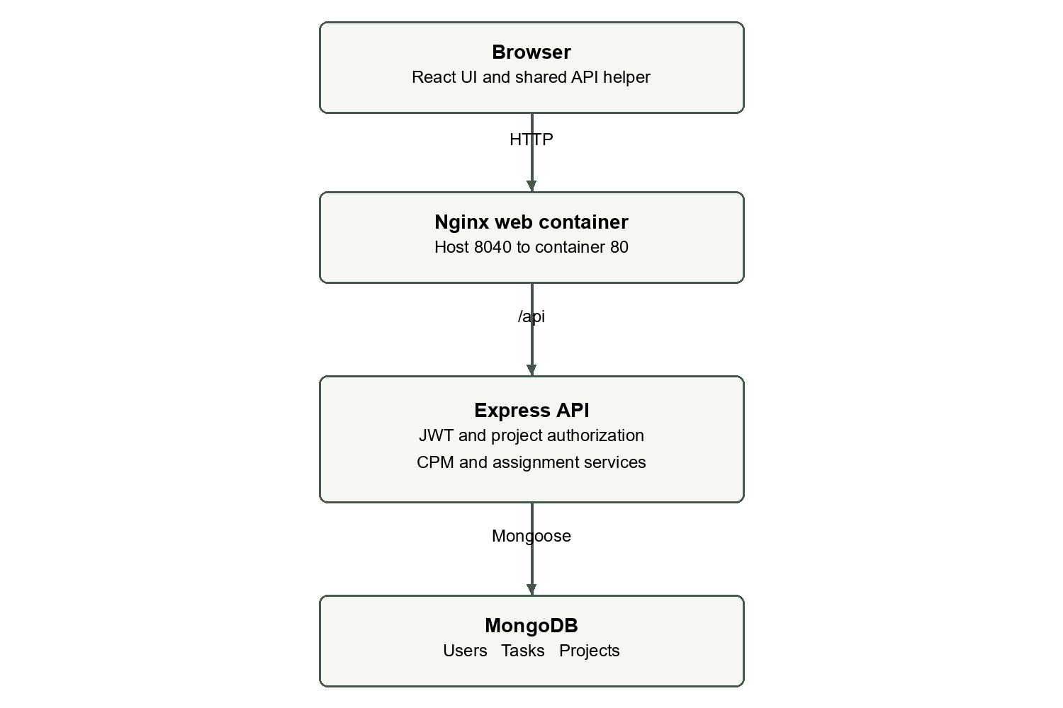
Fig. 3.1 Application Architecture

3.2 Logical data relationships
The User model represents an authenticated account. Personal tasks refer to their user. A project refers to its owner and embeds member and activity records. These two work areas are separate: a project activity is not automatically copied into My tasks.
Activities refer to other activities by stable string IDs within the same project. An assignment points to an embedded member ID. The controller validates these local references because Mongoose cannot treat a predecessor string as a cross-document foreign key.
Embedding supports whole-network validation and one-document persistence. It also avoids a collection and join process for every activity. The tradeoff is that project size is bounded and edits share the project document version.
Mongoose schemas describe document fields and options for persistence (Mongoose, n.d.). In ProdPilot, schema rules handle field shape while service rules handle graph properties. Both are required: a well-formed array can still contain a circular dependency.
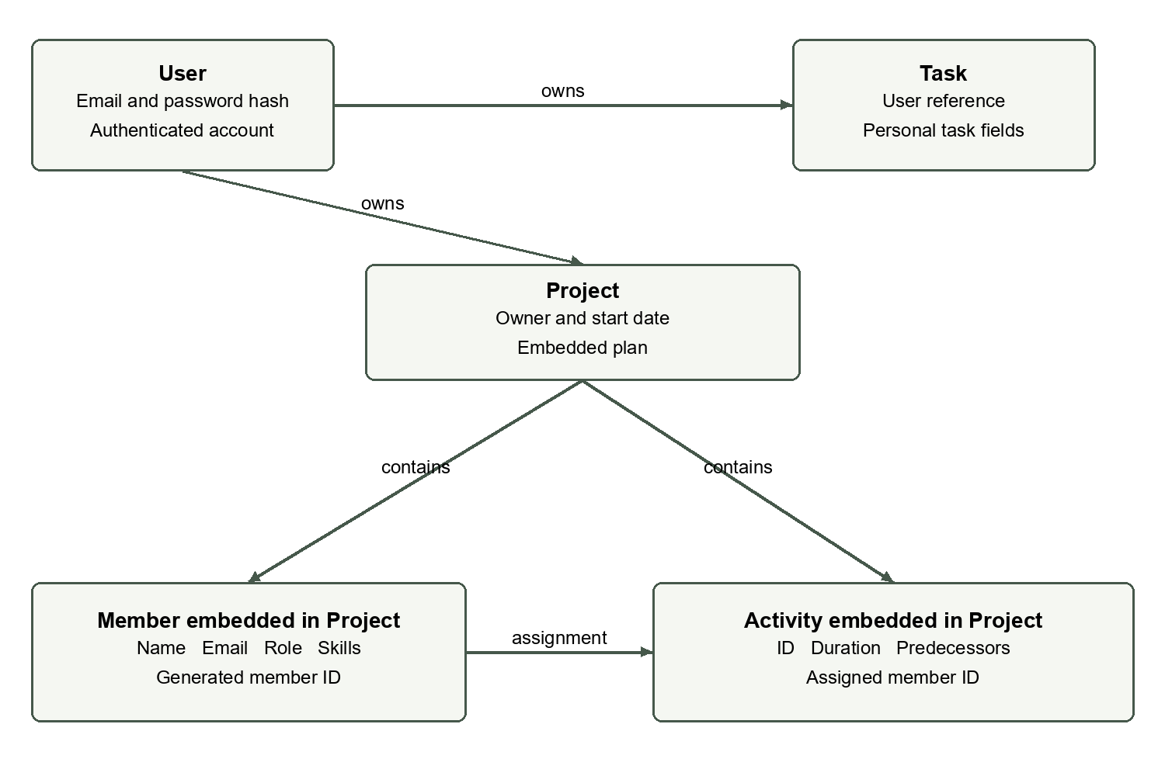
Fig. 3.2 Logical Data Model

3.3 Use cases and permissions
The project owner creates the project, edits its details, manages the team and controls activities. A Project Manager member can perform most planning changes. Only the owner can remove the entire project.
A project member can view the project, network and team. This supports shared visibility without giving every member editing rights. An unrelated authenticated user must not be able to retrieve the project by guessing its identifier.
Permissions are checked in stages. Authentication establishes the user. Accessible-project filtering loads only a project owned by the user or containing that user's email. A second check decides whether a change is allowed.
These rules apply equally to activity, member and assignment routes because they load the accessible parent project before operating on an embedded record. The structure prevents a child ID from becoming a route around parent-level authorization.
Table 3.1 Use Cases And Permissions
Operation | Owner | Project Manager | Member
View project and CPM | Yes | Yes | Yes
Edit project details | Yes | Yes | No
Create or edit activity | Yes | Yes | No
Manage project team | Yes | Yes | No
Preview or apply assignments | Yes | Yes | No
Delete whole project | Yes | No | No

3.4 Project update sequence
A planning update begins when the manager submits a form. The client sends only the relevant data to the project route. The server validates the JWT, finds the accessible project and checks whether the user can manage it.
The controller builds a candidate change in memory. It checks descriptive fields, member references and graph rules. The CPM service verifies the network before the model is saved. If validation fails, the request returns an error and the stored project remains unchanged.
On success, Mongoose saves the document with optimistic concurrency. The server then returns the project and CPM result. The browser updates its displayed data from this response instead of assuming the request succeeded.
This sequence matters when several fields affect the graph together. The bulk activities endpoint can validate an entire replacement network before saving it. A manager cannot use a partial replacement to leave missing predecessors in persistent data.
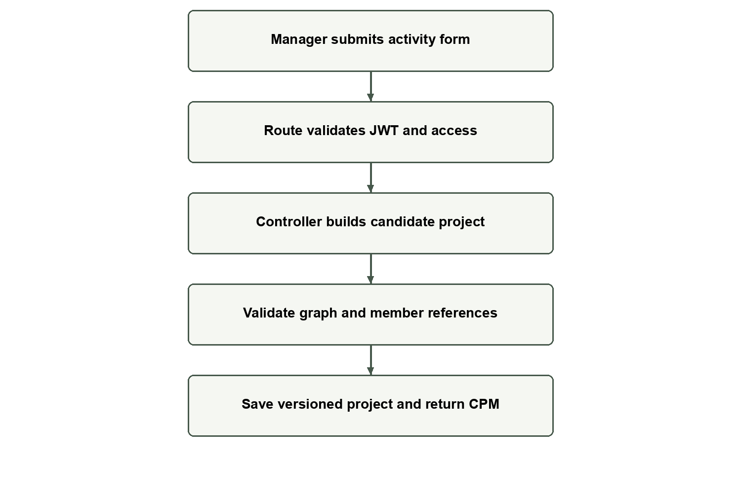
Fig. 3.3 Activity Update Sequence

3.5 Authentication and access filtering
The project feature uses the existing JWT authentication middleware. A valid token identifies the user making a request. Invalid or missing authentication is rejected before project handlers run.
The accessible-project condition is owner equals authenticated user ID, or members.email equals authenticated user email. Both list and detail lookups use this condition. The detail route combines the requested project ID with the access condition.
A manager check then permits the owner or a member whose role is Project Manager. Project deletion includes an additional owner check. Ordinary members cannot change activities even if they know the endpoint and send a direct request.
JWT is a token format defined by RFC 7519 (Jones et al., 2015). The existing implementation uses it for API authentication. Token use does not remove the need for record-level authorization, and it does not by itself provide encrypted browser storage or secure deployment.
accessible(user) = {
$or: [
{ owner: user.id },
{ 'members.email': user.email }
]
}
load Project by requested ID AND accessible(user)
then check manager permission for mutations

3.6 Graph validation
Validation starts by building a map from activity IDs to nodes. IDs must use allowed characters, remain unique and avoid the reserved START and FINISH names. Duration must be a finite non-negative number within the supported upper bound.
Each predecessor list must be an array of strings without duplicate entries. After all nodes have been mapped, every predecessor is checked against the map. This supports input that is not already in topological order while still rejecting missing references.
Cycle detection uses the number of nodes processed by topological sorting. If fewer nodes are processed than the graph contains, at least one dependency cycle remains. A separate traversal treats links in both directions to check that the activity network is connected.
The connectivity rule rejects unrelated islands. It does not require a single root or a single terminal. Branching and merging are valid as long as all stored activities belong to the same connected dependency network.
Table 3.2 Graph Validation
Invalid condition | Validation response
Repeated activity ID | Duplicate activity ID with the ID shown
Unknown predecessor | Activity and missing predecessor identified
Repeated predecessor | Duplicate predecessor message
Cycle | Circular dependency detected
Separate network island | Disconnected activities message
Negative or non-finite duration | Valid duration range explained

3.7 Topological ordering
The CPM service uses an indegree count for each node. Indegree is the number of immediate predecessors that have not yet been processed. Root activities begin with indegree zero and enter the processing order first.
When a node is processed, the service reduces the indegree of each successor. A successor is appended to the order when its indegree reaches zero. At that point, every predecessor already has an earliest finish value, so the forward pass can safely calculate the successor.
This is the purpose of topological ordering: dependency readiness, not alphabetical sorting. A project entered as F, C, A, B, E and D still calculates correctly if its links are valid. Activity labels only identify records.
The order is also used in reverse for the backward pass. The graph scan and the two scheduling passes are linear in the number of activities and predecessor edges. Enumerating many critical paths can be much larger, which is why the text preview is bounded separately.
map each activity by ID
count predecessors for each activity
queue all activities with count zero
for each activity in queue:
calculate its earliest times
reduce each successor count
append successor when count becomes zero
reject if processed count differs from node count

3.8 Forward pass
For a root activity, ES is zero. For any other activity, ES is the largest EF among its immediate predecessors. The maximum is necessary because every required predecessor must finish before the activity can start.
EF is found by adding the activity's duration to ES. Decimal durations use the same equation as whole-day durations. The calculation does not round 2.5 to 3 or remove a fractional result.
In CampusPay, H depends on E and F. E finishes at day 17, and F finishes at day 21. Therefore H starts at day 21 and finishes at day 25. Starting H at day 17 would ignore the unfinished mobile branch.
The forward pass also records a level for display. A root is at level one, and each successor is one level beyond the largest predecessor level. This is a graph-layout helper, not a calendar start date or a duration-based horizontal scale.
$ES(i) = max \{ EF(p) : p is a predecessor of i \}$ (Eqn. 3.1)
$EF(i) = ES(i) + duration(i)$ (Eqn. 3.2)
Table 3.3 Forward Pass
Activity | Predecessor EF values | ES | EF
A | None | 0 | 3
D | A = 3 | 3 | 11
E | D = 11 | 11 | 17
F | C = 12 | 12 | 21
H | E = 17, F = 21 | 21 | 25

3.9 Project duration and final activities
An activity is final when no other activity lists it as a predecessor. The project duration is the maximum earliest finish among all final activities. A short final branch does not end the project while another final branch remains unfinished.
CampusPay has two final activities, K and M. Both finish at day 37. The common FINISH node therefore represents day 37, and both final connections are critical.
START and FINISH simplify the drawing and path representation. Every root has an incoming START connection, and every final activity has an outgoing FINISH connection. Their connections do not change the stored predecessor lists or add extra work.
An empty draft has duration zero and a noncritical START-to-FINISH edge. Once an activity is added, its duration and links determine the output. This makes a newly created project viewable without requiring placeholder activities.
$Project duration = max \{ EF(t) : t is a final activity \}$ (Eqn. 3.3)
Table 3.4 Project Duration And Final Activities
Final activity | EF | Result
K Production Deployment | 37 | Reaches project finish
M Team Training and Handover | 37 | Reaches project finish
Project duration | max(37, 37) | 37 days

3.10 Backward pass
The backward pass begins with final activities. Their LF equals the calculated project duration. LS is LF minus duration. The service then moves backward through the topological order.
For a non-final activity, LF is the smallest LS among its immediate successors. The minimum is necessary because the predecessor must finish in time for every successor that depends on it. Finishing in time for only the latest successor would delay an earlier one.
For D, the successors are E and G. E has LS 15, while G has LS 22. D must finish by day 15, so its LS is 7 after subtracting its eight-day duration. Its early start is day 3, leaving four days of float.
The project deadline used here is the forward-pass duration. A user-entered target completion date is not part of the calculation. This avoids mixing a requested date with the network's earliest feasible finish.
$LF(i) = min \{ LS(s) : s is a successor of i \}$ (Eqn. 3.4)
$LS(i) = LF(i) - duration(i)$ (Eqn. 3.5)
Table 3.5 Backward Pass
Activity | Successor LS values | LF | LS
K | Final | 37 | 35
M | Final | 37 | 35
J | K = 35, M = 35 | 35 | 31
D | E = 15, G = 22 | 15 | 7

3.11 Float and decimal precision
Total float is LS minus ES. It can also be calculated as LF minus EF. An activity with float zero has no delay allowance under the current dependency schedule. A positive value describes how far that activity can move while preserving the calculated project finish, subject to the rest of the network.
JavaScript numbers use binary floating-point representation. A calculation such as 0.1 plus 0.2 may contain a small representation error. The service cleans arithmetic output to 15 significant digits and uses a scale-aware comparison near zero when classifying criticality.
This handling is intended to remove arithmetic noise, not to turn a genuine small positive float into zero. Fractional durations and fractional float remain numeric results. Tests include decimals and very small values.
The summary's totalFloat is the sum of all activity floats. In CampusPay it is 39 days. This is a descriptive total, not an extra 39 days that can be added to the project deadline. Shared dependencies mean activity allowances cannot be spent independently.
$Float(i) = LS(i) - ES(i) = LF(i) - EF(i)$ (Eqn. 3.6)
Table 3.6 Float And Decimal Precision
Activity | ES | LS | Float
D | 3 | 7 | 4
E | 11 | 15 | 4
G | 11 | 22 | 11
L | 12 | 32 | 20
Sum | — | — | 39

3.12 All critical paths
A critical path must follow actual dependency links from START to FINISH. Marking zero-float nodes is necessary, but it is not sufficient to mark every edge between those nodes. A critical edge must also be tight: the predecessor's EF must equal the successor's ES.
This condition prevents a redundant shortcut from being highlighted when it does not control the successor's start. The server calculates critical edges explicitly, and the drawing uses those flags. It does not infer critical edges from green endpoint nodes alone.
The service builds the critical-edge graph and counts complete paths using dynamic programming with BigInt. It returns the exact count as a string so JSON serialization does not lose integer precision. A depth-first walk lists up to the first 1000 paths for readable display.
The graph and count still represent all critical paths when the text list is truncated. The pathsTruncated field signals this limit. In the six-activity case and CampusPay, only two paths exist, so both are fully listed.
critical edge u -> v requires:
u.float == 0
v.float == 0
u.EF equals v.ES within numeric tolerance
count(FINISH) = 1
count(u) = sum(count(v) for critical successors v)
return exact count(START) and bounded path preview

3.13 Network layout
The network layout uses the topological levels from CPM. START is placed before the first activity column, and FINISH after the last. Nodes have consistent dimensions so the labels and six timing fields use a predictable layout.
Critical activity chains receive the main visual emphasis. Noncritical branches use separate lanes below the main chain. A branch keeps its lane until it reaches its merge point, reducing unnecessary movement between rows.
For CampusPay, D, E and G form the backend and security branch, while L carries documentation toward M. Their routes must remain readable even though the critical mobile branch controls H. The layout helper reserves lane space through the branch span rather than simply placing every column independently.
The graph is a dependency network, not a time-scaled chart. A long-duration node is not wider than a short-duration node. Position communicates dependency order; the printed duration and timing values communicate time.
Table 3.7 Network Layout
Layout item | Implementation choice
Node size | 220 by 120 SVG units
Column spacing | 320 SVG units
Row spacing | 180 SVG units
Main emphasis | Critical chains
Other branches | Reserved lanes through merges
Long network | Horizontal scrolling container

3.14 Connections and accessibility
Connections use rounded orthogonal segments and arrowheads. Separate ports and tracks reduce overlap where one activity branches to several successors or several predecessors merge into one node. Long shortcut links can use an outer routing track.
Green nodes and arrows identify critical work. Noncritical links use a muted blue-gray stroke with enough contrast to remain visible. START and FINISH have a distinct endpoint appearance. Criticality is also stated in text, so users do not need to rely only on color.
The SVG includes descriptive labels and titles. Each activity exposes its title, duration and timing values. A separate HTML table repeats the numbers in a conventional reading order. This also helps users inspect a wide graph on a small screen.
The current layout is suitable for modest project networks. It is not a general graph-editing canvas. Dense graphs may still require scrolling and careful reading; the size limit and timing table make this constraint explicit.
Table 3.8 Connections And Accessibility
Need | UI response
Recognize critical work | Green styling plus CRITICAL text
Follow other branches | Visible contrast and consistent lanes
Read full activity name | Accessible node title and timing table
Explore wide graph | Scrollable network region
Compare numeric output | HTML table below graph

3.15 Manual assignment
Manual assignment is part of the activity editor. The manager selects a project member or chooses Unassigned. The saved value is the member's ID, while the activity table displays the member's name.
The server confirms that the selected member belongs to the same project. A valid-looking ID from another project is not accepted. This preserves the relationship between the activity and its own team.
Deleting a team member clears that member's assignments. It does not delete the activities or silently assign them to another person. The manager can then choose a replacement. This behavior avoids orphaned assignment references.
Assignments do not control project access by themselves. Access comes from owner or member email, while an assignment describes responsibility for work. Similarly, a member's skill profile does not grant manager rights unless their role is Project Manager under the current permission model.
Table 3.9 Manual Assignment
Action | Saved effect
Choose team member | assignedMember set to member ID
Choose Unassigned | assignedMember becomes null
Delete member | Their activity assignments cleared
Edit member name | Assignments retain the same member ID
Unknown member ID | Request rejected before save

3.16 Deterministic assignment design
Auto Assign ranks members using simple phrase matching. Text is converted to lowercase tokens, with punctuation handling that retains useful skill names such as Node.js. Explicit requirements have more weight than incidental mentions in a title or description.
A matching required skill adds ten points, and a matching required role adds eight. A member skill mentioned in the activity text adds three points. A role mentioned in the activity text adds two. Candidates with score zero are not suggested.
If scores are equal, the service prefers the lower current assignment count, then a stable member-ID order. The suggested member's load is increased while processing later suggestions. This makes the result repeatable and avoids random selection.
The score is a matching heuristic, not an assessment of competence. It does not know availability, experience level or contractual restrictions. The preview explains matching reasons, and the manager can change the member before applying assignments.
Table 3.10 Deterministic Assignment Design
Match | Points
Required role phrase in member role | 8
Each required skill in member skills | 10
Each member skill mentioned in activity text | 3
Member role mentioned in activity text | 2
No positive match | Leave unassigned

3.17 Import design
The client accepts small CSV and JSON team files. CSV has headers name, email, role and skills. Skills containing commas must be quoted, or they can be separated with semicolons. The parser handles quoted fields and escaped quote characters.
JSON uses an array of member objects. The skills value can be an array or a string that is normalized for the member form. The import preview allows the manager to inspect records before adding them to the project.
The file size is limited to 100 KB, and the project allows up to 200 members. The server validates the resulting records and rejects duplicate emails. The import is one change, so a rejected batch does not partly add members.
TXT parsing is not implemented. Supporting CSV and JSON provides a clear structured starting point without adding a large dependency. A future format adapter could produce the same member objects and reuse the existing preview and API validation.
name,email,role,skills
Arun,arun@example.com,Developer,"React,Node.js,MongoDB"
[
{"name":"Arun","email":"arun@example.com",
"role":"Developer",
"skills":["React","Node.js","MongoDB"]}
]

3.18 Alternatives and tradeoffs
Separate activity collections could support independent activity queries and larger projects. The current embedded model is simpler for bounded plans and makes whole-network validation easier. A later migration would need to preserve access checks and atomic network integrity.
A graph library could provide dragging and zooming, but those capabilities are outside the present scope. SVG keeps the dependency cost small and allows exact control over node content. The tradeoff is that layout and routing rules must be maintained in the application.
An external language model could infer skills from free text. The deterministic service is cheaper to run, easier to test and does not transmit team data to an AI service. Its limitation is that synonyms and weakly described requirements may not match well.
Calendar-aware and resource-aware scheduling would be useful for operational planning. They are separate calculation problems and would change the interpretation of ES and EF. Keeping the current CPM method explicit is preferable to implying those features already exist.
Table 3.11 Alternatives And Tradeoffs
Decision | Benefit | Tradeoff
Embedded project plan | Whole-network save | Bounded document size
SVG without graph library | Small dependency footprint | Custom layout maintenance
Phrase-based suggestions | Repeatable and explainable | Limited semantic matching
Numeric day offsets | Simple CPM verification | No work calendar
Derived timings on load | No stale stored timing fields | Recalculation per response

CHAPTER 4
SCHEDULE TASKS AND MILESTONES

4.1 Development work breakdown
The work can be organized around the existing application's layers. First, identify authentication and task patterns. Then add project storage and routes, implement calculation services, connect forms and tabs, and verify behavior with both small and realistic networks.
This breakdown is a practical implementation plan rather than a record of dated sprints. The repository includes sample Agile documents, but those examples do not establish that every listed meeting or sprint took place.
The CPM service is a separate work package because its correctness can be tested before the graph is drawn. Assignment and import logic are also kept separate so changes to one feature do not require rewriting the planning engine.
The integration stage connects saved project data to the client and keeps the old task functionality in scope for regression checks. The final stage prepares the demonstration dataset and report evidence.
Table 4.1 Development Work Breakdown
Work package | Main output | Completion check
Existing code review | Reuse map | Auth and task patterns identified
Project API | Model and protected routes | CRUD and access tests
CPM service | Timings and critical graph | Numerical examples pass
Project UI | Forms and tabs | Saved data visible
Assignment and import | Preview and apply flow | Matching and parsing tests
Network layout | Readable branches | Layout regression test
Verification | Tests, build and screenshots | Evidence recorded

4.2 Proposed milestone sequence
Milestones should be defined by verified outputs rather than by a list of files alone. A model file is not enough for an API milestone if unauthorized users can still read a project. A graph component is not enough for the visualization milestone if its edges disagree with the calculation.
The proposed sequence below places mathematical correctness before visual refinement. It also places the production build and regression checks before the showcase. This reduces the risk of demonstrating only a development-server path that fails in the container build.
Each milestone has an observable acceptance condition. The sequence is reusable for future revisions of the project, but no historical completion dates are assigned here. The verified local test and build date is recorded in Chapter 6.
Changes to the network layout should be followed by the CampusPay regression case because it has both short and long noncritical branches. Changes to permissions should be followed by owner, manager, member and unrelated-user checks.
Table 4.2 Proposed Milestone Sequence
Milestone | Acceptance condition
M1 Existing system understood | Login and tasks located and preserved
M2 Project persistence ready | Accessible project CRUD works
M3 CPM ready | Integer, decimal and multiple-path cases pass
M4 Team allocation ready | Manual and suggested assignments validated
M5 UI ready | Tabs and network show saved results
M6 Verification ready | Tests and production build pass
M7 Showcase ready | Correct dataset and report screenshots available

4.3 Task dependencies in implementation
Implementation tasks also have dependencies. Project forms need a stable API shape. A network component needs a reliable CPM response. Integration tests need the model, routes and a running database. These dependencies help choose the order of work.
Some tasks can be developed independently. The role matcher can be tested with plain JavaScript objects, and the import parser can be tested with file text. Neither requires a completed SVG graph. Keeping these modules separate supports focused tests.
The graph layout depends on calculated levels and critical flags, but it should not depend on user-specific permissions. Permission flags decide whether controls are visible; they do not change the numerical schedule or positions of activities.
A dependency-aware work plan avoids using temporary assumptions as final API behavior. For example, a graph should not hard-code a single critical path while the service is still being designed to return several paths.
Table 4.3 Task Dependencies In Implementation
Task | Depends on | Reason
Activity UI | Project API | Needs saved activity response
Network drawing | CPM output | Needs timings and critical edges
Manual assignment | Member records | Needs valid local member IDs
Auto Assign preview | Matching service | Needs scores and reasons
Integration tests | API and MongoDB | Needs real persistence
Showcase screenshots | Running production services | Needs actual saved UI

4.4 Agile workflow
A small backlog can keep project work clear without creating a large process overhead. Each feature should have a user-facing purpose and a testable acceptance condition. Examples include adding a decimal duration, rejecting a cycle and showing every critical path.
The repository contains Agile guidance and sample artifacts. They can be used as a planning format, but sample burndown numbers and sprint review text should not be reported as measured project history. Evidence should come from actual tests, changes and demonstrations.
The Scrum Guide describes a backlog and inspection-based workflow (Schwaber & Sutherland, 2020). For this project, the useful practice is to work in small increments and verify each change against a clear condition. The report does not claim a formal Scrum team or a completed sequence of ceremonies.
Before a review, prepare a valid graph and an invalid edit to demonstrate both the main output and the safety checks. Feedback on branch readability should be converted into a reproducible layout case rather than a one-time visual adjustment.
Table 4.4 Agile Workflow
Backlog item | Acceptance condition
Decimal duration | 2.5 saved and used without integer rounding
Multiple predecessors | Merge ES uses maximum predecessor EF
Circular dependency | Save rejected with visible message
Noncritical routing | D, E, G and L remain traceable
Assignment preview | No persistence until Apply
Task regression | Personal task operations remain valid

4.5 Risks and mitigation
The most direct risk is an incorrect dependency network. A manager may omit a predecessor or link the wrong activity. Structural validation catches missing IDs and cycles, but it cannot know the intended business relationship. The manager must review the network against the real work plan.
Another risk is confusing total float with free float or with extra project time. The interface includes a warning, and the report interprets the values in context. A sum of floats is not a new project duration.
Concurrent edits can produce lost updates if the server saves an old document over a newer one. Optimistic concurrency detects this situation and asks the user to reload. It does not merge two different network edits automatically.
Demonstration risks include occupied ports, stopped containers and an empty account. The local web port is 8040, and the saved CampusPay project provides the planning data. The showcase account now has three personal demonstration tasks, two pending and one completed. These records remain separate from the thirteen project activities.
Table 4.5 Risks And Mitigation
Risk | Mitigation
Wrong but valid dependency | Manager review of arrows and predecessors
Cycle or missing predecessor | Server rejection before save
Float misinterpretation | Clear definition and summary warning
Competing edits | Version conflict and reload
Wide or dense graph | Scrolling plus timing table
Stopped services or port conflict | Check Compose state and host mappings

4.6 Showcase preparation
The faculty demonstration should follow a short route through the application. Begin with the Projects list and open CampusPay. Explain the start date and activity count before moving to the team and assignment fields.
Use H to show multiple predecessors, because it depends on both E and F. Use the Network / CPM tab to explain why F, rather than E, controls H's early start. Then show the two final critical branches from J through K and M.
The invalid-dependency demonstration should be performed carefully. Adding M as a predecessor of A creates a cycle and should be rejected. Since a rejected edit is not saved, the valid project can remain available for the main showcase.
Before presenting, check the numerical examples and keep the report open to the matching result tables. Do not describe deterministic matching as a generative AI service or claim that the schedule accounts for staffing constraints.
Table 4.6 Showcase Preparation
Demo step | Point to explain
Project overview | 13 activities, 9 members and 37 days
Team | Project-specific roles and skills
Activity H | Merge of E and F
Activity editor | Manual assignment remains available
Network | Critical nodes and noncritical branches
Path list | K and M are parallel final alternatives
Invalid link | Validation protects the saved graph

CHAPTER 5
IMPLEMENTATION

5.1 Backend module organization
Project planning follows the backend's existing route, controller and model structure. Project routes apply authentication and load the parent project before exposing details or changes. The controller handles permitted fields and persistence.
The CPM service is a pure function that accepts activities and returns derived results. It does not read the database. This allows numerical validation with simple fixtures and makes the scheduling behavior easier to test independently.
The assignment service is also independent from Express. It accepts activities and members and returns suggestions. The controller exposes those suggestions without saving them, while a separate assignments route applies reviewed selections.
Keeping these roles separate avoids a large controller containing both graph traversal and request handling. The structure remains small enough to follow during a project review.
Table 5.1 Backend Module Organization
Module | Responsibility
models/Project.js | Project, activity and member schemas
routes/projectRoutes.js | Protected routes and manager checks
controllers/projectController.js | Access, validation and save flow
services/cpm.js | Graph validation and schedule results
services/assignment.js | Deterministic candidate ranking
middleware/auth.js | Existing JWT verification

5.2 Project and activity endpoints
The API exposes project collection routes for listing and creation. Detail routes operate on the accessible parent project. A successful detail or change response includes the calculated schedule, which the UI can render immediately.
Activities can be added individually, edited by ID or removed. A bulk replacement endpoint accepts a complete graph. Bulk replacement is useful for importing a valid multi-root network that cannot be built through a series of temporarily disconnected saves.
Deletion of an activity is rejected when a successor still names it as a predecessor. The manager must first remove or replace those dependencies. This rule prevents silent changes to the meaning of downstream activities.
The endpoint table uses /api/projects as its base. Every route requires authentication; mutation routes additionally require project management permission. Deleting the whole project is restricted to its owner.
Table 5.2 Project And Activity Endpoints
Method | Path | Operation
GET | /api/projects | List accessible projects
POST | /api/projects | Create owned project
GET | /api/projects/:id | Read project and CPM
PUT | /api/projects/:id | Edit project details
DELETE | /api/projects/:id | Owner deletes project
POST | /api/projects/:id/activities | Add activity
PUT | /api/projects/:id/activities | Replace complete activity graph
PUT | /api/projects/:id/activities/:activityId | Edit one activity
DELETE | /api/projects/:id/activities/:activityId | Delete unreferenced activity

5.3 Team and assignment endpoints
A member can be added individually or in a batch. The batch format is used by team import after parsing and preview. Editing retains the member ID so existing assignments continue to refer to the same record.
Auto Assign is a preview operation. It returns suggested member IDs, matching scores and reasons for activities that are unassigned. It does not write assignments. The client lets the manager change selections before sending the apply request.
The apply route checks activity IDs and member references against the loaded project. A reviewed assignment can also be cleared by using a null member. Suggestions are therefore a convenience layer over the same manual assignment model.
Member deletion removes the member and clears related assignment references in one project save. Duplicate member emails and assignments to unknown members are rejected before persistence.
Table 5.3 Team And Assignment Endpoints
Method | Path suffix after /api/projects/:id | Operation
POST | /members | Add member or member batch
PUT | /members/:memberId | Edit member profile
DELETE | /members/:memberId | Remove member and clear assignments
POST | /auto-assign | Return suggestion preview
PUT | /assignments | Apply reviewed assignment batch

5.4 Validation and error handling
Validation errors use HTTP 400 with readable messages. Missing accessible projects return 404, and users without change permission receive 403. A competing saved version produces 409 and a message asking the user to reload.
The controller validates activity names and optional dates in addition to the graph. The graph service validates IDs, durations and dependencies. Schema validation adds length and enum checks when the document is saved.
The browser displays API errors near the relevant form or view. The user can correct input without needing to inspect server logs. The request does not silently repair a missing predecessor or turn a negative duration into zero.
The user should keep IDs stable and use immediate predecessors. If an activity is no longer needed, remove references to it before deleting it. A rejected save leaves the previous valid project available.
Table 5.4 Validation And Error Handling
Status | Meaning | User action
400 | Invalid input or graph | Correct fields or relationships
401 | Authentication required or invalid | Sign in again
403 | Insufficient permission | Use an owner or manager account
404 | Accessible project or record not found | Check project access and identifier
409 | Concurrent project change | Reload before editing again

5.5 Frontend organization
ProjectsPage handles the project list and the selected project's tabs. It uses the existing AppLayout navigation and the shared API helper. ProjectForm handles descriptive project fields without replacing the original task form.
CPMNetwork receives the calculated result and renders summary cards, the SVG network, critical path text and the timing table. The networkLayout helper chooses node coordinates and connection paths separately from the React component.
Member import parsing is kept in a small utility module. This allows the parser to be tested using text samples and gives future formats a clear place to normalize input before preview.
The existing styles are extended with project and network rules. The feature retains the application's typography, colors and form behavior. The build remains a Vite production build, rather than a separate application bundle or another frontend framework.
Table 5.5 Frontend Organization
Client module | Role
pages/ProjectsPage.jsx | List, details, tabs and project actions
components/ProjectForm.jsx | Create and edit project metadata
components/CPMNetwork.jsx | CPM summary, SVG and timing table
utils/networkLayout.js | Node lanes and edge routing
utils/memberImport.js | CSV and JSON normalization
api.js and App.jsx | API calls and authenticated routing
styles.css | Existing visual style and project additions

5.6 Activity editor behavior
The activity editor collects a stable ID, name, description and decimal duration. A multiple-selection predecessor control supports branches and merges. The current activity is excluded from its own predecessor choices, while the server still checks the complete graph for indirect cycles.
The assigned-member control lists the project's team. Required role and skills can be entered for matching. Status is selected from pending, in progress and completed. Optional start and end dates remain descriptive fields.
The editor explains that CPM depends on duration and predecessors. This prevents a user from assuming a selected calendar date will force the early-start calculation. Required data is validated in the browser where practical and on the server before save.
Editing an activity returns fresh project and schedule data. The user does not need to update the Network tab manually. Closing or cancelling the editor without saving leaves the stored activity unchanged.
Table 5.6 Activity Editor Behavior
Control | Planning purpose
Activity ID | Reference used by predecessor links
Duration | Fractional day estimate
Predecessor selector | Immediate dependencies
Assigned member | Manual responsibility selection
Required role and skills | Auto Assign matching input
Status and optional dates | Descriptive progress information

5.7 Consistency and concurrency
The project document is saved only after its candidate state has passed validation. This means a member removal, assignment change or activity update is checked against the complete resulting project, not only against the edited field.
Optimistic concurrency uses the document version to detect a save based on an older state. If another session changes the project first, the second save is rejected with a conflict message. The user must reload and decide how to reapply their edit.
This is different from automatic merging. Two dependency edits may be individually sensible but invalid when combined. A reload requirement is a safer simple behavior than guessing how to merge graph changes.
CPM is derived from the accepted state. The response after save contains a fresh calculation. Because ES, EF, LS and LF are not independent editable database fields, the interface cannot save a duration alongside an old manually entered timing result.
Table 5.7 Consistency And Concurrency
Situation | Implemented behavior
Invalid candidate graph | Reject before save
Unknown assigned member | Reject before save
Member removed | Clear their assignments before save
Activity still referenced | Reject activity deletion
Competing document versions | 409 conflict and reload message
Successful change | Return recalculated CPM

5.8 Preserving task functionality
Personal tasks remain separate from project activities. The existing task endpoints continue to use the authenticated user's ID. Their fields and dashboard statistics are not replaced by CPM values.
This separation avoids changing the meaning of an existing completed-task count. A project containing thirteen pending activities does not automatically create thirteen personal tasks or change the demo account's dashboard totals.
The UI keeps Dashboard and My tasks in the main navigation. Projects is an additional destination. The same sign-in flow gives access to all three areas, while their underlying data and actions remain distinct.
Regression tests create and modify personal tasks and check user isolation and statistics. The screenshots show three personal tasks, including a completed example and two pending reminders. The project still has thirteen activities; changing a personal task does not change those planning records.
Table 5.8 Preserving Task Functionality
Existing behavior | Preserved relationship
Task create and edit | Owned by authenticated user
Task delete | Restricted to task owner
Pending and completed filters | Personal task status
Dashboard statistics | Personal task totals
Project activities | Separate embedded project records
Authentication | Shared existing JWT flow

5.9 Build and deployment configuration
The client Dockerfile builds the Vite app and copies the output into Nginx. The server Dockerfile installs production server dependencies and runs the API. Compose starts the database, API and web services together.
The package scripts provide backend tests and a frontend production build. The repository also contains GitHub Actions workflows for checks and deployment. Workflow configuration is evidence of the intended process, not proof that a remote run or cloud deployment occurred.
The local verification used the existing Compose services. The web application responded at port 8040, the server connected to MongoDB and the production frontend build succeeded. The report's UI images were captured from this running local application.
The configured cloud deployment route would require separate secrets, host access and operational checks. The project can be demonstrated locally without using that route. Passwords, tokens and deployment secrets are not included in this report.
pnpm test
pnpm build
docker compose up -d
docker compose ps
Local showcase URL:
http://localhost:8040

CHAPTER 6
IMPLEMENTATION RESULTS AND SCREENSHOTS

6.1 Verification method and results
Verification combined pure service tests, API integration tests with MongoDB, a production client build and inspection of the running interface. The local verification date was 10 October 2026.
The backend command completed with 22 tests passed, zero failed and zero skipped. The integration suite ran with TEST_MONGO_URI pointing to the local MongoDB service. This distinction matters because those tests can be skipped when the database variable is absent.
The frontend production build completed successfully through Vite. The browser login succeeded, and the CampusPay project showed thirteen activities, nine members, a 37-day duration and two critical paths. The screenshots in this chapter show that saved state.
These results establish the tested local behavior. They do not establish cloud availability, high-load performance or complete security coverage. No load-test throughput, user study score or remote deployment success is claimed.
Table 6.1 Verification Method And Results
Verification | Observed result
Backend suite with MongoDB | 22 passed, 0 failed, 0 skipped
Frontend production build | Successful
Local web address | HTTP 200 at localhost:8040
Sign-in | Demo account authenticated
CampusPay overview | 13 activities, 9 members, 37 days
Network result | Two critical paths displayed

6.2 Test coverage
The automated suite covers mathematical results and API behavior. Pure CPM tests check the integer example, decimal timing, invalid networks and critical-path handling. Assignment tests check matching, preservation of existing assignments and unmatched activities.
Integration tests use the real database to check authentication, project persistence, member roles, assignment, validation and personal-task regression. This is more useful than only checking that route functions return a success code without saving data.
The network-layout test uses CampusPay to guard the noncritical branch behavior. It checks layout properties for D, E, G and L so a later visual change is less likely to place branches on conflicting lanes.
Browser inspection complements these assertions by checking labels, figures and saved data. The numerical examples below show expected and obtained scheduling values in a form that can be reviewed independently of the interface.
Table 6.2 Test Coverage
Test area | Cases checked
CPM | Two critical paths, decimals and precision
Invalid networks | Duplicates, missing references, cycles and islands
Assignments | Skill match, manual choice and preserved assignment
Imports | CSV and JSON parsing and invalid batch behavior
Authorization | Owner, manager, member and unrelated user
Tasks | CRUD, ownership and dashboard statistics
Network layout | CampusPay noncritical lane regression
Health | Health route and unknown route

6.3 Login screen
The login screen is the existing entry point for authenticated features. It retains the ProdPilot branding, email and password fields, and account creation link. A successful sign-in sends the user to the authenticated dashboard.
The screenshot was captured before entering the demo credentials. It therefore shows the form without exposing a password or token. The subsequent login was successful in the local browser session.
Project routes use the same authentication flow as personal tasks. Users do not need a second project-specific login. The project access rules are applied after authentication, so a valid account still cannot read an unrelated project.
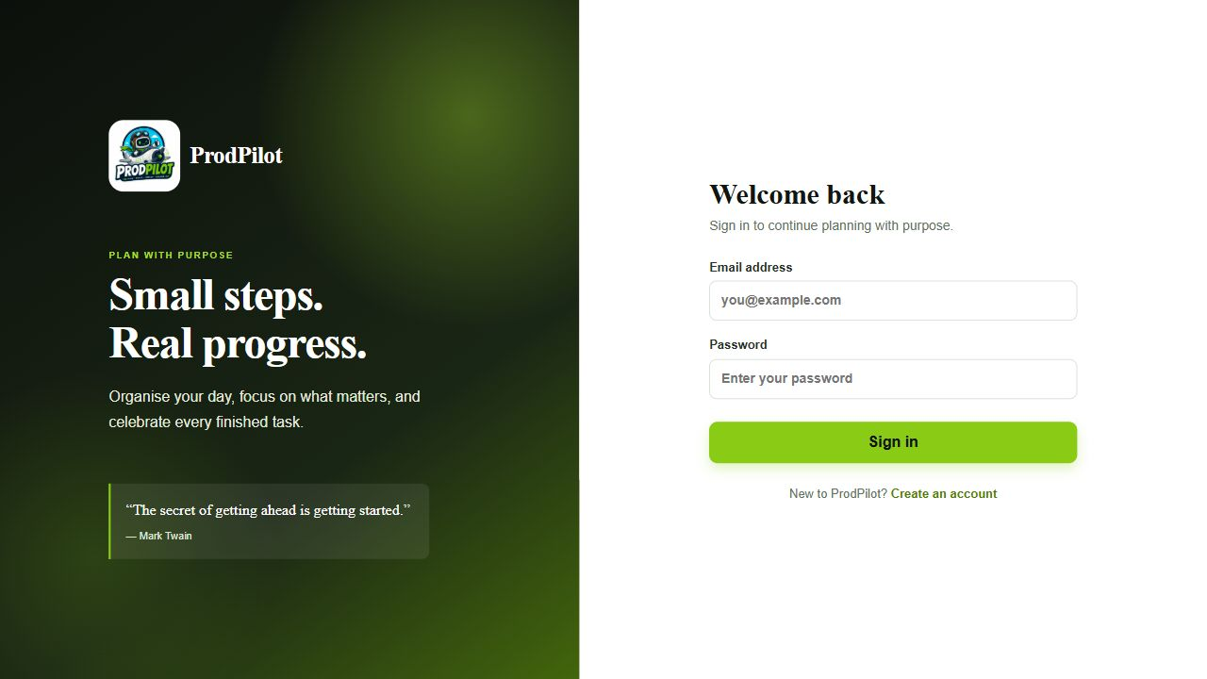
Fig. 6.1 ProdPilot Login Screen

6.4 Dashboard screen
The dashboard summarizes personal tasks rather than project activities. The updated showcase has three personal tasks: two pending and one completed. The progress display shows 33 percent complete and one of three tasks finished.
The sidebar includes Dashboard, My tasks and Projects. The Up next area shows the two pending tasks, including the high-priority preparation reminder. The completed decimal-example task is counted in the summary but is not listed as pending work.
The screenshot was captured after creating the tasks and marking one complete in the running application. It provides visible evidence that the existing task workflow still updates dashboard statistics. The thirteen CampusPay activities remain separate and pending; the 33 percent value is not project completion.
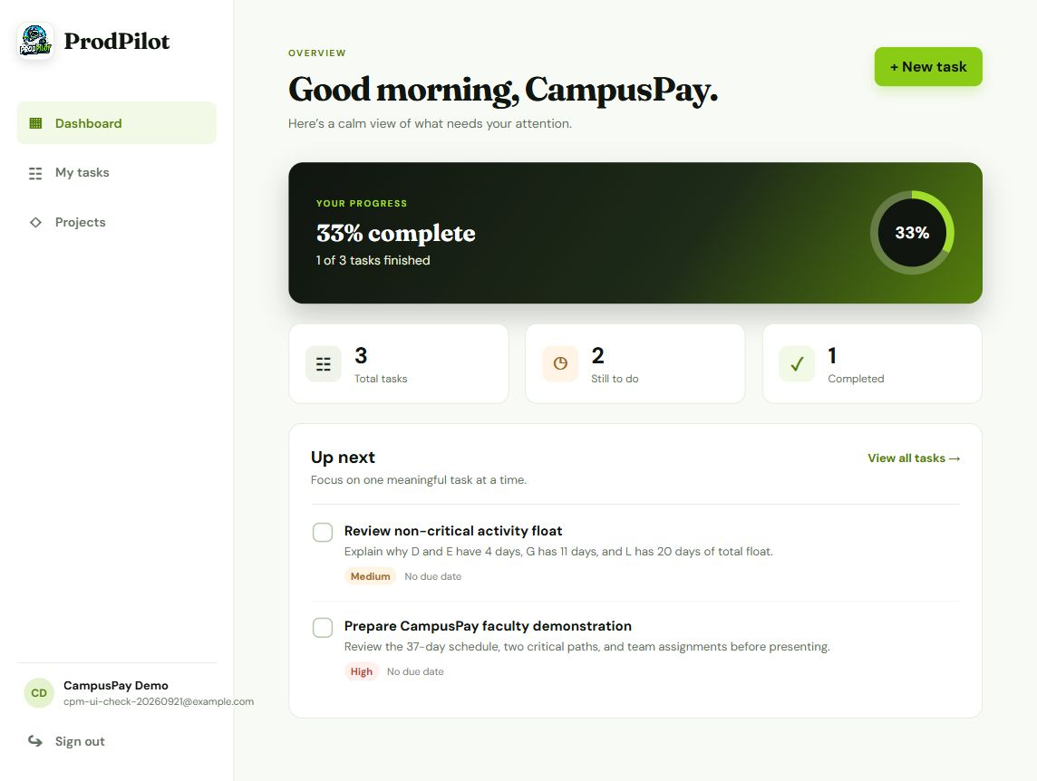
Fig. 6.2 Authenticated Dashboard

6.5 All tasks view
The All filter shows both pending and completed personal tasks in one list. The screenshot contains three showcase tasks: preparing the faculty demonstration, reviewing noncritical float and verifying the decimal CPM example.
The first two tasks are pending. The decimal-example task has a checked completion control and a crossed-out title. The counters read All 3, Pending 2 and Completed 1. All is selected, so the visible list includes records from both status groups.
Edit and Delete controls remain available on each task. The completion control can return a completed task to pending. These are personal reminders for the signed-in account and do not change the project activities or recalculate the CPM schedule.
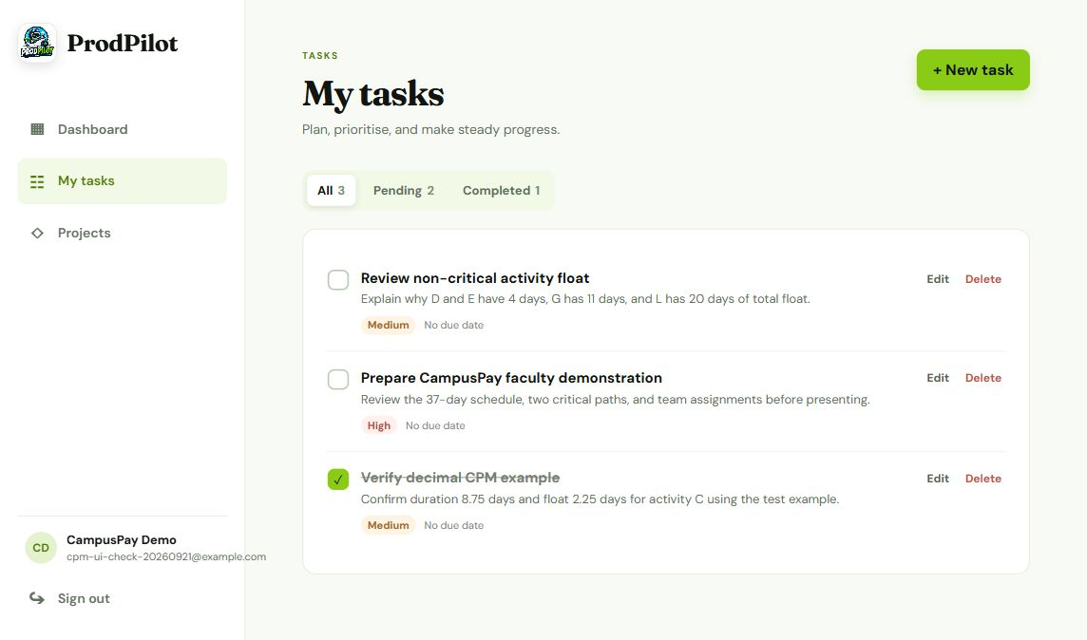
Fig. 6.3 My Tasks All Filter with Three Tasks

6.6 Adding a new task
The New task button opens the existing creation form. A user enters a title, an optional description, a priority and an optional due date. The screenshot shows the form filled before submission with Prepare CampusPay faculty demonstration and High priority.
The description gives a specific action: review the 37-day schedule, both critical paths and the team assignments. The due date is left blank because it is optional. Add task submits the record; Cancel closes the form without creating it.
After Add task was selected, the reminder appeared in My tasks and the task count increased. Two more showcase records were then created through the same form. This is a real task-creation capture, not a mock screen. The application stores these records under the authenticated demo account.
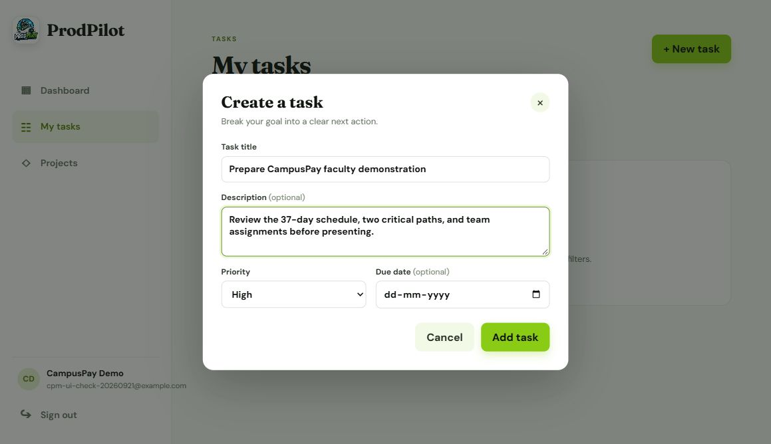
Fig. 6.4 New Task Form Before Submission

6.7 Pending tasks view
Selecting Pending limits My tasks to unfinished records. The screenshot shows Review non-critical activity float and Prepare CampusPay faculty demonstration. Their unchecked completion controls show that work is still pending.
The tab counters remain All 3, Pending 2 and Completed 1. Switching the filter changes the list without deleting data. The completed decimal-example task is absent from this view but remains available through All or Completed.
A user can mark either reminder complete using its completion control. In this verification, both were left pending to keep a clear faculty demonstration. The descriptions explain the schedule and float values to review, while task priorities support personal work planning.
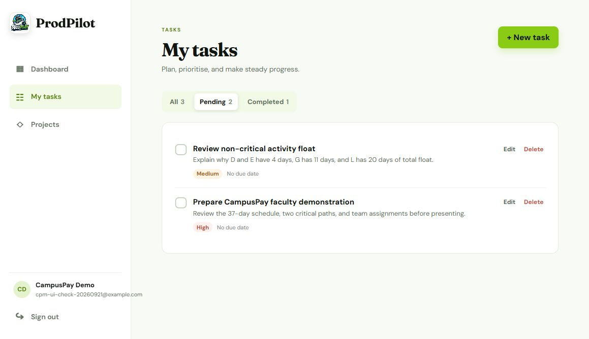
Fig. 6.5 My Tasks Pending Filter with Two Tasks

6.8 Completed tasks view
The Completed filter shows Verify decimal CPM example as the only completed personal task. Its description records the expected 8.75-day duration and the 2.25-day float for activity C. Those values also passed the automated CPM test.
The task was first created through New task and then marked complete from the pending list. The checked control and Completed 1 counter confirm the saved status change. All remains 3 and Pending becomes 2, which also agrees with the updated Dashboard.
The completed record can be edited or returned to pending. Marking this reminder complete records completion of the verification action, not completion of the CampusPay project. Project activities retain their own status and dependency information.
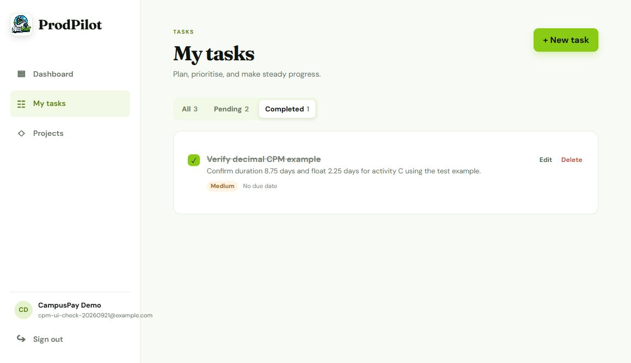
Fig. 6.6 My Tasks Completed Filter with One Task

6.9 Projects and overview screens
Projects lists the plans accessible to the signed-in user. The CampusPay card shows the name, description and start date. Opening the card loads the complete project and its calculated schedule.
The Overview tab shows thirteen activities, nine members and a 37-day duration. It provides a route to the network and manager controls for editing the project. Whole-project deletion is available only to the owner.
The plan's start date is 21 September 2026. Day zero in CPM refers to that date. The displayed duration is a numeric dependency result, not a work-calendar promise. The example description refers to a mobile payment launch plan; ProdPilot itself is the planning application.
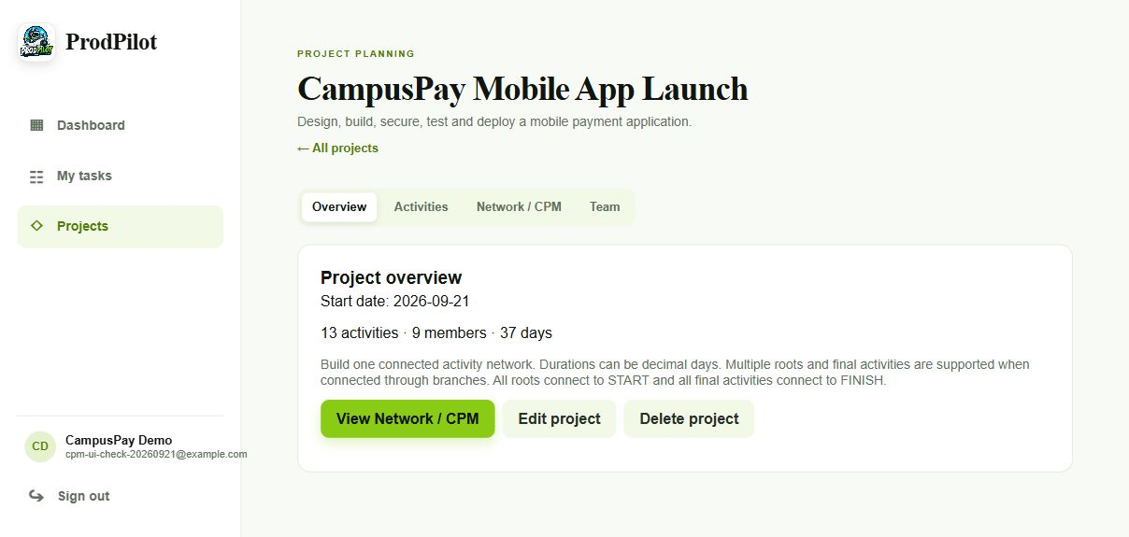
Fig. 6.7 CampusPay Project Overview

6.10 Activity list
The Activities tab displays the stored activity IDs, names, durations, predecessors, assigned members and status. H shows E and F as predecessors, which demonstrates a merge. I depends on H and G, and M depends on J and L.
All thirteen activities are pending in the saved showcase. Their assignments demonstrate project responsibility but do not imply that this work has been completed. CPM uses the entered plan regardless of those status labels.
The activity list includes manager controls to add, edit and delete records. Auto Assign opens a review flow for unassigned work. The screenshot shows the saved demonstration data rather than a mock interface.
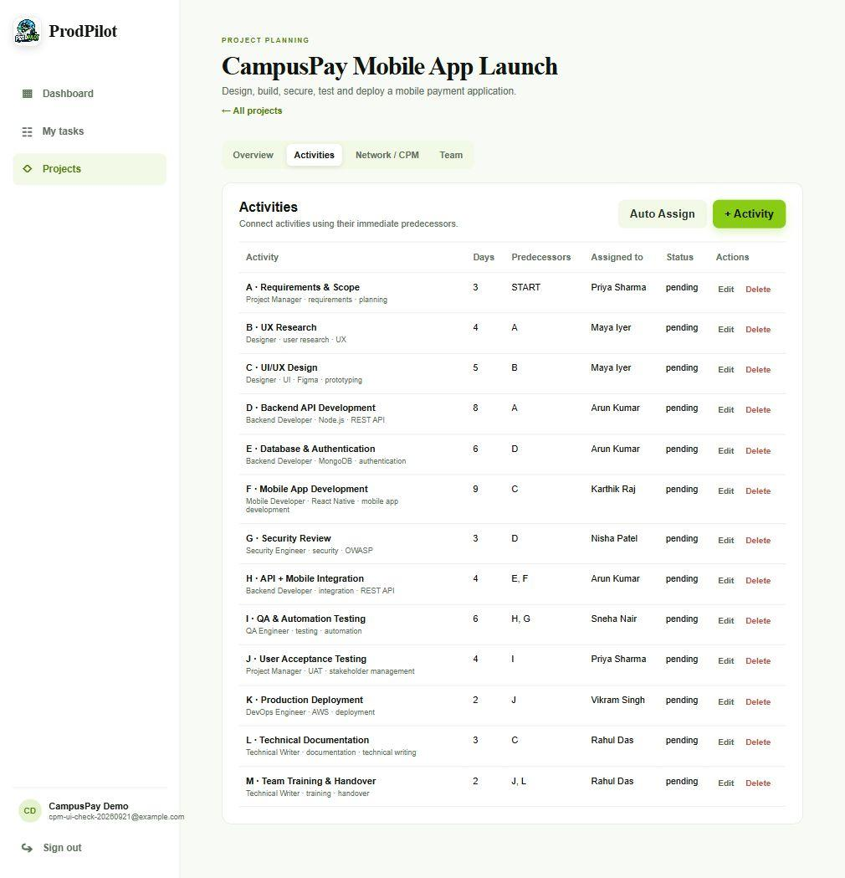
Fig. 6.8 CampusPay Activities and Predecessors

6.11 Activity editor
The activity editor provides duration, predecessor and assignment controls in the same form. The visible example is Security Review. It has a three-day duration and depends on Backend API Development.
The form continues below the visible portion with the assigned-member control, required role, required skills and optional dates. The editor was opened for inspection and cancelled without changing the saved showcase.
A manager can choose another member and save the activity. That manual choice remains valid even if the matching service would suggest someone else. Required skill matching is an aid to allocation, not a restriction on the manager's decision.
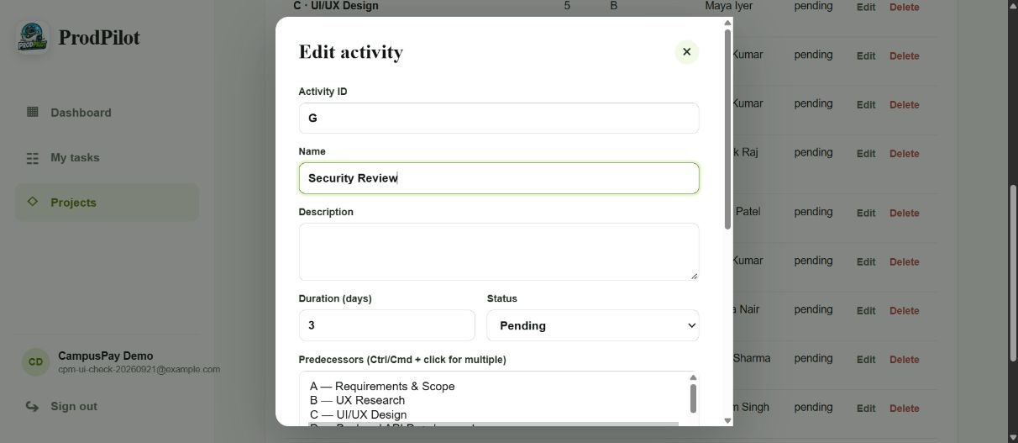
Fig. 6.9 Activity Editing Form

6.12 Project team
The Team tab shows nine project-specific members. Their roles include Project Manager, Backend Developer, Designer, Mobile Developer, QA Engineer, DevOps Engineer, Security Engineer and Technical Writer.
Member records contain role and skill information that supports manual selection and deterministic suggestions. The import control accepts CSV and JSON, and the help text explains the expected fields. These imported records do not automatically create user accounts.
The screenshot shows the saved team for the showcase. Example-domain email addresses are demonstration contact identifiers, not evidence of a real organization's employee directory. Existing assignments refer to these project member records.
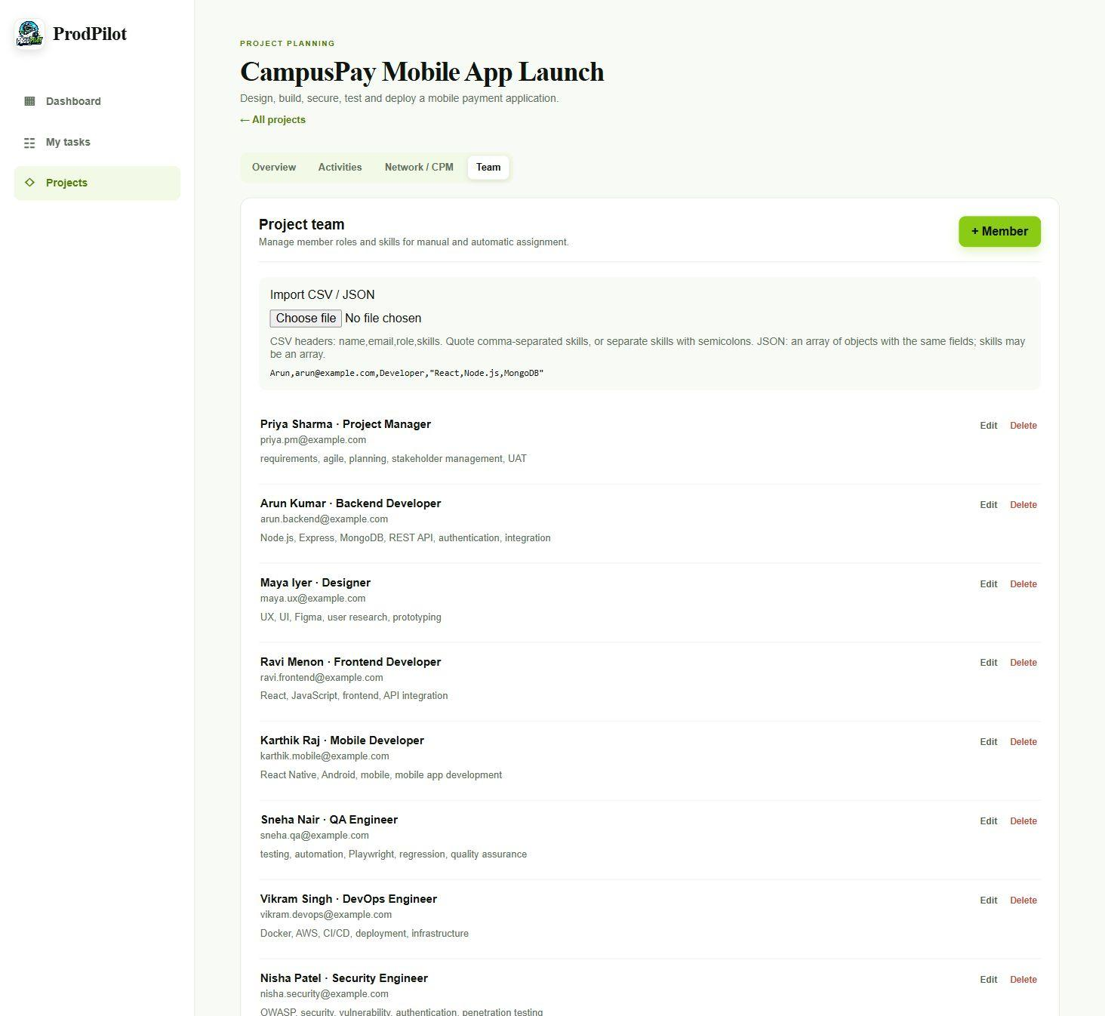
Fig. 6.10 CampusPay Project Team

6.13 Network screen
The Network / CPM tab displays the schedule summary and the activity network. The saved result is 37 days, thirteen activities, nine critical activities and two critical paths. The total float summary is 39 days and is accompanied by a warning about its meaning.
Green nodes and arrows identify critical work. Other nodes and arrows remain visible so the manager can follow backend, security and documentation branches. The graph scrolls horizontally; a desktop viewport shows a portion of the complete network at once.
The screenshot below is an actual partial viewport of the running network. The following pages show the full network export and numerical result, including activities outside this initial view. The separate timing table and path list are part of the same screen.
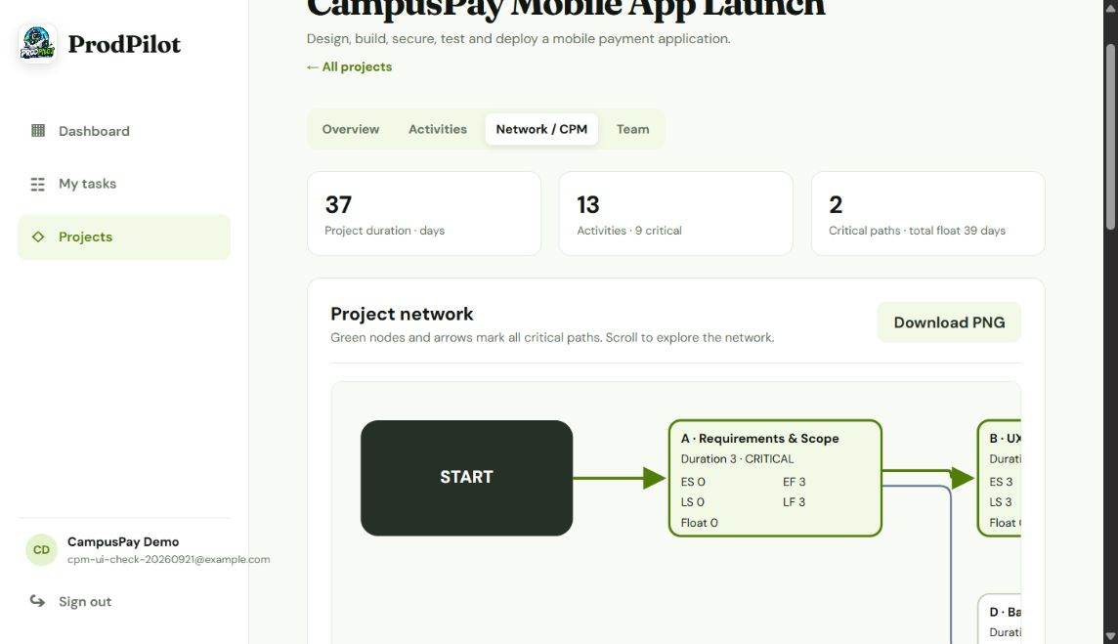
Fig. 6.11 CPM Network and Summary View

6.14 Network PNG export
Download PNG is available beside the Project network heading. It exports the complete SVG network, including branches outside the horizontal scrolling viewport. The screenshot shows the control in the running Network / CPM screen.
The client copies the rendered node and edge styles into a standalone SVG, draws it onto a canvas and saves a PNG. Green critical nodes and arrows, noncritical branches, timing labels, START and FINISH remain in the exported image. The feature uses browser APIs and does not add a graph or image-export dependency.
The button was clicked in the local browser and project-network.png was downloaded successfully. The downloaded file was inspected and inserted into this report. Exporting is a client-side action; it does not alter durations, dependencies, assignments or saved project data.
Fig. 6.12 Project Network Download PNG Control

6.15 Complete exported project network
This figure is the actual PNG downloaded from the CampusPay project. It contains all thirteen activities, START and FINISH. The green route follows A, B, C, F, H, I and J before branching through K or M. Both final routes finish at day 37.
The other branches are retained: A to D, D to E and G, E to H, G to I, and C to L to M. D and E have four days of float, G has eleven, and L has twenty. These connections explain why parallel work can move without immediately changing the planned finish.
The exported image is 6440 by 1540 pixels and is embedded without clipping. The whole network is wide, so its labels are small on a printed portrait page. Zoom the original PNG for node detail; the numerical table in this chapter provides readable ES, EF, LS, LF and float values for every activity.
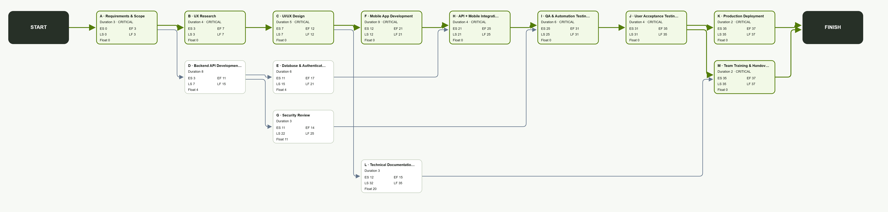
Fig. 6.13 Complete CampusPay Network Exported as PNG

6.16 CampusPay numerical result
The table gives the complete calculated schedule for CampusPay. H waits until F finishes at day 21, although E is ready at day 17. I waits for H until day 25, while G is ready at day 14.
The two critical paths are A → B → C → F → H → I → J → K and A → B → C → F → H → I → J → M. K and M are parallel final activities. There is no K-to-M dependency in the saved input.
Both paths last 37 days. D and E each have four days of float, G has eleven and L has twenty. Adding K as a predecessor of M would change the network and produce a 39-day result; it is not the demonstrated plan.
Table 6.3 Campuspay Numerical Result
ID | Dur. | ES | EF | LS | LF | Float
A | 3 | 0 | 3 | 0 | 3 | 0
B | 4 | 3 | 7 | 3 | 7 | 0
C | 5 | 7 | 12 | 7 | 12 | 0
D | 8 | 3 | 11 | 7 | 15 | 4
E | 6 | 11 | 17 | 15 | 21 | 4
F | 9 | 12 | 21 | 12 | 21 | 0
G | 3 | 11 | 14 | 22 | 25 | 11
H | 4 | 21 | 25 | 21 | 25 | 0
I | 6 | 25 | 31 | 25 | 31 | 0
J | 4 | 31 | 35 | 31 | 35 | 0
K | 2 | 35 | 37 | 35 | 37 | 0
L | 3 | 12 | 15 | 32 | 35 | 20
M | 2 | 35 | 37 | 35 | 37 | 0

6.17 Integer and decimal CPM examples
The six-activity example uses A = 4, B = 3 after A, C = 6 after A, D = 5 after B, E = 2 after C and F = 4 after D and E. Both branches reach F at day 12. F finishes at day 16, and all six activities have zero float.
Its critical paths are A → B → D → F and A → C → E → F. This confirms that the service does not select only one longest branch when equal branches exist.
The decimal example uses A = 2.5, B = 3.5 after A, C = 1.25 after A and D = 2.75 after B and C. B finishes at day 6, while C finishes at day 3.75. D starts at day 6 and finishes at day 8.75. The critical path is A → B → D, and C has 2.25 days of float.
$D duration result = 2.5 + 3.5 + 2.75 = 8.75 days$ (Eqn. 6.1)
Table 6.4 Integer And Decimal Cpm Examples
Decimal activity | Duration | ES | EF | LS | LF | Float
A | 2.5 | 0 | 2.5 | 0 | 2.5 | 0
B | 3.5 | 2.5 | 6 | 2.5 | 6 | 0
C | 1.25 | 2.5 | 3.75 | 4.75 | 6 | 2.25
D | 2.75 | 6 | 8.75 | 6 | 8.75 | 0

6.18 Assignment and invalid input results
The role and skill matcher produces clear choices for the showcase requirements. Backend activities match Arun, design matches Maya, mobile development matches Karthik and testing matches Sneha. The exact score depends on explicit requirements and words in each activity.
Existing assignments are preserved. If no positive role or skill match is found, the suggestion leaves the activity unassigned. The manager can select a member manually. These behaviors are covered by tests and do not require an external AI service.
Invalid network tests reject duplicate IDs, missing predecessors, negative durations, cycles and disconnected activity islands. Integration checks also reject invalid member references and duplicate team emails. The previously valid database state remains available after a rejected change.
A cycle such as making A depend on M in CampusPay cannot be sorted topologically. The service returns a circular-dependency error. This confirms that the graph is based on a validated network, not only on drawing positions.
Table 6.5 Assignment And Invalid Input Results
Activity group | Expected relevant member
A and J | Priya Sharma
B and C | Maya Iyer
D, E and H | Arun Kumar
F | Karthik Raj
G | Nisha Patel
I | Sneha Nair
K | Vikram Singh
L and M | Rahul Das

CHAPTER 7
COST ANALYSIS AND DEPLOYMENT

7.1 Cost analysis
No paid AI API is required for scheduling or assignment. CPM and matching run in the existing server process. The SVG graph runs in the client and does not require a commercial graph service.
The local demonstration uses the user's development computer and Docker services. There is no measured invoice or recorded project expenditure in the available project evidence. The categories below describe where costs would arise in a real deployment rather than claiming actual money spent.
Hosting, backups, domain registration and operational maintenance would need a separate budget if the project were deployed for an organization. Their prices depend on provider, region, service size and usage, so no unsupported fixed price is assigned.
The main implementation cost is development and testing effort. Reusing authentication, navigation and API patterns reduces the amount of code that must be maintained. This does not imply zero total cost or that every bundled tool has the same license terms.
Table 7.1 Cost Analysis
Cost category | Local showcase position
External AI usage | None required by the feature
Graph service | None; SVG generated in client
Database | Existing local MongoDB container
Web and API hosting | Existing local machine
Cloud infrastructure | Optional, not verified or costed
Development effort | Not recorded as paid hours
Backups and maintenance | Required for wider deployment

7.2 Deployment procedure
For the local presentation, Docker Compose is the supported startup route. Start the services from the repository folder and confirm that the client and server are running and MongoDB is healthy. Open http://localhost:8040 after startup completes.
If images are already current, a normal up command is enough. Use the build option after application code changes that need new images. Do not remove the MongoDB volume as a routine troubleshooting step because it contains saved account and project data.
The web port mapping is 8040:80. An occupied 8080 port no longer affects this client mapping. Other projects should remain running unless their own ports conflict with a service explicitly used here.
The repository also contains deployment documentation and an EC2-oriented workflow. That route is an available configuration path, not a verified production result. A public deployment would need HTTPS, secrets management, controlled database exposure and recovery procedures.
cd C:\Users\abdul\Downloads\ProdPilot
docker compose up -d
docker compose ps
After source changes when new images are needed:
docker compose up -d --build
Browser: http://localhost:8040

7.3 Continuous integration
The repository's workflows describe automated checks for the existing stack. A useful check sequence installs workspace dependencies, runs backend tests, builds the client and validates container builds. Failures should stop deployment rather than be hidden by a successful frontend build.
GitHub Actions runs workflows defined in the repository (GitHub, n.d.). The configuration files show this intended automation, but the report does not claim a successful hosted run without a recorded run result.
The database integration suite needs TEST_MONGO_URI. Without that variable, database-dependent tests may be skipped. A CI configuration without a MongoDB service or a reachable test database does not provide the same coverage as the locally verified suite.
For stronger CI coverage, supply an isolated test database and inspect pass, fail and skip counts. The local run reported in Chapter 6 had zero skipped tests. Cloud deployment secrets should remain outside source control and outside the report.
Table 7.2 Continuous Integration
Check | Reason
Frozen dependency install | Use recorded lockfile
Backend tests | Catch service and API regressions
MongoDB integration environment | Avoid silently skipped persistence coverage
Production client build | Catch bundling errors
Container build | Check deployment packaging
Secrets and environment review | Prevent accidental exposure

7.4 Security constraints
The implementation enforces project-level authorization, but it is still a small application rather than an enterprise identity platform. A project member's email and role affect access, so owners must manage those records carefully.
The existing client stores its token in localStorage. This is simple for the current app, but it makes browser-side script safety important. A production security review should consider token storage, content security policy, session expiry and protection against cross-site scripting.
The local showcase uses HTTP. Public use should use HTTPS and avoid exposing the database directly. The current scope does not add rate limiting, multi-factor authentication, verified invitations or a detailed audit log.
These limits do not cancel the tested record-level checks. They identify what remains before broader use. The report does not treat a valid JWT or a hidden edit button as proof of complete security.
Table 7.3 Security Constraints
Area | Current position | Further work
Project access | Owner or member email filter | Verified membership workflow
Editing | Owner or Project Manager | More detailed role policy if needed
Token storage | Existing localStorage | Review browser session protection
Transport | Local HTTP showcase | HTTPS for public use
Database | Local published service | Restrict production network access
Abuse controls | Not extended in this feature | Rate limits and monitoring

7.5 Scheduling and assignment limitations
CPM assumes fixed durations and precedence relationships. It does not estimate uncertainty or calculate the probability of meeting a date. A manager can change durations and recalculate, but that is a revised deterministic plan rather than a statistical forecast.
The plan does not enforce member availability. Arun may be assigned several activities that overlap in the early schedule. The matching service only counts assignments for tie-breaking; it does not schedule working hours or level resources.
Role matching depends on text. Node.js can match an explicit Node.js requirement, but a differently phrased requirement may need manual selection. The service is intended to provide simple, reviewable suggestions, not to judge people's skill quality.
The timing table reports total float. Free float, lead and lag, alternative relationship types and actual-progress rescheduling are not implemented. Adding these would require changes to the calculation model and tests, not just extra fields in the editor.
Table 7.4 Scheduling And Assignment Limitations
Not modeled | Consequence
Working-day calendar | Numeric days include weekends
Resource capacity | Assignment does not delay activities
Estimate uncertainty | No confidence interval or PERT result
Lead, lag or start-to-start links | Finish-to-start only
Actual progress rescheduling | Status does not change remaining duration
Skill synonyms and availability | Manager review remains necessary

7.6 Maintenance and extension plan
Maintenance should begin with the existing regression fixtures. Changes to graph calculations need integer, decimal and multiple-path checks. Changes to the layout need branching and long-merge cases. Changes to project access need direct API tests, not only button visibility checks.
Useful future work is limited to gaps that affect the current planning purpose. Verified team membership, better matching normalization and a calendar-aware option could improve practical use. Each should be introduced with a clear model and acceptance tests.
A larger project limit would require measurement before simply increasing 200 to a much higher value. Node density, request size, document size and path enumeration can become constraints at different rates.
The current separation of services and UI helpers gives a clear place for these changes. A new import format can normalize into member objects, while a richer scheduling method should remain separate from the SVG drawing. This keeps presentation from becoming the source of scheduling truth.
Table 7.5 Maintenance And Extension Plan
Potential improvement | Required verification
Verified member invitations | Access and identity tests
Skill normalization | Deterministic matching fixtures
Work calendars | Explicit date and fractional-day rules
Larger networks | Performance and visual density measurements
More edge types | Revised CPM equations and cycle checks
Backup and recovery | Restore test using isolated data

CHAPTER 8
FINDINGS DISCUSSION AND CONCLUSION

8.1 Findings
ProdPilot now includes project planning alongside its existing personal task features. A project can store a team and a connected activity graph, with decimal durations, several predecessors and manual assignments. The API retains JWT authentication and applies project-level access rules.
The CPM service calculates early and late timings, total float, critical activities and tight critical edges. It supports more than one critical path and returns an exact path count with a bounded text preview. Invalid graphs are rejected before saving.
The network view uses SVG and the existing visual style. It shows START, activities and FINISH, highlights critical work, and keeps noncritical branches visible. Summary cards, a path list and a timing table support review of the result.
Assignment suggestions use deterministic role and skill matching. They preserve existing assignments and allow manager review. CSV and JSON team imports provide a simple way to enter demonstration data without adding a large dependency.
Table 8.1 Findings
Delivered area | Result
Projects | Authenticated planning records and tabs
Activities | Decimal duration and predecessor CRUD
CPM | Forward/backward pass and all critical routes
Visualization | SVG graph with timing details
Team | Roles, skills and structured import
Assignment | Manual control and reviewable suggestions
Existing system | Personal tasks remain separate

8.2 Discussion and conclusion
The tested examples produced the expected dependency schedules. The six-activity plan finishes in sixteen days with two critical paths. The decimal plan finishes in 8.75 days, with 2.25 days of float on C. CampusPay finishes in thirty-seven days with two parallel final critical branches.
The local backend suite passed twenty-two tests with no failures or skipped tests, and the frontend production build succeeded. The running browser showed the saved CampusPay project, its team, activities and CPM result. These checks support the feature's correctness within the tested local scope.
The project also demonstrates the importance of separating mathematical correctness from appearance. A green node is useful only when its zero float was calculated correctly, and a green edge is useful only when it is a tight dependency. Validation, calculation and drawing therefore have separate responsibilities.
The completed system is suitable for demonstrating dependency-based project planning. Wider operational use still needs work on identity verification, deployment security, calendar rules, resource constraints and measured scale. Those additions should preserve the tested calculation rules and the manager's control over assignments.

CHAPTER 9
REFERENCES

9.1 Official platform references
The references below support the technologies and protocols discussed in the report. Documentation pages may change over time; the access date identifies the version of the source reviewed for this report. The application behavior and test results are documented separately through the repository and local verification.
React. (n.d.). Quick start. Retrieved October 10, 2026, from https://react.dev/learn
Express. (n.d.). Routing. Retrieved October 10, 2026, from https://expressjs.com/en/guide/routing/
Mongoose. (n.d.). Schemas. Retrieved October 10, 2026, from https://mongoosejs.com/docs/guide.html
Docker. (n.d.). Docker Compose. Retrieved October 10, 2026, from https://docs.docker.com/compose/
Vite. (n.d.). Getting started. Retrieved October 10, 2026, from https://vite.dev/guide/
GitHub. (n.d.). Understanding GitHub Actions. Retrieved October 10, 2026, from https://docs.github.com/en/actions/get-started/understand-github-actions

9.2 Protocol and process references
Jones, M., Bradley, J., & Sakimura, N. (2015). JSON Web Token (JWT) (RFC 7519). Internet Engineering Task Force. https://www.rfc-editor.org/rfc/rfc7519
Kelley, J. E., Jr., & Walker, M. R. (1959). Critical-path planning and scheduling. In Papers presented at the December 1–3, 1959, eastern joint IRE-AIEE-ACM computer conference (pp. 160–173). Association for Computing Machinery. https://doi.org/10.1145/1460299.1460318
Schwaber, K., & Sutherland, J. (2020). The Scrum Guide. https://scrumguides.org/scrum-guide.html
RFC 7519 provides the JWT format used by the existing authentication stack. The report cites it for token terminology, not as evidence that every security property has been implemented in ProdPilot.
The Scrum Guide is used to explain a backlog and inspection-based development approach. The schedule chapter presents a proposed milestone sequence. It does not claim measured sprint performance or attendance at ceremonies.
The frontend is bundled with the existing Vite workflow described in the project specification. The official Vite guide is a reference for that build tool (Vite, n.d.). The actual local build outcome is recorded in Chapter 6.

9.3 Project implementation references
ProdPilot project repository. (2026). Project planning implementation and technical documentation [Local software project]. Source files reviewed October 10, 2026.
The Project model, project routes and project controller define the implemented storage and access behavior. The cpm and assignment services define the calculation and matching rules. The tests provide repeatable examples for numerical results and API behavior.
The frontend implementation references are ProjectsPage, ProjectForm, CPMNetwork, networkLayout and memberImport. The existing authentication context, API helper and application layout explain how planning is connected to the original task application.
The repository documents include README.md, PROJECT_PLANNING.md, API.md, USER_MANUAL.md, DEPLOYMENT.md and AGILE.md. The Agile material contains sample planning artifacts and is treated as guidance rather than measured development history.
CampusPay demonstration files. (2026). Team and activity demonstration data [Local JSON and CSV files]. The supplied activities specify K after J and M after J and L. Those relationships determine the two 37-day critical paths shown in this report.

APPENDIX A
OPERATION AND VERIFICATION GUIDE

A.1 Local startup and project review
Open PowerShell in the ProdPilot repository and run docker compose up -d. Check docker compose ps before opening http://localhost:8040. If the client does not start, inspect the occupied host port and service logs without deleting the database volume.
Sign in with the showcase account using the credentials held separately by the project owner. The report intentionally contains no password or authentication token. Open Projects, then CampusPay Mobile App Launch.
Review Overview, Team and Activities. Check that the team has nine members and that H has E and F as predecessors. Open Network / CPM and confirm duration 37, nine critical activities and two critical paths.
Read the path list through K and M separately. K and M both follow J and are not sequential. Use the timing table to inspect D, E, G and L without relying on color. Their floats are 4, 4, 11 and 20 days.
For an assignment demonstration, open an activity editor, select a member and save only if the planned showcase change is intended. Use Cancel when inspecting the form without changing the saved project. Auto Assign works on unassigned activities and preserves current assignments.

A.2 Reproducible numerical inputs
The following compact inputs can be used in isolated test projects. IDs must remain unique, and predecessors must refer to existing activities. Create roots first when adding activities individually, or use the complete-network API for a bulk valid graph.
Table A.1 Six Activity CPM Input
ID | Duration | Predecessors
A | 4 | None
B | 3 | A
C | 6 | A
D | 5 | B
E | 2 | C
F | 4 | D, E

Expected duration is 16 days. Both A → B → D → F and A → C → E → F are critical. Every activity has zero total float.
Table A.2 Decimal CPM Input
ID | Duration | Predecessors
A | 2.5 | None
B | 3.5 | A
C | 1.25 | A
D | 2.75 | B, C

Expected duration is 8.75 days. A → B → D is critical, and C has 2.25 days of float. Negative durations, missing predecessor IDs and cycles should be rejected.

A.3 Verification commands and module map
The database integration tests require a reachable isolated test database. The test suite uses its own test records. Do not point an unfamiliar test script at a production database.
$env:TEST_MONGO_URI='mongodb://127.0.0.1:27017'
$env:NODE_ENV='test'
pnpm test
pnpm build
Inspect the total passed, failed and skipped counts. A successful build checks bundling but does not replace numerical or permission tests. After code changes, build updated container images before capturing the production UI.
Table A.3 Implementation Module Map
File group | Purpose
server/src/services | CPM and assignment logic
server/src/models/Project.js | Project schema and embedded records
server/src/controllers/projectController.js | Accessible queries and validated updates
server/tests | CPM, API, layout and regression tests
client/src/pages/ProjectsPage.jsx | Project screens and management actions
client/src/components/CPMNetwork.jsx | SVG view and timing table
client/src/utils | Network layout and import parsers

Team CSV requires name,email,role,skills headers. JSON requires an array with the same fields. Review the preview before import. Avoid importing CSV and JSON versions of the same team into one project because duplicate emails are rejected.

