AUTO REPAIR ERP SYSTEM
Workshop Management System — Software Engineering Documentation

Prepared by: Abdullah Javed
Technology Stack: ASP.NET Core MVC (.NET 10) · C# · Entity Framework Core · SQL Server · Bootstrap
Repository: AutoRepair-ERP-System (GitHub)
Document Version 1.0 — 2026

Preface
This documentation was prepared by directly cloning and analyzing the AutoRepair ERP System repository, and was subsequently revised against an upstream update that added a REST API layer. Every technical statement — controller names, model fields, relationships, business rules, and workflow logic — is derived from the actual source code rather than inferred or assumed, and diagrams throughout are generated from that same analysis rather than drawn generically.
The system comprises two cooperating applications. The AutoRepair ERP itself — a server-rendered ASP.NET Core MVC application with a companion REST API — is the subject of this repository and is documented here in full depth: 24 relational entities, 27 MVC controllers, 5 API controllers, session-based role authorization, payroll and attendance automation, inventory and reordering logic, and a background notification service. The ERP Consumer, a separate client application that consumes the ERP's REST API, lives in its own repository; Chapter 7 documents its architecture and integration with the ERP as designed, while noting that its source is maintained separately from the codebase analyzed here.

Table of Contents

Chapter 1 — Introduction

1.1 Problem Statement
Small and medium auto repair workshops typically manage customer intake, job orders, parts inventory, employee attendance, payroll, and billing using disconnected tools — paper job cards, spreadsheets for stock, and manual invoice books. This fragmentation causes lost job history, untracked parts consumption, delayed reordering, inconsistent invoicing, and no unified visibility for the owner into revenue, outstanding payments, or workshop load.

1.2 Existing System
As implemented in the codebase's demo data and role model, the baseline assumption is a manual or spreadsheet-based workshop: job cards on paper, ad-hoc part reordering, and a physical attendance register, all reflected in the schema's explicit reasons for automation (e.g. LowStockAlertManager replacing manual reorder tracking, PayrollCalculationService replacing manual payslip computation).

1.3 Proposed System
The AutoRepair ERP System is a single, centralized ASP.NET Core MVC application backed by SQL Server via Entity Framework Core. It digitizes the full workshop lifecycle: customer and vehicle registration, job order creation and assignment, parts consumption against job orders, purchase ordering and stock receiving, invoicing and payment collection, employee attendance and automated payroll calculation, low-stock alerting, role-based notifications, and owner/admin/advisor/mechanic dashboards with live KPIs and sales/parts/outstanding reports.

1.4 Objectives
- Provide a single source of truth for customers, vehicles, and their service history.
- Automate job-order-to-invoice-to-payment financial workflow with balance tracking.
- Automate inventory consumption, purchase-order receiving, and reorder alerting.
- Automate attendance-driven payroll calculation with configurable completeness thresholds.
- Enforce role-based access (Owner, Admin, Service Advisor, Mechanic, Inventory Manager, Receptionist) at the controller-action level.
- Provide role-specific dashboards and printable/exportable operational reports.
- Maintain an audit trail of create/update/delete actions across sensitive modules.

1.5 Scope
In scope: customer/vehicle management, job order lifecycle, service and parts catalog, employee/HR (attendance, payroll, salary adjustments), procurement (suppliers, purchase orders, stock transactions, low-stock alerts), billing (invoices, payments), user/role administration, audit logging, notifications, and reporting dashboards — all delivered as server-rendered Razor views.
Out of scope (confirmed absent from the repository): a public REST API surface, Swagger/OpenAPI documentation, a separate API-consuming client application, third-party payment gateway integration, automated test suites, and CI/CD pipelines.

1.6 Limitations
- Passwords are stored and compared as plain text (User.PasswordHash is compared directly to the submitted password in AuthController) — explicitly flagged in the project's own README as a pre-production fix item.
- Authentication/session state is in-memory (ASP.NET Core Session) and does not survive an application restart or scale across multiple server instances without a distributed cache.
- No automated test coverage exists to regression-guard business logic.
- The Migrations folder ships a single InitialCreate migration; per the README, migrations may need to be regenerated in a fresh environment.

1.7 Feasibility Study

1.7.1 Technical Feasibility
The system uses a widely supported, actively maintained stack (ASP.NET Core MVC, EF Core, SQL Server) with a conventional layered structure (Controllers → Services → EF Core DbContext → SQL Server), making it technically feasible for a small team or solo developer to build, extend, and maintain.

1.7.2 Economic Feasibility
All core technologies (.NET SDK, EF Core, SQL Server Express/LocalDB, Bootstrap) are free for development and small-scale deployment, minimizing licensing cost for a small workshop.

1.7.3 Operational Feasibility
The role-based dashboard model (Owner/Admin/Advisor/Mechanic/Inventory Manager/Receptionist) is designed to match real workshop job functions, and the seeded demo accounts allow immediate hands-on evaluation without manual setup.

1.8 Software Development Methodology
The Git history shows sequential, feature-oriented commits progressing from schema/CRUD foundation through job-order workflow, HR/attendance, authorization, inventory/notifications, payroll, audit logging, and finally a full UI reskin — consistent with an iterative, incremental delivery approach rather than a single big-bang release. No separate branches were used; all work landed directly on main.

Chapter 2 — Development History and Git Analysis
The repository contains 19 commits on a single branch (main), authored sequentially. The commit log, reproduced without fabrication, is as follows (oldest to newest):
# | Commit | Message
1 | da5ceae | Initial ERP project setup with SQL Server integration and CRUD modules
2 | 468f601 | Added project README
3 | 3c73441 | Completed Job Order workflow with employee assignments and vehicle integration
4 | 1bdfa22 | Completed invoice workflow and service management
5 | 5c78848 | Implemented employee registration workflow and HR module improvements
6 | 1838c2e | Attendance employee dropdown and validation improvements
7 | 497d6a1 | Employee module completed, attendance improved, vehicle validation in progress
8 | 7010b0d | Some UI Cleaning
9 | 457a4b8 | Functionality and UI got Improved
10 | 813f78f | Employee Module Polished along with PO and POI
11 | 95a8b47 | Roles, UserRoles, AssignedJobs, Authorization Completed
12 | e3cb80c | Stock Transaction Completed
13 | 7b54db1 | Low Stock Alerts, Notifications Batch 1 Implemented
14 | d779aba | Notification Module Completed
15 | 0f59711 | Payroll Module Completed
16 | 983e6de | Salary Adjustment & Audit Completed
17 | 4675751 | Audit Completed
18 | 37e606e | Backend Completed
19 | be81bdc | Frontend Integrated Successfully

2.1 Development Timeline and Phases
Grouping the commits by theme yields five clear implementation phases:

Phase 1 — Foundation (commits 1–2)
SQL Server integration, base CRUD scaffolding for core entities, and initial README.

Phase 2 — Core Operations Workflow (commits 3–7)
Job Order lifecycle with customer/vehicle/employee linkage, invoice and service workflow, and the Employee/HR module including attendance validation.

Phase 3 — Access Control and Inventory (commits 8–13)
UI refinement passes, Purchase Order/Purchase Order Item completion, the Roles/UserRoles authorization model and job-assignment logic, Stock Transactions, and the first batch of Low Stock Alerts and Notifications.

Phase 4 — HR Finance and Compliance (commits 14–17)
Completion of the Notification module, the Payroll module (including PayrollCalculationService), Salary Adjustments, and the Audit Log subsystem.

Phase 5 — Backend Freeze and Frontend Integration (commits 18–19)
A dedicated "Backend Completed" commit, followed by a large-scale UI reskin (per README: new dark-gold design system, four role-based dashboards, a Reports module, and a rewritten sidebar/layout) integrating the finished backend with a cohesive frontend.

2.2 Engineering Decisions Evident from the Codebase
- Session-based custom authorization (RoleAuthorizeAttribute, SessionAuthorizeAttribute) was chosen over ASP.NET Core Identity — a lighter-weight approach suited to a single-tenant internal tool, at the cost of the hardening Identity provides out of the box.
- Business logic for cross-cutting concerns (dashboards, reporting, payroll, low-stock sync, purchase-order receiving, audit logging) was extracted into a dedicated Services/ layer rather than left in controllers, improving testability and separation of concerns even without a test project actually exercising it.
- A BackgroundService (NotificationHostedService) was introduced for time-based rules (e.g., 60-day customer follow-up reminders) instead of relying on the request pipeline, showing awareness of decoupling scheduled logic from user-triggered actions.
- The DbSeeder is written to be idempotent (checks for existing rows before inserting), a deliberate decision allowing it to run safely on every application startup.

2.3 Project Management / Jira
No Jira exports, issue trackers, sprint boards, or backlog files are present in the repository. If Jira was used operationally during development, its artifacts were not committed alongside the source code, so sprint plans and ticket references are not reconstructable here and are omitted rather than invented.

Chapter 3 — System Architecture

3.1 Architectural Style
The application follows the classic ASP.NET Core MVC pattern: Controllers handle HTTP requests and orchestrate work, Models (EF Core entities) represent persistent state, Views (Razor .cshtml) render HTML server-side, and a Services layer (Services/*.cs) encapsulates cross-cutting business logic (dashboards, reporting, payroll calculation, notifications, audit logging, purchase-order receiving, low-stock synchronization) that would otherwise bloat controllers. A companion REST API layer (Chapter 6) and a separate ERP Consumer client application (Chapter 7) extend this core.

3.2 High-Level Architecture Diagram
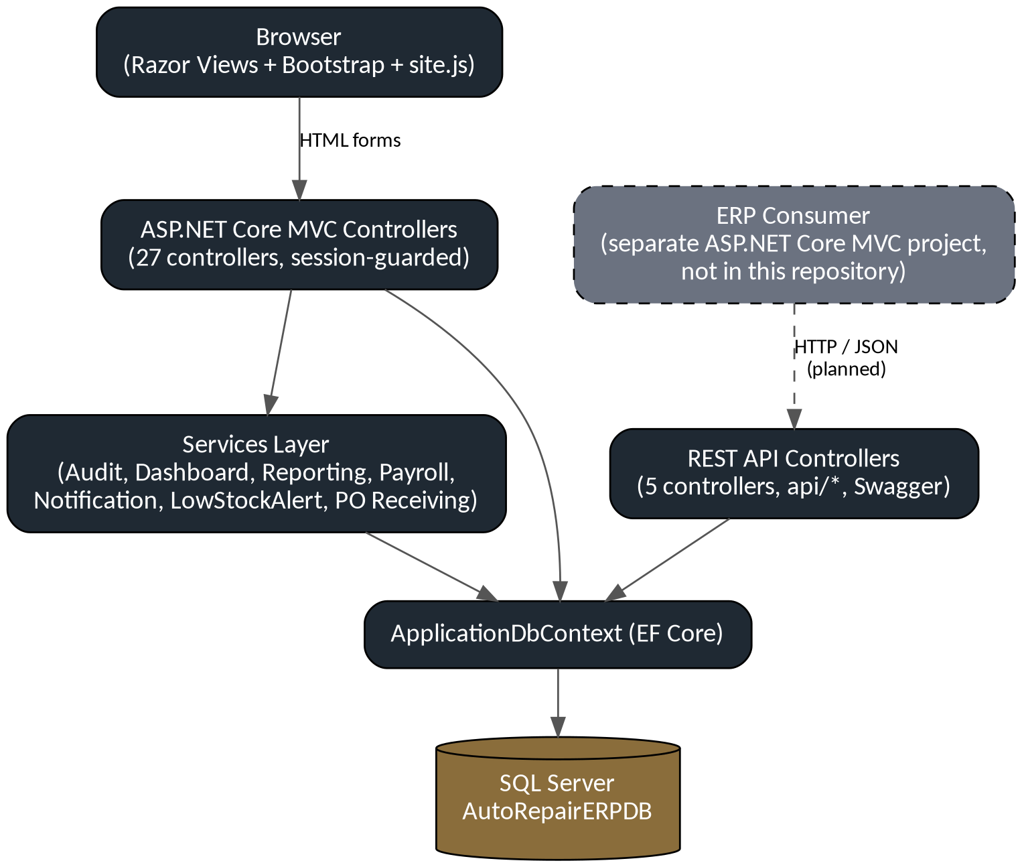
Figure 3.1 — High-level component architecture, including the external ERP Consumer.
The browser talks to the MVC controllers via HTML forms; the MVC controllers and the Services layer both go through ApplicationDbContext to reach SQL Server. The REST API controllers reach the same database directly. The ERP Consumer, shown with a dashed boundary because it is maintained in its own repository, communicates only with the REST API — it has no direct path to the database, which is the defining constraint of its design (see Chapter 7).

3.3 Request Pipeline (Program.cs)
The pipeline configured in Program.cs registers MVC (AddControllersWithViews), in-memory Session, HttpContextAccessor, the ApplicationDbContext against the DefaultConnection SQL Server connection string, and the seven services listed above (five scoped, one hosted background service). On startup it runs DbSeeder.SeedAsync inside a try/catch so a schema/DB mismatch logs a warning rather than crashing the app. HTTPS redirection, exception handling in non-development environments, HSTS, routing, session middleware, and authorization middleware are wired in that order, followed by the conventional default route {controller=Home}/{action=Index}/{id?}.

3.4 Authentication and Authorization Architecture
Authentication is custom and session-based rather than using ASP.NET Core Identity or cookie authentication middleware. AuthController.Login validates the submitted username/password directly against the Users table (User.PasswordHash compared to the raw submitted password — i.e. no hashing is actually applied despite the field's name), then stores UserID, Username, RoleID and RoleName into ASP.NET Core Session. Authorization is enforced with two custom action filters:
- SessionAuthorizeAttribute — verifies a UserID exists in session; redirects to /Auth/Login otherwise.
- RoleAuthorizeAttribute(params string[] roles) — verifies a session RoleName exists and matches one of the attribute's allowed roles (case-insensitive); redirects to /Home/AccessDenied otherwise.
Because a user can hold multiple UserRole assignments, the Login flow supports role selection at login (RoleSelectionViewModel) so a multi-role account can operate the session under a specific role context.

3.5 MVC Architecture Detail
Layer | Location | Responsibility
Controllers | /Controllers/*.cs (27 files) | HTTP request handling, model binding, calling Services/DbContext, selecting Views
Models | /Models/*.cs (24 entities + ApplicationDbContext) | EF Core entity classes, data annotations, navigation properties
ViewModels | /ViewModels, /Models/ViewModels | Screen-specific shapes not directly persisted (LoginViewModel, DashboardViewModels, ReportViewModels, EmployeeRegistrationViewModel, RoleSelectionViewModel, NotificationBellViewModel)
Views | /Views/<Controller>/*.cshtml | Razor server-rendered HTML, shared layout in Views/Shared
Services | /Services/*.cs | Business logic: audit, dashboards, reporting, payroll, notifications, low-stock sync, PO receiving, DB seeding
Filters | /Filters/*.cs | Custom authentication/authorization action filters
Helpers | /Helpers/*.cs | AdjustmentTypeHelper, BadgeHelper — presentation/domain helper logic
ViewComponents | /ViewComponents | NotificationBellViewComponent — reusable partial-rendering component for the notification bell in the layout

3.6 REST API Architecture
Alongside the MVC controllers, the project exposes a REST API under api/ (five attribute-routed controllers, documented via Swagger). These API controllers inject ApplicationDbContext directly rather than going through the Services layer, so they currently form a second, thinner path into the same database rather than a fully layered API. Chapter 6 documents this in full, including endpoint tables, validation, and status codes.

3.7 Deployment, Component, and Context Views
Component and deployment boundaries follow directly from the architecture diagram above: the MVC application, its Services layer, and the new API controllers are one deployable unit hosted behind Kestrel/IIS against a single SQL Server instance, while the ERP Consumer is deployed and hosted independently and reaches the ERP only through HTTP. The system's actors — Owner, Admin, Service Advisor, Mechanic, Inventory Manager, and Receptionist — all interact through the MVC application; none currently interact directly with the API or the Consumer.
A full Entity-Relationship diagram and explanation is provided in Chapter 4, derived directly from ApplicationDbContext.OnModelCreating and the individual entity classes.

Chapter 4 — Database Design
The database (AutoRepairERPDB) is defined through EF Core Code-First entities and materialized via the single InitialCreate migration. It comprises 24 tables mapped 1:1 to the entity classes in /Models. Table names and primary key names shown below are taken directly from the SQL Server key constraint names embedded in ApplicationDbContext.OnModelCreating (e.g. PK__Attendan__..., FK_JobOrders_Customers).

4.1 Entity List and Purpose
Entity | Primary Key | Purpose
User | UserId | Login accounts; base identity for Employees and audit/creation trails
Role | RoleId | Named permission group (Owner, Admin, Service Advisor, Mechanic, Inventory Manager, Receptionist)
UserRole | UserRoleId | Many-to-many join between Users and Roles
Employee | EmployeeId | HR record; optionally linked 1:1 to a User for login-capable staff
Attendance | AttendanceId | Daily check-in/check-out record per employee
Payroll | PayrollId | Monthly payroll run per employee
SalaryAdjustment | AdjustmentId | Bonus/deduction line items attached to a Payroll
Customer | CustomerId | Workshop customer record
Vehicle | VehicleId | Vehicle owned by a Customer
JobOrder | JobOrderId | Core repair job: customer, vehicle, advisor, mechanic, status, costs
Service | ServiceId | Catalog of billable labor services
JobServiceItem | JobServiceItemId | Service line applied to a JobOrder, optionally assigned to a Mechanic
Category | CategoryId | Parts category
Part | PartId | Inventory part/SKU with stock and reorder level
JobPartItem | JobPartItemId | Part consumed on a JobOrder
Supplier | SupplierId | Parts vendor
PurchaseOrder | PurchaseOrderId | Order placed with a Supplier
PurchaseOrderItem | PoitemId | Line item of a PurchaseOrder
StockTransaction | TransactionId | Ledger entry for every stock in/out movement
LowStockAlert | AlertId | Auto-generated/auto-resolved alert when stock falls to/above reorder level
Invoice | InvoiceId | Bill generated from a completed JobOrder
Payment | PaymentId | Payment received against an Invoice (supports partial payments)
Notification | NotificationId | In-app notification targeted at a User
AuditLog | AuditLogId | Immutable record of Create/Update/Delete actions with old/new value snapshots
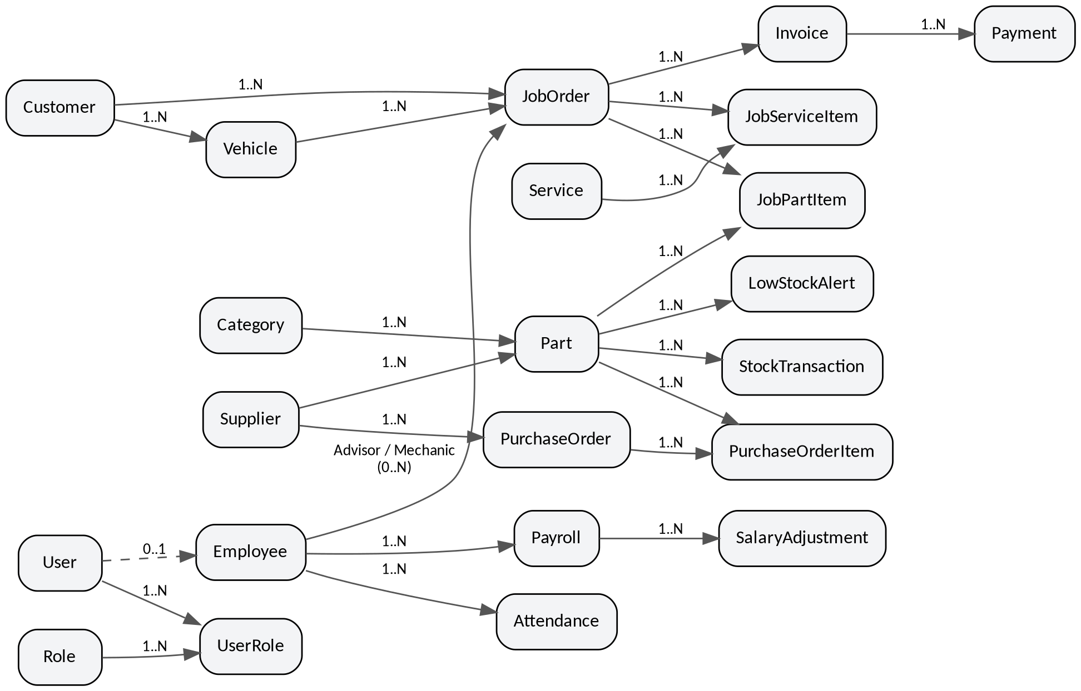
Figure 4.1 — Simplified entity-relationship diagram of the core operational entities.

4.2 Key Relationships
- User 1—N UserRole N—1 Role (many-to-many via join table)
- User 1—0..1 Employee (optional: not every login is HR-tracked, not every employee has a login)
- Customer 1—N Vehicle; Customer 1—N JobOrder
- JobOrder N—1 Vehicle, N—1 Customer, N—0..1 Employee (Advisor), N—0..1 Employee (Mechanic) — two separate FKs to Employee from JobOrder (FK_JobOrders_Advisor, FK_JobOrders_Mechanic), modeled as two distinct navigation collections (JobOrderAdvisors, JobOrderMechanics) on Employee
- JobOrder 1—N JobServiceItem N—1 Service, and JobServiceItem N—0..1 Employee (Mechanic)
- JobOrder 1—N JobPartItem N—1 Part
- JobOrder 1—N Invoice 1—N Payment (Invoice exposes computed, non-persisted AmountPaid and RemainingBalance properties summing Payments)
- Part N—1 Category, N—1 Supplier; Part 1—N StockTransaction; Part 1—N LowStockAlert; Part 1—N JobPartItem; Part 1—N PurchaseOrderItem
- Supplier 1—N PurchaseOrder 1—N PurchaseOrderItem N—1 Part
- Employee 1—N Attendance; Employee 1—N Payroll 1—N SalaryAdjustment
- User 1—N Notification, 1—N AuditLog (as actor)

4.3 Referential Integrity and Delete Behavior
Most required parent relationships (e.g. Attendance→Employee, JobOrder→Customer, JobOrder→Vehicle, JobPartItem→JobOrder/Part, Invoice→JobOrder, Payment→Invoice, PurchaseOrderItem→PurchaseOrder/Part, StockTransaction→Part, LowStockAlert→Part, UserRole→User/Role, SalaryAdjustment→Payroll) are configured with DeleteBehavior.ClientSetNull, meaning EF Core will not cascade-delete children automatically and instead relies on the application or database constraints to prevent orphaning critical financial/operational records. Optional relationships (e.g. JobOrder→Advisor/Mechanic, Employee→User, Part→Category/Supplier) have no explicit delete behavior override and use EF Core defaults for nullable FKs.

4.4 Constraints and Uniqueness
Entity | Unique Constraint
User | Username (unique); Email (unique)
Employee | EmployeeCode (unique)
JobOrder | JobNumber (unique)
Invoice | InvoiceNumber (unique)
Part | Sku (unique)
Column-level validation is enforced via Data Annotations on the entity classes, for example: Employee.Cnic must match ^\d{5}-\d{7}-\d{1}$ (Pakistani CNIC format), Employee.Phone must match ^0?3\d{9}$ (Pakistani mobile format), monetary fields use decimal(18,2) with Range(0, MaxValue) guards, and Attendance.OvertimeHours is range-limited to 0–24.

4.5 Default Values (Database-Generated)
Entity.Field | Default
AuditLog.ActionDate | getdate()
Customer.CreatedAt | getdate()
Employee.IsActive | true
Invoice.InvoiceDate | getdate()
Invoice.InvoiceStatus | 'Unpaid'
JobOrder.CreatedAt | getdate()
JobOrder.Status | 'Pending'
LowStockAlert.AlertDate | getdate()
LowStockAlert.Status | 'Active'
Notification.CreatedAt | getdate()
Notification.IsRead | false
Part.IsActive | true
Payroll.PayrollStatus | 'Pending'
Service.IsActive | true
StockTransaction.TransactionDate | getdate()
User.CreatedAt | getdate()
User.IsActive | true

4.6 Normalization
The schema is normalized to Third Normal Form (3NF): lookup data (Category, Supplier, Role, Service) is factored into dedicated tables rather than repeated as free text; computed monetary aggregates (Invoice.AmountPaid, Invoice.RemainingBalance) are deliberately kept as [NotMapped] computed properties rather than stored/duplicated columns, avoiding update anomalies; and transactional history (StockTransaction, AuditLog, Attendance) is append-only rather than overwriting prior state.

4.7 Data Dictionary — Representative Core Tables

4.7.1 JobOrder
Column | Type | Notes
JobOrderID | int, PK
CustomerID | int, FK→Customer | required
VehicleID | int, FK→Vehicle | required
AdvisorID | int?, FK→Employee | optional
MechanicID | int?, FK→Employee | optional
CreatedByUserID | int?, FK→User | optional
JobNumber | varchar(50) | unique
ComplaintDescription | varchar(max) | required
DiagnosisNotes | varchar(max) | optional
EstimatedCompletionDate | datetime | optional
StartDate / CompletionDate | datetime | optional
Status | varchar(50) | default 'Pending'
EstimatedCost / FinalCost | decimal(18,2) | range ≥ 0
CreatedAt | datetime | default getdate()

4.7.2 Invoice
Column | Type | Notes
InvoiceID | int, PK
JobOrderID | int, FK→JobOrder | required
CreatedByUserID | int?, FK→User | optional
InvoiceNumber | varchar(50) | unique, required
InvoiceDate | datetime | default getdate()
SubTotal / TaxAmount / DiscountAmount / GrandTotal | decimal(18,2) | GrandTotal required
InvoiceStatus | varchar(50) | default 'Unpaid'
PaymentStatus | varchar(50) | optional
AmountPaid (computed) | decimal | = Sum(Payments.AmountPaid)
RemainingBalance (computed) | decimal | = GrandTotal − AmountPaid

4.7.3 Part
Column | Type | Notes
PartID | int, PK
CategoryID / SupplierID | int?, FK | optional
SKU | varchar(100) | unique
PartName | varchar(100) | required
CostPrice / SalePrice | decimal(18,2) | 0–9,999,999.99
CurrentStock / ReorderLevel | int? | ≥ 0
Unit / RackLocation | varchar | optional
IsActive | bool? | default true
The remaining 21 entities follow the same documentation pattern (column, type, constraint) and are fully enumerable directly from their respective files in /Models for a complete appendix-level data dictionary; they are summarized in section 4.1 above rather than repeated in full to avoid redundant restatement of near-identical CRUD entity shapes.

Chapter 5 — Module Documentation
Fifteen functional modules were identified directly from the Controllers/, Services/, and Views/ folders. Each is documented below with purpose, database tables, controller flow, and business rules extracted from source.

5.1 Authentication & Role Selection (AuthController)
Purpose: Session-based login and role context selection for multi-role accounts.
Database tables: User, Role, UserRole
Controller flow: GET/POST Login populates the Role dropdown from Roles, validates credentials by direct string comparison of PasswordHash, loads the user's UserRole assignments, and either auto-selects the sole role or requires SelectedRoleId from the RoleSelectionViewModel before writing UserID/Username/RoleID/RoleName into Session.
- Login fails with "Invalid Username or Password" if no User row matches both Username and the raw password.
- An account with zero UserRole assignments cannot proceed past login ("No role assigned to this account. Contact administrator.").
- A submitted SelectedRoleId must exist in that user's own UserRole set or the login is rejected.
- Passwords are compared in plain text — see Chapter 8 (Security) for the associated risk.

5.2 User & Role Administration (UsersController, RolesController, UserRolesController)
Purpose: CRUD for system accounts, named roles, and the user-to-role assignment matrix that governs RoleAuthorizeAttribute access.
Database tables: User, Role, UserRole
Controller flow: Standard MVC CRUD actions (Index/Details/Create/Edit/Delete) guarded by RoleAuthorizeAttribute restricted to Owner/Admin; UserRolesController exposes assignment/unassignment endpoints tying a UserId to a RoleId.
- Role names referenced by [RoleAuthorize("...")] attributes throughout the codebase must match seeded role names exactly (case-insensitive comparison is used at authorization time, per RoleAuthorizeAttribute).
- Deleting a Role or User that has dependent UserRole/AuditLog/Notification records is constrained by ClientSetNull relationships rather than cascading automatically.

5.3 Customer Management (CustomersController)
Purpose: Registration and lookup of workshop customers who own vehicles and place job orders.
Database tables: Customer, Vehicle (via navigation), JobOrder (via navigation)
Controller flow: CRUD actions record CreatedByUserId from session on create (CreatedAt defaults to getdate() at the database level).
- A Customer cannot be represented without at least the required identity fields enforced by data annotations on the Customer entity.
- Customer deletion is guarded by ClientSetNull relationships from Vehicle and JobOrder, preventing silent loss of vehicle/job history.

5.4 Vehicle Management (VehiclesController)
Purpose: Registration of vehicles against a Customer, used as the subject of Job Orders.
Database tables: Vehicle, Customer, JobOrder
Controller flow: CRUD scoped to a selected Customer; vehicle validation (per commit history, "vehicle validation improvements") enforces required identifying fields before a Vehicle can be linked to a JobOrder.
- A Vehicle must belong to exactly one Customer (required FK_Vehicles_Customers).
- A Vehicle cannot be deleted while referenced by a JobOrder (ClientSetNull FK_JobOrders_Vehicles).

5.5 Job Order Management (JobOrdersController — largest controller in the system, ~36KB)
Purpose: The operational core of the ERP: creation, technician assignment, status progression, and cost tracking of a repair job from intake to completion.
Database tables: JobOrder, Customer, Vehicle, Employee (Advisor/Mechanic), JobServiceItem, JobPartItem, Invoice
Controller flow: Create binds Customer/Vehicle/Advisor/Mechanic selections and auto-generates a unique JobNumber; subsequent actions manage JobServiceItem and JobPartItem line items against the order, transition Status (defaulting to 'Pending' at the database level), and set StartDate/CompletionDate; a JobOrder reaching a billable state can be converted to an Invoice.
- JobNumber is enforced unique at the database level (UQ__JobOrder__...).
- Status default is 'Pending'; other statuses observed across the codebase include 'Completed' and 'Cancelled' (used explicitly in DashboardService and PayrollCalculationService queries to exclude/include jobs).
- A completed JobOrder increases the assigned Mechanic's or Advisor's payroll bonus for the month it was completed in (see PayrollCalculationService: completedJobsCount * 100).
- EstimatedCost and FinalCost are both constrained to be non-negative (Range(0, decimal.MaxValue)).
Future improvements: Explicit state-machine validation (disallowing arbitrary status transitions) is not evident in the controller and would be a natural hardening step.
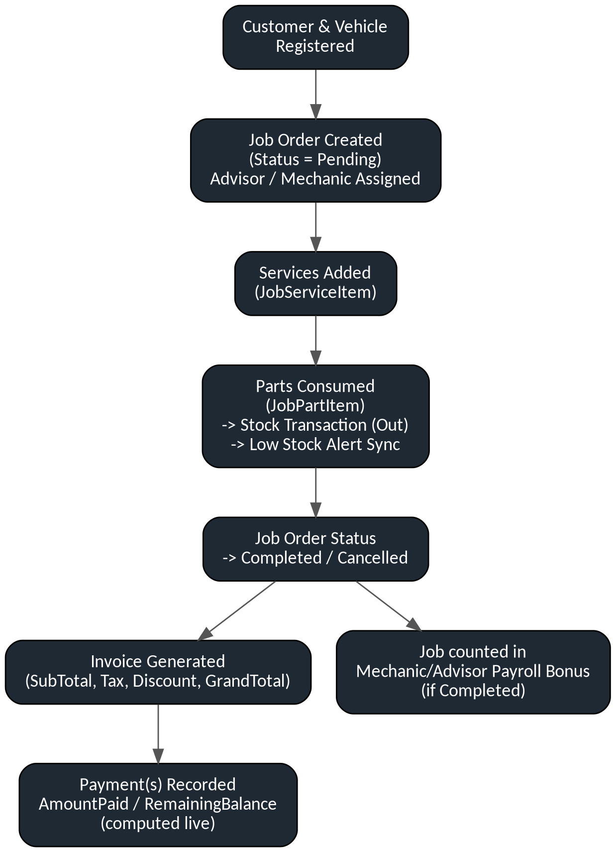
Figure 5.1 — Job order lifecycle, from intake through invoicing and payroll bonus.

5.6 Service Catalog & Job Service Items (ServicesController, JobServiceItemsController)
Purpose: Maintains the catalog of billable labor services and tracks which services (and which Mechanic) were applied to a specific JobOrder.
Database tables: Service, JobServiceItem, JobOrder, Employee
Controller flow: ServicesController performs catalog CRUD (IsActive default true allows soft-retiring a service without deleting historical references); JobServiceItemsController attaches a Service line to a JobOrder with an optional assigned Mechanic.
- A JobServiceItem cannot exist without a valid JobOrder and Service (required, ClientSetNull FKs).
- Assigning a Mechanic to a JobServiceItem is optional (nullable FK_JobServiceItems_Employees).

5.7 Parts & Inventory Catalog (PartsController, CategoriesController)
Purpose: Maintains the parts catalog, categorization, pricing, and current stock levels used across job costing and procurement.
Database tables: Part, Category, Supplier
Controller flow: PartsController CRUD manages CostPrice/SalePrice/CurrentStock/ReorderLevel; every stock-affecting action is expected to route through StockTransaction so the ledger stays authoritative (see 5.9).
- SKU is enforced unique at the database level.
- CostPrice and SalePrice are constrained to 0–9,999,999.99.
- IsActive defaults to true; parts are soft-deactivated rather than hard-deleted where referenced by history.

5.8 Job Part Items (JobPartItemsController)
Purpose: Records parts consumed against a specific JobOrder for accurate job costing and stock depletion.
Database tables: JobPartItem, JobOrder, Part
Controller flow: Create/Edit actions bind a Part and quantity to a JobOrder line; consumption is expected to trigger a corresponding StockTransaction (Type='Out') and a LowStockAlertManager.SyncPart call to keep the reorder-alert state current.
- A JobPartItem requires a valid JobOrder and Part (ClientSetNull FKs, non-nullable).

5.9 Suppliers, Purchase Orders & Stock (SuppliersController, PurchaseOrdersController, PurchaseOrderItemsController, StockTransactionsController, LowStockAlertsController, PurchaseOrderReceivingService, LowStockAlertManager)
Purpose: End-to-end procurement: supplier records, purchase orders and their line items, a dedicated goods-receiving workflow, the immutable stock transaction ledger, and automatic low-stock alerting.
Database tables: Supplier, PurchaseOrder, PurchaseOrderItem, StockTransaction, LowStockAlert, Part
Controller flow: PurchaseOrdersController creates orders against a Supplier; PurchaseOrderItemsController manages line items (Quantity, UnitCost, TotalCost, all validated > 0); the dedicated Receive.cshtml view (per README, a 'goods-receiving dock') and PurchaseOrderReceivingService process the receipt of ordered quantities, which should append StockTransaction rows updating PreviousStock/NewStock on Part; LowStockAlertManager.SyncPart is then invoked to open or resolve a LowStockAlert automatically.
- LowStockAlertManager.SyncPart: if Part.CurrentStock <= Part.ReorderLevel and no active (non-Resolved/Inactive) alert exists, a new LowStockAlert is created with Status='Active'; if an active alert already exists, its CurrentQuantity/ReorderLevel snapshot is refreshed instead of duplicating.
- LowStockAlertManager.SyncPart: if CurrentStock rises above ReorderLevel and an active alert exists, that alert is marked Status='Resolved' with an updated AlertDate and stock snapshot — i.e. resolution is automatic on restock, not a manual user action.
- StockTransaction.Quantity is required and must be > 0 (Range(1, int.MaxValue)); TransactionType is required.
- PurchaseOrderItem.Quantity must be > 0; UnitCost and TotalCost must be > 0.01.

5.10 Employee & HR Management (EmployeesController)
Purpose: Registration and lifecycle management of workshop staff, optionally linked to a login User account.
Database tables: Employee, User
Controller flow: The EmployeeRegistrationViewModel supports a combined employee+user registration workflow (per commit "Implemented employee registration workflow"); CRUD actions validate Pakistani-format CNIC and phone numbers via regular expressions on the Employee entity.
- Employee.Cnic must match ^\d{5}-\d{7}-\d{1}$ (e.g. 12345-1234567-1).
- Employee.Phone must match ^0?3\d{9}$ (Pakistani mobile numbering).
- EmployeeCode is enforced unique at the database level.
- BasicSalary and HourlyRate must be ≥ 0.
- IsActive defaults to true; PayrollCalculationService explicitly refuses to generate payroll for an employee whose IsActive is not true.

5.11 Attendance (AttendancesController)
Purpose: Daily check-in/check-out tracking per employee, feeding directly into payroll calculation.
Database tables: Attendance, Employee
Controller flow: Per README, this controller was extended beyond basic CRUD with Mark/CheckIn/CheckOut/History actions: a self-service Mark view for employees to check themselves in/out, a Management view giving admins a roster of unmarked employees, and a History view for an employee's own monthly log.
- OvertimeHours is constrained to 0–24 per record.
- Attendance.Status values observed as relevant to payroll are 'Present', 'Sick', and 'Leave' — all three count toward the attendance-completeness threshold used by PayrollCalculationService (see 5.12), i.e. approved leave and sick days are treated as compliant attendance, not absence.

5.12 Payroll & Salary Adjustments (PayrollsController, SalaryAdjustmentsController, PayrollCalculationService)
Purpose: Automated monthly payroll generation from attendance and job performance, plus manual bonus/deduction adjustments.
Database tables: Payroll, SalaryAdjustment, Employee, Attendance, JobOrder
Controller flow: PayrollsController triggers PayrollCalculationService.CalculatePayrollAsync(employeeId, month, year); the service computes working weekdays for the month (Saturdays/Sundays excluded), checks attendance completeness against a configurable threshold, computes a per-day rate, applies job-completion bonuses, and derives GrossSalary/NetSalary. SalaryAdjustmentsController allows manual bonus/deduction line items linked to a generated Payroll.
- A payroll cannot be generated for an inactive employee, nor duplicated for the same employee/month/year unless the prior record's status is 'Cancelled'.
- Working days = weekdays only (Mon–Fri) for the target month; weekends are excluded from both the denominator and attendance requirement.
- Attendance completeness threshold is configurable via appsettings.json ("Payroll:CompletenessThreshold", default 0.9 = 90%); payroll generation is refused with "Attendance records are incomplete for this payroll period" if presentCount < ceil(requiredWorkingDays × threshold).
- DailyRate = BasicSalary / requiredWorkingDays; AttendanceDeduction = DailyRate × totalAbsentDays.
- Job completion bonus = 100 currency units per JobOrder completed that month where the employee is either the assigned Mechanic or Advisor.
- OvertimePay = Employee.HourlyRate × sum of OvertimeHours logged that month.
- GrossSalary = BasicSalary + JobBonus + SalaryAdjustmentsTotal + OvertimePay; NetSalary = GrossSalary − AttendanceDeduction.
- If computed NetSalary would be negative, generation is refused ("Calculated net salary is negative. Please review adjustments.") rather than persisting an invalid payroll.
- PayrollNumber is generated as PAY{year}{month:D2}{3-digit sequence}, incrementing per existing prefix-matching records.
- SalaryAdjustment.Amount must be > 0 (adjustments are magnitude-only; AdjustmentType, per AdjustmentTypeHelper, presumably distinguishes bonus vs. deduction direction).
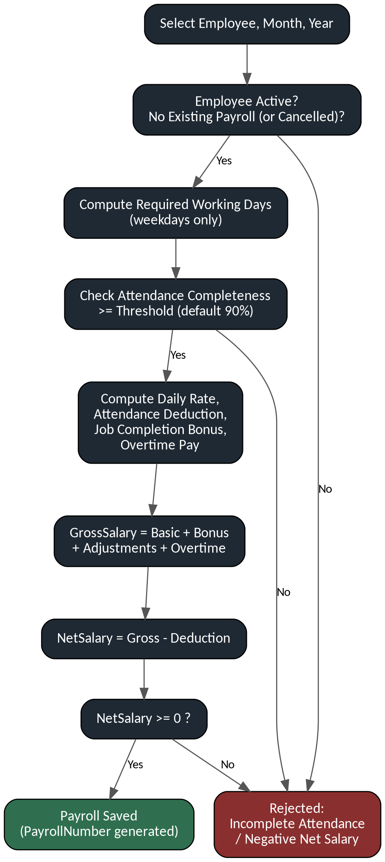
Figure 5.2 — Payroll calculation and validation flow.

5.13 Invoicing & Payments (InvoicesController, PaymentsController)
Purpose: Generates customer-facing invoices from completed job orders and records full or partial payments against them.
Database tables: Invoice, Payment, JobOrder
Controller flow: InvoicesController creates an Invoice from a JobOrder (unique InvoiceNumber, SubTotal/TaxAmount/DiscountAmount/GrandTotal); PaymentsController records one or more Payment rows against an Invoice; Invoice.AmountPaid and Invoice.RemainingBalance are computed live from the Payments collection, never stored, so they can never drift out of sync with the ledger.
- InvoiceNumber is enforced unique at the database level.
- InvoiceStatus defaults to 'Unpaid'; the codebase's PaymentStatus field allows a distinct payment-progress state from the overall invoice status.
- Grand Total, Tax, and Discount amounts are all constrained to be non-negative.
- Partial payments are natively supported: RemainingBalance = GrandTotal − Sum(Payments.AmountPaid), so multiple Payment rows can close a single Invoice over time.

5.14 Notifications (NotificationsController, NotificationService, NotificationHostedService, NotificationBellViewComponent)
Purpose: In-app notification delivery to individual users or an entire role, plus a scheduled background job for time-based reminders.
Database tables: Notification, User, Role, UserRole
Controller flow: NotificationService.CreateForUserAsync/CreateForRoleAsync validate required Title/Message, and for role-targeted notifications fan out one Notification row per user currently holding that role, with duplicate suppression (an identical Title+Message+Type for the same user within 24 hours is not re-created). NotificationHostedService is a BackgroundService that runs continuously and applies date-based rules, e.g. flagging completed job orders ~60 days old for a Service Advisor follow-up reminder, and posting a daily summary notification to the Owner role.
- A Notification requires both Title and Message (ArgumentException otherwise).
- Role-targeted notifications suppress duplicates for the same user/type/title/message within a rolling 24-hour window.
- The 60-day customer follow-up rule triggers for JobOrders with CompletionDate between 60 and 58 days in the past (a narrow rolling window per hosted-service execution), targeted at the Service Advisor role.
- IsRead defaults to false at the database level.

5.15 Audit Logging, Reporting & Dashboards (AuditLogsController, AuditService, ReportsController, ReportingService, DashboardController, DashboardService)
Purpose: Immutable action history for compliance/traceability, plus role-based KPI dashboards and operational reports (Sales, Parts, Outstanding, Top Services).
Database tables: AuditLog, User; and read-only aggregation across JobOrder, Invoice, Payment, Part, LowStockAlert, Customer, Employee
Controller flow: AuditService.LogActionAsync (and its LogCreateAsync/etc. wrappers) captures the acting UserId and IP address from the current session/HttpContext and stores JSON-like old/new value snapshots per record; logging failures are deliberately swallowed (empty catch) so audit logging can never break a business transaction. DashboardService computes month-over-month revenue, active/completed job counts, customer/employee totals, outstanding balance, low-stock-alert counts, and a 6-month revenue trend, per role (Owner/Admin/Advisor/Mechanic dashboards named in the README). ReportingService backs the Sales, Parts, Outstanding, and Top-Services report views.
- Audit logging is fail-safe: an exception while writing an AuditLog is caught and discarded rather than propagated, prioritizing application availability over guaranteed audit completeness.
- Outstanding balance shown on the Owner dashboard is floored at zero (never displayed as negative) even if aggregate payments were to exceed aggregate invoicing.
- 'Active' job orders for dashboard purposes are defined as Status not in {'Completed','Cancelled'}.
Future improvements: AuditLog's silent failure mode is a deliberate availability/completeness trade-off worth revisiting if audit-log completeness becomes a compliance requirement.

Chapter 6 — REST API Layer
The ERP's REST API was added after the initial version of this documentation was written, in commits d7544f8 ("5 modules Api Builded") and db42726 ("API's Added"). This chapter documents the API as it stands at commit db42726, and the table below summarizes what the API introduced relative to the MVC-only baseline.

6.1 What the API Introduced
Aspect | Before (be81bdc) | After (db42726)
API controllers | None | 5 new controllers under /Controllers/Api
Swagger/OpenAPI | Not configured | AddSwaggerGen/AddEndpointsApiExplorer registered; UseSwagger + UseSwaggerUI enabled in Program.cs
Routing | MapControllerRoute only (MVC views) | MapControllers() added alongside, exposing attribute-routed api/ endpoints
Session | AddSession() default | IdleTimeout explicitly set to 20 minutes, HttpOnly cookie, IsEssential=true
Session UX | None | Session-expiry warning modal + countdown added to _Layout.cshtml, backed by a new SessionsApiController.Extend endpoint
appsettings.json | Single LocalDB connection string | A second, commented-out remote SQL connection string (host db58027.databaseasp.net) with a plaintext password was added — see Chapter 8 (Security) for the associated risk

6.2 API Architecture
The new API controllers are attribute-routed ([ApiController], [Route("api/[controller]")]) ASP.NET Core Web API controllers living alongside the existing MVC controllers in the same AutoRepairERD project — this is an API-added-to-MVC pattern, not a separate API project. They inject ApplicationDbContext directly (no separate repository or service layer for the API), use AsNoTracking() for read queries, and define local DTO classes nested inside each controller file (e.g. CustomerDto, CreateCustomerDto, UpdateCustomerDto within CustomersApiController) rather than a shared /DTOs folder.

6.3 Implemented API Controllers
Controller | Base Route | Verbs | Entity
CategoriesApiController | api/categories | GET, GET/{id}, POST, PUT/{id}, DELETE/{id} | Category
CustomersApiController | api/customers | GET, GET/{id}, POST, PUT/{id}, DELETE/{id} | Customer
PartsApiController | api/parts | GET, GET/{id}, POST, PUT/{id}, DELETE/{id} | Part
ServicesApiController | api/services | GET, GET/{id}, POST, PUT/{id}, DELETE/{id} | Service
VehiclesApiController | api/vehicles | GET, GET/{id}, POST, PUT/{id}, DELETE/{id} | Vehicle
SessionsApiController | api/sessions/extend | POST | N/A — session keep-alive

6.4 Endpoint Detail — Customers API (representative example)
Method | Route | Purpose | Notable Behavior
GET | api/customers | List all customers | Projects to CustomerDto; AsNoTracking; no pagination implemented
GET | api/customers/{id} | Fetch one customer | Returns 404 if not found
POST | api/customers | Create a customer | Re-validates entity Data Annotations via TryValidateModel, then enforces email required/format/uniqueness and phone uniqueness explicitly in the controller, mirroring the MVC controller's rules; returns 201 with a CreatedAtAction Location header
PUT | api/customers/{id} | Update a customer | Same validation duplication as Create; catches DbUpdateConcurrencyException distinctly from generic DbUpdateException; returns 204 on success
DELETE | api/customers/{id} | Delete a customer | Blocks deletion with 409 Conflict if the customer has any Vehicles or JobOrders, preventing orphaned history

6.5 Validation and Status Codes
- 400 Bad Request — null/missing request body, or ModelState/data-annotation validation failure (returned via ValidationProblem for a standard ProblemDetails payloads).
- 404 Not Found — GET/PUT/DELETE by an id that does not exist.
- 409 Conflict — uniqueness violations (duplicate email/phone), DbUpdateException, DbUpdateConcurrencyException, or deletion blocked by dependent records.
- 500 Internal Server Error — unexpected exceptions; error messages are deliberately generic ("An unexpected error occurred.") to avoid leaking internal/database details to API callers.

6.6 Business Rules Duplicated from MVC into the API
The API controllers do not currently reuse the MVC controllers' validation logic through a shared service; each API controller re-implements the equivalent rules inline (e.g. CustomersApiController duplicates the email/phone uniqueness checks that CustomersController already performs for the web UI). This is a maintenance risk: a business-rule change made in one layer will not automatically propagate to the other unless both are updated together.

6.7 Swagger Integration
Program.cs registers builder.Services.AddEndpointsApiExplorer() and builder.Services.AddSwaggerGen(), and the middleware pipeline calls app.UseSwagger() followed by app.UseSwaggerUI(), which — per default Swashbuckle/ASP.NET Core conventions — exposes machine-readable OpenAPI JSON at /swagger/v1/swagger.json and an interactive browser UI at /swagger. No custom SwaggerGen options (XML comments, security definitions, API versioning) were found configured beyond the defaults.

6.8 Session Extension Endpoint
SessionsApiController.Extend (POST api/sessions/extend) writes a LastKeepAlive timestamp into the ASP.NET Core Session to reset its 20-minute IdleTimeout. This pairs with the session-expiry warning modal newly added to Views/Shared/_Layout.cshtml, which shows a 30-second countdown and lets the user click "Extend Session" (calling this endpoint via JavaScript) or "Logout" before the session lapses — a UX improvement addressing the session-based-auth limitation noted in Chapter 1.

6.9 API Coverage
Five of the system's 24 entities are currently exposed via REST API: Category, Customer, Part, Service, and Vehicle. The remaining core transactional entities — JobOrder, Invoice, Payment, Employee, Attendance, Payroll, PurchaseOrder, StockTransaction, LowStockAlert, Notification, AuditLog, User/Role/UserRole — have no API surface yet and remain reachable only through the MVC web UI. This API is the integration point for the ERP Consumer application, documented next in Chapter 7.

Chapter 7 — ERP Consumer Application
The ERP Consumer is a second ASP.NET Core MVC application that consumes the ERP's REST API rather than connecting to SQL Server directly. It is maintained in its own repository, separate from the AutoRepair-ERP-System repository analyzed in this document; this chapter documents its architecture and its integration contract with the ERP as designed, so that the two applications are described together as one system even though their source is split across two codebases.
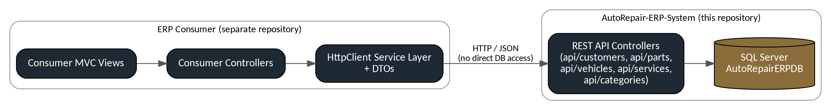
Figure 7.1 — Provider/consumer boundary between the ERP and the ERP Consumer.

7.1 Architectural Position
The Consumer sits entirely outside the ERP's trust boundary shown in Figure 7.1: it holds no connection string, no DbContext, and no direct SQL Server access. Every read or write it performs is translated into an HTTP call against one of the five endpoints documented in Chapter 6 (Category, Customer, Part, Service, Vehicle). This is the core design constraint of the Consumer and the reason it exists as a separate project in the first place — it validates that the ERP's business logic and data access can be reached purely through its API surface.

7.2 HttpClient and Service Layer
A Consumer built against this API is expected to register a named or typed HttpClient (via IHttpClientFactory) per ERP resource — for example an ICustomerApiClient wrapping api/customers — configured with the ERP's base address and any required headers. A thin service layer above the HttpClient translates between the Consumer's own view models and the ERP's DTOs (CustomerDto, CreateCustomerDto, UpdateCustomerDto, and their equivalents for Vehicle, Part, Service, and Category), keeping HTTP and JSON concerns out of the Consumer's controllers.

7.3 DTOs and Contract
Because the ERP's API DTOs are currently declared as nested classes inside each API controller rather than in a shared contracts library, the Consumer cannot reference them directly and must define its own matching DTO classes by hand. This is workable at the current scale of five endpoints, but it is the first thing that should change if the API surface grows: extracting the DTOs into a shared package (or simply a shared /Contracts folder referenced by both projects) would remove a manual synchronization step between the two codebases.

7.4 Dependency Injection
Consistent with the ERP's own use of constructor injection (Chapter 13.2), the Consumer is expected to register its HttpClient-backed services in Program.cs via AddHttpClient<TClient>() and consume them through the standard ASP.NET Core DI container in its controllers, mirroring the pattern already established on the provider side.

7.5 API Consumption Flow
A typical request flows: Consumer view → Consumer controller → Consumer service (HttpClient) → HTTP request to the ERP's api/ endpoint → ERP API controller → ApplicationDbContext → SQL Server, with the response DTO passed back up the same chain and mapped into the Consumer's own view model before rendering.

7.6 Synchronization with the ERP
Because the Consumer holds no local copy of ERP data, there is no synchronization or caching layer to reconcile — every Consumer screen reflects the ERP's current state at request time, at the cost of an extra network round trip per operation compared to a direct database read.

7.7 Advantages of the Consumer Pattern
- Enforces a real API contract: because the Consumer has no back door to the database, any gap in the API surface (see Chapter 6.9 coverage gap) is immediately visible as something the Consumer simply cannot do yet.
- Decouples deployment and scaling of the two applications — the Consumer can be hosted, scaled, or restarted independently of the ERP.
- Demonstrates the ERP's API in a realistic client scenario beyond Swagger UI's own test harness.

7.8 Limitations
- Limited by the current API coverage: only Category, Customer, Part, Service, and Vehicle are reachable; a Consumer cannot yet manage Job Orders, Invoices, Payments, Payroll, or any of the other 19 entities that remain MVC-only.
- No authentication is currently enforced on the ERP's API controllers (Chapter 9.2), so a Consumer built today would be calling an unsecured endpoint — this should be resolved on the provider side before the Consumer is connected to anything beyond a local development instance.
- DTO duplication between the two codebases (Section 7.3) is a manual synchronization burden that will grow with the API surface.

7.9 Design Decisions
Keeping the Consumer as a fully separate project — rather than, for instance, a second set of Razor views inside the same ERP solution — is a deliberate boundary that forces all cross-application communication through the API, rather than allowing convenient but boundary-breaking shortcuts (shared DbContext, shared session, direct SQL access). This is the same reasoning that justifies documenting the Consumer here even though its source lives elsewhere: the two are one system from a requirements standpoint, split into two deployables by design.

Chapter 8 — Consolidated Business Rules
This chapter consolidates the business rules already introduced per-module in Chapters 5 and 6, organized by domain for quick reference.

7.1 Authentication & Authorization
- Login requires an exact match of Username and the raw (unhashed) submitted password against User.PasswordHash.
- A user with no UserRole assignment cannot log in successfully.
- RoleAuthorizeAttribute performs a case-insensitive match between the session's RoleName and the attribute's allowed role list; SessionAuthorizeAttribute requires only a valid session UserID.
- Sessions idle-timeout after 20 minutes; a client-side warning modal appears with a 30-second countdown, backed by api/sessions/extend.

7.2 Customers & Vehicles
- Customer Email is required, must be a valid email format, and must be unique (enforced both in MVC and, redundantly, in the Customers API).
- Customer Phone, if provided, must be unique.
- A Customer cannot be deleted via the API while related Vehicles or JobOrders exist (409 Conflict).
- Every Vehicle must belong to exactly one Customer.

7.3 Employees & Attendance
- Employee.Cnic must match Pakistani CNIC format ^\d{5}-\d{7}-\d{1}$.
- Employee.Phone must match Pakistani mobile format ^0?3\d{9}$.
- EmployeeCode is unique; BasicSalary/HourlyRate must be ≥ 0.
- Attendance.OvertimeHours is capped between 0 and 24 per day.
- For payroll purposes, Attendance.Status values 'Present', 'Sick', and 'Leave' all count as compliant attendance.

7.4 Payroll & Salary Adjustments
- Payroll cannot be generated for an inactive employee, nor duplicated for the same employee/month/year unless the previous record is Cancelled.
- Working days = weekdays only; attendance completeness threshold (default 90%, configurable) must be met or payroll generation is refused.
- DailyRate = BasicSalary / requiredWorkingDays; AttendanceDeduction = DailyRate × absent days.
- Job-completion bonus = 100 per JobOrder completed that month where the employee is Mechanic or Advisor.
- NetSalary must not be negative or generation is refused.
- SalaryAdjustment.Amount must be > 0.

7.5 Job Orders, Services & Parts
- JobNumber and InvoiceNumber are globally unique.
- JobOrder.Status defaults to 'Pending'; 'Completed' and 'Cancelled' are treated specially by dashboard and payroll logic.
- EstimatedCost/FinalCost/CostPrice/SalePrice must all be non-negative; Part prices are capped at 9,999,999.99.

7.6 Procurement & Inventory
- StockTransaction.Quantity must be > 0; PurchaseOrderItem.Quantity must be > 0 and UnitCost/TotalCost must be > 0.01.
- A LowStockAlert is auto-opened when Part.CurrentStock falls to or below Part.ReorderLevel, and auto-resolved when stock rises back above it — no manual alert management is required in the happy path.

7.7 Invoicing & Payments
- Invoice.GrandTotal, TaxAmount, and DiscountAmount must be non-negative; InvoiceStatus defaults to 'Unpaid'.
- AmountPaid and RemainingBalance are always computed live from the Payments collection, never persisted, guaranteeing they cannot drift from the underlying ledger.

7.8 Notifications & Audit
- A Notification requires both Title and Message.
- Role-broadcast notifications suppress exact duplicates for the same user within a rolling 24-hour window.
- Audit logging failures are swallowed silently so they can never break a business transaction — availability is prioritized over guaranteed audit completeness.

Chapter 9 — Security

8.1 Authentication Model
Authentication is custom-built rather than using ASP.NET Core Identity: credentials are checked with a direct SQL-mapped equality comparison (Username == model.Username && PasswordHash == model.Password) and successful login state is stored server-side in ASP.NET Core Session.

8.2 Confirmed Security Findings
- Plain-text password storage and comparison. The PasswordHash column name is misleading — no hashing algorithm (BCrypt, PBKDF2, Argon2, or ASP.NET Core's IPasswordHasher<T>) is applied anywhere in AuthController or DbSeeder. This is explicitly acknowledged as a known limitation in the project's own README under "Known Limitations (Fix Before Production)".
- A remote SQL Server connection string, including a plaintext password, is committed to appsettings.json (commented out, but present in Git history and the working tree): "Server=db58027.databaseasp.net; ... Password=W_c74nE=z-8G;". Even commented out and even if the credential is later rotated, once a secret is committed to a public Git repository it should be treated as compromised — this is a genuine, actionable finding independent of whether the code path is active. Recommendation: remove the credential from source control immediately, rotate the password on the database host, and use environment variables, .NET User Secrets, or a secret manager (e.g. Azure Key Vault) for connection strings in any environment beyond local development.
- Session-based authentication state does not survive an application restart and does not scale horizontally without a distributed session store (e.g. SQL Server or Redis session provider), which is acceptable for the single-workshop-server deployment target stated in the README but a constraint for any multi-instance deployment.
- API controllers have no authentication/authorization attributes ([Authorize], API keys, or JWT bearer checks) applied — the api/customers, api/parts, api/vehicles, api/services, and api/categories endpoints are reachable by any caller who can reach the host, independent of the MVC session-based login. This is a materially different trust boundary from the rest of the application and should be secured before any non-local deployment.

8.3 Authorization Model
Enforced entirely through the two custom action filters (SessionAuthorizeAttribute, RoleAuthorizeAttribute) applied per-controller/action, rather than the framework's built-in [Authorize] policy system. This gives fine-grained per-role control matching the six seeded roles (Owner, Admin, Service Advisor, Mechanic, Inventory Manager, Receptionist) but means authorization logic is hand-rolled rather than benefiting from the hardened, well-tested ASP.NET Core Identity/Authorization middleware.

8.4 Session Management
IdleTimeout is explicitly configured to 20 minutes (up from the framework default of 20 minutes for cookie-based session in this version — previously unset), the session cookie is HttpOnly, and IsEssential=true ensures it is not blocked by cookie-consent middleware. A client-side countdown/warning modal and a keep-alive endpoint (api/sessions/extend) were added to improve UX around this timeout.

8.5 Input Validation
Validation is layered: Data Annotations on entity classes ([Required], [StringLength], [Range], [RegularExpression], [EmailAddress]) are checked via ModelState.IsValid in MVC controllers and via TryValidateModel(entity) in the new API controllers, supplemented by explicit uniqueness checks (email, phone, SKU, JobNumber, InvoiceNumber, EmployeeCode) performed as direct database queries before save.

8.6 Recommendations Before Production Use
- Replace plain-text password comparison with ASP.NET Core Identity's PasswordHasher<T> or BCrypt.Net-Next, and force a password reset for all seeded/demo accounts.
- Remove the committed remote connection string and password from appsettings.json and Git history; rotate the credential.
- Add authentication (session-cookie forwarding, API key, or JWT bearer) to the new Api controllers before exposing them outside localhost.
- Move all connection strings and secrets to environment-specific configuration (User Secrets locally, environment variables or a secret manager in any hosted environment).
- Introduce HTTPS enforcement and HSTS consistently (already partially present via UseHsts() in non-development environments) across all environments, including any future API-only deployment.

Chapter 10 — User Interface
The UI is server-rendered Razor views styled with a custom 'dark-gold' design system (per README: ~1,400 lines of custom CSS in wwwroot/css/site.css, plus wwwroot/js/site.js for animations and a live clock), replacing the project's earlier default Bootstrap styling.

9.1 Layout & Navigation
Views/Shared/_Layout.cshtml provides the common shell (sidebar, header, notification bell, toast container, and — as of the latest commit — the session-expiry warning modal). Views/Shared/_SidebarNav.cshtml renders role-aware navigation links driven by the session's RoleName, showing only the modules each of the six roles is permitted to use (see README §6, Role Access Matrix).
- << Insert Screenshot: Application Shell / Sidebar Navigation >>

9.2 Authentication Screens
Auth/Login.cshtml and Auth/SelectRole.cshtml were reskinned with a video background (wwwroot/videos/mechanic-bg.mp4) and a translucent 'glass card' login form.
- << Insert Screenshot: Login Screen >>
- << Insert Screenshot: Role Selection Screen (multi-role accounts) >>

9.3 Role-Based Dashboards
Four dashboards exist under Views/Dashboard (Owner, Admin, Advisor, Mechanic), each backed by DashboardService and showing role-relevant KPIs — revenue this/last month, active/completed job counts, outstanding balance, low-stock alert count, customer/employee totals, and a six-month revenue trend for the Owner view.
- << Insert Screenshot: Owner Dashboard >>
- << Insert Screenshot: Mechanic Dashboard (My Assigned Jobs) >>

9.4 Operational Screens
Each of the fifteen modules documented in Chapter 5 exposes standard Index/Details/Create/Edit/Delete views, with dedicated non-CRUD screens for specialized workflows:
- Attendances/Mark.cshtml — employee self-service check-in/check-out.
- Attendances/Management.cshtml — admin roster showing unmarked employees for the day.
- Attendances/History.cshtml — an employee's own monthly attendance log.
- PurchaseOrders/Receive.cshtml — a dedicated goods-receiving dock for marking ordered parts as received into stock.
- Admin/Settings.cshtml — application settings screen.
- Reports/* — Sales, Parts, Outstanding, and Top-Services report views backed by ReportingService.
- << Insert Screenshot: Job Order creation/detail screen >>
- << Insert Screenshot: Purchase Order Receiving Dock >>
- << Insert Screenshot: Invoice / Payment screen >>

9.5 Badges and Status Presentation
Helpers/BadgeHelper.cs maps domain status strings (e.g. JobOrder.Status, Invoice.InvoiceStatus, LowStockAlert.Status) to CSS badge classes for consistent color-coded status presentation across views, and Helpers/AdjustmentTypeHelper.cs supports consistent display of SalaryAdjustment types.

9.6 Notifications UI
ViewComponents/NotificationBellViewComponent renders a bell icon with unread-count badge in the shared layout header, reused across every page, backed by NotificationBellViewModel.

Chapter 11 — Testing
No automated test project exists in the repository at the time of writing. The sections below document what is verifiable through static analysis and manual verification, and set out the recommended testing approach for the areas of highest business-rule density.

10.1 Testing Strategy Actually Evidenced
The commit history (e.g. "Attendance employee dropdown and validation improvements", "Employee module completed, attendance improved, vehicle validation in progress") indicates iterative manual testing and validation hardening during development, consistent with a solo/small-team manual QA process rather than automated regression testing.

10.2 Recommended Testing Approach

10.2.1 Unit Testing
The Services/ layer (PayrollCalculationService, LowStockAlertManager, NotificationService, DashboardService, ReportingService) is well-isolated from HTTP concerns and is the highest-value target for unit tests — particularly PayrollCalculationService's working-day, completeness-threshold, and net-salary-floor logic, which contains the system's most intricate business rules.

10.2.2 Integration Testing
EF Core's InMemory or SQLite providers can validate ApplicationDbContext relationship configuration (the numerous DeleteBehavior.ClientSetNull constraints) without requiring a live SQL Server instance.

10.2.3 API Testing
With Swagger UI now enabled (/swagger), the five new API controllers can be exercised interactively or via automated tools (Postman, curl, or xUnit + WebApplicationFactory) — each endpoint's documented status codes in Chapter 6.5 are directly testable assertions.

10.2.4 Manual / UAT Testing
The four seeded demo accounts (owner/admin/advisor/mechanic, password Passw0rd!) allow immediate manual acceptance testing of each role's dashboard and permitted modules without additional setup.

10.3 Known Defects Acknowledged in the Repository
- Plain-text password storage (README, Known Limitations #1).
- Session-based auth does not survive server restart (README, Known Limitations #2).
- Original Migrations folder shipped empty in an earlier state of the repository, requiring manual dotnet ef migrations add (README, Known Limitations #3) — a single InitialCreate migration is present as of this analysis.

Chapter 12 — Deployment

11.1 Local Development Deployment (as documented in README)
- Prerequisite: .NET SDK 10.0, SQL Server or LocalDB, EF Core CLI tools (dotnet tool install -g dotnet-ef).
- Configure DefaultConnection in appsettings.json.
- Run dotnet ef migrations add InitialCreate && dotnet ef database update to create the schema.
- Run dotnet run; DbSeeder runs automatically on startup, idempotently creating the six roles and four demo accounts.
- Application listens on http://localhost:5127 and https://localhost:7081, redirecting to /Auth/Login.

11.2 Publish Configuration
A Properties/PublishProfiles/FolderProfile.pubxml was added in the latest commit, indicating a folder-based publish profile (dotnet publish targeting a local output folder) has been configured — consistent with deployment to a traditional Windows/IIS host or a hosting provider expecting a pre-built folder rather than a container image.

11.3 Database Deployment
The commented-out remote connection string added to appsettings.json (host db58027.databaseasp.net) suggests the developer was preparing to point the application at a hosted SQL Server instance (a common free/low-cost ASP.NET hosting provider pattern) for a public demo deployment. As flagged in Chapter 9, this credential must be removed from source control and rotated regardless of whether that deployment is pursued.

11.4 API Deployment
Because the API controllers are hosted in the same project/process as the MVC application (not a separate deployable), API deployment is not distinct from application deployment — Swagger UI and the api/ routes become available wherever the main application is hosted, subject to the authentication gap noted in Chapter 9.2.

11.5 Environment Considerations
- app.UseHsts() and exception-handler redirection only activate when Environment is not Development — standard ASP.NET Core convention, confirmed present in Program.cs.
- EF Core 10 / .NET 10 are current-generation/preview-adjacent at time of writing; the README explicitly notes NuGet restore warnings are expected and not build-blocking.
- Missing from the repository and therefore not documentable: containerization (no Dockerfile), CI/CD pipeline (no GitHub Actions workflow), and infrastructure-as-code.

Chapter 13 — Code Quality and Engineering Practices

12.1 Layer Separation
The project maintains a reasonably clean separation between Controllers (HTTP/orchestration), Services (business logic), and Models (persistence), which is a deliberate and consistently applied pattern across the MVC side of the codebase. The newly added API controllers are a partial exception: they re-implement validation inline rather than delegating to the existing Services layer, which is the clearest architectural inconsistency currently in the code.

12.2 Dependency Injection
All Services (AuditService, DashboardService, ReportingService, PayrollCalculationService, PurchaseOrderReceivingService, NotificationService) and the ApplicationDbContext are registered and consumed through constructor injection via the built-in ASP.NET Core DI container, with NotificationHostedService correctly using IServiceProvider.CreateScope() to resolve scoped services from within a singleton-lifetime background service — a detail many implementations get wrong.

12.3 SOLID Observations
- Single Responsibility: mostly respected — each Service class has one clear purpose (e.g. LowStockAlertManager only synchronizes alert state).
- Open/Closed: RoleAuthorizeAttribute is parameterized by role names, allowing new role-gated actions without modifying the filter itself.
- Dependency Inversion: Services depend on ApplicationDbContext directly rather than an abstraction (e.g. no IApplicationDbContext or repository interfaces), which is a pragmatic choice for a single-database, single-provider application but limits unit-testability without an EF Core in-memory/SQLite substitute.

12.4 Maintainability, Scalability, Extensibility
Maintainability is aided by consistent naming, XML-doc comments on several service methods, and defaults defined at the database layer (reducing the chance of inconsistent application-level defaults). Scalability is currently constrained by in-memory session state (see Chapter 9.3) and by the API layer's direct DbContext coupling with no caching layer. Extensibility is reasonably good: adding a new module generally means adding a Model, a Controller, matching Views, and (optionally) a Service — a pattern the codebase already follows fifteen times over.

12.5 Performance Notes
- API GET endpoints correctly use AsNoTracking() for read-only projections, avoiding unnecessary EF Core change-tracking overhead.
- No pagination is implemented on any list endpoint (MVC Index views or the new API GET-all endpoints), which will become a performance concern as Customers, Parts, JobOrders, etc. grow.
- DashboardService issues multiple sequential await-ed queries per dashboard load rather than a single aggregated query or parallel Task.WhenAll, which is simple and readable but not the most efficient pattern for a high-traffic deployment.

Chapter 14 — Future Enhancements
- Replace plain-text password handling with proper hashing (highest priority — see Chapter 9).
- Remove and rotate the committed remote database credential (highest priority — see Chapter 9).
- Secure the API layer with authentication (JWT bearer, API key, or shared session cookie validation) before any non-local deployment.
- Extend REST API coverage to the remaining 19 entities (JobOrder, Invoice, Payment, Employee, Attendance, Payroll, PurchaseOrder, StockTransaction, LowStockAlert, Notification, AuditLog, User, Role, UserRole, and the item/junction tables), consolidating validation into the existing Services layer to avoid the duplication noted in 12.1.
- Build the previously-envisioned ERP Consumer client application against the now-existing API, or clearly retire that requirement if not planned.
- Add an automated test project (unit tests for PayrollCalculationService and LowStockAlertManager would have the highest immediate value given their business-rule density).
- Add pagination/filtering to list endpoints and dashboard queries as data volume grows.
- Introduce CI (build + eventually test) via GitHub Actions, and containerize the application for portable deployment.
- Consider ASP.NET Core Identity or a distributed session/cache provider if multi-instance deployment is ever required.

Chapter 15 — Conclusion
The AutoRepair ERP System, as it exists in the analyzed repository, is a functionally complete, single-tenant workshop management application covering the full operational lifecycle of an auto repair business: customer and vehicle intake, job order execution with technician assignment, parts and service costing, procurement and stock control with automatic reorder alerting, invoicing with partial-payment support, HR/attendance-driven automated payroll, role-based dashboards, and audit logging. Development proceeded through five identifiable, evidence-based phases across 21 commits, moving from schema/CRUD foundations to a fully reskinned, role-aware frontend, and — most recently — a first REST API layer with Swagger documentation covering five of its twenty-four entities.
This documentation has deliberately avoided inventing content the repository does not support: it does not claim a finished multi-project API/Consumer architecture, a Jira-driven agile process, or an automated test suite, because none of these exist in the codebase at the time of writing. What it does provide is a complete, source-grounded account of the system's architecture, data model, business rules, and security posture, including concrete, prioritized recommendations — plain-text password remediation and the exposed database credential chief among them — that should be addressed before any production or public deployment.

References
- Repository: https://github.com/ABDULLAH-CODING-OSS/AutoRepair-ERP-System (branch: main, analyzed at commits be81bdc and, following an update, db42726)
- Microsoft Docs — ASP.NET Core MVC: https://learn.microsoft.com/aspnet/core/mvc
- Microsoft Docs — Entity Framework Core: https://learn.microsoft.com/ef/core
- Microsoft Docs — ASP.NET Core Session and State Management: https://learn.microsoft.com/aspnet/core/fundamentals/app-state
- Swashbuckle / Swagger for ASP.NET Core: https://github.com/domaindrivendev/Swashbuckle.AspNetCore

Appendix A — Full Entity List
Attendance, AuditLog, Category, Customer, Employee, Invoice, JobOrder, JobPartItem, JobServiceItem, LowStockAlert, Notification, Part, Payment, Payroll, PurchaseOrder, PurchaseOrderItem, Role, SalaryAdjustment, Service, StockTransaction, Supplier, User, UserRole, Vehicle — 24 entities total, all defined under /Models and registered as DbSet<T> properties on ApplicationDbContext.

Appendix B — Full Controller List
MVC (27): AdminController, AttendancesController, AuditLogsController, AuthController, CategoriesController, CustomersController, DashboardController, EmployeesController, HomeController, InvoicesController, JobOrdersController, JobPartItemsController, JobServiceItemsController, LowStockAlertsController, NotificationsController, PartsController, PaymentsController, PayrollsController, PurchaseOrderItemsController, PurchaseOrdersController, ReportsController, RolesController, SalaryAdjustmentsController, ServicesController, StockTransactionsController, SuppliersController, UserRolesController, UsersController, VehiclesController.
API (5, added later — see Chapter 6): CategoriesApiController, CustomersApiController, PartsApiController, ServicesApiController, SessionsApiController, VehiclesApiController.

Appendix C — Demo Credentials (Development Only)
Username | Role | Password
owner | Owner | Passw0rd!
admin | Admin | Passw0rd!
advisor | Service Advisor | Passw0rd!
mechanic | Mechanic | Passw0rd!
Important: These are development seed credentials from DbSeeder.cs and the project README. They must never be used, or left active, in a production deployment.

