BAHRIA UNIVERSITY,

(Karachi Campus)

Department of Software Engineering

Assignment #03– Spring 2022

Complex Engineering Problem

COURSE TITLE: D&AA COURSE CODE: CSC-321 Class: BSE 4 Shift: Morning

Course Instructor: ENGR. BUSHRA FAZAL KHAN Assignment Date: 08- Jun -2022

Max. Marks: 4 Points(CLO3) Assignment Due: 20-Jun-2022

Name:Abdul Quddos Enrollment No:02-131202-033

Question No 1

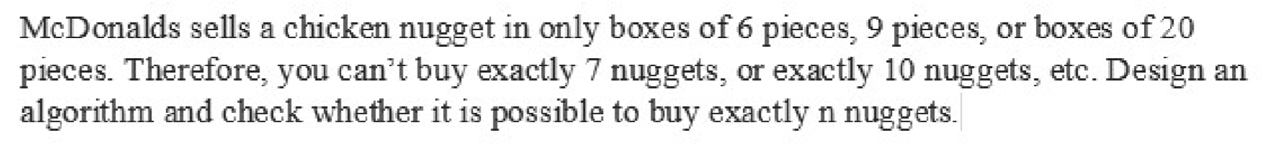

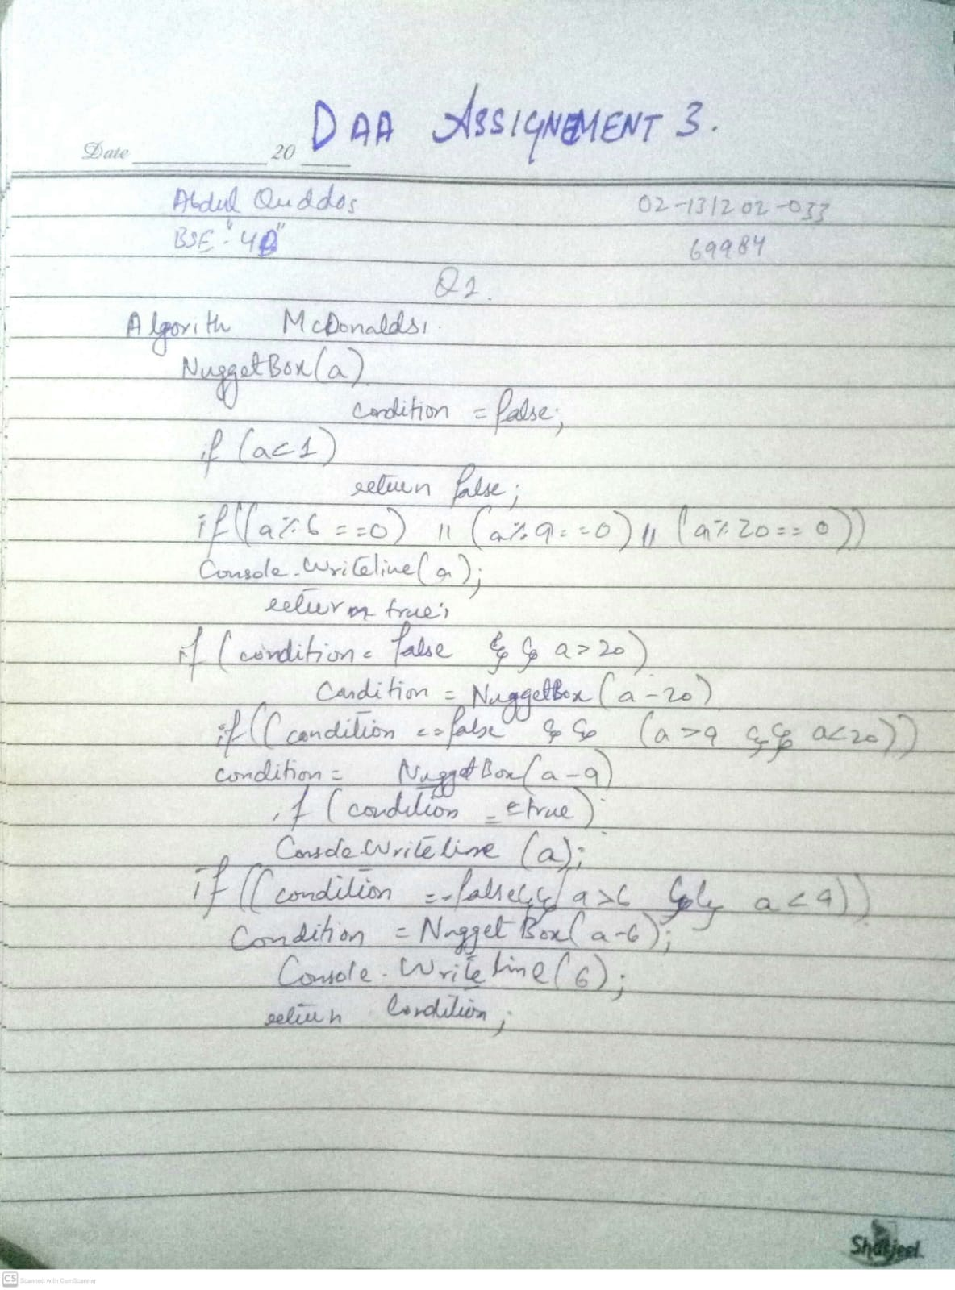

Question No 2

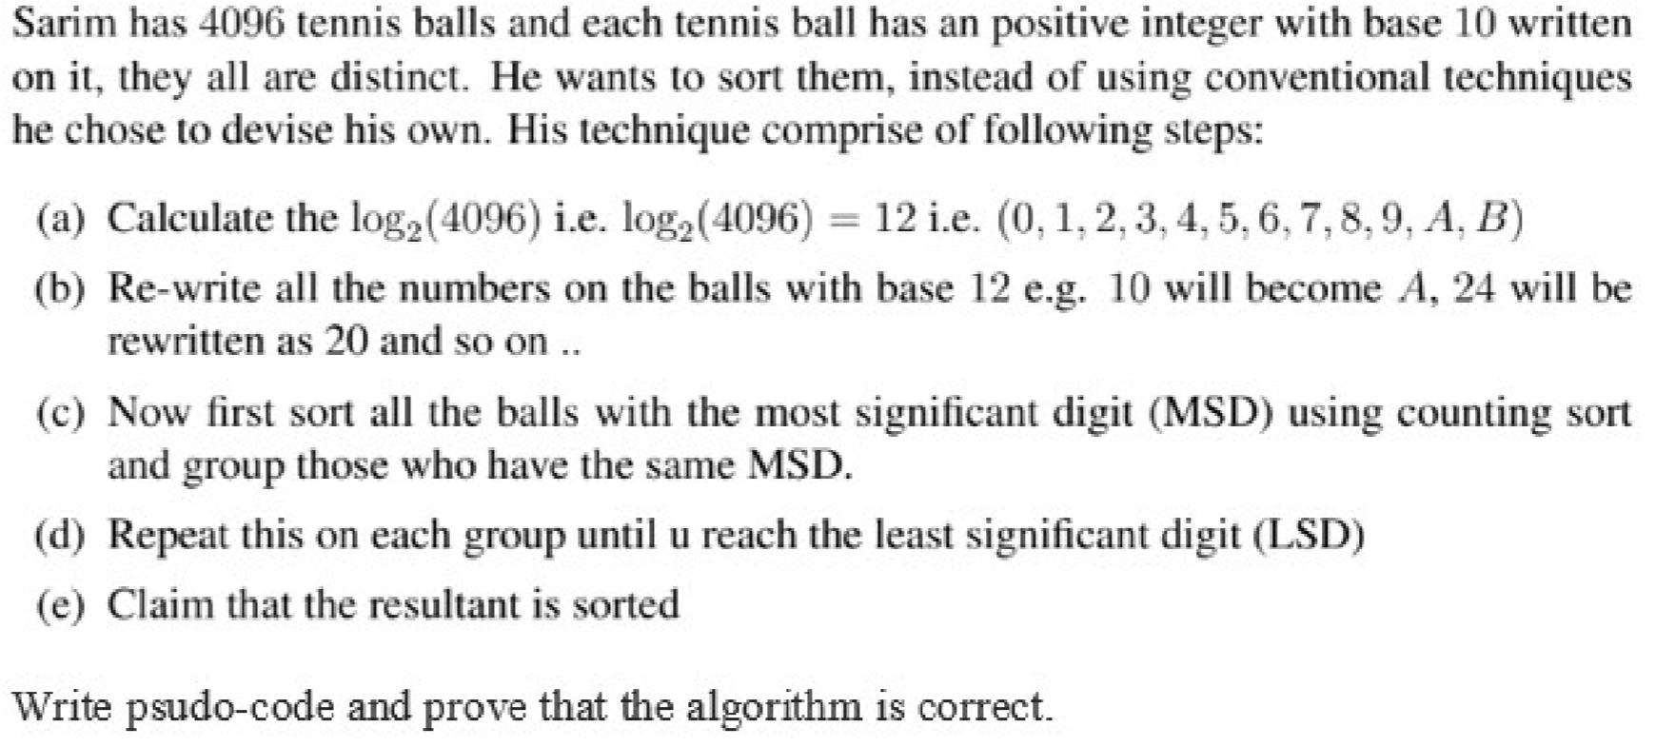

# Algorithm customSorting(char[] tennisBalls):-

**//Input: -** An array of the labels of 4096 tennis balls tennisBalls.

//**Output: -** A sorted array sortedTennisBalls int logValue = Math.log(4096) //returns 12 int aValue = 10,bValue = 11,inc = 0; for (int I = 0;I < tennisBalls.length;I++) {

if (I == aValue) { tennisBalls[i] = ‘A’; aValue = aValue + 10;

}

If (I == bValue) {

tennisBalls[i] = ‘B’; bValue = bValue + 10;

}

Else { tennisBalls[i] = ‘’+inc; inc++;

} }

radixSort(tennisBalls);

for (int I = 0;I < tennisBalls.length;i++) {

print tennisBalls[i];

}