|  |  |
| --- | --- |
| **CSC-220– Database Management System- Assignment 3** | |
| CLO-3 | Deadline: 19th June, 2022 |
| Class: BSE-4A/4B | Total Marks 5 |
| Name:Abdul Quddos | Enrollment:02-131202-033 |

1. Consider the following two transactions:

T1: read(A); read(B); if A = 0 then B := B + 1; write(B). T2: read(B); read(A); if B = 0 then A := A + 1; write(A).

Add lock and unlock instructions to transactions T1 and T2, so that they observe the two-phase locking protocol. Can the execution of these transactions result in a deadlock?

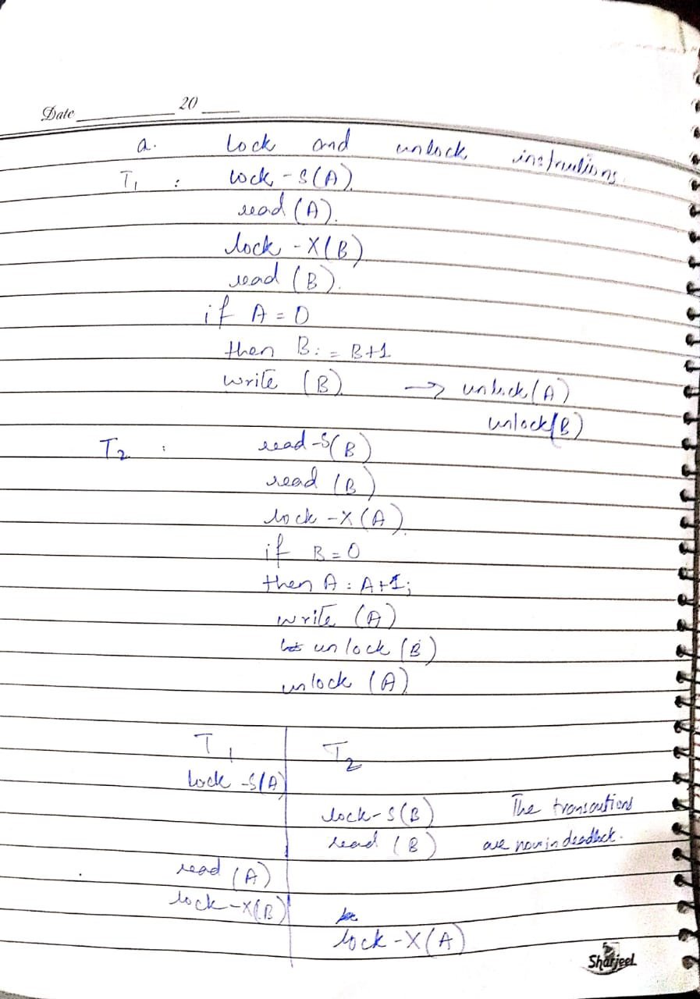

1. Consider the given log. Suppose there is a crash just before the log record*<T*0 abort*>*is written out. Explain what would happen during recovery.

<*T0* start>

<*T0*, *B*, 2000, 2050>

<*T1* start>

<*T1*, C, 700, 600>

<*T1* commit>

<*T2* start>

<*T2*, A, 500, 400>

<*T0*, B, 2000>

<*T0* abort>

<*T2*, A, 500>

<*T2* abort>

