|  |  |
| --- | --- |
| **CSC-220– Database Management System- Assignment 2** | |
| CLO-4 | Deadline: 29th April, 2022 |
| Class: BSE-4A/4B | Total Marks 5 |
| Name:Abdul Quddos | Enrollment No:02-131202-033 |

Select any online database to explore what information it provides. Then list the entities and attributes (as per your perspective) that the company running the Web site must keep track of in its databases.

Design a conceptual schema and draw an ER diagram for your schema. The preceding information describes the situation that the database must model. Be sure to indicate all keys and cardinality constraints and any assumptions you make.

**Daraz Online Shopping System ER Diagram:**

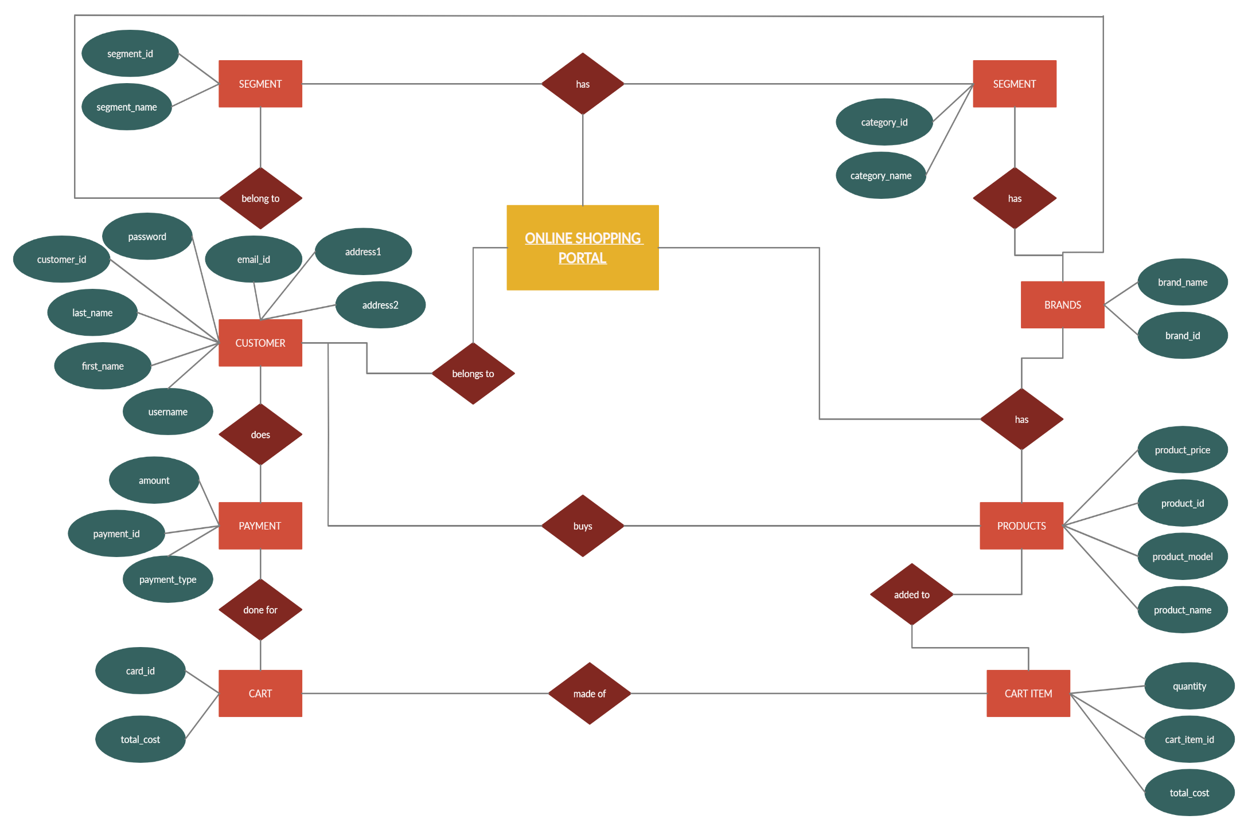

1