

**BAHRIA UNIVERSITY,**

**)**

**Karachi Campus**

**(**

*Department of Software Engineering*

**ASSIGNMENT #. 02**

**–**

**Spring 2021**

COURSE TITLE:

**Operating Systems**

COURSE CODE:

**CSC**

**-**

**320**

Class:

**BSE**

**-**

**)**

**A & B**

**4(**

Shift:

**Morning**

Course Instructor:

**Engr. Rizwan Fazal**

Date:

**17**

**-**

**MAY**

**-**

**2021**

Due Date:

**04**

**-**

**JUNE**

**-**

**)**

**pm**

**2021 (4**

Max. Marks:

**10**

**Points**

**Instructions:**

**1.**

**Attempt all**

**questions.**

**2.**

**This is an individual effort**

**task.**

**3.**

**Only handwritten answers are accepted on A4 size**

**papers**

**4.**

**Write your full name, registration number and section on the title page at**

**tached with**

**this assignment.**

**Assignment WITHOUT title page will NOT be**

**(**

**accepted!)**

**5.**

**The given deadline is final and will not be extended in any case, therefore, it**

**is**

**highly recommended to start it as soon as**

**possible**

[

CLO

-

?]

**Q.**

Referring to the book ti

tle ‘

**O**

**PERATING**

**S**

**YSTEMS**

**, I**

**NTERNALS AND**

**D**

**ESIGN**

**P**

**RINCIPLES**

’, 9

th

edition, by William Stallings, Chapter #. 9, Page #. 456, (Problems section), attempt the

following questions in the

*given order*

.

•

Problem #: 9.1 and 9.2 (total 2 problem questions)

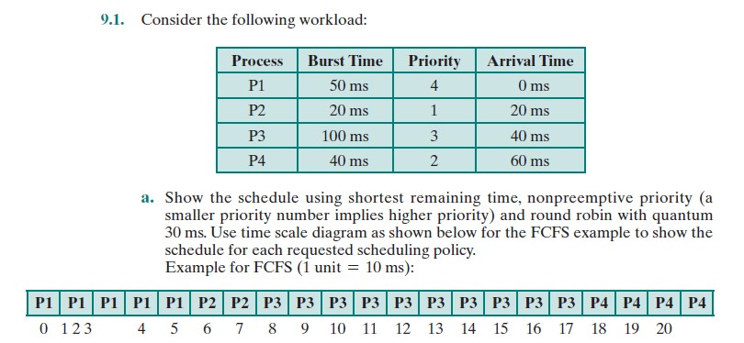

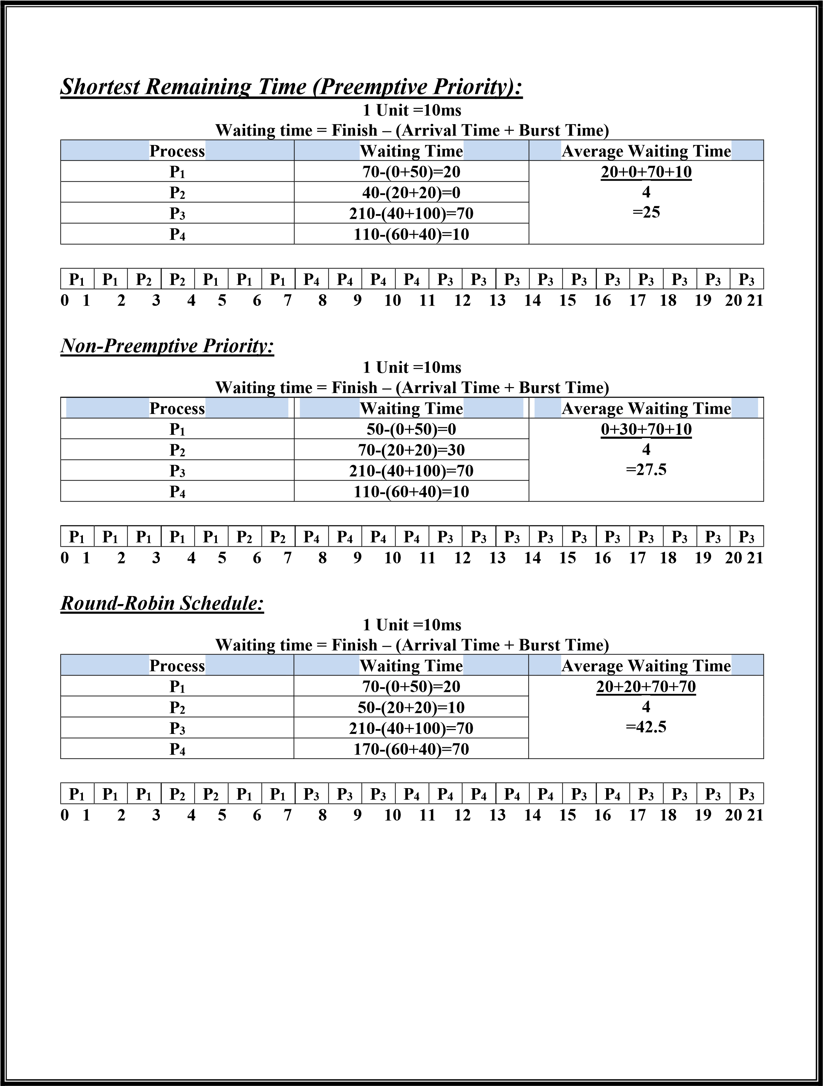

|  |  |  |  |  |  |  |  |  |  |  |  |  |  |  |  |  |  |  |  |  |  |  |  |  |  |  |  |  |  |  |  |  |  |  |  |  |  |  |  |  |  |  |  |  |  |  |  |
| --- | --- | --- | --- | --- | --- | --- | --- | --- | --- | --- | --- | --- | --- | --- | --- | --- | --- | --- | --- | --- | --- | --- | --- | --- | --- | --- | --- | --- | --- | --- | --- | --- | --- | --- | --- | --- | --- | --- | --- | --- | --- | --- | --- | --- | --- | --- | --- |
| **FACTORS OF ROUND ROBIN:**  The performance of round robin scheduling is heavily dependent on the selection of the size of quantum. That’s why time quanta are effective in the performance of round robin scheduling. Time quanta affect the performance in such ways:  1. Setting too short time quanta becomes the reason for many context switching and because of this, the CPU efficiency gets lower. Setting too long time quanta will result for poor response to the short processes.    ***Round-Robin Schedule:***  ***Time Quanta q=2***  **Turnaround Time(TAT)=Finish - Arrival Ready Queue:**     |  |  |  |  |  |  |  |  |  |  |  |  |  |  |  | | --- | --- | --- | --- | --- | --- | --- | --- | --- | --- | --- | --- | --- | --- | --- | | **P1** | **P2** | **P1** | **P2** | **P1** | **P3** | **P2** | **P4** | **P1** | **P3** | **P4** | **P1** | **P3** | **P1** | **P3** |   **Running Queue:**     |  |  |  |  |  |  |  |  |  |  |  |  |  |  |  |  |  |  |  |  | | --- | --- | --- | --- | --- | --- | --- | --- | --- | --- | --- | --- | --- | --- | --- | --- | --- | --- | --- | --- | | **P1** | **P2** | **P1** | **P2** | **P1** | **P3** | **P2** | **P4** | **P1** | **P3** | **P4** | **P1** | **P3** | **P1** | **P3** | **P3** | **P4** | **P3** | **P3** | **P3** |   **0 2 4 6 8 10 12 14 16 18 20 22 24 26 28 30 32 34 36 38 40**  ***Context Switching =15 Times*** | | | | | | | | | | | | |
|  |  | **Process** |  |  | **Exit Time** |  |  | **Turnaround Time** |  |  | **Average Turnaround Time** |  |
| **P1** | | | **28** | | | **28-0=28** | | | **28+12+32+12**  **4**  **=21** | | |
| **P2** | | | **14** | | | **14-2=12** | | |
| **P3** | | | **40** | | | **40-8=32** | | |
| **P4 22 22-10=12**      ***Round-Robin Schedule:***  ***Time Quanta q=4***  **Turnaround Time(TAT)=Finish - Arrival Ready Queue:**     |  |  |  |  |  |  |  |  | | --- | --- | --- | --- | --- | --- | --- | --- | | **P1** | **P2** | **P1** | **P3** | **P2** | **P4** | **P1** | **P3** | | | | | | | | | |

|  |  |  |  |  |  |  |  |  |  |  |  |  |  |  |  |  |  |  |  |  |  |  |
| --- | --- | --- | --- | --- | --- | --- | --- | --- | --- | --- | --- | --- | --- | --- | --- | --- | --- | --- | --- | --- | --- | --- |
| **Running Queue:**     |  |  |  |  |  |  |  |  |  |  | | --- | --- | --- | --- | --- | --- | --- | --- | --- | --- | | **P1** | **P2** | **P1** | **P3** | **P2** | **P4** | **P1** | **P3** | **P3** | **P3** |   **0 4 8 12 16 18 22 26 30 34 36**  ***Context Switching =7 Times*** | | | | | | | | | | | | |
|  |  | **Process** |  |  | **Exit Time** |  |  | **Turnaround Time** |  |  | **Average Turnaround Time** |  |
| **P1** | | | **26** | | | **26-0=26** | | | **26+16+28+12**  **4**  **=20.5** | | |
| **P2** | | | **18** | | | **18-2=16** | | |
| **P3** | | | **36** | | | **36-8=28** | | |
| **P4** | | | **22** | | | **22-10=12** | | |
| ***Round-Robin Schedule:***  ***Time Quanta q=8***  **Turnaround Time(TAT)=Finish - Arrival Ready Queue:**     |  |  |  |  |  |  | | --- | --- | --- | --- | --- | --- | | **P1** | **P2** | **P3** | **P1** | **P4** | **P3** |   **Running Queue:**     |  |  |  |  |  |  |  | | --- | --- | --- | --- | --- | --- | --- | | **P1** | **P2** | **P3** | **P1** | **P4** | **P3** | **P3** |   **0 8 14 24 28 32 40 42**  ***Context Switching =5 Times*** | | | | | | | | | | | |
| **Process** | | | **Exit Time** | | | **Turnaround Time** | | | **Average Turnaround Time** | | |
| **P1** | | | **28** | | | **28-0=28** | | | **28+12+34+22**  **4**  **=24** | | |
| **P2** | | | **14** | | | **14-2=12** | | |
| **P3** | | | **42** | | | **42-8=34** | | |
| **P4** | | | **32** | | | **32-10=22** | | |
| **Submitted by:**    Name: ADIL WAHEED  Registration #: 65190  Section: 4A | | | | | | | | | | | |