Software Requirements Specification

Museum Management System

Version 1.0 approved

Prepared by:

Date created: 29th Jan,2022

Table of Contents

1. Introduction

1.1 Purpose

1.2 Document Conventions

1.3 Intended Audience and Reading Suggestions

1.4 Product Scope

1.5 References

2. Overall Description

2.1 Product Perspective

2.2 Product Functions

2.3 User Classes and Characteristics

2.4 Operating Environment

2.5 Design and Implementation Constraints

2.6 User Documentation

2.7 Assumptions and Dependencies

3. External Interface Requirements

3.1 User Interfaces

3.2 Hardware Interfaces

3.3 Software Interfaces

3.4 Communications Interfaces

4. System Features

4.1 System Feature 1

5. Other Nonfunctional Requirements

5.1 Performance Requirements

5.2 Safety Requirements

5.3 Security Requirements

5.4 Software Quality Attributes

5.5 Business Rules

6. Other Requirements

Appendix A: Glossary



# Introduction

## Purpose and Scope:

To make a Software System that will help the Martine Museum staff to improve their work efficiency and work environment by taking care of their employees and their valuable customers, the focus is both in the work and business section of the museum system.

The workers/ Museum staff will benefit from the Software Management System by creating schedules and handling previous, new, expected work records as well as transaction History saving, hence saving time for other works required to be done hence increasing the profit per employee.

On the Business side, the Museum will benefit by giving the customers a human free interaction counter as well as no waiting in long ticket lines since all tickets can and will be purchased online,   
This will increase the revenue, estimated about 30%.

## Background Information and History:

**ABOUT THE MUSEUM**

Pakistan Martine Museum is especially dedicated to Pakistan Navy. In Pakistan Maritime Museum, we preserve and display the achievements of maritime significance and values. Construction of the building began in 1993 and the museum was opened to the general public in 1997.

**Objective of the Museum:**

To educate the general public and foreign visitors about the maritime history and heritage of Pakistan.

**Mission of the Museum:**

To preserve and conserve the maritime history of the coastal and hinterland of Pakistan in the form of relics, exhibits and artefacts of heritage/ historical nature.

**Vision of the Museum:**

To emerge as the beacon of interactive learning about maritime history to provide facility for housing maritime heritage for knowledge and wisdom for an illuminated future.

**Overview:**

Pakistan Maritime Museum shows the commitment of the Pakistan Navy towards nation-building by documenting and preserving rich maritime history and cultural heritage for knowledge and a long-lasting legacy for future generations. The maritime zone is considered the backbone of coastal states and about 95% of the world trade takes place through seas. Pakistan Navy not only defends and secures the coastlines and territorial boundaries of the sea but is also dedicated to educating the people of Pakistan about the significance of maritime affairs and its role in the economic growth of the country.

**BEFORE THE MUSEUM SYSTEM**

**CASH COUNTERS:**

People will make long lines to get a ticket of entry into the museum, and if all the tickets were sold out, the counter staff would have to send back all the visitors without considering how much time they were already waiting in line, hence the museum was losing visitors by gaining bad reviews from unsatisfied and furious visitors.

**ACCOUNT STAFF:**

Before the TMS/ MMS, the most errors occurred in the accounts office, since the dealing and recording of money flow can be really challenging, it was hard for the staff to manage Museum employees’ salaries while also handling the treasury of the Museum, which led to huge and enormous amount of loss for the Museum.

**MUSEUM STAFF (Simple Workers, Managers and others…):**

Everyday it was the manager’s job to assign the working staff there daily routine and schedule, and to view and record how much work had been done, as this resulted into a lot of physical work meaning it involved a lot of walking causing a slope of deficiencies in the working speed.

**IMPACT ON THE MUSEUM DUE TO THE ERRORS MENTIONED ABOVE:**

* Slow working and information processing speed
* Loss in Revenue
* Paying the staff extra for small amount of work
* Loss in customers/ visitors
* Loss in sales
* Bad ratings and reviews

## ACRONYMS AND DEFINITIONS:

**PMM:** PAKISTAN MARTIME MUSEUM

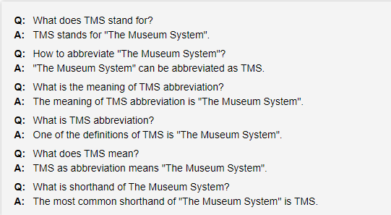

## Basic accounting terms, acronyms, abbreviations and concepts to remember

Check out these basic accounting definitions and start to commit them to memory. That way, when you start your **accounting education** journey, you’ll already feel like you’re a step ahead and speaking the language.

### Accounts receivable (AR)

**Accounts receivable (AR) definition:** The amount of money owed by customers or clients to a business after goods or services have been delivered and/or used.

### Accounting (ACCG)

**Accounting (ACCG) definition:** A systematic way of recording and reporting financial transactions for a business or organization.

### Accounts payable (AP)

**Accounts payable (AP) definition:** The amount of money a company owes creditors (suppliers, etc.) in return for goods and/or services they have delivered.

### Assets (fixed and current) (FA, CA)

**Assets (fixed and current) definition: Current assets (CA)** are those that will be converted to cash within one year. Typically, this could be cash, inventory or accounts receivable. **Fixed assets (FA)** are long-term and will likely provide benefits to a company for more than one year, such as a real estate, land or major machinery.

### Asset classes

**Asset class definition:** An asset class is a group of securities that behaves similarly in the marketplace. The three main asset classes are equities or stocks, fixed income or bonds, and cash equivalents or money market instruments.

### Balance sheet (BS)

**Balance sheet (BS) definition:** A financial report that summarizes a company's assets (what it owns), liabilities (what it owes) and owner or shareholder equity, at a given time.

### Capital (CAP)

**Capital (CAP) definition:** A financial asset or the value of a financial asset, such as cash or goods. Working capital is calculated by taking your current assets subtracted from current liabilities—basically the money or assets an organization can put to work.

### Cash flow (CF)

**Cash flow (CF) definition:** The revenue or expense expected to be generated through business activities (sales, manufacturing, etc.) over a period of time.

### Certified public accountant (CPA)

**Certified public accountant (CPA) definition:** A designation given to an accountant who has passed a standardized **CPA exam** and met government-mandated work experience and educational requirements to **become a CPA**.

### Cost of goods sold (COGS)

**Cost of goods sold (COGS) definition:** The direct expenses related to producing the goods sold by a business. The formula for calculating this will depend on what is being produced, but as an example this may include the cost of the raw materials (parts) and the amount of employee labor used in production.

### Credit (CR)

**Credit (CR) definition:** An accounting entry that may either decrease assets or increase liabilities and equity on the company's balance sheet, depending on the transaction. When using the **double-entry accounting method** there will be two recorded entries for every transaction: A credit and a debit.

### Debit (DR)

**Debit (DR) definition:** An accounting entry where there is either an increase in assets or a decrease in liabilities on a company's balance sheet.

### Diversification

**Diversification definition:**The process of allocating or spreading capital investments into varied assets to avoid over-exposure to risk.

### Enrolled agent (EA)

**Enrolled agent (EA) definition:** A tax professional who represents taxpayers in matters where they are dealing with the Internal Revenue Service (IRS).

### Expenses (fixed, variable, accrued, operation)

**Expenses (FE, VE, AE, OE) definition:** The fixed, variable, accrued or day-to-day costs that a business may incur through its operations.

* **Fixed expenses (FE)**: payments like rent that will happen in a regularly scheduled cadence.
* **Variable expenses (VE):**expenses, like labor costs, that may change in a given time period.
* **Accrued expense (AE):**an incurred expense that hasn’t been paid yet.
* **Operation expenses (OE)**: business expenditures not directly associated with the production of goods or services—for example, advertising costs, property taxes or insurance expenditures.

### Equity and owner's equity (OE)

**Equity and owner's equity (OE) definition:** In the most general sense, equity is assets minus liabilities. An owner’s equity is typically explained in terms of the percentage of stock a person has ownership interest in the company. The owners of the stock are known as shareholders.

### Insolvency

**Insolvency definition:** A state where an individual or organization can no longer meet financial obligations with lender(s) when their debts come due.

### Generally accepted accounting principles (GAAP)

**Generally accepted accounting principles (GAAP) definition:** A set of **rules and guidelines** developed by the accounting industry for companies to follow when reporting financial data. Following these rules is especially critical for all publicly traded companies.

### General ledger (GL)

**General ledger (GL) definition:** A complete record of the financial transactions over the life of a company.

### Trial balance

**Trial balance definition:** A business document in which all ledgers are compiled into debit and credit columns in order to ensure a company’s bookkeeping system is mathematically correct.

### Liabilities (current and long-term)

**Liabilities (current and long-term) definition:** A company's debts or financial obligations incurred during business operations. Current liabilities (CL) are those debts that are payable within a year, such as a debt to suppliers. Long-term liabilities (LTL) are typically payable over a period of time greater than one year. An example of a long-term liability would be a multi-year mortgage for office space.

### Limited liability company (LLC)

### Net income (NI)

**Net income (NI) definition:** A company's total earnings, also called net profit. Net income is calculated by subtracting total expenses from total revenues.

### Present value (PV)

**Present value (PV) definition:** The current value of a future sum of money based on a specific rate of return. Present value helps us understand how receiving $100 now is worth more than receiving $100 a year from now, as money in hand now has the ability to be invested at a higher rate of return.

### Profit and loss statement (P&L)

**Profit and loss statement (P&L) definition:** A financial statement that is used to summarize a company’s performance and financial position by reviewing revenues, costs and expenses during a specific period of time, such as quarterly or annually.

## REFRENCE LINKS:

[OFFICIAL WEBSITE OF PMM](https://pmm.com.pk/)

[ACCRONYMS FOR ACCOUNTS OFFICE](https://www.rasmussen.edu/degrees/business/blog/basic-accounting-terms-acronyms-and-abbreviations-students-should/)



## Estimated Cost on the Project:

AUD: $22,000 first year and $2,280 annual license fee  
NZD: $25,985 first year and $2,280 annual license fee  
USD: $19,000 first year and $1,800 annual license fee  
GBP: £11,000 and £940 annual license fee

# STANDARDS OVERVIEW

## Standards Scope:

* To achieve maximum profit
* To save maximum amount of revenue of the museum
* To remove the work load from the workers
* Have a manageable and traceable work history record

## Architectural and Open System Interactions:

### Architectural:

The platforms that the system will be built on is Windows using the languages JAVA, C#, Python and MySQL for the Data Base.

As well as Android and IOS app will also be built of the MMS/TMS

### Open System Interactions:

The system will be interlinked with all the different versions of operating systems, as well as the official website of the PMM.

## Requirements:

* A view of the background of the work environment currently playing out
* Budget of $30,000 estimated on hand
* A person of the client who can answer all the required questions by the developers
* Complete description and overview of the project
* SRS Document
* Interviews with the client side stakeholders
* Query forms
* Customers/ Visitors Views and feedbacks
* USE Case diagrams
* Graphic representation of the MMS by the GU/IX Team
* Complete History on the artifacts in word/pdf form
* Sample Data of the accounts office in digital form to test out the MMS
* Working schedules should be provided by the managers

## Product Functions:

* Ticket Generation
* Schedule Generation
* Accounts Handling
* Salary calculation and delivering
* QR Scanning
* Open System Interconnection
* Displaying previous data History
* Showing articles and information on the QR scanned artifact

## User Classes and Characteristics:

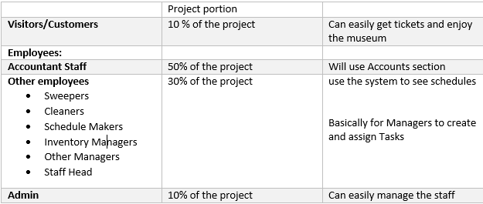

## Operating Environment:

* World Wide Web
* Android
* IOS

## Standards Compatibility:

* 5% of the system software is used for visitors and will be made in 1 month
* Success rate of scanning with QR would be 100% (no compromise)
* System refreshment time (assigning new task time) will be 24hrs
* Max loading time on web servers shall be 3sec
* Max loading time on app shall be 1.5 sec

## Data Dictionary:

|  |  |  |
| --- | --- | --- |
| **FOR CUSTOMERS** | **FOR ACCOUNTS OFFICE** | **FOR MANAGERS** |
| Name | Employee Name | Employee Name |
| **CNIC** | Employee NADRA Information | Task Assigned to Employee |
| **Ticket Number** | Total hrs Worked by an Employee | Total hrs Worked by an Employee |
|  | Employee Joining Date |  |
|  | Salary Record |  |

## Constraints and Assumptions:

* The system shall print the schedule of each day as well as keep record of the previous one
* System requires high tech servers
* Server inspection every 15 days
* The business requires computers monitors and TV screens
* The Software System would take about 3 months to develop giving the competition time to catch up
* Chance of system not being ideal, cause of some incorrect information
* Chances of misinformation
* Visitors may use the system inappropriately
* Security leak
* Hacking

## Entity Information:

* Customer
* Manager
* Accounts Staff
* Employees
* Working Staff
* Admin
* Counter staff

## Entity Relation:

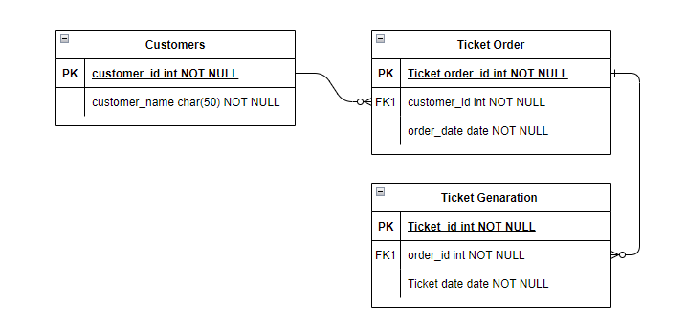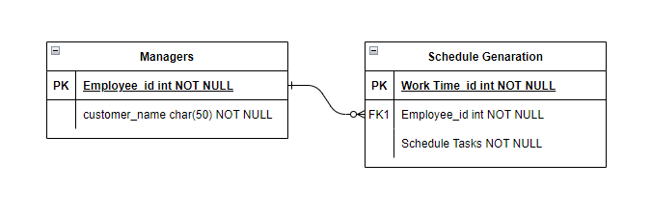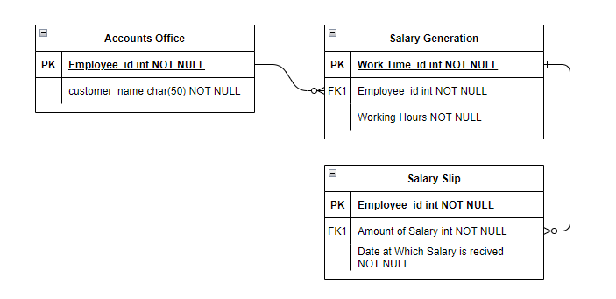

# Usability Focus

## Actors Profile:



# External Interface Requirements

## 4.1 User Interfaces

* For a client, a visual user interface was designed to provide flexible access to the integrated information in multimedia databases.
* Users can browse or query by means of predicates to retrieve the required information. At the server end, a searching manager is needed to receive the requests from clients and transform them into standard query commands for the DBMS to use to find the target information.
* Once the results are found, the object manager organizes the media objects according to the predefined structures, and delivers them to the presentation manager. Then, the presentation manager generates the display formats dynamically and, through the network, transmits them back to the client end for display.

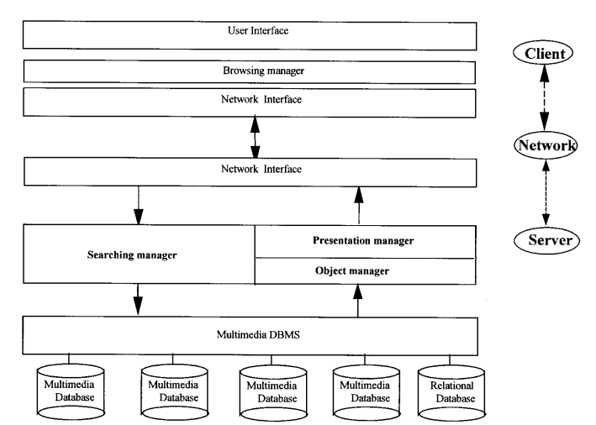

## 4.2 Hardware Interfaces

The only link to an external system is the link to the Museum Society (MS) Database to verify the membership of a Visitors. The Editor believes that a society member is much more likely to be an effective reviewer and has imposed a membership requirement for a Reviewer. The MS Database fields of interest to the Web Publishing Systems are Visitor’s name, (ID) number, and Time of visit (an optional field for the HS Database).

## Communications Interfaces

Communication Interface for Visitors and other employees is possible by using different means. To give ease at every level we have had provided different platforms for the communication for instance

* E-mail ID
* Phone Number
* Online Server
* Website Queries

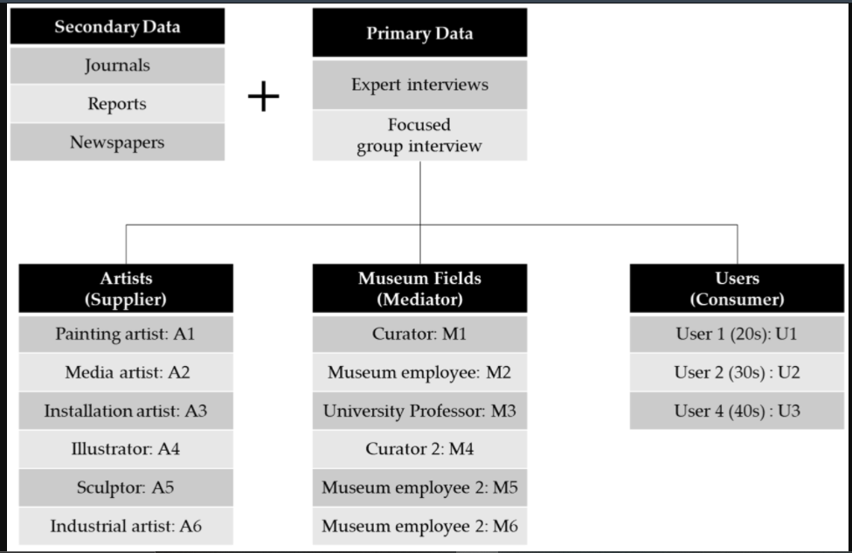

As figure shows these all actors are ivolved in th communication process.

# **5.** System Features

This illustrates organizing the functional requirements for the product by system features, the major services provided by the product.

## 5.1 System Feature

The major features of our project which is Museum Management System are as follows:

* Ticketing
* Visitor’s record
* Artifacts - QR generation
* Employee Management
* Schedule Generation
* Task Assigning
* Keeping records of how much work is each employee doing
* Bug Free
* Error Free
* User friendly

Schedule Basic data Pay role

**5.1.1 Description and Priority**

* Visitor Record Functionality – Highly Prioritized
* Artifacts – QR Generation – Medium Prioritized
* Employee Management – Highly Prioritized
* Payroll – Medium Prioritized

**5.1.2 Functional Requirements**

**Visitor’s Record:**

This particular module will be serving in the favor of visitor’s Record keeping and, in this release, costumer will come to know that he can get the whole data of visitors just as

1. Name
2. Number of tickets booked
3. Date of visit
4. Feasibility (if education trip)

**Artifacts – QR Generation:**

1. QR Generation will be the third release of our Management System. As its obvious that Museum consists of different ancient artifacts and antique ornaments and there must be complete info about particularly if someone visits QR Code will definitely help to get whole information about that Artifact just on one scan.

**Employee Management:**

Fourth module falls upon Employee Management and is further divided into sub-headings which will furthermore hold more detailed structure of this release. It may be explained as follows:

1. **Schedule:**

Different shifts of employees with their duties throughout the Museum.

1. **Basic Data:**
2. Bio-Data of employees will be considered.

**Payroll:**

Payroll will depend on the designation of each employee and will be kept in record in this management. If there is any change in designation or promotion payroll will be updated.

## Use Case Diagram

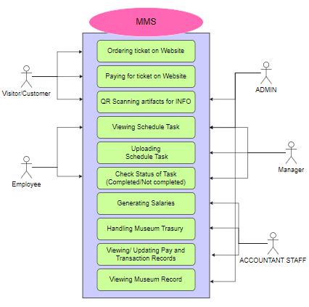

## Context Diagram:

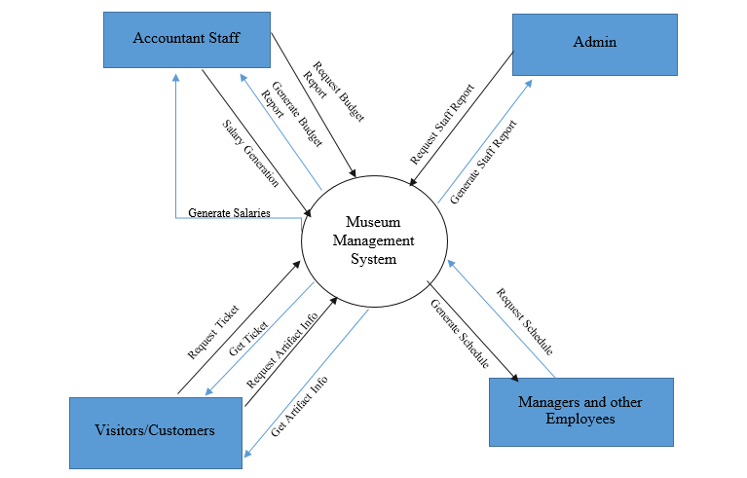

## Tree Diagram

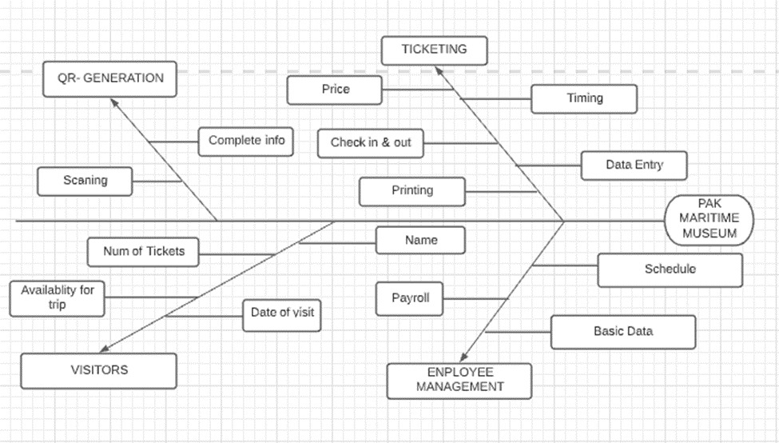

# Other Nonfunctional Requirements

## Performance Requirements

Performance of overall system depends on all its functionalities which are as follows:

* **Ticketing** – this functional requirements supports the safety and trust of visitors as the details are to be entered and online payment of tickets has been added to it where user can add their credentials.
* **Visitor’s Record** – the record of visited visitors is safe using the non – functionality **privacy and security** where the visitors are given 100% encryption.
* **QR Generation** – in this **maintainability & aesthetics** are considered as QR Generation is of each and every artifact present within museum.
* **Schedule Generation** – **maintainability** is a key source nonfunctional requirement in this schedule generation which may be changed later on depending upon employees and timings.

## Security Requirements

* Customer/Visitors
* Museum Staff
* Fast transactions
* Error free work and management

Security of all above mentioned are considered and within the software encryption can be used.

**Sensor diagnostic**

**Deviation detector**

**Fault detections**

## Software Quality Attributes

This approach to software quality is best exemplified by fixed quality models, such as ISO/IEC 25010:2011. This standard describes a hierarchy of eight quality characteristics, each composed of sub-characteristics:

* Functional suitability
* Reliability
* Operability
* Performance efficiency
* Security
* Compatibility
* Maintainability
* Transferability

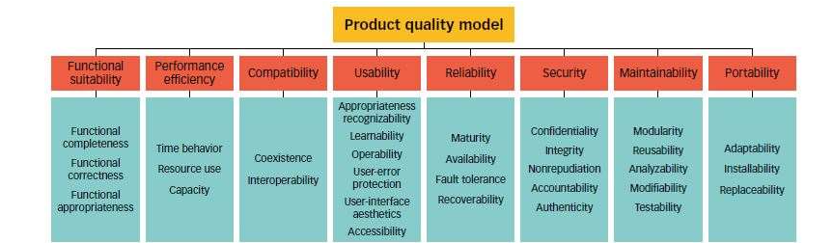

## Business Rules

* It well helps the business by saving the expenses of tour guides.
* The software system will help improve in money handling activities like money transfer and transactions  
  causing a low human error rate as well as speed up the business process.
* Handling tasks of scheduling and other basic data.
* Ticketing system would ease the visitors since they will be able to get a ticket from home via the internet, also reducing human errors

**5.5 Business Objectives:**

* Customer Satisfaction
* Increase in Visitors/Customers
* Employee Management
* Keeping records of Inventory
* Error free work
* Risk free transactions
* Safety and Security
* Increase in Business sales (Ticketing and other stuff)
* Assigning tasks to workers easily
* Spend less money on hiring staff members like tour guide and different managers.

# Other Requirements

Review

Employee check

Booking

Visitor

Tickets

Confirm

Verify

has

1. Figure 4 - Logical Structure of the Ticket Booking Manager Data

FIGURE: showing the Non- Functional Requirements

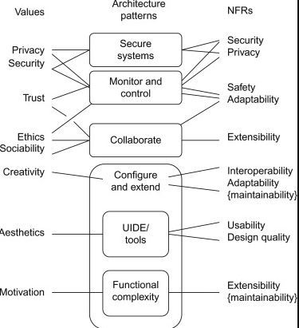

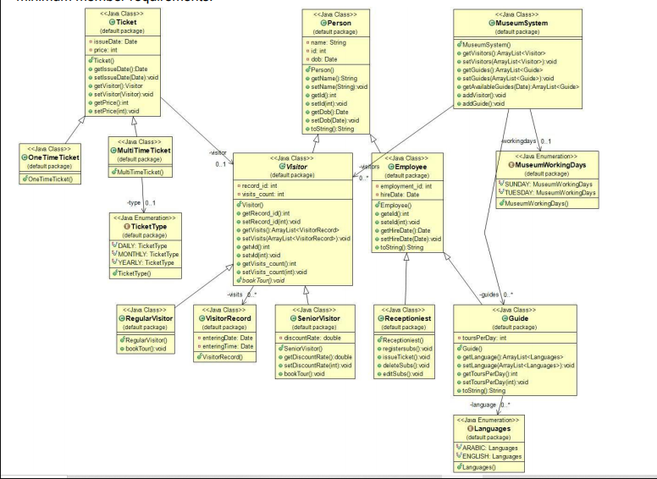

**Software Design Document (SWDD) Template**

(Team Name: SDA Assignment)

**(Project Title: Museum Management System)**

#### Software Design Document

Name (s):

**Section:** A

**Workstation:BSE 4**

Date: (06/25/2022)

**TABLE OF CONTENTS**

1.0 INTRODUCTION 4

1.1 Purpose 4

1.2 Scope 4

1.3 Overview 4

1.4 Reference Material 4

1.5 Definitions and Acronyms 4

2.0 SYSTEM OVERVIEW 4

3.0 SYSTEM ARCHITECTURE 4

3.1 Architectural Design 4

3.2 Decomposition Description 5

3.3 Design Rationale 5

4.0 DATA DESIGN 5

4.1 Data Description 5

4.2 Data Dictionary 5

5.0 COMPONENT DESIGN 5

6.0 HUMAN INTERFACE DESIGN 5

6.1 Overview of User Interface 5

6.2 Screen Images 6

6.3 Screen Objects and Actions 6

7.0 REQUIREMENTS MATRIX 6

## INTRODUCTION

## Purpose

To make a Software System that will help the Martine Museum staff to improve their work efficiency and work environment by taking care of their employees and their valuable customers, the focus is both in the work and business section of the museum system.

## Scope

The workers/ Museum staff will benefit from the Software Management System by creating schedules and handling previous, new, expected work records as well as transaction History saving, hence saving time for other works required to be done hence increasing the profit per employee.

## Overview

On the Business side, the Museum will benefit by giving the customers a human free interaction counter as well as no waiting in long ticket lines since all tickets can and will be purchased online,   
This will increase the revenue, estimated about 30%.

## Reference Material

SRS of Project.

[OFFICIAL WEBSITE OF PMM](https://pmm.com.pk/)

[ACCRONYMS FOR ACCOUNTS OFFICE](https://www.rasmussen.edu/degrees/business/blog/basic-accounting-terms-acronyms-and-abbreviations-students-should/)



## Definitions and Acronyms

**PMM:** PAKISTAN MARTIME MUSEUM



## Basic accounting terms, acronyms, abbreviations and concepts to remember

Check out these basic accounting definitions and start to commit them to memory. That way, when you start your **accounting education** journey, you’ll already feel like you’re a step ahead and speaking the language.

### Accounts receivable (AR)

**Accounts receivable (AR) definition:** The amount of money owed by customers or clients to a business after goods or services have been delivered and/or used.

### Accounting (ACCG)

**Accounting (ACCG) definition:** A systematic way of recording and reporting financial transactions for a business or organization.

### Accounts payable (AP)

**Accounts payable (AP) definition:** The amount of money a company owes creditors (suppliers, etc.) in return for goods and/or services they have delivered.

### Assets (fixed and current) (FA, CA)

**Assets (fixed and current) definition: Current assets (CA)** are those that will be converted to cash within one year. Typically, this could be cash, inventory or accounts receivable. **Fixed assets (FA)** are long-term and will likely provide benefits to a company for more than one year, such as a real estate, land or major machinery.

### Asset classes

**Asset class definition:** An asset class is a group of securities that behaves similarly in the marketplace. The three main asset classes are equities or stocks, fixed income or bonds, and cash equivalents or money market instruments.

### Balance sheet (BS)

**Balance sheet (BS) definition:** A financial report that summarizes a company's assets (what it owns), liabilities (what it owes) and owner or shareholder equity, at a given time.

### Capital (CAP)

**Capital (CAP) definition:** A financial asset or the value of a financial asset, such as cash or goods. Working capital is calculated by taking your current assets subtracted from current liabilities—basically the money or assets an organization can put to work.

### Cash flow (CF)

**Cash flow (CF) definition:** The revenue or expense expected to be generated through business activities (sales, manufacturing, etc.) over a period of time.

### Certified public accountant (CPA)

**Certified public accountant (CPA) definition:** A designation given to an accountant who has passed a standardized **CPA exam** and met government-mandated work experience and educational requirements to **become a CPA**.

### Cost of goods sold (COGS)

**Cost of goods sold (COGS) definition:** The direct expenses related to producing the goods sold by a business. The formula for calculating this will depend on what is being produced, but as an example this may include the cost of the raw materials (parts) and the amount of employee labor used in production.

### Credit (CR)

**Credit (CR) definition:** An accounting entry that may either decrease assets or increase liabilities and equity on the company's balance sheet, depending on the transaction. When using the **double-entry accounting method** there will be two recorded entries for every transaction: A credit and a debit.

### Debit (DR)

**Debit (DR) definition:** An accounting entry where there is either an increase in assets or a decrease in liabilities on a company's balance sheet.

### Diversification

**Diversification definition:**The process of allocating or spreading capital investments into varied assets to avoid over-exposure to risk.

### Enrolled agent (EA)

**Enrolled agent (EA) definition:** A tax professional who represents taxpayers in matters where they are dealing with the Internal Revenue Service (IRS).

### Expenses (fixed, variable, accrued, operation)

**Expenses (FE, VE, AE, OE) definition:** The fixed, variable, accrued or day-to-day costs that a business may incur through its operations.

* **Fixed expenses (FE)**: payments like rent that will happen in a regularly scheduled cadence.
* **Variable expenses (VE):**expenses, like labor costs, that may change in a given time period.
* **Accrued expense (AE):**an incurred expense that hasn’t been paid yet.
* **Operation expenses (OE)**: business expenditures not directly associated with the production of goods or services—for example, advertising costs, property taxes or insurance expenditures.

### Equity and owner's equity (OE)

**Equity and owner's equity (OE) definition:** In the most general sense, equity is assets minus liabilities. An owner’s equity is typically explained in terms of the percentage of stock a person has ownership interest in the company. The owners of the stock are known as shareholders.

### Insolvency

**Insolvency definition:** A state where an individual or organization can no longer meet financial obligations with lender(s) when their debts come due.

### Generally accepted accounting principles (GAAP)

**Generally accepted accounting principles (GAAP) definition:** A set of **rules and guidelines** developed by the accounting industry for companies to follow when reporting financial data. Following these rules is especially critical for all publicly traded companies.

### General ledger (GL)

**General ledger (GL) definition:** A complete record of the financial transactions over the life of a company.

### Trial balance

**Trial balance definition:** A business document in which all ledgers are compiled into debit and credit columns in order to ensure a company’s bookkeeping system is mathematically correct.

### Liabilities (current and long-term)

**Liabilities (current and long-term) definition:** A company's debts or financial obligations incurred during business operations. Current liabilities (CL) are those debts that are payable within a year, such as a debt to suppliers. Long-term liabilities (LTL) are typically payable over a period of time greater than one year. An example of a long-term liability would be a multi-year mortgage for office space.

### Limited liability company (LLC)

### Net income (NI)

**Net income (NI) definition:** A company's total earnings, also called net profit. Net income is calculated by subtracting total expenses from total revenues.

### Present value (PV)

**Present value (PV) definition:** The current value of a future sum of money based on a specific rate of return. Present value helps us understand how receiving $100 now is worth more than receiving $100 a year from now, as money in hand now has the ability to be invested at a higher rate of return.

### Profit and loss statement (P&L)

**Profit and loss statement (P&L) definition:** A financial statement that is used to summarize a company’s performance and financial position by reviewing revenues, costs and expenses during a specific period of time, such as quarterly or annually.

## SYSTEM OVERVIEW

Pakistan Maritime Museum shows the commitment of the Pakistan Navy towards nation-building by documenting and preserving rich maritime history and cultural heritage for knowledge and a long-lasting legacy for future generations. The maritime zone is considered the backbone of coastal states and about 95% of the world trade takes place through seas. Pakistan Navy not only defends and secures the coastlines and territorial boundaries of the sea but is also dedicated to educating the people of Pakistan about the significance of maritime affairs and its role in the economic growth of the country.

## SYSTEM ARCHITECTURE

## Architectural Design

## 

The Architectural design of our Museum Management System is using a Data Centric Approach and having a Clint-Server Architectural pattern is adopted by our system.

The above diagram shows the distribution of each tier and represents the client, network, and server representation in a better way.

## Decomposition Description

Every other Module is a sub module of three main components,

* + Museum Management System
  + Ticket System
  + Person Module

All other Modules are as you can say an extension of these three modules or use or implement these three modules.

Further Explanation or description of the partitioning and divisions plus sub divisions can be seen clearly in the Module Diagram above.

##### Context Diagram to show how the modules would interact with one another in the Management System:



##### Object Oriented Repersentation of the system:



##### The flow or the hierachy of the module can be visualized using the following Tree Diagram:



## Design Rationale

The Client-Server architecture is chosen by our team and the data centric approach suggested by us is by looking at the functional requirements of our system. Since our main approach is security and having a manageable server room for the Maritime Museum to have a management system not only for the museum staff but also the visitors of the museum giving them the service to book a ticket from the comfort of there home

## DATA DESIGN

## Data Description



In the figure above is the list of our data storage items and how they are interlinked defining the relationship between each table.

The information taken by the presentation tier is sent and stored to the relevant database connecting to that particular model which the user has just passed the data from.

## Data Dictionary

The Module Distribution or OO diagram does a fine job in clarifying and showing the attributes model and parameters.



## COMPONENT DESIGN

* + Museum Management System
  + Ticket System
  + Person Module

**Museum Management System Module Pseudo Code,**

1. addEmployee(string name, int age, string number, string address)
2. {
3. Id = new id;
4. addinSQL;
5. }
6. removeEmployee(int id)
7. {
8. RemovefromSQL(Employee with id);
9. }
10. updateINFO(strin infoToBeUpdated)
11. {
12. updateSQL();
13. }
14. CreateSchedule()
15. {
16. Random.CreateSchedule;
17. }

**Ticket Module Pseudo Code,**

EventHandler_OnClick GenerateTicketButton()

1. {
2. assignTicket(string customer){
3. int ticketNUM = new Num;
4. createTicket for cutomer;
5. }
6. }

**Person Module Pseudo Code,**

1. customerStatus(string customer, int ticketID);
2. EmployeeStatus(string empName, int empID);

## HUMAN INTERFACE DESIGN

## Overview of User Interface

The UI would be divided into two parts,

* + 1. For Customer/Visitor
    2. For Employee

The customer would mainly see things like About the Museum or Ticketing service, on the other hand the employee would see a complete dashboard

## Screen Images

UI FOR CUSTOMERS:

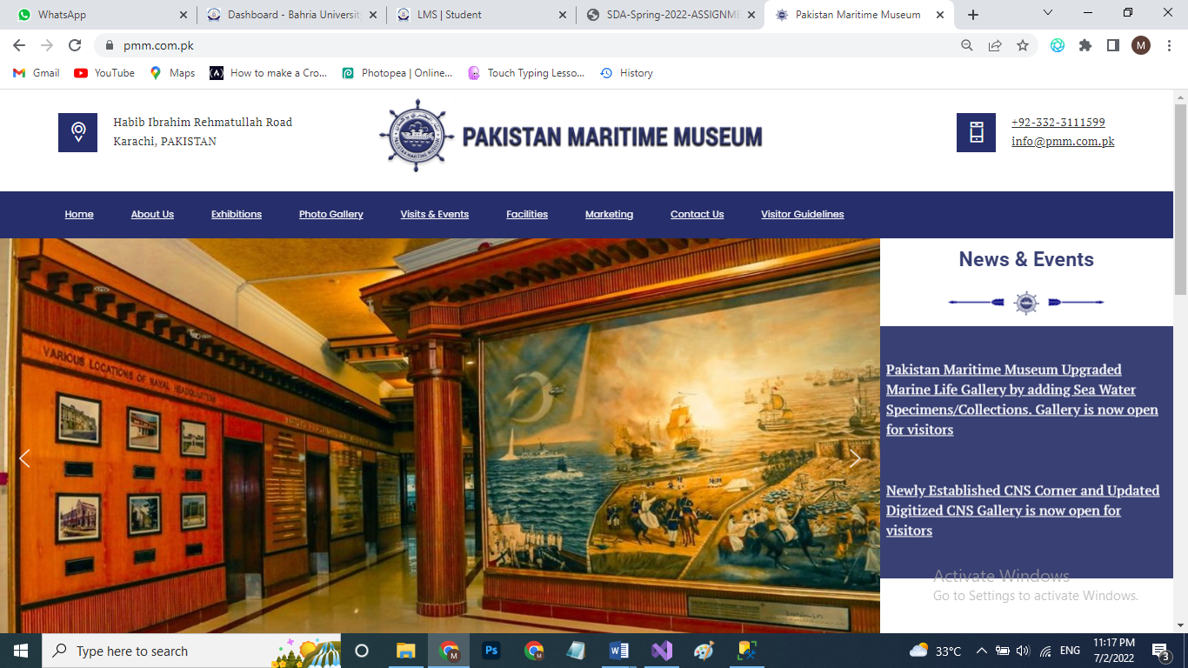

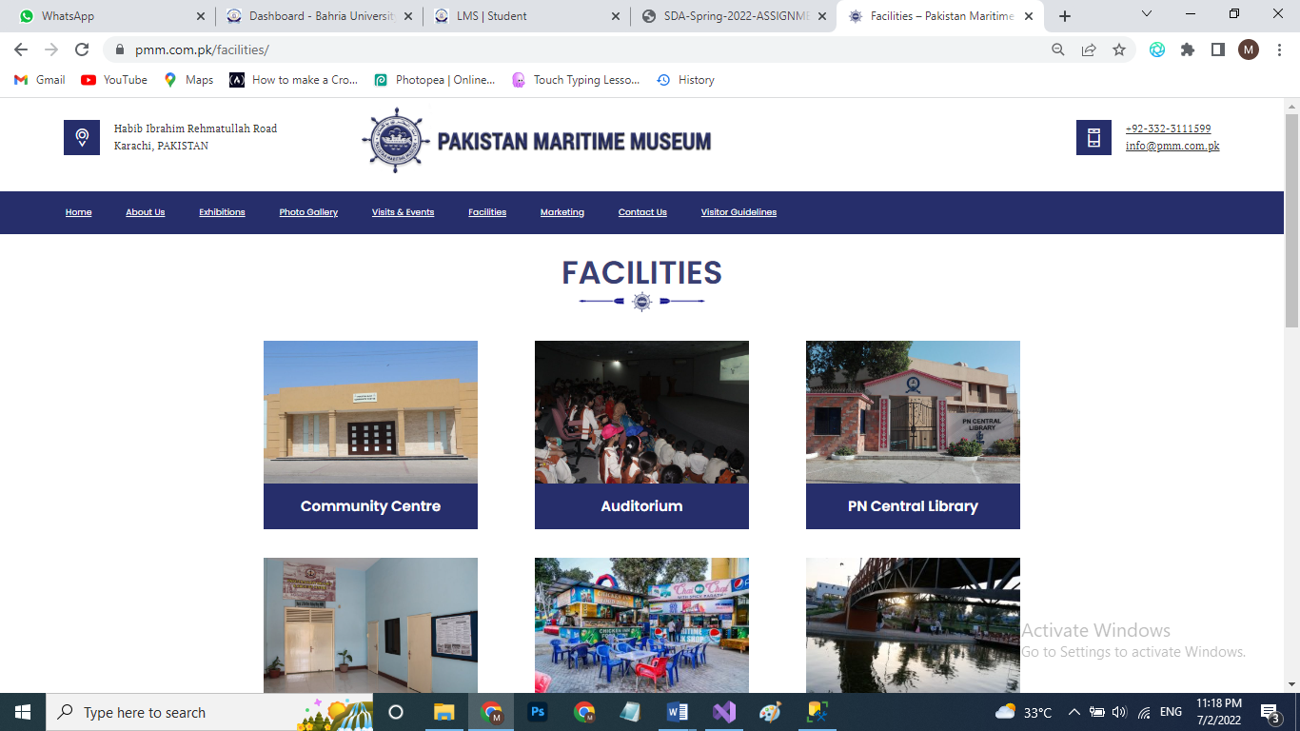

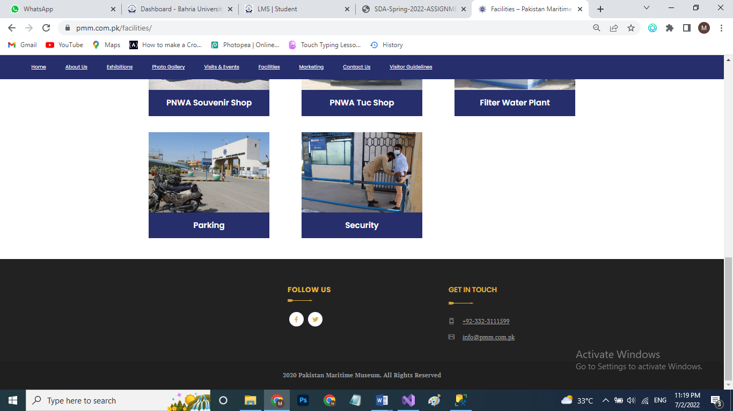

DASHBOARD FOR EMPLOYEES:

1. 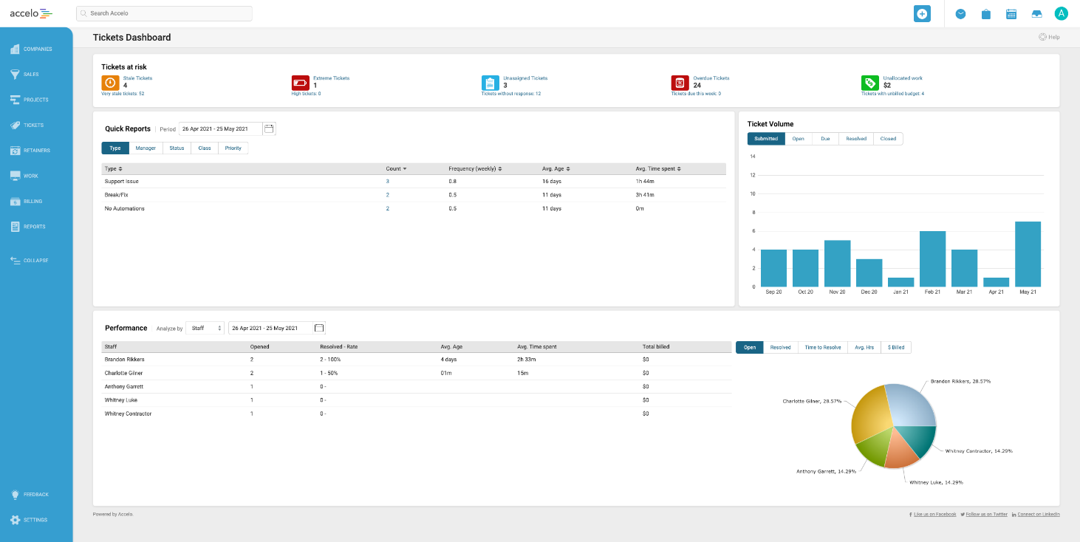

## Screen Objects and Actions

Nav Bar Buttons:

* HOME
* About Us
* Exhibitions
* Contact Us
* Book a Ticket
* Generate QR

DASHBOARD FOR EMPLOYEES:

Contains Insights and overview plus info on each employee and tasks remaining plus task done as well as creating schedules

## REQUIREMENTS MATRIX

Provide a cross-reference that traces components and data structures to the requirements in your softwarerequirements specification (SWRS) document.

Use a tabular format to show which system components satisfy each of the functional requirements from the SWRS. Refer to the functional requirements by the numbers/codes that you gave them in the SWRS.

|  |  |  |  |
| --- | --- | --- | --- |
| Use Case ID: | 1 |  | |
| Use Case Name: | Ordering ticket on Website |  | |
| Created By: | - | Last Updated By: | - |
| Date Created: | - | Date Last Updated: | - |

|  |  |
| --- | --- |
| Actors: | Visitor Customer |
| Description: | The person who visit museum |
| Trigger: | Online ticket booking |
| Preconditions: | Logged in |
| Postconditions: | Payment |
| Normal Flow: Sunny Day Scenario: | Easy access to book tickets. |
| Alternative Flows: Rainy Day Scenario: | Try again after some time  Closed |
| Exceptions: | Availability of tickets might be uncertain |
| Includes: | Personal info, payment method |
| Priority: | Customer |
| Frequency of Use: | Oftenly |
| Business Rules: | Avoid questioning |
| Special Requirements: | Log in to the website |
| Assumptions: | - |
| Notes and Issues: | The customer may be new to avail the services |

|  |  |  |  |
| --- | --- | --- | --- |
| Use Case ID: | 2 |  | |
| Use Case Name: | QR Scanning artifacts |  | |
| Created By: | - | Last Updated By: | - |
| Date Created: | - | Date Last Updated: | - |

|  |  |
| --- | --- |
| Actors: | Visitor/Customer |
| Description: | Visitors and customers both can avail this feature |
| Trigger: | QR Scanning of artifacts will display their all history |
| Preconditions: | Visit to museum |
| Postconditions: | Enhancement in knowledge |
| Normal Flow: Sunny Day Scenario: | No restrictions of scanning machine |
| Alternative Flows: Rainy Day Scenario: | Read the small history instead by using code |
| Exceptions: | QR code may not detects |
| Includes: | Admin, Manager |
| Priority: | - |
| Frequency of Use: | It depends on the visitor |
| Business Rules: | Less time consumption |
| Special Requirements: | QR code |
| Assumptions: | History teller |
| Notes and Issues: | Detection failed |

|  |  |  |  |
| --- | --- | --- | --- |
| Use Case ID: | 3 |  | |
| Use Case Name: | Viewing schedule task |  | |
| Created By: | - | Last Updated By: | - |
| Date Created: | - | Date Last Updated: | - |

|  |  |
| --- | --- |
| Actors: | Admin, manager, employee |
| Description: | It shows the schedule of tasks to be performed |
| Trigger: | Scheduling |
| Preconditions: | Tasks to be aligned |
| Postconditions: | Check whether tasks are done or still pending |
| Normal Flow: Sunny Day Scenario: | Tasks performed on time |
| Alternative Flows: Rainy Day Scenario: | Delayed or schedule B |
| Exceptions: | Everything will be aligned and on point |
| Includes: | Employees to do their jobs well |
| Priority: | Ease of customers |
| Frequency of Use: | Every time |
| Business Rules: | Fulfill the requirements of all stakeholders |
| Special Requirements: | Tools and features to be provided |
| Assumptions: | - |
| Notes and Issues: | Unemployment |

|  |  |  |  |
| --- | --- | --- | --- |
| Use Case ID: | 4 |  | |
| Use Case Name: | Viewing/ updating pay and traction records |  | |
| Created By: | - | Last Updated By: | - |
| Date Created: | - | Date Last Updated: | - |

|  |  |
| --- | --- |
| Actors: | Accountant staff |
| Description: | Check and balance of pay records |
| Trigger: | Employees transactions state |
| Preconditions: | Must be an employee of museum |
| Postconditions: | Should acknowledge the transaction |
| Normal Flow: Sunny Day Scenario: | No deductions and problem free processing |
| Alternative Flows: Rainy Day Scenario: | Registration of complaints |
| Exceptions: | Provide service for employees |
| Includes: | Bank account |
| Priority: | - |
| Frequency of Use: | As per employees requirement |
| Business Rules: | Should not be malfunctioned |
| Special Requirements: | Credit card and unique identity |
| Assumptions: | Maybe spam |
| Notes and Issues: | - |

|  |  |  |  |
| --- | --- | --- | --- |
| Use Case ID: | 5 |  | |
| Use Case Name: | Uploading schedule task |  | |
| Created By: | - | Last Updated By: | - |
| Date Created: | - | Date Last Updated: | - |

|  |  |
| --- | --- |
| Actors: | Manager, employee |
| Description: | Manager assign the task to employees |
| Trigger: | The schedule of task is being uploaded by manager which then were performed be employees of museum |
| Preconditions: | Undone tasks |
| Postconditions: | Assignment of tasks |
| Normal Flow: Sunny Day Scenario: | Everything will be done as per schedule on time |
| Alternative Flows: Rainy Day Scenario: | Delay in tasks with burden on employees |
| Exceptions: | Absence of employees |
| Includes: | Required tasks |
| Priority: | Improvement in environment |
| Frequency of Use: | Frequently for balanced system |
| Business Rules: | Feasibility |
| Special Requirements: | - |
| Assumptions: | - |
| Notes and Issues: | - |

|  |  |  |  |
| --- | --- | --- | --- |
| Use Case ID: | 6 |  | |
| Use Case Name: | Paying online ticket |  | |
| Created By: | - | Last Updated By: | - |
| Date Created: | - | Date Last Updated: | - |

|  |  |
| --- | --- |
| Actors: | Visitors/ Customers |
| Description: | Payment of tickets to be done online by customers depending on their choices |
| Trigger: | Online payment on website |
| Preconditions: | Bank account |
| Postconditions: | Confirmation |
| Normal Flow: Sunny Day Scenario: | Smooth flow without interruption |
| Alternative Flows: Rainy Day Scenario: | Payment by hand on museum gate |
| Exceptions: | It will lessen the time for entrance of visitors |
| Includes: | Ordering tickets |
| Priority: | Permanent members will be prioritized |
| Frequency of Use: | 24/7 |
| Business Rules: | Ease for customers and avoid wastage of time |
| Special Requirements: | Promo codes |
| Assumptions: | It will help out family members and customers to get information about the place |
| Notes and Issues: | - |