|  |  |
| --- | --- |
| Assignment No. | 02 |
| Assignment Title | Description of various Architectural Styles |
| Course Learning Outcome | CLO-03  *“Apply design models using modeling and objectoriented programming languages.”* |
| Full Name | Abdul Quddos |
| Semester | BSE 4 B |
| Submission Deadline | 26th April 2022 |

**INSTRUCTIONS:**



SEN

-

221

-

SOFTWARE DESIGN & ARCHITECTURE



SPRING

20

2

2



COURSE INSTRUCTOR



ENGR. MAJID KALEEM



*Department of Software Engineering*

* USE ONLY TIMES NEW ROMAN SIZE 12 FONT.
* EACH HEADING (UNDERLINED, BOLD AND IN CAPITAL LETTERS) AND EXAMPLE MUST START FROM A NEW LINE.
* UPLOAD SOFTCOPY ON LMS AS A PDF FILE.
* DO NOT EDIT (THIS) ASSIGNMENT FILE GIVEN AS A PDF FILE.
* LAST PAGE OF YOUR ASSIGNMENT MUST CONTAIN SOURCES/REFERENCES (USE IEEE REFERENCING STYLE).
* NO MAKEUP ASSIGNMENTS WILL BE GIVEN & DATE WILL NOT BE EXTENDED.
* VIOLATION OF ANY OF THE INSTRUCTIONS MENTIONED HERE WILL RESULT IN MARKS DEDUCTION.

**BAHRIA UNIVERSITY (KARACHI CAMPUS)**

**Software Design & Architecture (SEN-221)**

**ASSIGNMENT # 2 – Spring 2022**

**Based on: CLO-3**

Class:  **BSE-4B** Submission Deadline: **26 th April 22**



Course Instructor: **ENGR. MAJID KALEEM** Max Marks: **05**

1. Designing software applications is a serious job which requires experience and expertise. Suppose you start your professional software engineering career as a developer and you are given the following designs by your senior team members. Your task is to convert (*produce code in C Sharp*) the following designs into code. Please write the code in Visual Studio.

(a)

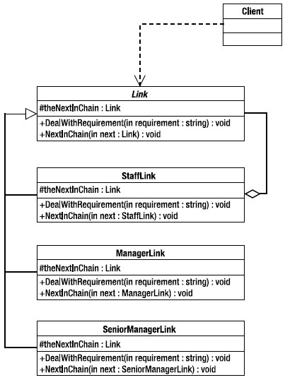

**Solution:**

**Client Class:**

using System;

public class Client {

}

**Link Class:**

using System;

public class Link {

protected Link theNextInChain;

public void DealWithRequirements(ref string in_requirement) {

}

public void NextInChain(ref Link in_next) {

}

private StaffLink staffLink;

}

**Staff link:**

using System;

public class StaffLink : Link {

protected Link theNextInChain;

public override void DealWithRequirements(ref string in_requirement) {

}

public void NextInChain(ref StaffLink in_next) {

}

private Link link;

}

**Manager Link:**

using System;

public class ManagerLink : Link {

protected Link theNextInChain;

public override void DealWithRequirements(ref string in_requirement) {

}

public void NextInChain(ref ManagerLink in_next) {

}

}

**Senior Manager Link:**

using System;

public class SeniorManagerLink : Link {

protected Link theNextInChain;

public override void DealWithRequirements(ref string in_requirement) {

}

public void NextInChain(ref SeniorManagerLink in_next) {

}

}

(b)

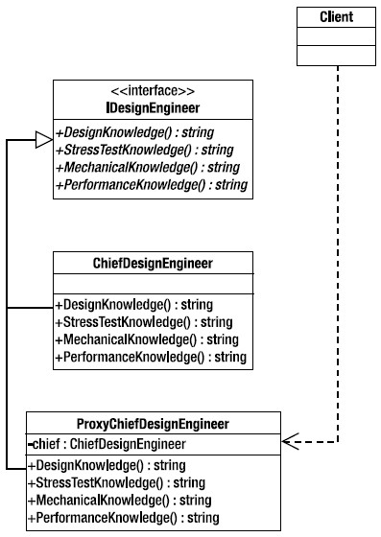

**Solution:**

**Client Class:**

using System;

namespace designEngineer {

public class Client {

}

}

**Design Engineer:**

using System;

namespace designEngineer {

public interface DesignEngineer {

string DesignKnowledge();

string StressTestKnowledge();

string MechanicalKnowledge();

string PerformanceKnowledge();

}

}

**Chief Design Engineer class:**

using System;

namespace designEngineer {

public class CheifDesignEngineer : DesignEngineer {

public string DesignKnowledge() {

}

public string StressTestKnowledge() {

}

public string MechanicalKnowledge() {

}

public string PerformanceKnowledge() {

}

}

**Proxy Chief Design Engineer:**

using System;

namespace designEngineer {

public class ProxyCheifDesignEngineer : DesignEngineer {

private CheifDesignEngineer chief;

public string DesignKnowledge() {

}

public string StressTestKnowledge() {

}

public string MechanicalKnowledge() {

}

public string PerformanceKnowledge() {

}

}

}

G☺☹d Luck!