**Department of Electrical and Computer Engineering**

**COMSATS University Islamabad, Attock Campus**

|  |  |  |  |
| --- | --- | --- | --- |
| **Complex Engineering Problem Rubrics (Form)** | | | |
| **Project Title** | | Rain detector circuit with alarm and automatic rain sensing car wipers. | |
| **Subject** | | Electronics II (EEE-232) | |
| **Submitted by** | | | |
| **Names** | | | **Registration No #** |
| ***1.*** | Hamna Baig | | FA20-BEE-030 |
| ***2.*** | Areeba Abid | | FA20-BEE-004 |
| ***3.*** | Arbab Fatima | | FA20-BEE-036 |

|  |  |  |  |  |
| --- | --- | --- | --- | --- |
| **Rubrics name & number** | | **Marks** | | |
| **1** | **2** | **3** |
| **PLO-1**  **Engineering Knowledge** | **CR1: Interpretation of Subject Knowledge:**  Ability to interpret and explain mathematical and/or visual forms, including equations, diagrams, graphics, figures and tables. |  |  |  |
| **PLO-2**  **Problem Analysis** | **CR3: Data/Evidence Measurements:**  Ability to record raw data / evidence. |  |  |  |
| **CR4: Experimental Data Analysis:**  Ability to interpret findings, compare them to values in the literature, identify weaknesses and limitations. |  |  |  |
| **PLO-3**  **Engineering Design** | **CR5: Implementing Design Strategy:**  Ability to execute a solution taking into consideration design requirements and  pertinent contextual elements.  [Block or circuit Diagram/Flow chart] |  |  |  |
| **PLO-5**  **Modern Tools Usage** | **CR9: Tools Evaluation:**  Ability to simulate the experiment and then using hardware tools to verify the results. |  |  |  |
| **PLO0-9**  **Individual and Teamwork** | **CR10: Individual Work Contributions:**  Ability to carry out individual responsibilities. |  |  |  |
| **PLO-10**  **Communication Skills (Report/Presentation)** | **CR12:** Language and Grammar, and Formatting Style |  |  |  |
| **CR13: Delivery & Presentation Skills** |  |  |  |
| **Total:** | |  |  |  |

# ACKNOWLEDGEMENT

By The Grace Of ALLAH Almighty we Completed Our Project **“**Rain Detector Circuit with Alarm and Automatic Rain Sensing Car Wipers.**”** with the help of the knowledge which we have gathered from the course. The satisfaction that accompanies the successful completion of the task would be put incomplete without the unlimiting effort of teaching of our teacher during the course who made us able to do so, whose constant guidance crown all the efforts with success

We express our heartfelt thanks toEngr. Ihtesham Jadoon Department of Electrical Engineering our Course and lab instructor for her valuable guidance, knowledge from the course and encouragement during the project.

TABLE OF CONTENTS

|  |  |  |
| --- | --- | --- |
| No |  | Page no |
| i. | Acknowledgment | 2 |
| 1 | Project Tittle | 3 |
| 2 | Project Aims and Objectives | 3 |
| 3 | Introduction | 3 |
| 4 | Components Required | 3 |
| 5 | Circuit Explanation | 4 |
| 6 | Working of the Circuit | 5-6 |
| 7 | General Relations | 7 |
| 8 | Mathematical Calculations | 7-8 |
| 9 | Simulation on Proteus Software | 9-11 |
| 10 | Observation Tables | 12 |
| 11 | Circuit Design Requirements and limitations | 13-14 |
| 12 | Other Applications of Circuit | 15 |
| 13 | Hardware Circuit | 15-16 |
| 14 | Project Conclusion | 16 |

1. **PROJECT TITTLE**

Rain Detector Circuit with Alarm and Automatic Rain Sensing Car Wipers.

1. **PROJECT AIMS AND OBJECTIVES**

* To implement the knowledge in practical applications which we have gathered from the electronics-II course.
* To investigate what influences can occur by changing values of certain components in the circuit.
* To investigate the limitations and requirements of the designing the circuit learned from the project.
* The main objective of our project is to detect the rain and then buzz the alarm and

automatically switching on the car wipers when it is raining and vice versa.

* The aim of our project is providing automation to car wipers by using the rain sensing circuit and also providing indication for rain sensing.

1. **INTRODUCTION**

Rain detector alarm is used for rain detection for many purposes but in our project we used it to automate the car wipers. Electronic Wiper is very common device that is attached in every car to wipe the water on the windshield during the rain. But generally they are manually operated and we need to switch them ON and OFF manually. But we can automate the car wiper using the circuit as discussed in project. The circuit automatically detects the rainfall and activates the wiper to clear the windscreen. More over when the rain is detected the alarm also got activated.

1. **COMPONENTS REQUIRED**

* 555 Timer IC
* L293D IC
* IC LM358
* Transistor BC557
* Resistors (1k, 10k, 2.2M)
* Capacitors (0.01uF, 0.47uF)
* DC Motor
* Buzzer
* Rain Sensor
* Power supply (9V)
* Soldering wire
* Vero Board
* Soldering Iron
* DMM
* Wires

1. **CIRCUIT EXPLANATION**

This **Automatic Rain Sensing with buzzer and wiper Control Circuit** can be divided into five parts.

First part includes [555 IC in Astable Mode](http://circuitdigest.com/electronic-circuits/555-timer-astable-multivibrator-circuit-diagram), second part includes [Comparator LM358](http://circuitdigest.com/lm358-circuits), third part has Motor Driver circuitry using L293D,forth part is [Rain Detector](http://circuitdigest.com/electronic-circuits/rain-alarm-project) and fifth part consist of Buzzer and motor which activates when rain is detected and it get switched off when there is no water(rain) on windscreen.

* **555 Timer IC**

For Astable Multi-vibrator, we have used a [555 Timer IC](http://circuitdigest.com/article/555-timer-ic) for generating pulse in every 1-2 seconds (depends on C1 capacitor value), means 555 Timer IC is configured in Astable mode.

* **LM358 Comparator IC**

Output of Astable Multivibrator is directly connected to inverting pin of **Comparator LM358.** Comparator LM358 IC is used here for comparing 555 timer IC’s output voltage and reference voltage across comparator’s non inverting terminal, set by using Voltage Divider Circuit (R3 and R4).

* **LM358 Comparator IC**

Output from 555 timer IC is connected to Pin No 7 **and also the** output of comparator is directly connected at pin 2 of **Motor Driver L293D.**

* **Rain Sensor**

A Rain Sensor is used for detecting the water or rain. Output of Astable Multivibrator and Comparator is applied to motor driver IC L293D, which will further drive the wiper motor. Whole circuit can be powered using 9V battery depending upon the application.

* **Indication in Circuit**

Two LEDs have been used, one at the output of 555 Astable circuit and other at the output of comparator LM358. Buzzer is used which activated when rain is detected.

1. **WORKING OF CIRCUIT**

Working of this rain sensor circuit with alarm and automatic car sensing wipers is

simple. As mentioned that this circuit has five parts namely Astable Multivibrator, Comparator, Motor Driver, indication part (buzzer, led) and Rain Sensor. When water drops of rain falls over the [Rain Sensor](http://circuitdigest.com/electronic-circuits/rain-alarm-project) then it will trigger the PNP transistor BC557 and PNP transistor turns ON the power supply of whole circuit and circuit start working until there is water on the Rain Sensor. Note that PNP transistor here works as a switch for the circuit , the switch is off when transistor is in cutoff region and on when transistor is in saturation region. Now after the power supply has been turned ON, Astable Multivibrator starts oscillating in configured frequency(calculated in section 7 ). Output from emitter side of PNP transistor is used as source of the circuit. Base of PNP transistor is connected to Rain Sensor Output.

Now when the output of 555 Timer IC goes HIGH then the comparator LM358 gives LOW output and when the output of 555 IC goes LOW then the Comparator’s output goes HIGH. And by using these two outputs DC motor turns clock wise and anticlockwise and wiper attached to it turns right to left and left to right, through Motor Driver IC L293D where output of comparator is connected at pin 2 (Input 1) and output of 555 timer IC is connected at pin 7 (Input 2).Both the pins together generates an output obtained at pin 3 and 6.



Two LEDs are also used here used for indication. When the output of 555 Timer IC goes HIGH then the comparator LM358 gives LOW output and led 1 glow which shows the output of 555 timer IC and when the output of 555 IC goes LOW then the Comparator’s output goes HIGH and led 2 glows. Both LEDs on and off shows the frequency which we have set using 555 timer IC in Astable mode of operation

Dc motor is connected at the pin 3 and 6 of Motor Driver IC L293D similarly buzzer is also connected with pin 3 and 6 of L293D.Then with DC motor wipers are connected which moves the wipers clockwise and anticlockwise on the cars windscreen with phenomena as mentioned above. That is how the wipers automatically sense rain (rain sensor is also connected at the windscreen so the rain can be detected) and gets activated. They remain activated until there is water on Rain sensor, as soon as the water evaporates wipers get stopped and so the buzzer.

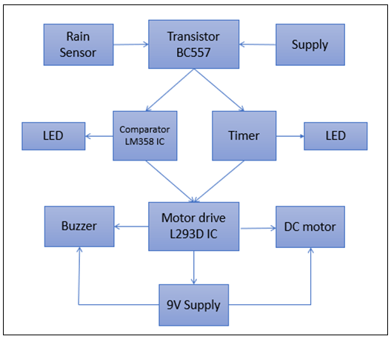

Figure 1 : Flow Chart For Circuit



1. **GENERAL RELATIONS**

* Emitter current is equal to sum of both base and collector current;
* Base and collector current are related by;
* For a voltage Divider Circuit when and are used to find voltage across resistor we use formula;
* For 555 Timer IC in Astable mode of operation;

1. Frequency= can also be find directly by relation;

* For Comparator IC;

Comparator is used as inverting one input is given at inverting pin and reference voltage at non-inverting pin. We have two conditions for it;

1. When then -
2. When ,then +
3. **MATHEMATICAL CALCULATIONS**

* **For PNP transistor;**

Emitter-Base Voltage or maximum is -5V.

Therefore supply to all circuit is 5V when transistor act as closed switch since ICs need 5V as their Vcc.

* **For 555 Timer IC;**

=

50% Duty cycle means then signal will be low and high for the same time period.

Frequency= can also be find directly by relation;

0.695.85 Hz

* For a **voltage Divider Circuit** to provide reference voltage to non-inverting pin of comparator;

2.5 V

* **For comparator IC LM358**

is 2.5 V as calculated above;

When output of 555 is high Vin will be 5 V so;

=

then -

When because of the high open loop gain of the OP-AMP the output voltage immediately goes positive when input voltage is less than reference voltage,

+

will be between as we are using supply of 5V.

1. **SIMULATION ON PROTEUS SOFTWARE**

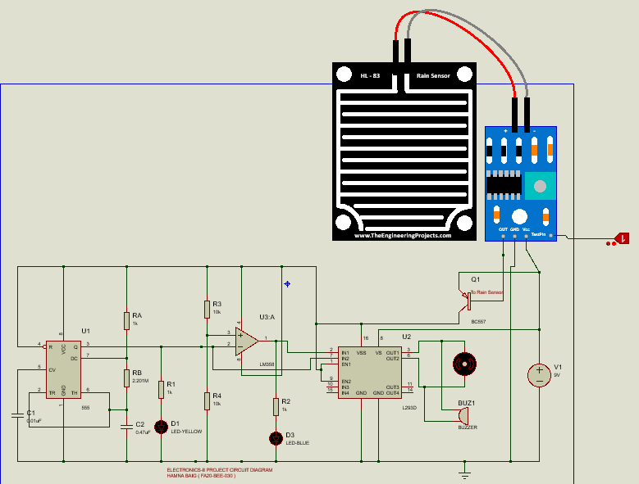

Figure 2 : Complete Circuit Diagram of Project on Proteous

* **Closed Circuit View**

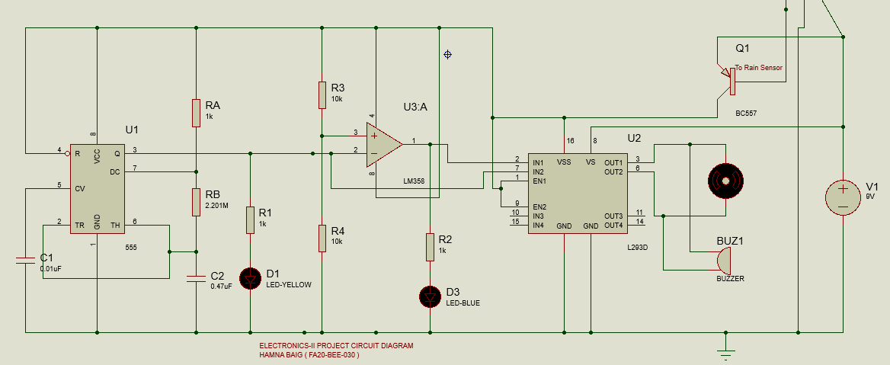

Figure 3 : Closed view on Proteus

* **Logic 0 is used that no Rain water is detected so the circuit is off as PNP transistor is not triggered so the whole circuit is off;**

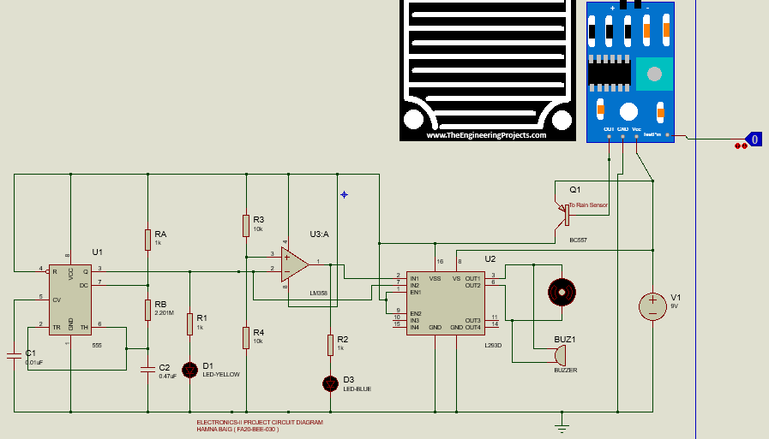

Figure 4 : Circuit response when it’s not raining

* **Logic 1 is used that Rain water is detected so the circuit is on as PNP transistor is got triggered so the whole circuit is on;**

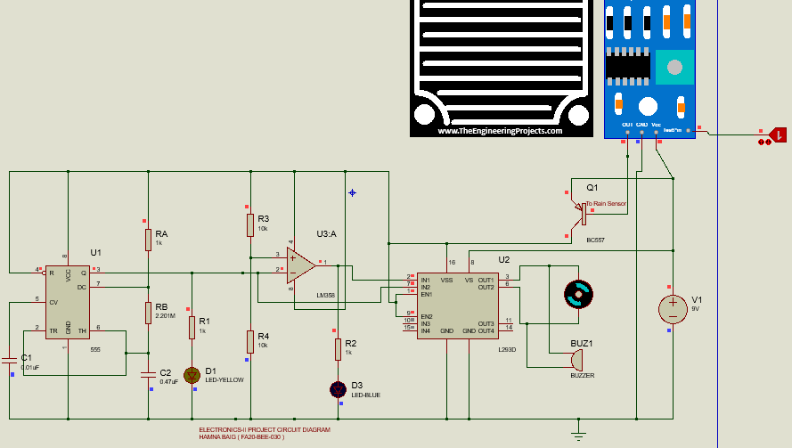

Figure 5 : Circuit Response when it’s raining

* **Voltages Measurement when circuit is working;**

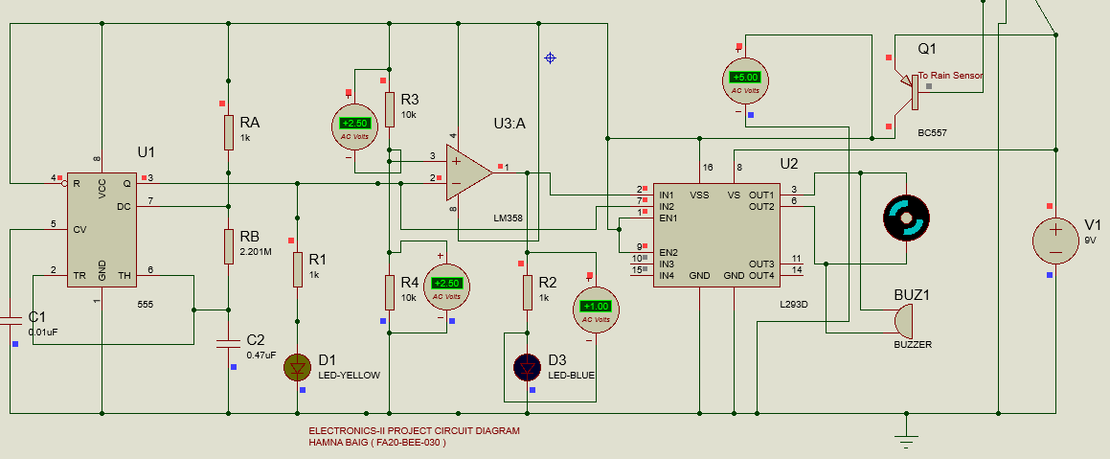

Figure 6 : Voltage measurements of circuit

* **Current Measurement when circuit is working;**

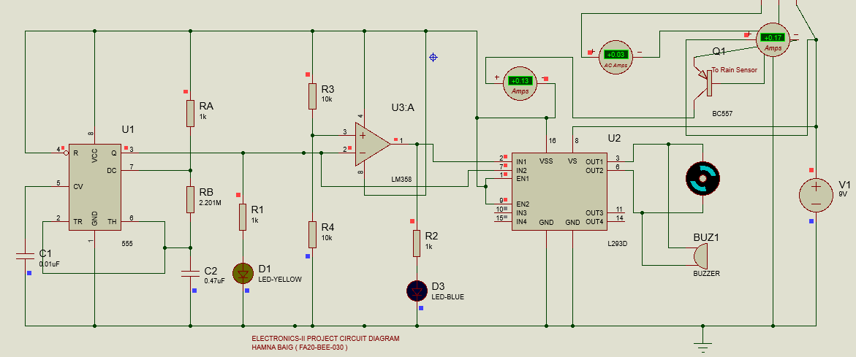

Figure 7 :Current measurements of circuit

1. **OBSERVATION TABLE**

**Table No 1 : For 555 Timer IC**

|  |  |  |  |
| --- | --- | --- | --- |
|  | **Expected Peak** | **Measured Peak** | **% Error** |
|  | 50 % | 49.30% | 1.4 % |
|  | 1.45 s | 1.443 s | 1.17 % |
|  | 0.69585 Hz | 0.684 Hz | 1.58 % |

**Table No 2 : For LM358 comparator (used as inverting comparator)**

|  |  |  |  |
| --- | --- | --- | --- |
|  | **Expected Value** | **Measured Value** | **% Error** |
|  | 2.5 V | 2.43 V | 2.8% |

**Table No 3 : For PNP Transistor**

|  |  |  |  |
| --- | --- | --- | --- |
|  | **Expected Value** | **Measured Value** | **% Error** |
| **Collector Current ( )** |  |  | 1.53 % |
| **Base Current ()** |  |  | 0.23 % |
| **Emitter Current ( )** |  |  | 0.047 % |

1. **CIRCUIT DESIGN REQUIREMENTS AND LIMITATIONS**

There is certain requirements and limitations while choosing the components for our circuit design that which will be suitable for the circuit requirements keeping in view the several parameters. Below we provide some reason of selecting specific components for our circuit.

* **Why we used BC557 PNP Transistor ?**

We used this transistor here as a switching device and selected it’s because of its certain features and specifications as stated below;

* Switching speed is very quick..
* Handling capability of current & power is high.
* Collector Base Voltage or Max is-50V.
* Emitter Base voltage pr max is 5V.

As ICs requires 5V for working and we use emitter-base voltage as source of our circuit so BC557 is best suitable for the transistor used here as a switch. We connected output of rain sensor to Base terminal of PNP and emitter terminal is used as a source for the circuit. So, when water falls on Sensor some current flows from it to base of PNP and triggered it so transistor act as an open switch and provides 5V to circuit. Pin diagram of IC is

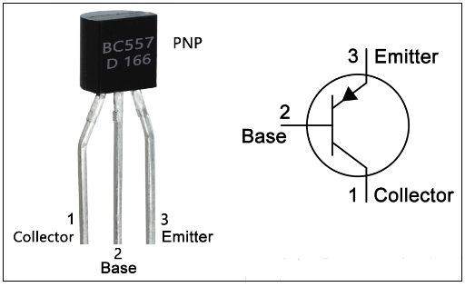

Figure 8: BC557Transistor Pin Diagram

* **Role of Rain Sensor in Circuit**

It simply works as switch the switch is open when it’s raining and closed when not. When it is raining small amount of current flows from its output terminal to base terminal of PNP transistor. Since BJT is current controlled device so it gets triggered.

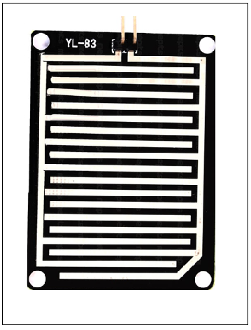

Figure 9 : Rain Sensor

* **Why we used 555 Timer IC?**

We used here it in Astable mode of operation as a clock generator. We set value of Resistances and capacitance to operate in Astable mode accordingly.

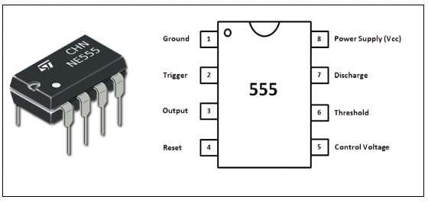

Figure 10 : Pin Diagram of NE555 Timer IC

* **Why we used LM358 Comparator IC?**

We used it to compare output of NE555 with reference voltage which we set using resistances of certain values. So it compares both voltage when 555 output goes high ,comparator output goes low and vice versa

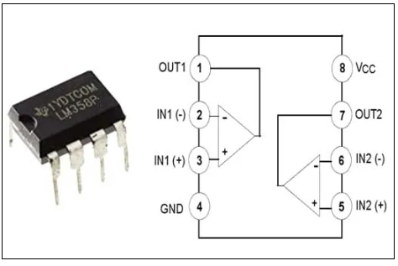

Figure 11 : Pin Diagram of LM358 Comparator I

* **Why we used L293D Motor Driver IC?**

L293D is used to drive the dc motor of the car wipers and also be used to operate the buzzer alarm.

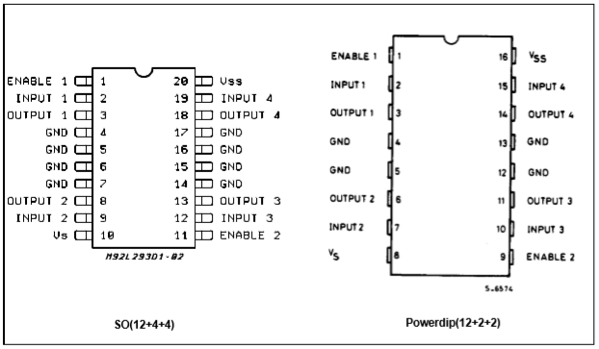

Figure 12 : Pin Diagram of L293D

1. **OTHER APPLICATIONS OF CIRCUIT**

The basic circuit of rain detection in our project can also be used for some other purposes as mentioned below;

* In the irrigation, it will detect the rain and immediately alert the farmer.
* In communications, it will boost the power of the antenna and increase the signal strength to send or receive the signals.
* In normal house hold, with the help of rain water detector we can automatically save the rain water. (This can be done only when home automation is done and there is proper equipment to save the rain water. In this, rain water detector will detect the rain and helps to switch ON the equipment which will automatically save rain water for different purposes).
* This can also be used if there is a chemical rain also. This is very common in industrial areas.

1. **HARDWARE CIRCUIT**

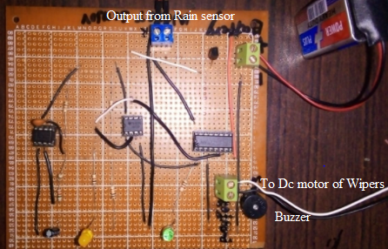

Figure 13 : Picture of hardware Basic Circuit

1. **PROJECT CONCLUSION**

The entitle of this project “Rain detector circuit with alarm and automatic rain sensing car wipers” is essential for providing automation to Car wipers for rain detection.

We can say that above circuit is reliable and simple which can be constructed at low cost. there is special type of automatic wipers that turn on when it begins to rain and turn off when rain stops. The three main components of the project are the Rain Water Sensor, 555 Timer IC and Buzzer with motor for wipers. When the Rain Water Sensor detects the Rain, it sends a signal to the 555 Timer. The 555Timer IC, which is configured in its Astable Mode, will then activate the buzzer and wipers through motor.

Moreover the basic circuit used for rain detection can be used for many other applications as discussed in Section 12.

We now are also able to investigate the limitations of circuit designing and requirements for the circuit working .How to implement the basic knowledge of the components in designing the circuit.

**------------------------------------------------------------------------------------------------------**

1. In the irrigation, it will detect the rain and immediately alert the farmer.
2. ¬In automobiles, when the rain detector detects the rain, it will immediately active the wipers
3. and inform the driver.
4. ¬In communications, it will boost the power of the antenna and increase the signal strength
5. to send or receive the signals.
6. ¬In normal house hold, with the help of rain water detector we can automatically save the
7. rain water. (This can be done only when home automation is done and there is proper
8. equipment to save the rain water. In this, rain water detector will detect the rain and helps
9. to switch ON the equipment which will automatically save rain water for different
10. purposes).
11. ¬This can also be used if there is a chemical rain also. This is very common in industrial
12. area