**Code:**

create schema cars;

use cars;

-- 1. READ DATA --

**Input:**

select * from car_dekho;

**output:**

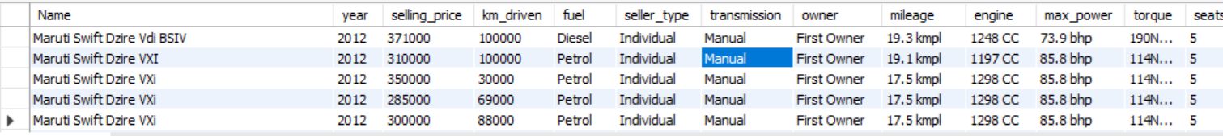



There are more than thousands of data for car_dekho but I show here only data of 10 data for car_dekho.

-- 2. Total Cars: To get a count of total records –

**Input:**

select count(*) from car_dekho;

*output*:

-- 3.The manager asked the employee How many cars will be available in 2023? --

**Input:**

select count(*) as 2023_cars from car_dekho

where year = 2023;

**output:**

-- 4. The manager asked the employee How many cars is available in 2020,2021,2022 --

**Input:**

select count(*) as cars_available_in_2020_to_2022 from car_dekho

where year in (2020,2021,2022)

group by year;

**output:**

-- 5. Client asked me to print the total of all cars by year. I don't see all the details. --

**Input:**

select year,count(*) as total_of_all_cars_year_wise from car_dekho

group by year;

**output:**

-- 6. Client asked to car dealer agent How many diesel cars will there be in 2020? --

**Input:**

select count(*) as diesel_car_2020 from car_dekho

where year = 2020 and fuel = 'diesel';

**output:**

--7. Client requested a car dealer agent How many petrol cars will there be in 2020? --

**Input:**

select count(*) petrol_car_2020 from car_dekho

where year = 2020 and fuel = 'petrol';

**output:**

-- 8. The manager told the employee to give a print All the fuel cars (petrol, diesel and CNG) come by all year.

**Input:**

select year,count(*) from car_dekho where fuel = 'petrol' group by year;

select year,count(*) from car_dekho where fuel = 'diesel' group by year;

select year,count(*) from car_dekho where fuel = 'cng' group by year;

**output:**

-- 9. Manager said there were more than 100 cars in a given year, which year had more than 100 cars?

**Input:**

select year,count(*) as this_year_had_more_than_100_cars from car_dekho

group by year

having count(*) > 100;

**output:**

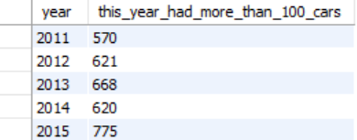

-- 10. The manager said to the employee All cars count details between 2015 and 2023; we need a complete list. –

**Input:**

select count(*) as cars_between_2k15_to_2k23 from car_dekho

where year between 2015 and 2023;

**output:**

-- 11. The manager said to the employee All cars details between 2015 to 2023 we need complete list --

**Input:**

select * from car_dekho

where year between 2015 and 2023

limit 10;

**output:**

