Women Connect International
Two-page Executive Summary

A concise partner-facing summary shaped around the reviewer’s guidance: founder background, problem observed, and the solution being proposed.

1. Origin of the initiative
Women Connect International (WCI) emerged from direct psychosocial and community practice with women navigating migration, economic disruption, caregiving pressure, and emotional strain across borders. Through counselling support, peer engagement, and informal mentoring, the founders repeatedly observed the same pattern: many African women in the diaspora are resilient, capable, and deeply committed to supporting both their households abroad and families back home, yet they remain structurally unsupported.
Fatima Abubakar, a counselling psychologist, saw this problem first-hand in her work with women experiencing stress, isolation, self-doubt, burnout, and limited access to culturally responsive support. Rakiya Shuaibu Mohammed brings systems strategy, digital product thinking, governance, and sustainability design. Together, they are translating lived community realities into a practical, scalable intervention that starts with emotional resilience and extends into economic participation, leadership, and accountable community impact.
Core insight
When women are psychologically strained, isolated, or carrying unresolved stress, they are less able to work consistently, lead confidently, build enterprises, or coordinate meaningful collective action.

2. The problem WCI is addressing
African women in the diaspora often play multiple invisible roles at once: breadwinner, caregiver, remittance sender, emotional anchor, and community mobilizer. Yet many face underemployment, credential barriers, limited mental health support, reduced professional confidence, and fragmented social networks. Their contributions are real, but the systems around them are not built to help them convert resilience into stable livelihoods and leadership.
At the same time, communities back home continue to experience needs in food security, women’s enterprise support, psychosocial wellbeing, and basic social protection. Diaspora women often help informally, but these efforts remain scattered, difficult to verify, and hard to scale. The result is a double gap: women abroad need structured support to regain agency, and communities at home need more coordinated, transparent pathways for help.

3. WCI’s proposed solution
WCI is building a focused NGO-led model that begins at the heart of the problem: psychosocial stability as a precondition for productivity, entrepreneurship, and leadership. The initiative will provide trauma-informed resilience support, peer healing circles, structured digital and income-oriented training, mentorship, and leadership development for women in the diaspora.
This support will be delivered through a simple, scalable operating model that combines human facilitation with digital tools. The platform is not positioned as therapy; rather, it is a structured empowerment system that offers guided wellbeing check-ins, learning pathways, mentorship support, and transparent tracking for vetted humanitarian or women-enterprise interventions.
In practical terms, WCI moves women through a clear pathway: stabilize wellbeing, strengthen confidence, build marketable skills, improve income opportunities, develop leadership capability, and then channel collective energy into accountable social impact.
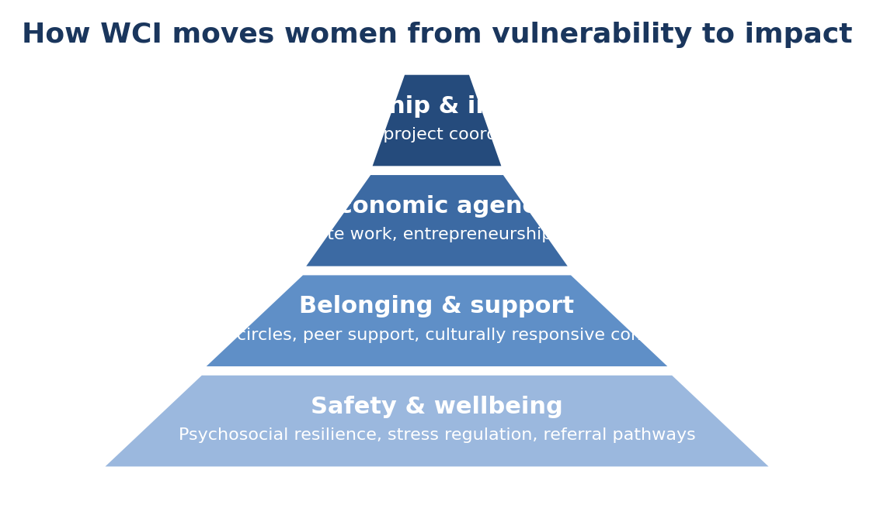
Illustrative pathway: WCI moves women from safety and support toward economic agency and leadership.

4. Why this matters now
Migration is increasing, diaspora remittance flows remain significant, and women continue to carry disproportionate emotional and financial burdens across borders. Yet very few initiatives connect wellbeing, employability, leadership, and accountable diaspora action in one coherent model. WCI fills that gap with an approach that is human-centered, practical, and scalable.

5. Delivery and sustainability
At this stage, WCI should be presented primarily as an NGO initiative solving a real and urgent problem. Over time, selected components can become financially sustainable through training services, partnerships, sponsored cohorts, and platform-enabled delivery. In other words, the social mission leads; earned-income opportunities may follow as the model proves value.

