Women Connect International
Partner Concept Note | NGO-facing version

A sharper external version distilled from the longer donor document and aligned to the reviewer’s comments.

1. Executive overview
Women Connect International (WCI) is a women-focused empowerment initiative designed to support African women in the diaspora who are carrying high emotional, social, and economic burdens but lack structured support systems that help them regain stability, confidence, productivity, and leadership capacity.
The initiative begins from a simple premise: when women are psychologically fragile, isolated, or overwhelmed, they struggle to function at their full potential. They may find it harder to qualify for jobs, complete training, sustain enterprise activity, or step into leadership roles. WCI therefore starts with resilience and wellbeing, then connects that foundation to economic participation, mentoring, leadership, and accountable social impact.
Positioning for partners
For now, WCI should be presented primarily as an NGO solving a real problem. The business dimension can remain secondary and supportive until the model is validated.

2. Founder insight and institutional origin
The idea was shaped through direct work with women navigating migration-related stress, underemployment, family obligations across borders, and emotional strain. Fatima Abubakar’s counselling and community-facing experience surfaced the recurring patterns of silent stress, diminished confidence, and limited support. Rakiya Shuaibu Mohammed contributes systems design, digital infrastructure thinking, governance, and sustainability planning.
What began as informal emotional support, peer engagement, and practical mentoring evolved into a larger insight: resilience alone is not enough if women are not connected to skills, income pathways, trusted networks, and structured channels for impact. WCI is the response to that systems gap.

3. The heart of the problem
Many diaspora women are expected to be stable for everyone else while lacking stability themselves. They may be supporting households abroad, sending money home, managing children, handling marital stress, and trying to find work or re-enter professional life under restrictive conditions. Even highly qualified women can become underemployed because of visa limitations, credential barriers, lack of networks, or reduced confidence.
This has direct consequences. Emotional overload reduces productivity. Social isolation weakens belonging. Persistent stress can make it difficult to learn new skills, complete certification, launch a business, or lead community efforts. The pathway to empowerment breaks before it fully starts.
Meanwhile, their support to communities back home usually remains informal. Funds are sent, urgent needs are met, but collective action is rarely pooled, tracked, or linked to measurable outcomes. Goodwill exists; structure does not.
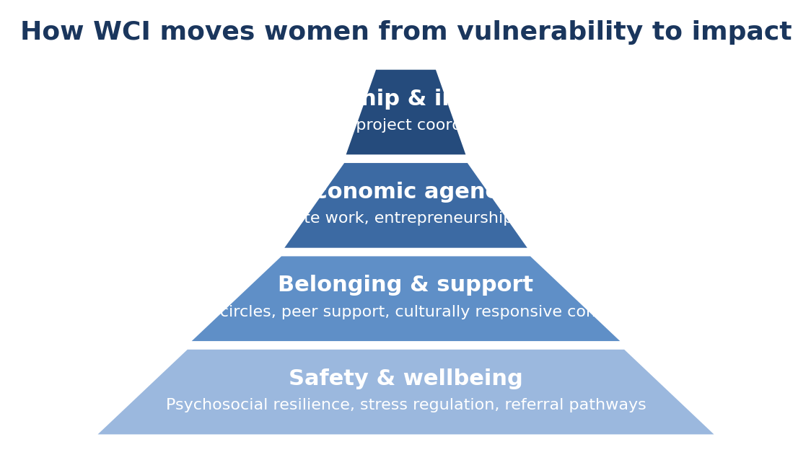
Maslow-style framing: wellbeing and safety are the base on which economic agency and leadership are built.

4. WCI’s focused solution
WCI proposes an integrated but tightly focused model. It does not try to solve every diaspora challenge at once. Instead, it concentrates on a clear progression:
First, provide psychosocial resilience support through guided emotional check-ins, healing circles, practical coping tools, and safe referral pathways where needed.
Second, connect women to market-relevant opportunity through digital skills, remote work readiness, entrepreneurship support, financial literacy, and mentorship.
Third, build confidence and voice through leadership development, peer networks, and community ambassador pathways.
Fourth, where collective action emerges, channel it into transparent, verifiable support for women-led and community-level interventions.

5. Program components
Component | What it solves | Illustrative activities
Resilience & wellbeing | Emotional strain, burnout, self-doubt, isolation | Healing circles, guided check-ins, resilience workshops, referrals
Economic empowerment | Underemployment and reduced agency | Digital skills, remote work readiness, enterprise support, financial literacy
Mentoring & leadership | Limited confidence and weak networks | Mentor matching, public speaking, advocacy basics, ambassador roles
Transparent impact | Fragmented informal giving | Vetted projects, milestone reporting, dashboard updates, community verification

6. Delivery model
WCI is envisioned as a light but disciplined NGO operating model. Human facilitation remains central, while digital tools provide scale and continuity. The platform can include four practical modules: a non-diagnostic emotional companion, a learning hub, mentor matching, and a transparency dashboard for any vetted community interventions.
The platform should be described as infrastructure that supports empowerment, not as the initiative itself. The project is fundamentally about women, not software.

7. Monetization and sustainability logic
The reviewer’s central question was correct: where is the viable model? At this stage, the clearest answer is that WCI should first be advanced as a mission-led NGO initiative with a credible path to sustainability, rather than as a fully commercial startup.
Near-term sustainability can come from partner-funded cohorts, sponsored training, grants, CSR-backed women’s empowerment programs, and philanthropy. As the model matures, selected services can generate earned income: resilience workshops for institutions, women-focused training programs, premium professional mentorship, and digital delivery support.
This creates a practical 70/30 framing: 70% mission-driven social intervention, 30% structured revenue pathways that help sustain delivery without distorting the mission.

8. Business model canvas snapshot
Primary beneficiaries | African women in the diaspora experiencing stress, isolation, underemployment, or stalled confidence
Value proposition | A practical pathway from emotional resilience to income, mentoring, leadership, and accountable impact
Key partners | Diaspora associations, mental health professionals, women-focused NGOs, sponsors, corporate CSR teams
Channels | Community networks, partner referrals, virtual cohorts, digital learning and mentoring platform
Revenue / support streams | Grants, sponsorship, paid training, premium mentoring pathways, platform-enabled delivery support

9. What partners can support now
At this stage, WCI is seeking validation, partnerships, and early institutional support more than large-scale capital. Relevant support could include pilot funding, introductions to women’s networks in different countries, psychosocial advisory support, implementation partnerships, or co-designed cohort programs.
A short two- to three-minute founder video and a one-page business model canvas can complement this concept note for presentations to assemblies, networks, and possible supporters.

10. Immediate next steps
- Sharpen the beneficiary definition and first pilot geography.
- Complete a one-page business model canvas to force strategic choices.
- Run a small pilot cohort and document the change pathway.
- Develop a brief founder profile and short presentation video.
- Use the NGO framing for outreach while keeping the company as back-end technical support only, where needed.

Conclusion
WCI has a real problem to solve and a meaningful opportunity to create impact. Its strength lies not in trying to be everything at once, but in clearly articulating one central insight: women cannot consistently build income, leadership, and social impact when their emotional foundation is unstable. By addressing that foundation first and then building upward, WCI becomes clearer, sharper, and more viable.

