**Department of Computer Science**

**Project Report, [Spring 2022-2023]**

**Project Title: Theme Park Management System**

**Project Description:**

The theme park management system encompasses four distinct user roles: Admin, Customer, Ride Operator, and Ticket Seller, each carrying out unique responsibilities within the system. Admins, equipped with attributes A_username and A_password, by the power to approve and manage customers, ride operators, ticket sellers, and job applications. Individuals aspiring to visit the theme park can register as customers within the system, providing personal details and buying tickets for various rides. Customers can access the park and enjoy the rides managed by ride operators. Ride operators, responsible for the operation and safety of the rides, ensure smooth and safe experiences for visitors. They are equipped with attributes such as Rd_Username, Rd_Name, Rd_Age, Rd_Sex, Rd_Nationality, Rd_Blood_Group, Rd_Password, and Rd_Salary. In parallel, ticket sellers manage ticket sales, customer queries, and transactions, equipped with attributes like T_Username, T_Name, T_Age, T_Sex, T_Nationality, T_Blood_Group, T_Password, and T_Salary. Individuals can also apply for jobs within the park, providing detailed information about their qualifications, which the admin reviews and approves. Admins oversee multiple operations within the park, ensuring everything runs efficiently and safely. The Ride entity, with attributes such as Ride_Name, Ride_No, Photo, and Ride_Price, details each ride available in the park. Tickets, with attributes like Ticket_ID, C_Username, and Ride_No, link customers to their chosen rides. This system's primary objective is to facilitate a seamless, enjoyable experience for visitors while maintaining efficient and safe park operations.

**ER DIAGRAM:**

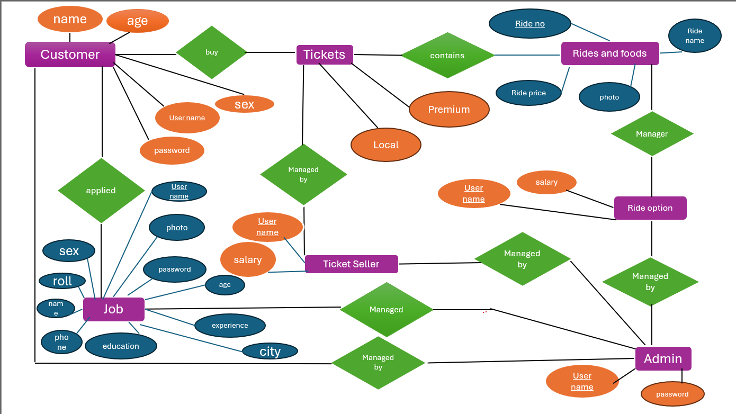

**Entity and Attributes for each Entity:**



**Roles and their individual responsibilities:**

* **Admin:** This role plays an important role for managing the entire system. Admin can add the customer, Ride_operator, Ticket_seller. Moreover, when any person want to job in this system and apply for any role/position admin approve them. Additionally, the admin can remove any customer , Ride_operator, Ticket_seller and also reject an applicant.
* **Customer:** As a customer individuals can show the details about ride and also can buy tickets which has different types. Customer can pay through online.
* **Ride_Operator:** As a ride operator, he/she can manage the rides and also update the food service.
* **Ticket_Seller:** As a ticket seller, he/she manages tickets. And also take care of the vault.

**User Details:**

* Admin
* Customer
* Ride Operator
* Ticket Seller

|  |  |  |
| --- | --- | --- |
| **Use Case Name** | **Actor** | **User Story** |
| Sign In | ADMIN | Responsible for managing and regulating the entire system |
| Sign In | CUSTOMER | Access the system to buy tickets and select different Rides |
| Approval | ADMIN | Approve Ride_Operator and Ticket_Seller for their desire work |
| Rejections | ADMIN | Can reject a job applicant |
| Changes | RIDE_OPERATOR | Can update the rides and food menu also |
| Updates | TICKET_SELLER | Update ticket prices according to types |
| Modification | ADMIN | Modify or update data of other system users as needed |

**User Interface Design:**

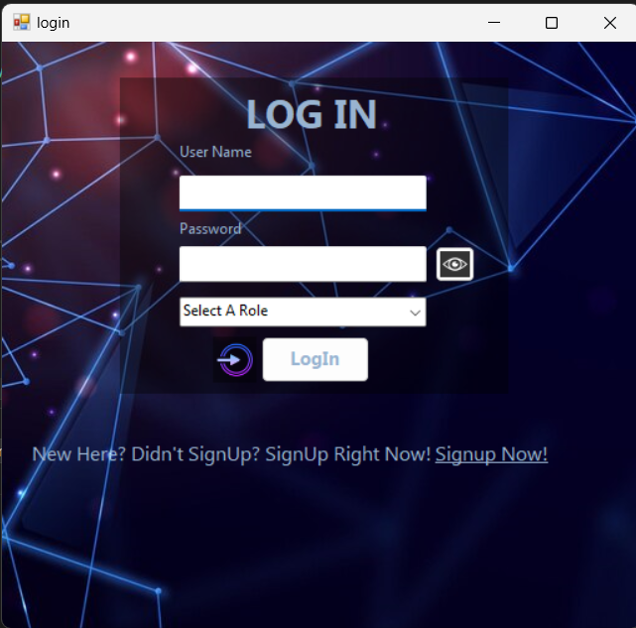

**Fig 1: Login for all User**

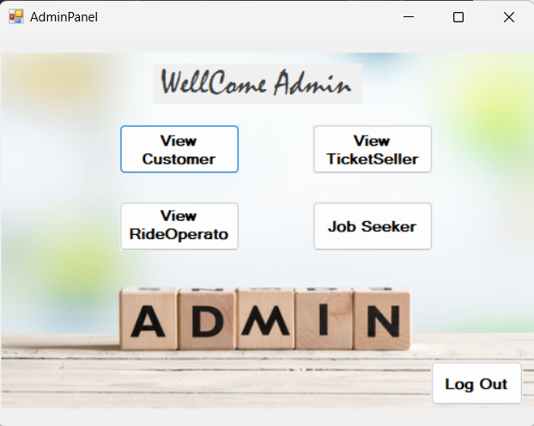

**Fig 2: Admin Dashboard**

**Fig-03: Show All Customer**

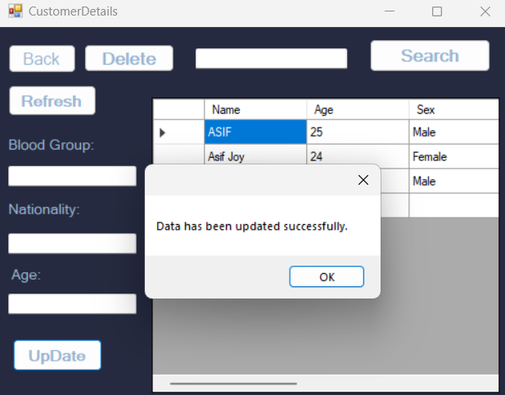

**Fig-04: Updated Customer**

**Fig-05: Show All Ticket Seller**

**Fig-06: Show All Ride Operator**

**Fig-07: Adding Ride Operator**

**Fig-08: Adding Ticket Seller**

**Fig-09: Logout from Admin Dashboard**

**Fig-10: Customer Dashboard**

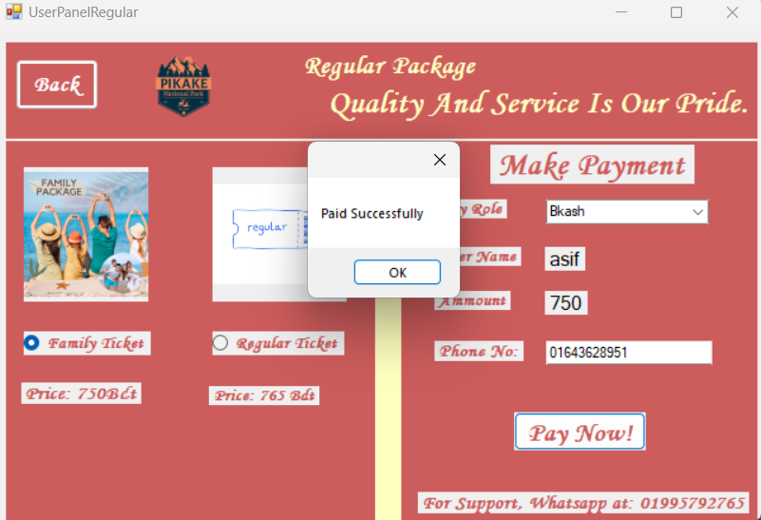

**Fig-11: Customer Buying Regular Packages**

**Fig-12: Customer After Buying Premium Package**

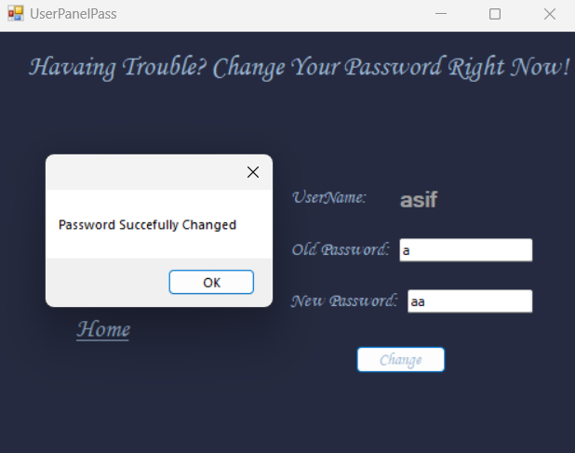

**Fig-13: Customer Resets his/her Password**

**Fig-14: Dashboard For Ride Operator**

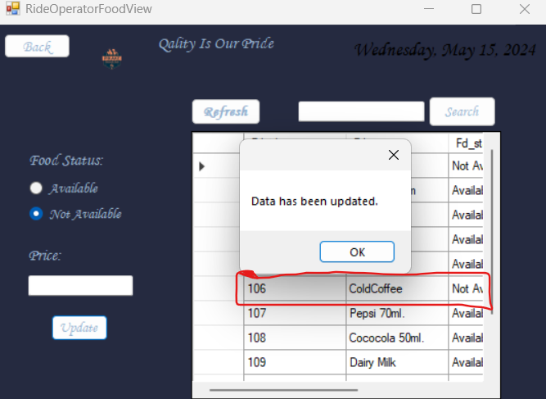

**Fig-15: Ride Operator updating Food Service**

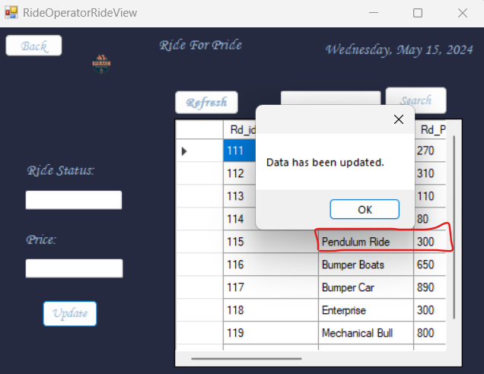

**Fig-16: Ride Operator Updating Ride Service**

**Fig-17: Dashboard For Ticket Seller**

**Fig-18: Ticket Seller Updating Ticket Info**

**Fig-19: Sold Ticket Information History**

**Fig-20: Wanna Apply for Any Job...?**

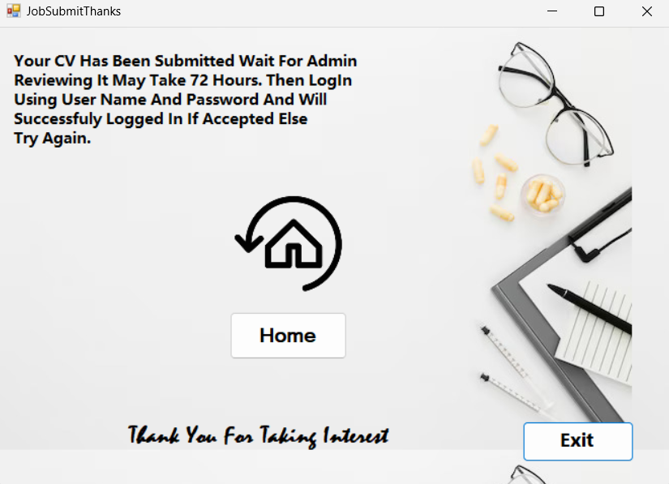

**Fig-21: Application Has Been Submitted**

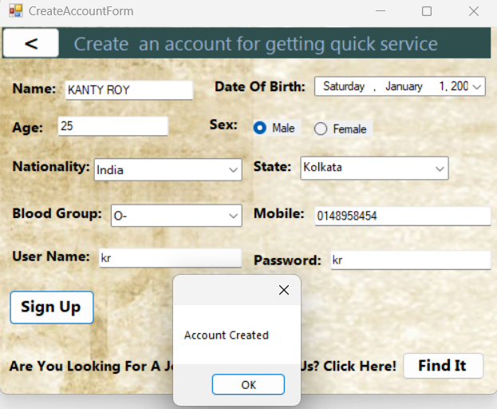

**Fig-22: If You Are New, Sign Up Here…!**

**Database Schema:**

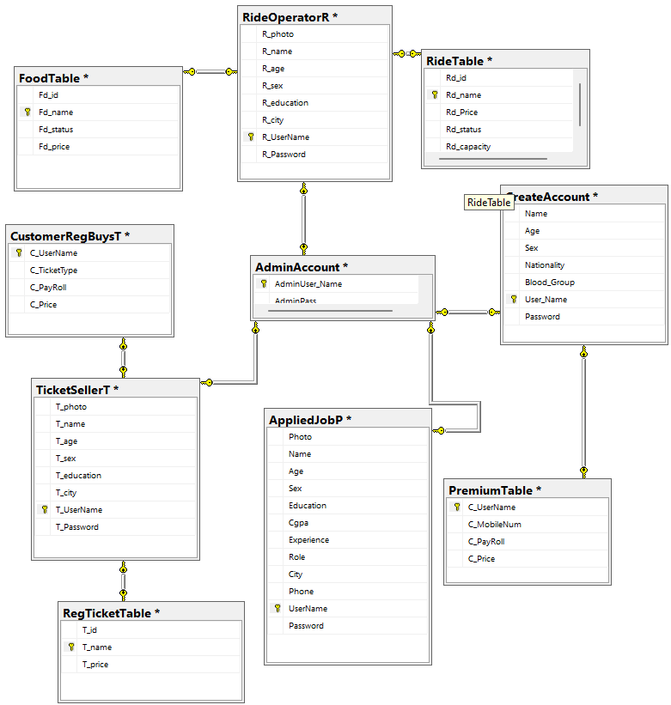

**Admin:**

**Create Account:**

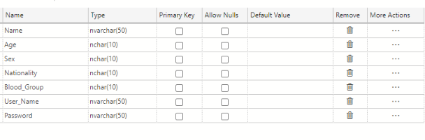

**Ride Operator:**

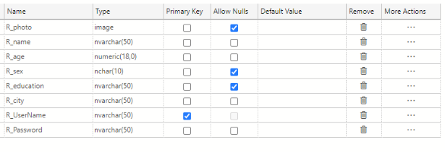

**Ticket Seller:**

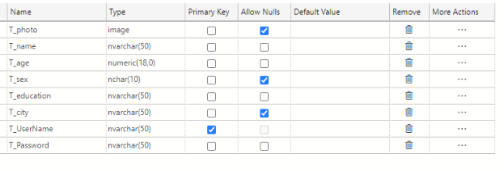

**Applied Job:**

**Premium Table:**

**Customer Reg Buys:**

**Ride Table:**

**Reg. Ticket Table:**

**Food Table:**

