Dots and Boxes

Ahmed Bahgat El-Sherif 1801 0078 Moaz Fathy Mohamed El-Dafrawy 1801 1823
Abdallah Yasser Ibrahim 1801 5026

Description:
We have implemented a “Dots and Boxes” game using C and CodeBlocks IDE. Dots and Boxes is a game where two players race to complete squares and gain points. The players take turns placing one line each turn in a grid. If a player’s line completes a square the player gains one point. The games ends when all the lines have been chosen and the winner is the player with the most points.

Features:
The user can:
- Choose grid size
- Choose to play against computer or another player
- See the time
- Undo and redo moves
- Save and load games
- Checkout the high scores

Design Overview:
The main component is the “Game” struct which holds all information related to the game state. The grid is built with a 2d array of “Square” structs which has four variables for four sides and a variable for the player who completed it. The input validation is done by inputting a string then getting the information we need from it. We save and load using binary files to take advantage of easier storing of the Game struct.

Assumptions:
- The game is played on the same computer.
- Undo returns two steps back
- The number of users is reasonable.
- The user will only use the executable and has no access to the save files.
- Only three save files numbered 1,2, and 3.
- Saving to a file will overwrite the previous save. So, the user has to remember which file he saved to.

Data Structures:
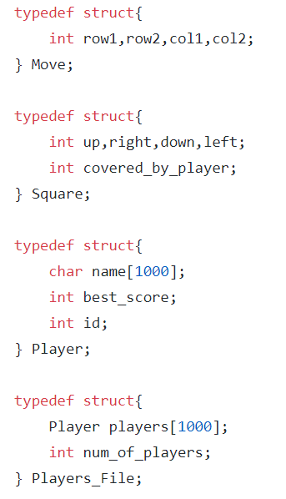
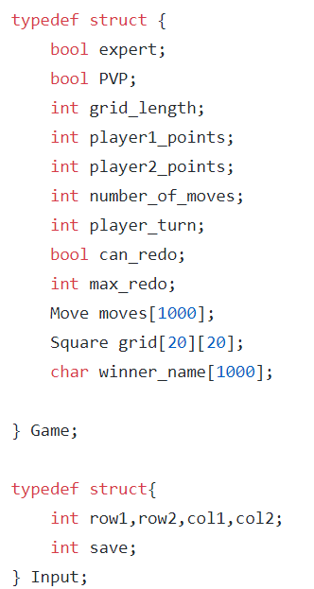

Important Functions:
play_game:
play_game is the main loop of the actual game-play. It handles the choices inputs (enter line, save, undo, redo) and validation.

take_coordinates_input:
Takes user input and validates it. Then, updates the appropriate place in the 2d array of Squares.

computer_to_play:
Checks valid moves and chooses the favorable move to play automatically.

print_grid:
print_grid prints the grid lines from the Game.

after_game:
Handles what happens after the game ends (Decide winner, ask for name and updates the top 10 list).

display_top_10_players:
Soads the saved list of high scores, adds the winner, then sorts it, saves it and displays the players.

Save and load functions:
Saves the game using save_game. Load the game using load_game.

Pseudo Code:
Main Menu:
play_main_menu(){
print(“Enter the option number:”)
char input[1000]
fgets(input, 1000)

if ( strlen(input) != 2){
recall main_menu()
return
}
switch ( input[0] ):
case ‘1’:
enter_options()
play_game()
break

case ‘2’:
load_game()
break

case ‘3’:
display_top_10_players()
break

case ‘4’:
exit()
break

default:
play_main_menu()
break
}
Game Loop:
play_game( Game *game){
exit_game = 0 //global to indicate exit from game
float seconds = 0
start clock()
int row1, row2, col1, col2
while( still space for more lines){

display_game(game) //prints the UI options
print( (int)seconds/60, seconds%60) //minutes, seconds

if ( game mode is player_Vs_comp and it’s computer’s turn)
computer_to_play(game, &row1, &row2, &col1, &col2)
else
take_coordinates_inputs(game, &row1, &row2, &col1, &col2)

if (exit_game)
return

Square *square1, *square2

point to the appropriate squares from the grid according to the input
update the square side values according to the input
flag = 0

if (square1 is completed){
update it’s “covered_by_player” to the player_turn
player whose turn it is -> points++
flag = 1
}
same thing for square2 …
if (flag = 0)
change the turn (player_turn = 3 – player_turn)
number_of_moves++
end clock()
seconds = (end – start) / 1000
}
//if we are here then the game is finished
after_game(game)
}
Input line coordinates and game options:
take_coordinates_inputs(*game, *row1, *row2, *col1, *col2){
do{
char input_str[1000]
fgets input_str

if (input_str = “save\n”){
save_game(game)
continue
}

else if (input_str = “undo\n” and number_of_moves > 0){
game → can_redo = true
keep undo(game) until the player returns to his turn
continue
}
else if (input_str = “redo\n” and can_redo and max_redo > 0{
return the furthest move the players have gotten to
}
else if input_str = “exit\n”{
exit_game = true
return
}
if input_str format is like “cIJ” or “rIJ” {
if rIJ {
row2 = row1 = input_str[1]
col1 = input_str[2]
col2 = col1 + 1
}
similarly for cIJ ...{
col1 = col2 = input_str[2]
row1 = input_str[1]
row2 = row1 + 1
}
}
validinput = validate_points(row1,row2,col1,col2) & move not played before
if validinputs = true record_move
}while(!validinput)
}

Computer:
computer(*game){
if (three_sided_box_exists){
play the fourth side and record it
return
}
check for empty any horizontal lines and place and return
same for vertical lines
}
After Game
int score_to_update;
char name_to_update[1000];

print information depending on
- player vs computer or player vs player
- who won

ask winning player for name and add his name to the high score list
display_top_10_player()

Display top 10:
display_top_10_players(){
load playersfile
sort players
print players
}

USER MANUAL
Starting the game:
First, enter the desired option. Let’s say you enter ‘1’ then press enter.
You will be prompted with more options. Select the desired settings until you get to the game.

To choose a game option, make sure to enter the option’s name exactly like it’s written (case sensitive).

In-Game options:
save: Choose a file number from 1 to 3. Be careful, Because saves overwrite the previous game.

undo: Returns to the last move
redo: Returns to the last undo
exit: Returns to the main menu
------------------------------------------------------------------------------------------
To choose a line to draw. Enter the line in the following format:
rIJ or cIJ
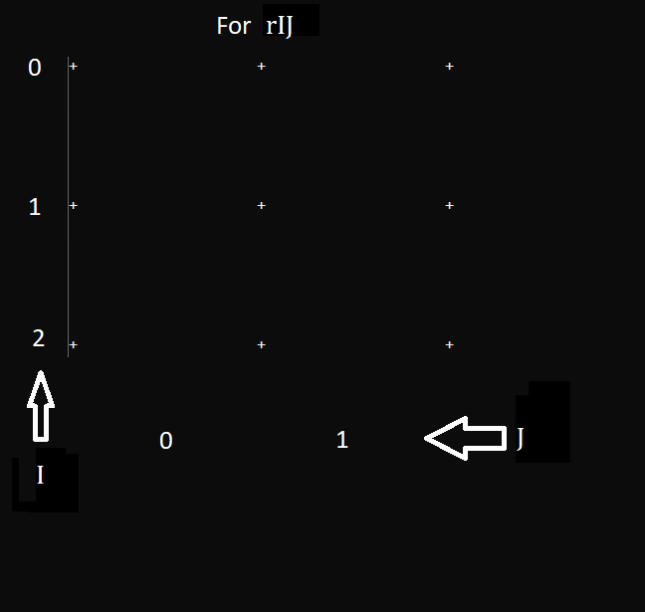
where I and J are coordinates for the given grid
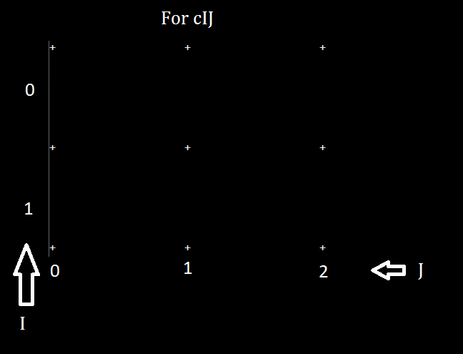

Loading a previous game:
To load a previously saved game, go to the main menu using exit if you are in the middle of a game. Then, choose a file number from 1 to 3.
The game will be loaded and ready to play.

High-score lists:
To see the top 10 rankings, choose number 3 from the menu. You will be presented with the list. To return to the main menu, simply press enter.

