1. Here is the original plot of the series:

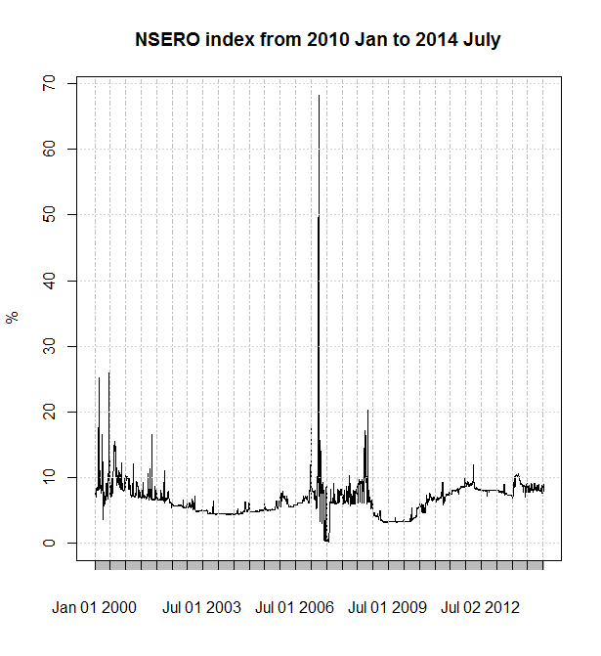

1. Then I manually deleted the obviously outliers, which are likely to be wrongly input, to avoid their potential influence on later analysis. The threshold is set at 30% (really subjective). And I replace them with the mean value of the whole series. After this manipulation, the series plot looks like this:

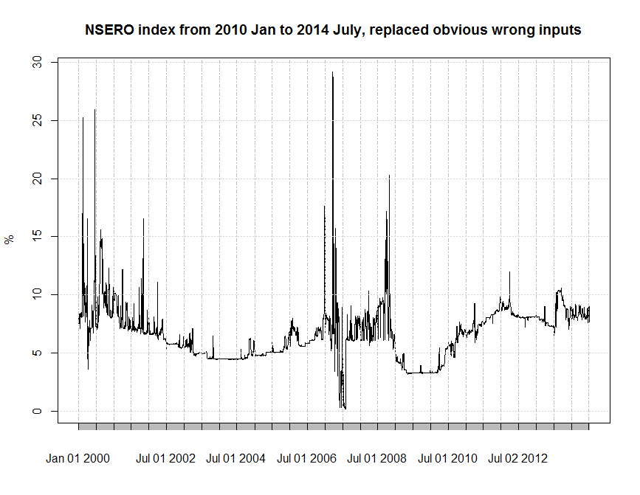

1. The basic idea is to find robust estimates of the trend and seasonal components and subtract them. Then find outliers in the residuals. Here I employ the Local Polynomial Regression Fitting (LOESS) method. The test for residual outliers is the same as for the standard boxplot -- points greater than 2 IQR (subjective choice again) above or below the upper and lower quartiles are assumed outliers. After the calculation, there are 149 outliers, which accounts for around 3.3% of whole series length (4546).

The points labelled in red are the detected possible outliers:

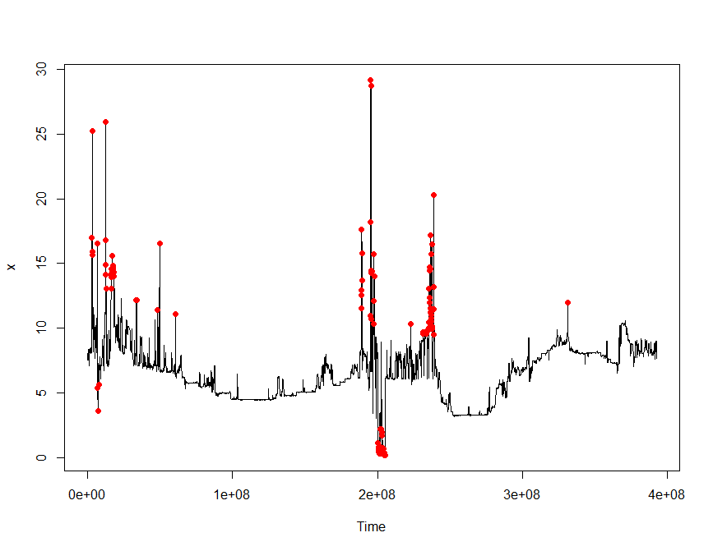

Remarks:

1. I use R to perform the analysis.
2. The method I use is really simple and preliminary; I may have to spend some time to do some further research on this topic to improve the detection procedure.
3. I will think method to interpolate the outlier value later.
4. For your reference, I’ve attached the R code and csv data.