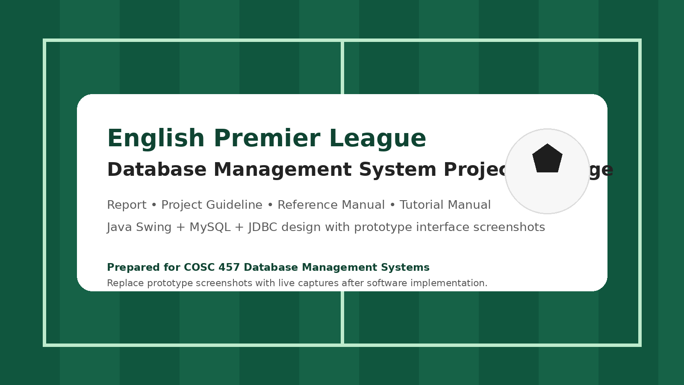
Project Guideline
English Premier League Database Application • COSC 457

This guideline is a working blueprint for planning, building, documenting, and packaging the English Premier League (EPL) database application. It aligns the proposed project with the class expectations shown in the supplied guideline deck: report content, Java Swing implementation, manuals, and executable delivery.
1. Project Vision
The project will simulate the business operations of a professional football league environment. The database application will manage clubs, players, managers, stadiums, fixtures, match results, match events, transfers, standings, and selected commercial relationships. The final software package should feel like a practical business system rather than a simple classroom demo.
1.1 Objectives
- Design a realistic relational database model that supports league operations from season setup to reporting.
- Implement the user interface in Java Swing with JDBC connectivity to MySQL.
- Produce meaningful SQL reports for operational and analytical use.
- Deliver complete documentation: design report, reference manual, tutorial manual, and software package.
2. Scope of the Application
The recommended minimum scope is intentionally broad enough to support a strong ERD and SQL reporting, but narrow enough to complete within a semester project. The scope can be expanded with sponsor tracking, attendance, or broadcast contracts only after the core workflow is stable.
Module | In Scope | Out of Scope / Optional Later
Season Management | season creation, matchweeks, active season status | multi-league support
Club Management | club profile, manager, stadium, city | academy teams
Player Management | player master data, positions, club registration | agent contracts
Fixture Management | schedule, venue, match date, status | automated fixture generation engine
Result Processing | scores, winner, match events, standings update | VAR decision logs
Transfers | incoming/outgoing transfers, fee, date, history | loan clauses and installments
Reports | standings, top scorers, roster views, fixtures by week | predictive analytics

3. Recommended Deliverables
- Database design report with introduction, target business, business process, user requirements, ERD, and Gantt chart.
- Java source code and executable JAR file for the Swing application.
- Database script containing CREATE TABLE statements and INSERT statements for sample data.
- Reference manual with functions explained in alphabetical order and accompanied by screenshots.
- Tutorial manual organized by work scenarios and step-by-step walkthroughs.
- Promotional flyer or one-page application summary if required by the instructor.
4. Team Roles and Suggested Task Split
Role | Primary Responsibility | Suggested Outputs
Project coordinator | schedule, integration, final packaging | timeline, checklist, final review
Database designer | ERD, schema, keys, sample data | ERD, SQL script, data dictionary
Application developer | Swing forms, JDBC, validations | screens, controllers, executable JAR
Documentation lead | report and manuals | report, tutorial, reference manual
QA / testing support | test cases, bug tracking, screenshots | test log, corrected screenshots

5. Development Standards
5.1 Database Standards
- Use singular table names or a consistent plural naming style; do not mix naming patterns.
- Primary keys should be simple, stable identifiers such as club_id, player_id, fixture_id, and season_id.
- Foreign keys must be enforced and named consistently.
- Use lookup tables for positions, event types, and status values when repeated values appear across records.
- Capture history rather than overwrite critical transfer or registration information.
5.2 Java Swing Standards
- Use a consistent menu structure: Dashboard, Clubs, Players, Fixtures, Results, Transfers, Reports, Admin.
- Place validation messages near the relevant form controls and avoid silent failures.
- Every input screen should have clear Save, Reset, Search, and Back/Close actions where appropriate.
- Use JTable for listings and search results; avoid free-form outputs for tabular data.
- Use prepared statements for all database operations to prevent SQL injection and formatting errors.
5.3 Documentation Standards
- Use one naming convention across all documents, schema objects, and screens.
- Every manual screenshot should include a short caption that explains what the user is seeing.
- Replace prototype screenshots with live application screenshots before final submission if the software is complete.
- When describing a function, include purpose, required inputs, actions, validation, and output.
6. Core Screens to Implement
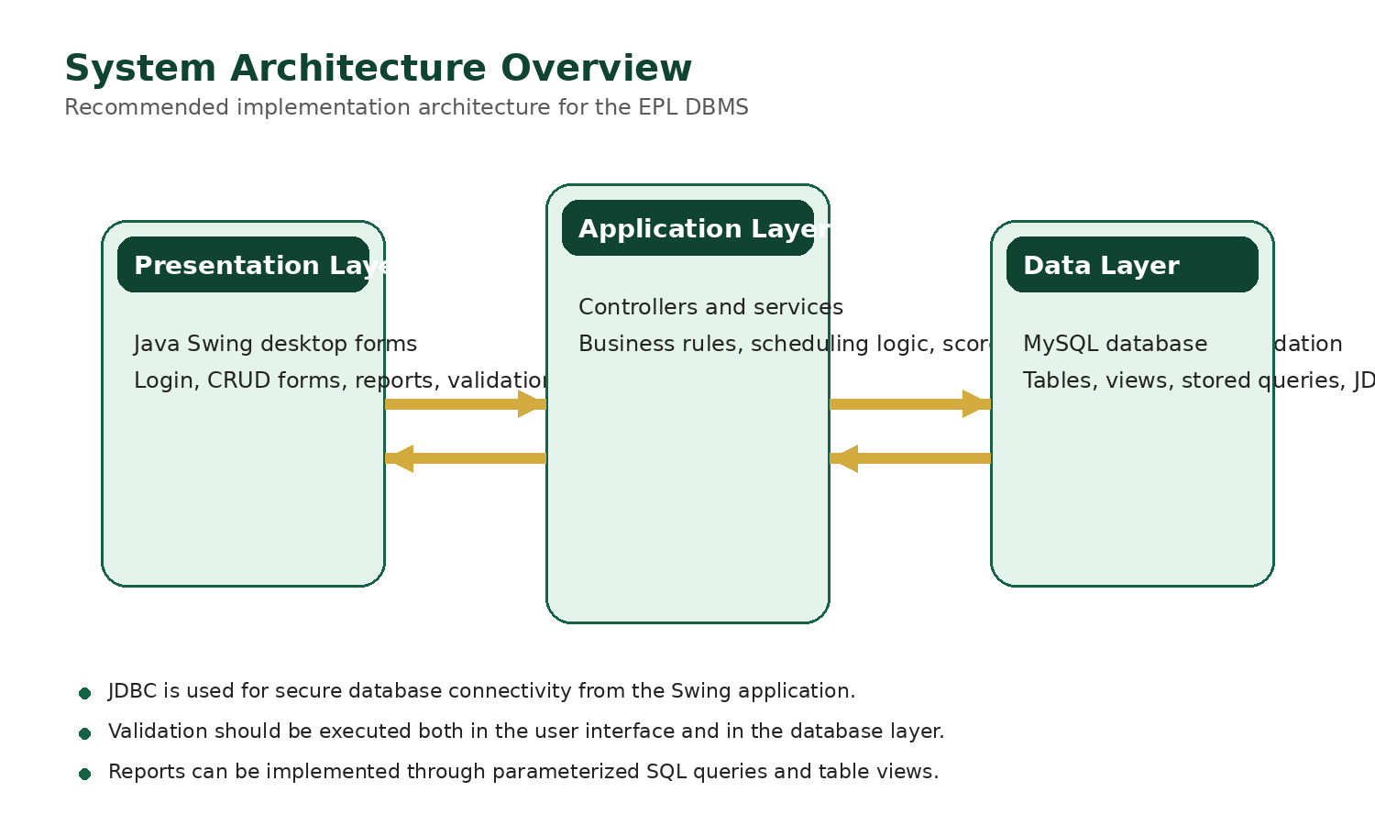
Recommended three-layer implementation view.
Screen | Purpose | Priority
Login | authenticate administrator or reporting user | High
Dashboard | show quick statistics and navigation | High
Club Management | create, update, and browse clubs | High
Player Registration | manage player master data and season registration | High
Fixture Scheduler | schedule matches by season and matchweek | High
Result Entry | record score and match events | High
Transfer Management | maintain transfer history | Medium
Standings / Reports | run queries and analytical outputs | High

7. Testing and Quality Checklist
- Does every table load without runtime errors?
- Are all required fields validated before save?
- Do foreign key lookups prevent invalid club-player or fixture relationships?
- Do result updates refresh standings correctly?
- Do reports show the expected data for a selected season or matchweek?
- Can the application connect to the database from the required environment?
8. Risk Log and Mitigation
Risk | Impact | Mitigation
Scope becomes too large | unfinished features and weak testing | freeze the minimum viable scope early
Inconsistent sample data | queries return incorrect results | assign one owner for data seeding
Late documentation | rushed manuals and missing screenshots | capture screenshots during each completed screen
Database connection problems | application fails during demo | test JDBC connection early and keep local fallback setup
Weak integration between modules | broken workflows | merge work frequently and run scenario-based tests

9. Submission Checklist
- Confirm that the report matches the actual design and features implemented in the application.
- Export and test the executable JAR on a clean environment if possible.
- Include the database creation and sample data script.
- Review the reference manual for alphabetical function ordering.
- Review the tutorial manual for realistic user scenarios and step-by-step screenshots.
- Perform a final spelling, layout, and screenshot audit across all deliverables.
10. Recommended Weekly Plan
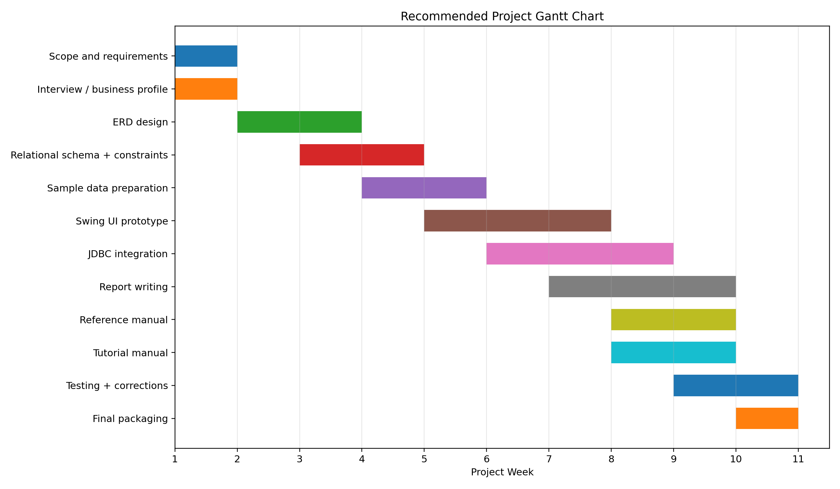
Recommended development timeline for the semester project.
This guideline is intended to keep the team focused on a realistic build path. It should be updated whenever the team changes scope, adds a module, or reorganizes the division of work.

