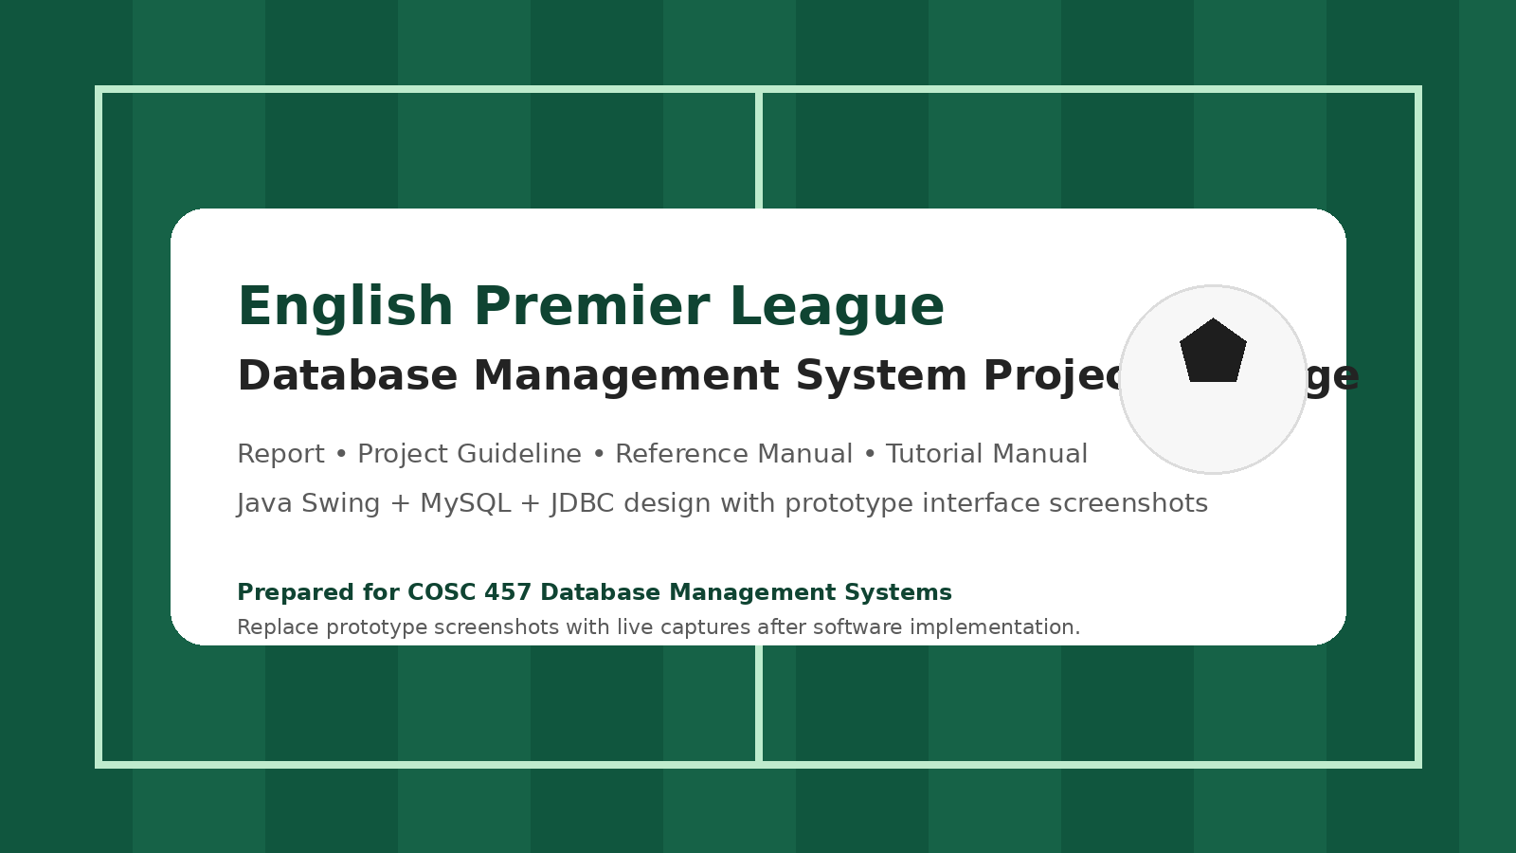
Reference Manual
English Premier League Database Application

This reference manual explains the main functions of the proposed application in a function-by-function format. The screenshots included in this manual are prototype screen mockups prepared to support planning and documentation. They should be replaced with live software screenshots once the final Java Swing application is complete.
How to Use This Manual
- Functions are presented in alphabetical order for quick lookup.
- Each entry explains the purpose of the function, the fields involved, and the expected result.
- Validation and usage notes are listed whenever they are important to correct operation.
Add Club
Use this function to create a new club record or update a club profile.
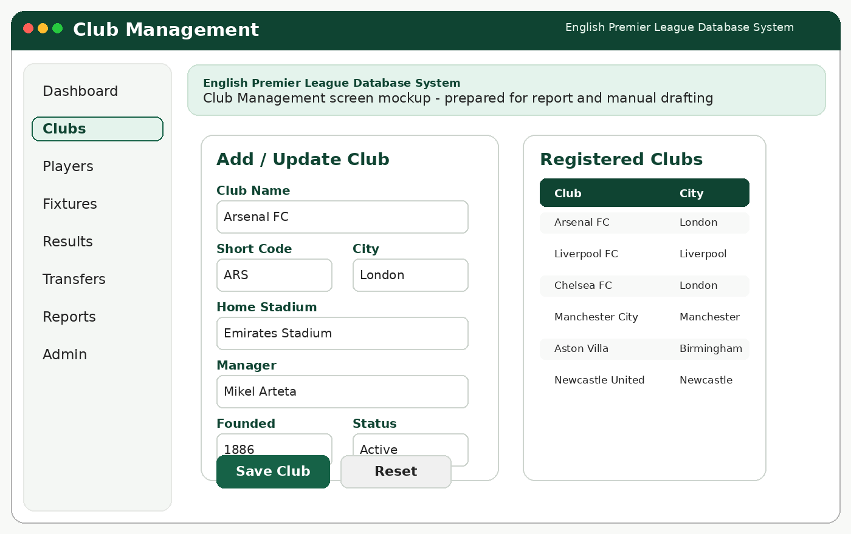
Add Club screen.
Procedure
- Open Clubs from the left navigation menu.
- Enter club name, code, city, stadium, manager, and status.
- Click Save Club to store the record.
Validation / Notes
- club name should be unique
- stadium and manager should exist or be entered consistently
Expected Result
A new club becomes available for roster registration, fixture scheduling, and reports.
Add Fixture
Use this function to schedule a match for a season and matchweek.
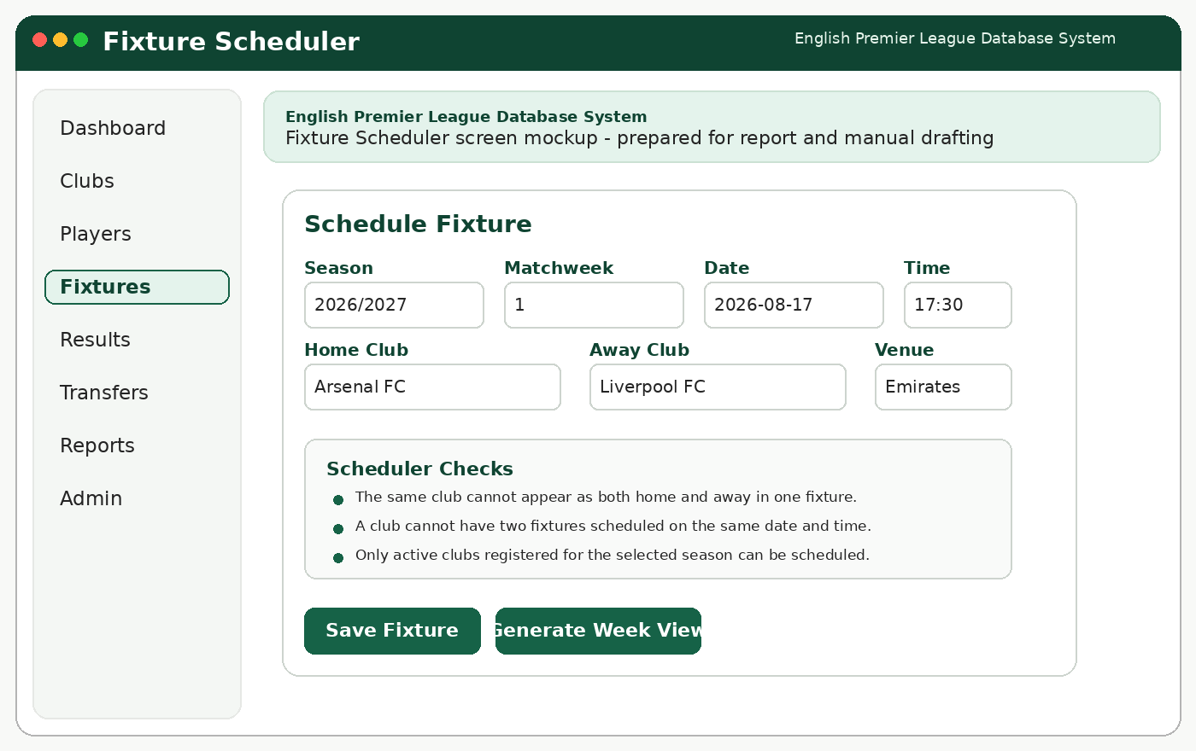
Add Fixture screen.
Procedure
- Select season, matchweek, date, and kickoff time.
- Choose the home club and the away club.
- Confirm the venue and click Save Fixture.
Validation / Notes
- home club and away club must be different
- clubs cannot be double-booked at the same time
Expected Result
The fixture is added to the schedule and becomes available for result entry.
Add Match Event
Use this function to record event details such as goals and cards after a match is selected.
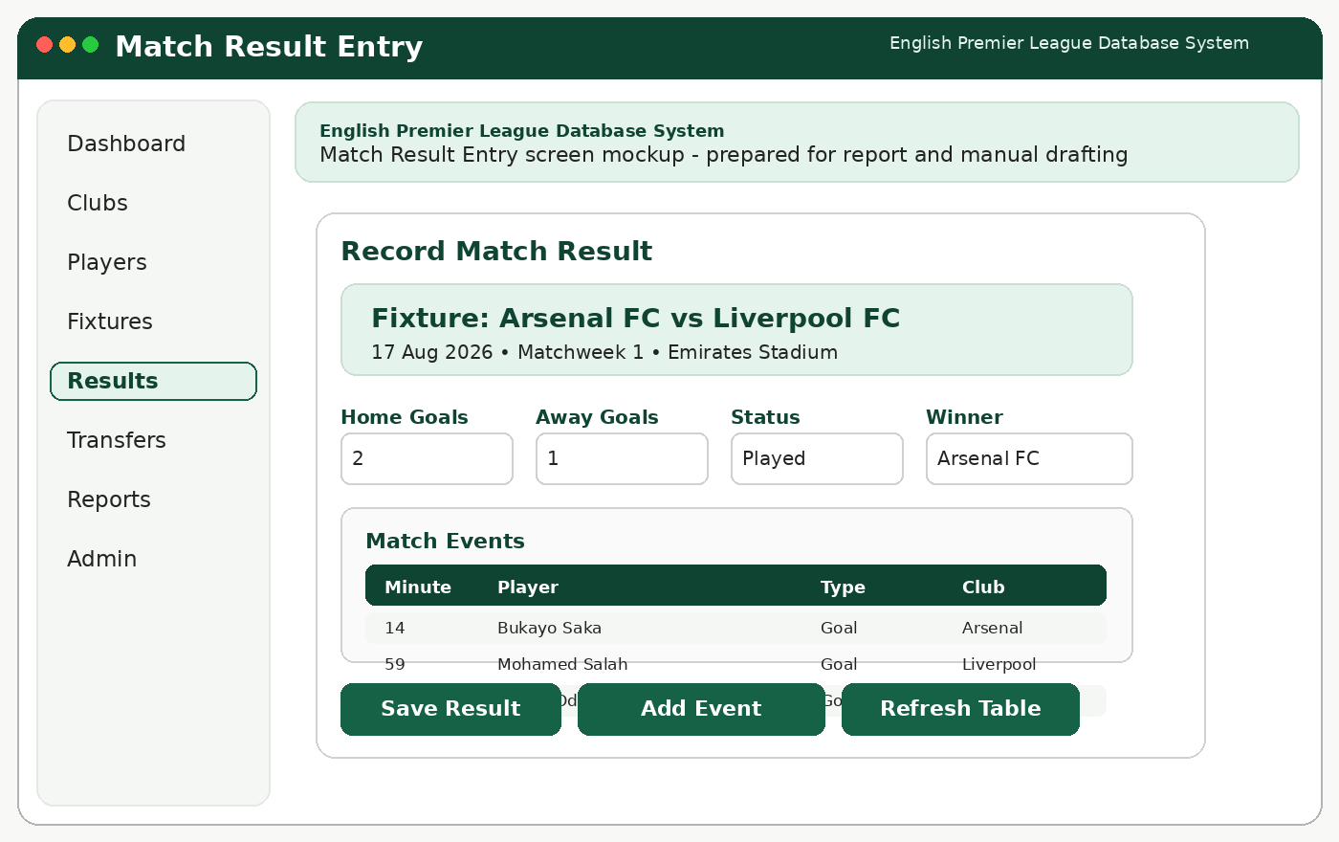
Add Match Event screen.
Procedure
- Open the result entry screen.
- Load the correct fixture.
- Click Add Event and enter minute, player, and event type.
Validation / Notes
- event minute must be numeric
- player should belong to one of the clubs in the fixture
Expected Result
Match event data is saved and becomes available for reports such as top scorers and disciplinary summaries.
Add Player
Use this function to create a player record and register the player for a season.
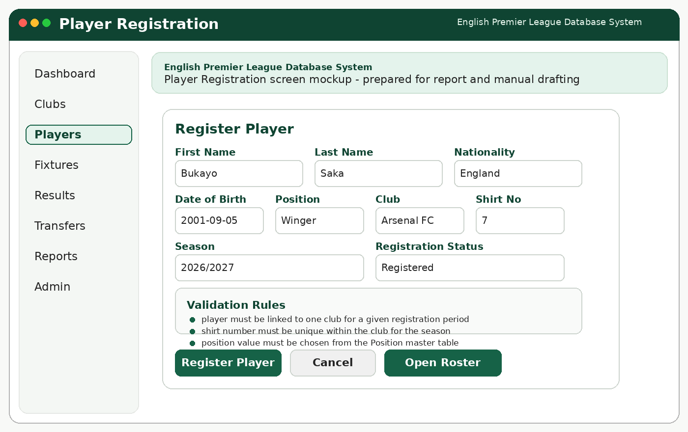
Add Player screen.
Procedure
- Open Players from the navigation menu.
- Enter player biographical data, club, and position.
- Click Register Player.
Validation / Notes
- shirt number should be unique within the club for the season
- position should come from the Position table
Expected Result
The player becomes part of the active roster for the selected season.
Add Season
Use this function to create the competition season and prepare matchweeks.

Add Season screen.
Procedure
- Open the season setup form or admin area.
- Enter season name, start date, end date, and active status.
- Save the season before scheduling fixtures.
Validation / Notes
- only one season should be marked active at a time
Expected Result
The application can associate registrations, fixtures, standings, and reports with the selected season.
Add Transfer
Use this function to move a player from one club to another and preserve history.
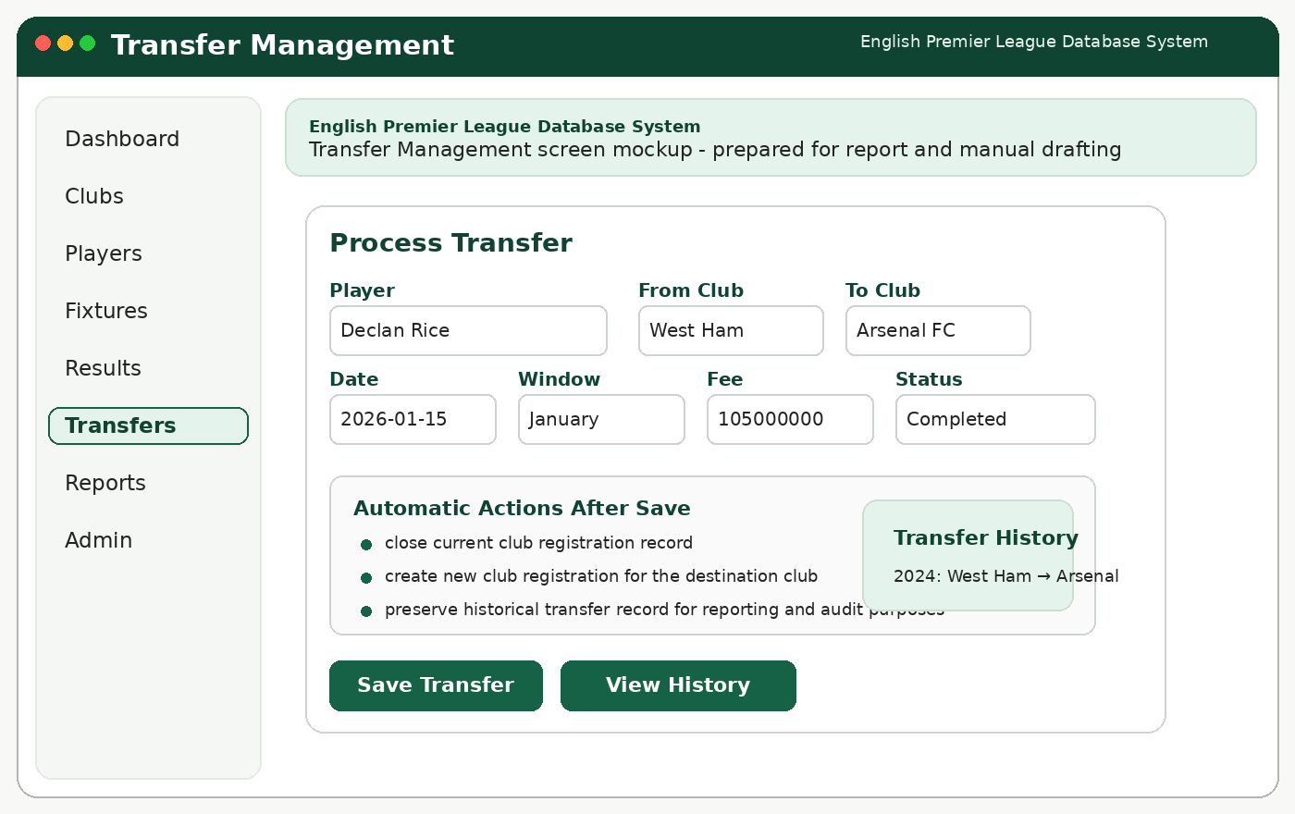
Add Transfer screen.
Procedure
- Select the player to transfer.
- Enter origin club, destination club, date, fee, and transfer window.
- Click Save Transfer.
Validation / Notes
- origin and destination clubs must differ
- a completed transfer should close the previous registration
Expected Result
A historical transfer record is created and the player can be re-registered to the destination club.
Dashboard
This screen gives the user a quick overview of counts, upcoming fixtures, and shortcut actions.
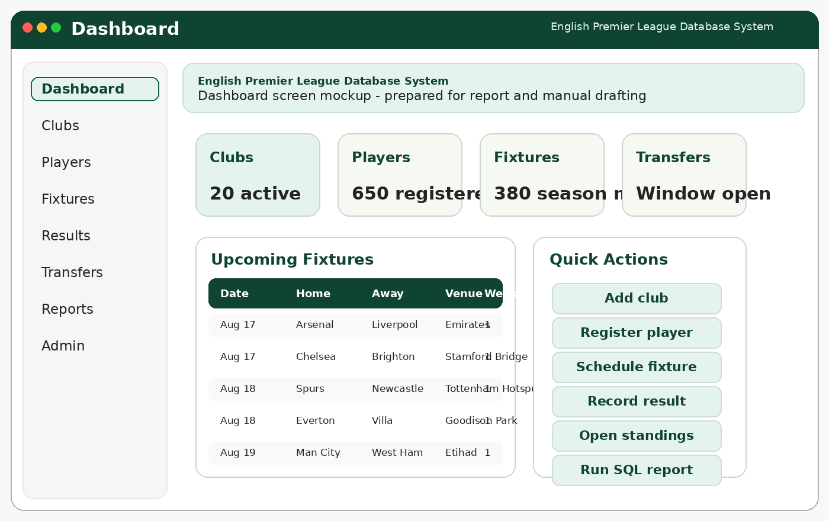
Dashboard screen.
Procedure
- Review the summary cards for clubs, players, fixtures, and transfers.
- Use the quick actions to open common tasks.
- Use the upcoming fixture list for operational awareness.
Validation / Notes
- dashboard values should refresh after updates
Expected Result
The dashboard serves as the landing page after login.
Generate League Table
Use this report to view the current ranking of clubs in a season.
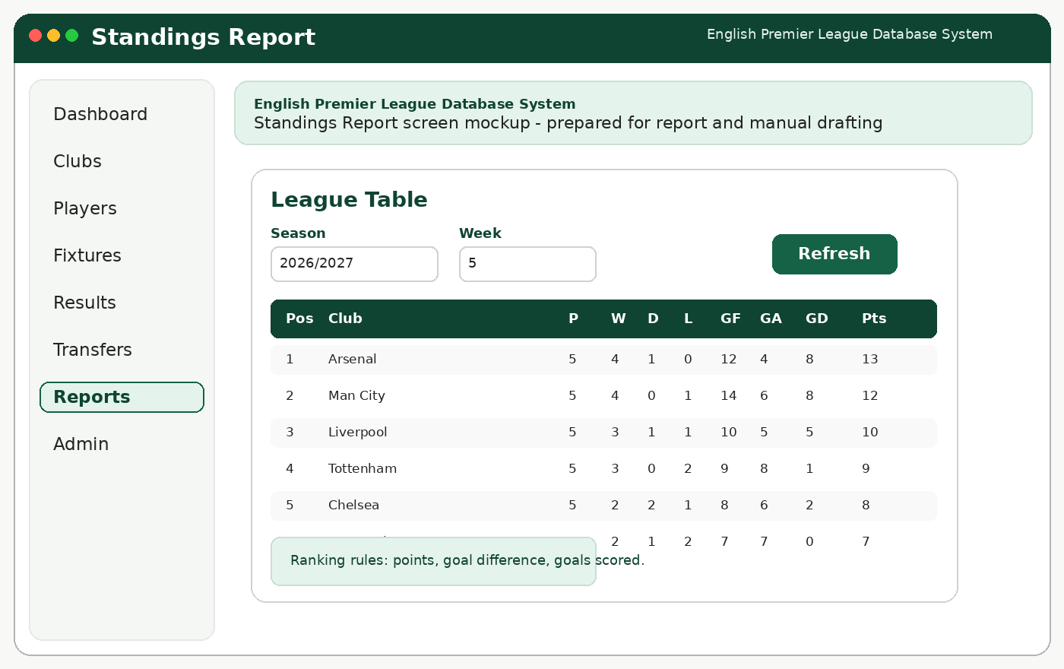
Generate League Table screen.
Procedure
- Open Reports.
- Select the season and optional week.
- Click Refresh to view the table.
Validation / Notes
- ranking order should follow points, goal difference, and goals scored
Expected Result
The standings table is displayed for review or export.
Generate Player Statistics Report
Use this function to display player-focused reports such as top scorers.
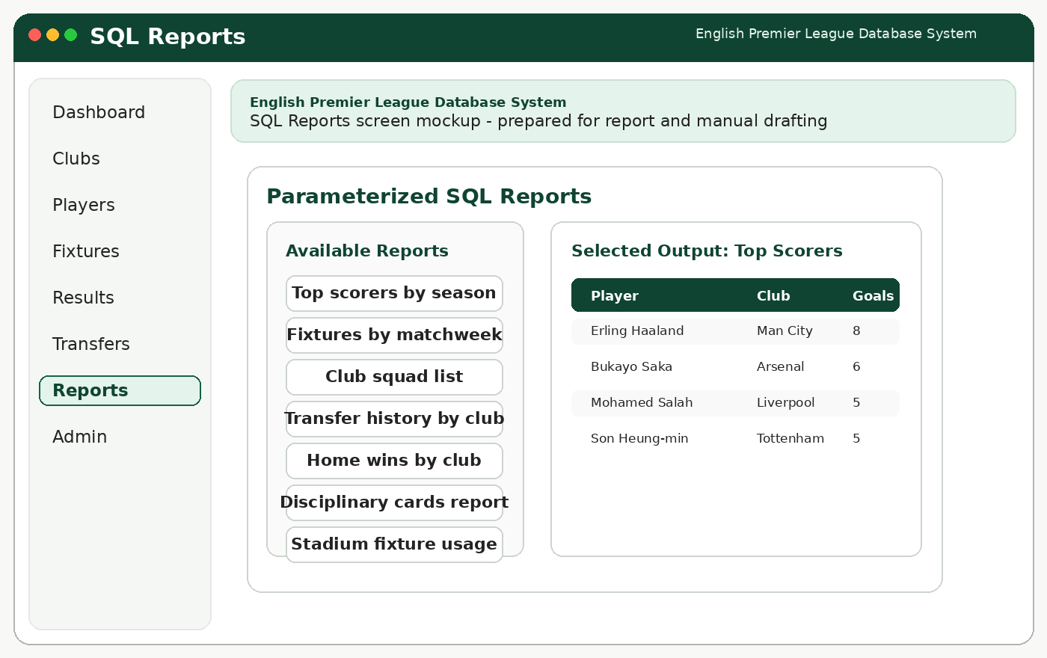
Generate Player Statistics Report screen.
Procedure
- Open Reports.
- Choose a player statistics report.
- Set any required parameters and run the report.
Validation / Notes
- filters should match available season and club values
Expected Result
A ranked or filtered player statistics table is displayed.
Login
This is the entry point to the system for authorized users.
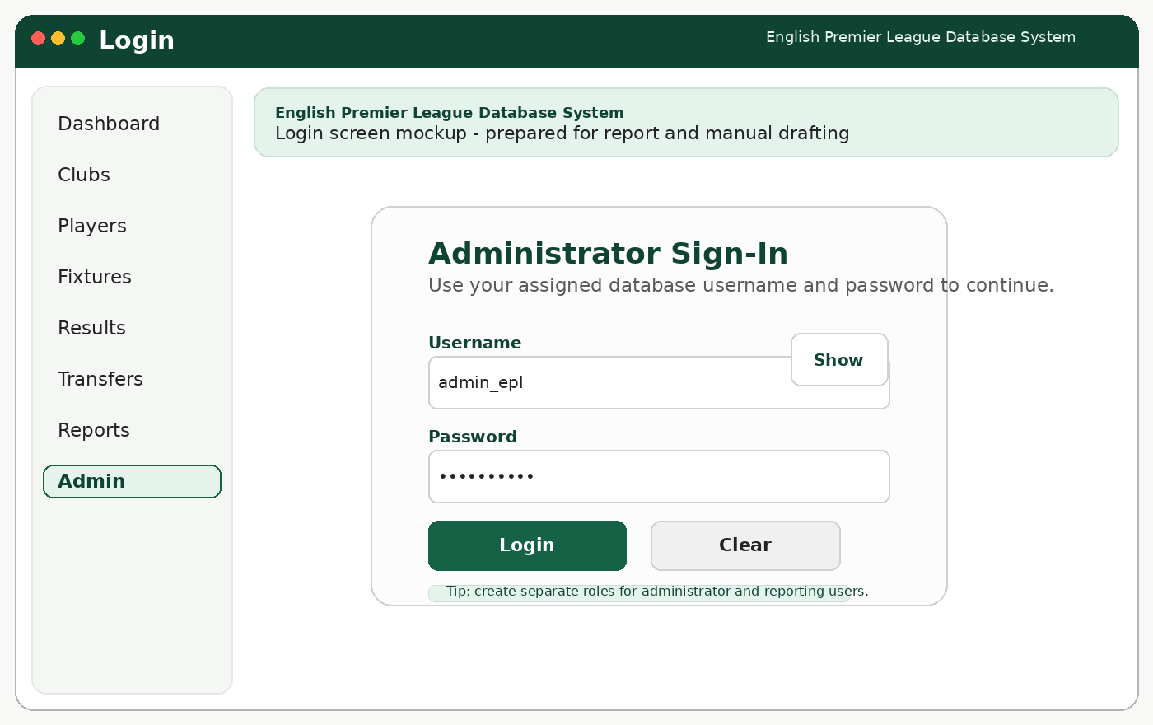
Login screen.
Procedure
- Enter username and password.
- Click Login.
- Wait for the dashboard to load.
Validation / Notes
- blank credentials should be rejected
- access should be role-aware if multiple user types are used
Expected Result
The user enters the application and reaches the dashboard.
Manage Club Roster
Use this function to review or adjust the list of active players registered to a club.

Manage Club Roster screen.
Procedure
- Search by club and season.
- Review the roster table.
- Add, update, or deactivate player registrations as needed.
Validation / Notes
- avoid duplicate active registrations for the same player and season
Expected Result
The club roster is updated and reflected in reports.
Search Fixtures
Use this function to locate fixtures by club, date, or matchweek.

Search Fixtures screen.
Procedure
- Open the fixture list or report screen.
- Enter one or more search parameters.
- Submit the search and review the table.
Validation / Notes
- blank searches should either show all results or require at least one filter
Expected Result
Matching fixtures are displayed for review or follow-up action.
Update Match Result
Use this function to store the final score of a fixture and refresh standings.

Update Match Result screen.
Procedure
- Load the fixture on the result entry screen.
- Enter home goals, away goals, status, and winner.
- Save the result and refresh derived reports.
Validation / Notes
- only completed matches should affect standings
- scores must be numeric and nonnegative
Expected Result
Match outcome is saved and the standings can be recalculated.
View Transfer History
Use this function to review prior player movement between clubs.

View Transfer History screen.
Procedure
- Open Transfer Management.
- Search by player or club.
- Use View History to see earlier transfer records.
Validation / Notes
- historical rows should not be overwritten
Expected Result
The application displays a traceable record of player movement.

