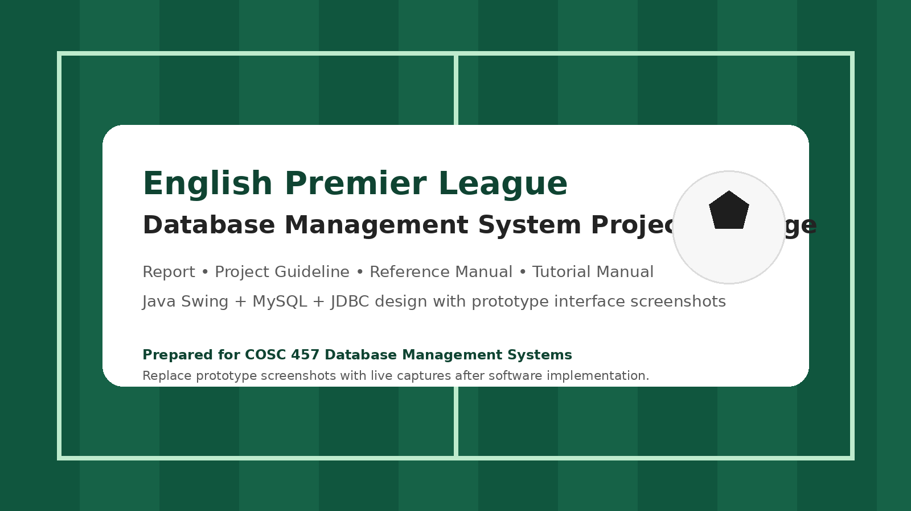
Tutorial Manual
English Premier League Database Application

This tutorial manual walks a new user through realistic business scenarios for the English Premier League database application. The screenshots shown in this guide are prototype mockups used to explain the intended workflow before the final Java Swing interface is captured.
1. Intended Users
This guide is intended for first-time users, student demonstrators, and instructors who want to understand the planned workflow of the application from login through reporting. It is especially useful during system demonstrations because it follows realistic operational scenarios instead of isolated functions.
2. Before You Begin
- The database should already contain reference data such as positions, clubs, stadiums, and at least one administrator account.
- The Java Swing application should be connected to the MySQL database through JDBC.
- Sample credentials may be configured as admin_epl / password for demonstration purposes.
3. Scenario 1 - Log in to the application
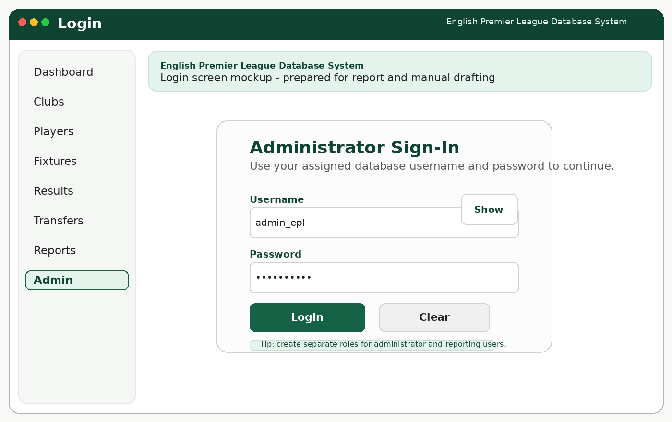
3. Scenario 1 - Log in to the application
Steps
- Launch the application JAR file from the desktop or command line.
- When the login screen appears, enter the administrator username and password.
- Click Login.
- Confirm that the dashboard appears without an error message.
Expected Outcome
You should now be on the main dashboard of the system.
4. Scenario 2 - Review the dashboard and quick actions
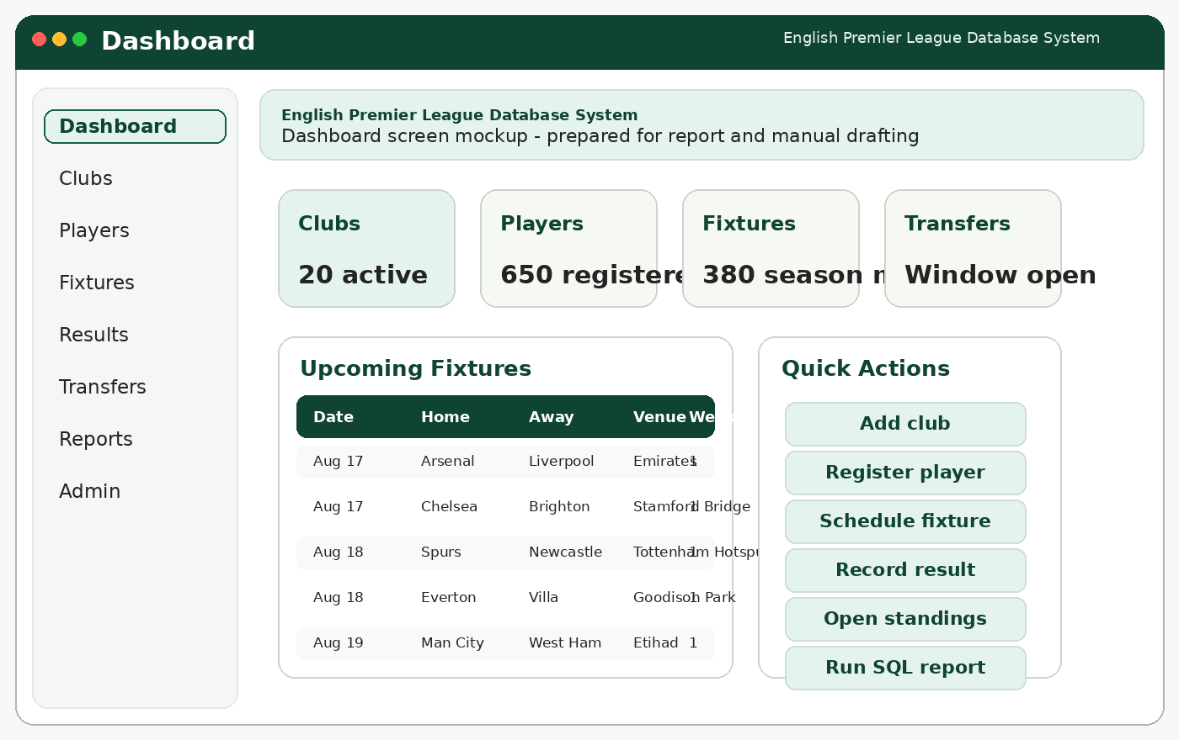
4. Scenario 2 - Review the dashboard and quick actions
Steps
- Study the summary cards at the top of the dashboard.
- Review the upcoming fixtures table in the center of the screen.
- Use the quick action buttons to understand where each major workflow begins.
Expected Outcome
You should understand where to navigate for club, player, fixture, result, transfer, and report tasks.
5. Scenario 3 - Register a new club
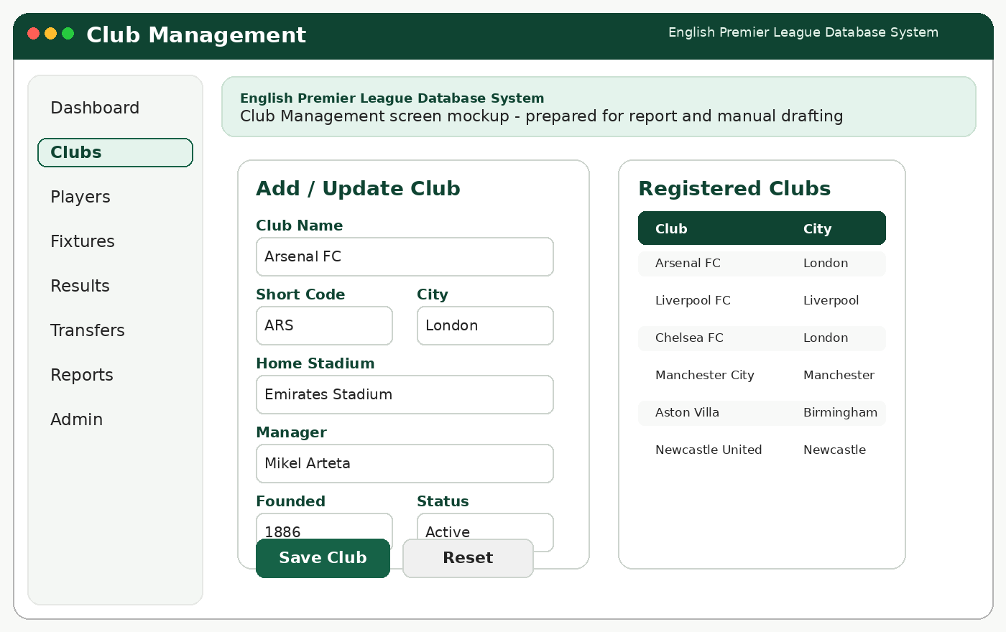
5. Scenario 3 - Register a new club
Steps
- Open the Clubs module from the left navigation area.
- Enter club profile information such as club name, short code, city, stadium, manager, and status.
- Click Save Club.
- Verify that the saved club appears in the club list on the right side of the screen.
Expected Outcome
The new club should be available for future fixture and roster operations.
6. Scenario 4 - Register a player to a club
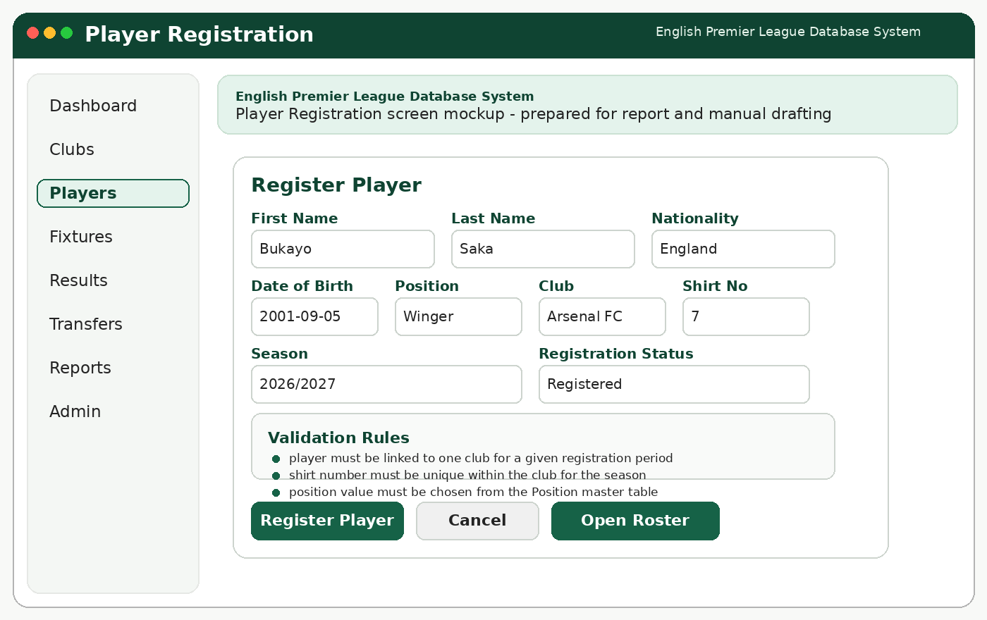
6. Scenario 4 - Register a player to a club
Steps
- Open the Players module.
- Enter the player name, date of birth, nationality, position, club, season, and shirt number.
- Click Register Player.
- Review any validation message if a required field is missing.
Expected Outcome
The player should become part of the selected club roster for the selected season.
7. Scenario 5 - Schedule a fixture for matchweek 1
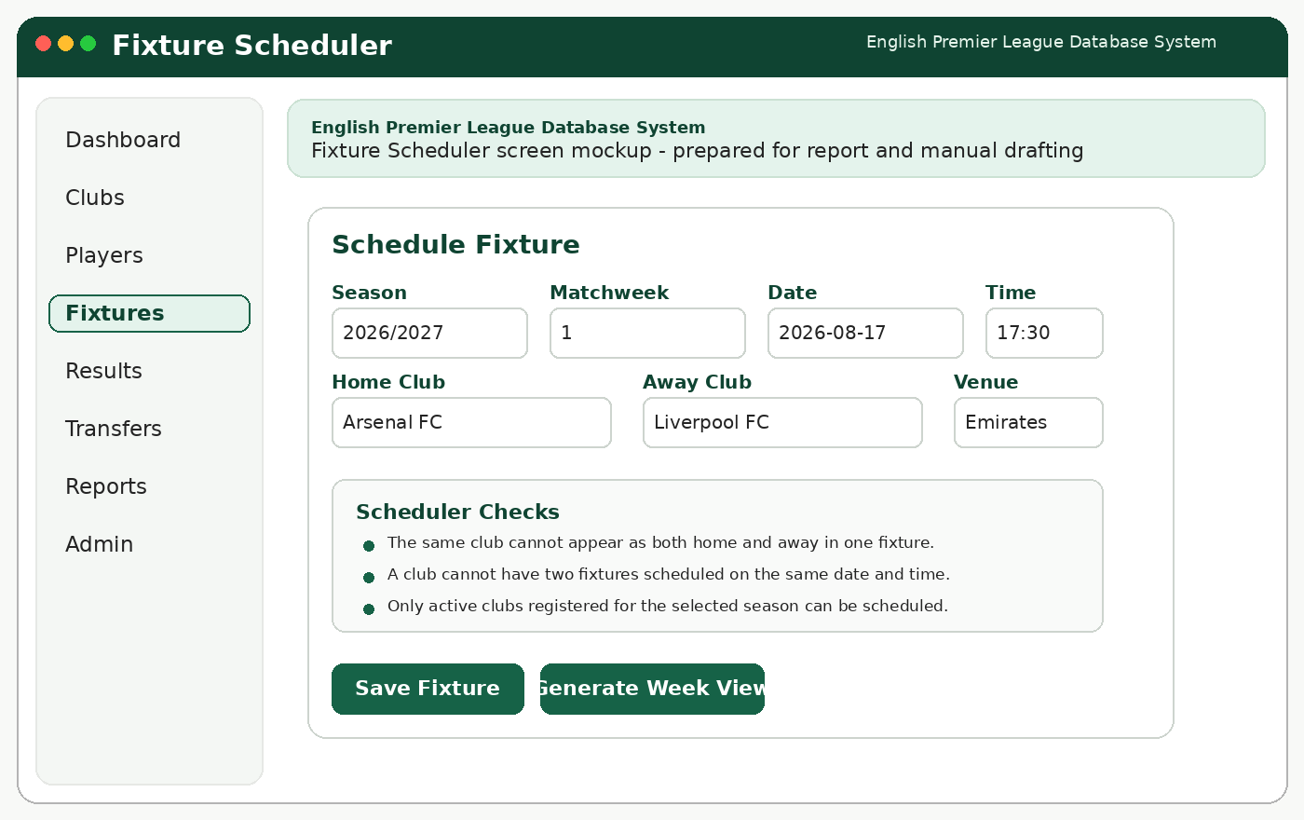
7. Scenario 5 - Schedule a fixture for matchweek 1
Steps
- Open the Fixtures module.
- Choose the season, matchweek, date, and time.
- Select the home club and away club.
- Click Save Fixture.
- Generate the week view or return to the dashboard to verify the new fixture appears.
Expected Outcome
The fixture should now be stored and ready for result entry.
8. Scenario 6 - Record a played match and its events
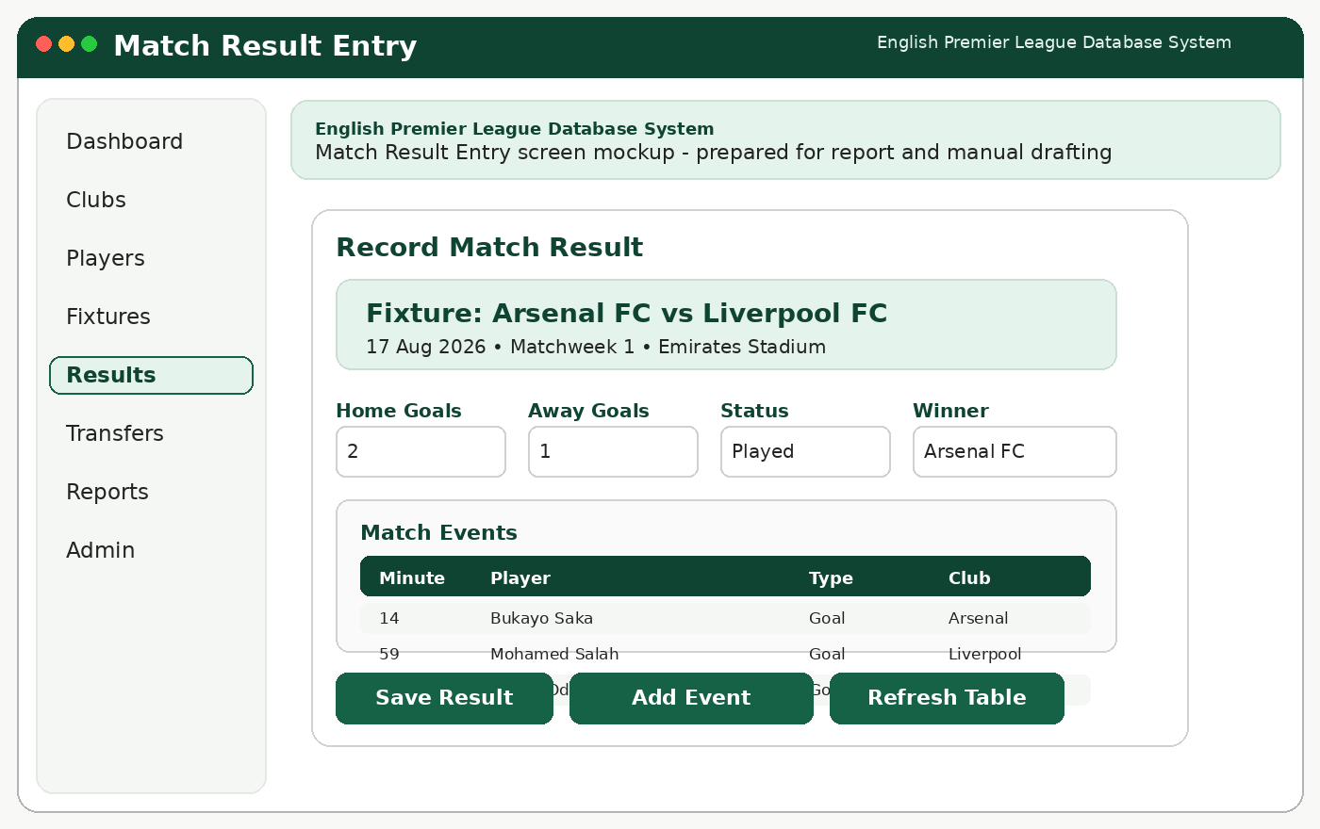
8. Scenario 6 - Record a played match and its events
Steps
- Open the Results module.
- Load the fixture you scheduled earlier.
- Enter the home goals, away goals, status, and winner.
- Add event records for goals and cards if needed.
- Click Save Result and then Refresh Table.
Expected Outcome
The result and its events should be saved, and the standings should be ready to update.
9. Scenario 7 - Process a transfer during the window
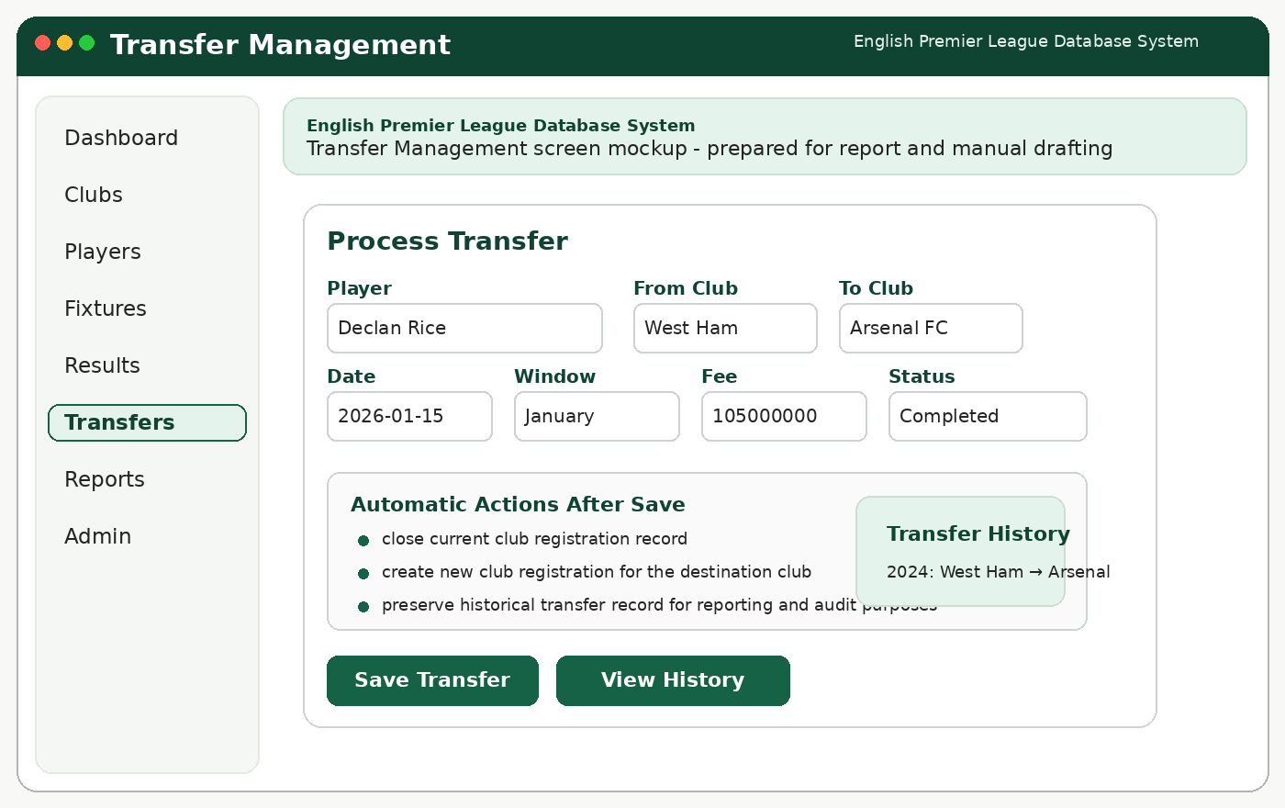
9. Scenario 7 - Process a transfer during the window
Steps
- Open the Transfers module.
- Search for the player who is moving clubs.
- Enter the source club, destination club, transfer date, transfer window, and fee.
- Save the transfer and review transfer history.
Expected Outcome
A historical transfer row should be created and the system should preserve the previous club record.
10. Scenario 8 - Run the league table report
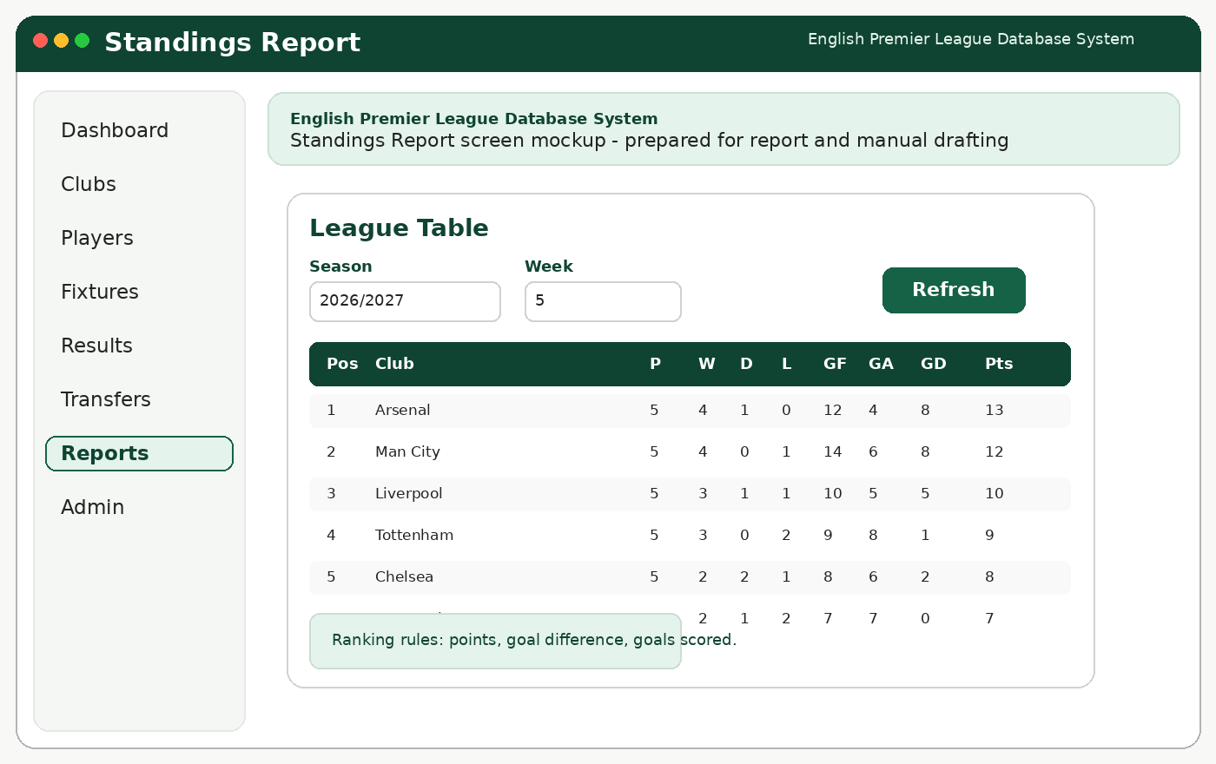
10. Scenario 8 - Run the league table report
Steps
- Open the Reports module.
- Select League Table.
- Choose the season and week if needed.
- Click Refresh and review the ranking order.
Expected Outcome
The standings table should display ordered club performance statistics.
11. Scenario 9 - Run a player statistics report
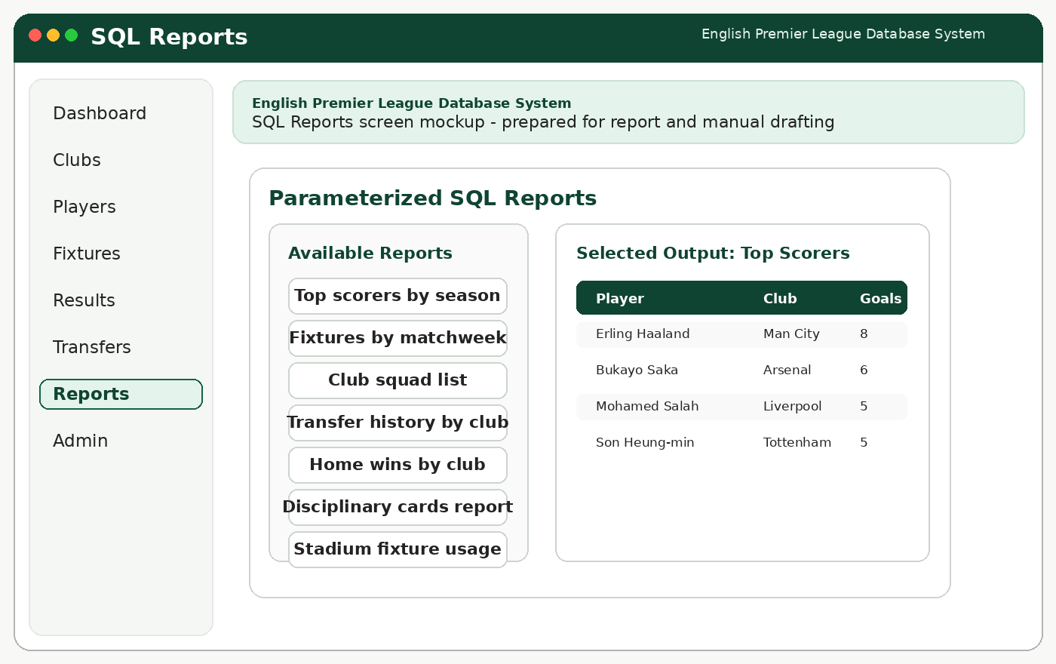
11. Scenario 9 - Run a player statistics report
Steps
- Remain in the Reports module.
- Select Top Scorers by Season or another player statistics report.
- Apply the available filter values.
- Run the report and review the displayed result table.
Expected Outcome
The application should display the player statistics requested by the user.
12. Scenario 10 - Exit the application safely

12. Scenario 10 - Exit the application safely
Steps
- Save or cancel any unfinished work.
- Return to the dashboard if necessary.
- Use the logout or close action to leave the application.
Expected Outcome
The user session should end without losing committed data.
13. Troubleshooting Tips
- If the application cannot connect to the database, verify the JDBC URL, username, password, and database server status.
- If a save fails, review required fields and check whether a unique or foreign-key rule has been violated.
- If report results look empty, confirm that sample data exists for the selected season or matchweek.
- If standings do not refresh, review the result entry logic and confirm that the fixture status is marked as played.

