TITANIC SURVIVAL ANALYSIS USING EXCEL

**SUBMITTED BY:** ABHINAV  
**DATE OF SUBMISSION:** 18/07/2025

**E-mail** :abhinavteotia448@gmail.com

**INDEX**

|  |  |  |
| --- | --- | --- |
| **Sr. No.** | **Topics** | **Page No.** |
| 1 | Introduction | 2 |
| 2 | Data Cleaning Steps | 3 |
| 3 | Data Visualization | 4 |
| 4 | Observations/Insights | 5 |
| 5 | Conclusion | 6 |

**1. Introduction**

This project focuses on analyzing the Titanic dataset using Microsoft Excel. The main goal of this project is to understand survival patterns based on different factors such as Age, Gender, and Passenger Class (Pclass). By using Excel tools like Pivot Tables, Charts, and basic formulas, we gain meaningful insights from the data without the use of complex programming.

**2. Data Cleaning Steps**

* Removed blank rows and handled missing values (like Age, Embarked, Cabin).
* Added a new column **"Survival Status"** using an IF formula where 0 = "Not Survived" and 1 = "Survived".
* Checked and removed duplicate rows from the data (if any).
* Arranged the data in a structured format for easy analysis.

**3. Data CLEANING**

Following visualizations were created using Excel Charts:

**3.1 RAW DATASET:**

“This is the raw dataset containing passenger details like Age, Gender, Class, Embarked, etc., along with survival status.”

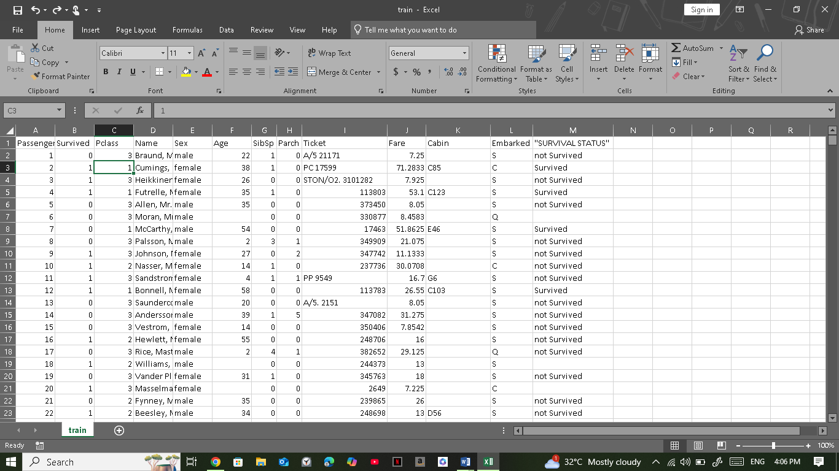

**3.5 Data Cleaning Section**:

“In this step, missing values were handled, and a new column called 'Survival Status' was created using IF condition to improve data readability.”

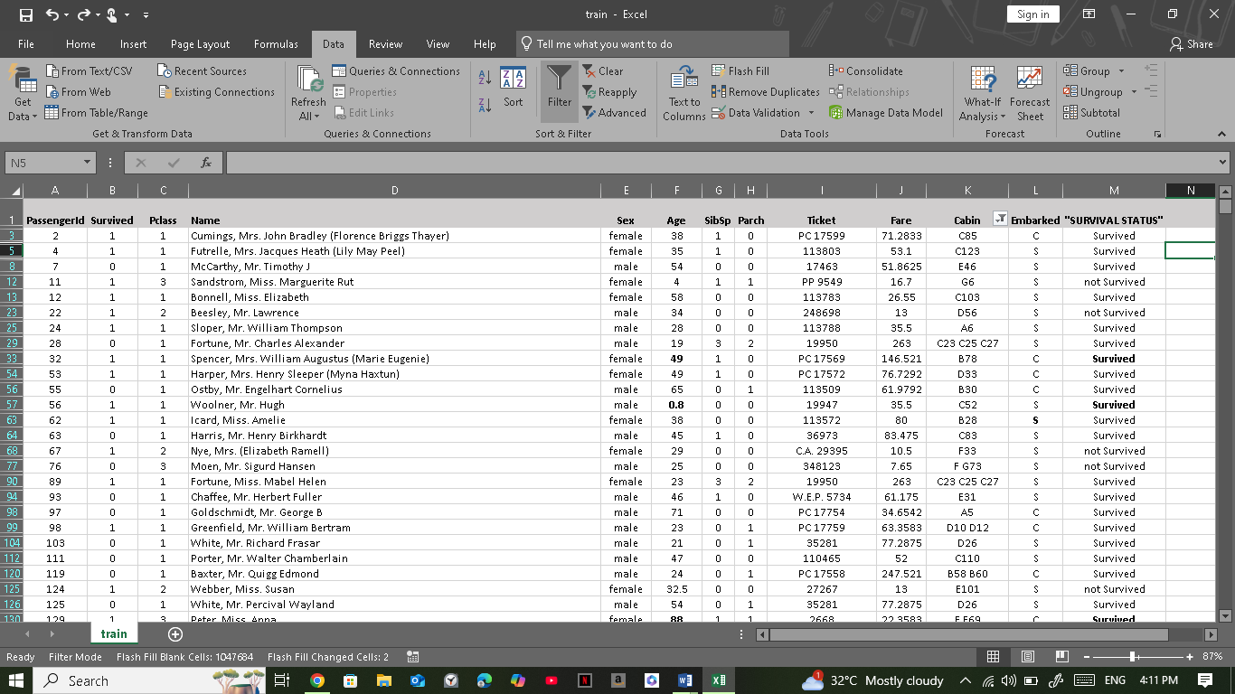

**3.3 Age vs Survival Line Chart**

*(Screenshot of chart here)*

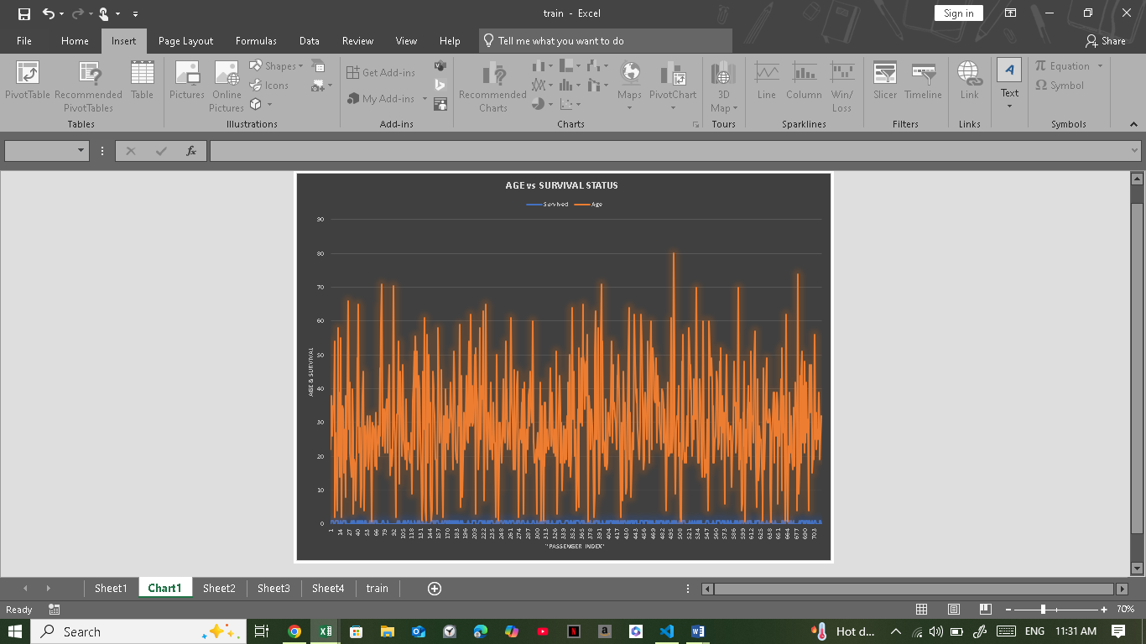

**3.4 Gender-wise Survival Rate Pie Chart**

*(Screenshot of pie chart)*

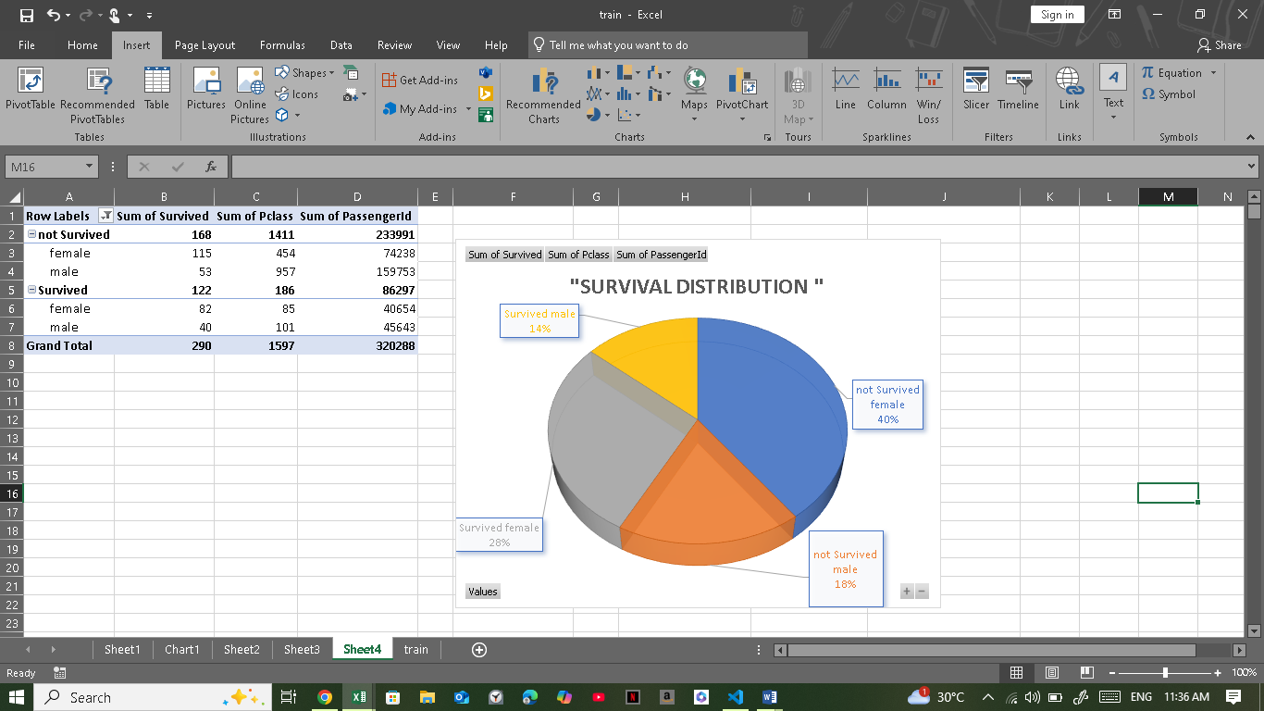

**3.5 Class-wise Survival Rate**

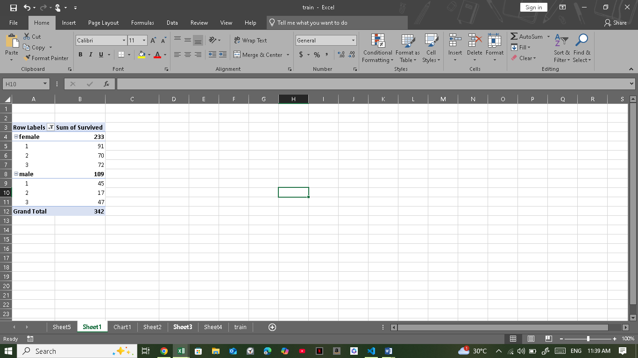

**4. Observations/Insights**

* **Female passengers had a higher survival rate compared to males.**
* **Passengers from First Class had better survival chances compared to Second and Third Class.**
* **The age distribution shows that survival was more favorable among certain age groups, especially children and young adults.**

**5. Conclusion**

Through this project, we explored how Excel can be a useful tool for quick data analysis and visualization. By using simple formulas, pivot tables, and charts, we derived key insights from the Titanic dataset in an easy and understandable manner. This analysis proves that even without coding knowledge, one can draw valuable conclusions from data using Excel.

**6. Acknowledgement:**

I would like to thank my faculty and mentors who guided me during this project. This project helped me gain practical knowledge of Excel data analysis and visualization techniques**.**

**7.REFERENCES:**

- Kaggle Titanic Dataset

- Microsoft Excel Documentation

**Submitted by:**  
ABHINAV