1.(a) Steps: -

Create a crontab using command crontab -e & write the job that runs daily at 14:23 local time and executes /bin/echo hiya. List this job using command as shown in image below-



Now set system time which should be less than 14:23 in order to run the job. It is shown below as-

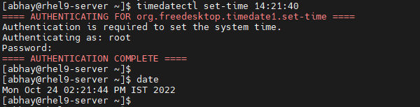

Restart crond service as shown below-

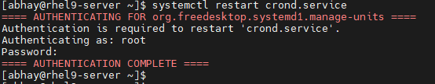

As soon as it is 14:23, job will get executed & print output which can be found in image below-



We can check logs generated in /var/log/cron file as shown below-

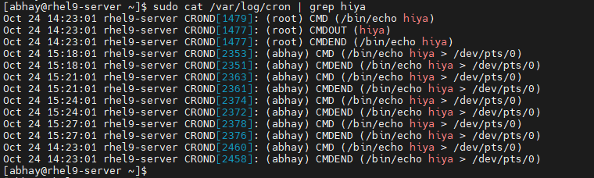

This job will run everyday at 14:23. If we want to remove this job, we need to use command crontab -r. It is shown in image below-

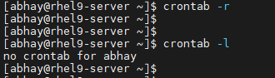

1. (b) Steps: -

Create a crontab using command crontab -e & write the job that runs daily at every 3-minute local time and executes /bin/echo hiya.

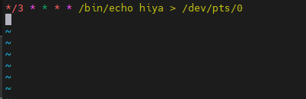

List this job using command as shown in image below-



Restart crond service as shown below-

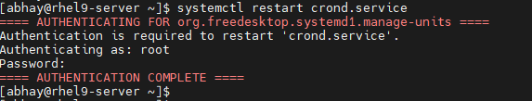

As soon as it is 3-minutes, job will get executed & print output which can be found in image below-



We can check logs generated in /var/log/cron file as shown below-

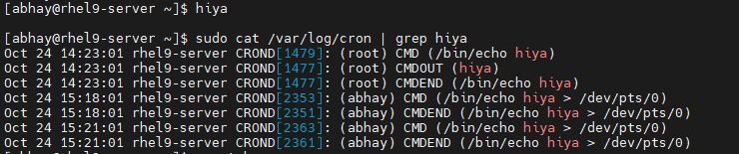

This job will run daily at every 3-minuts. If we want to remove this job, we need to use command crontab -r. It is shown in image below-



2. Steps: -

Create user john with uid 1800 & set password thuctive-

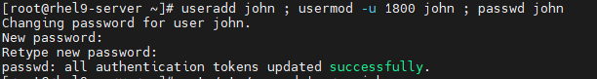

Verify it in /etc/passwd file as shown below-



Or, create user john as shown below-



Set password thuctive-

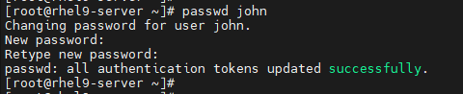

Set its uid 1800-



Verify it in /etc/passwd file as shown below-



3. Steps: -

Create a group names sysadmin using groupadd command & verify it in /etc/group file-

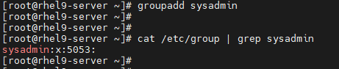

Create a user natasha, set password thuctive, verify it in /etc/passwd & /etc/group file-

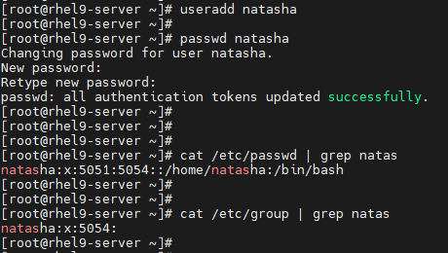

Add natasha in sysadmin group (secondary) & verify it in /etc/group file as shown below-

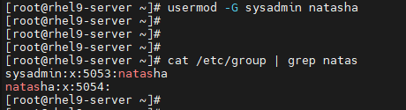

Alternatively, we can login with natasha user & use id command to check primary & secondary group as shown below-

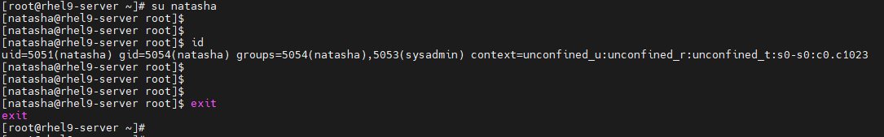

Now create another user sarah, set password thuctive as shown below-

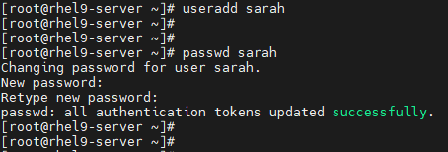

Verify it in /etc/passwd & /etc/group file-

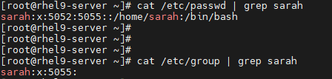

Add sarah in sysadmin group (secondary) & verify it in /etc/group file as shown below-

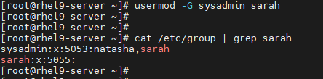

Alternatively, we can login with natasha user & use id command to check primary & secondary group as shown below-

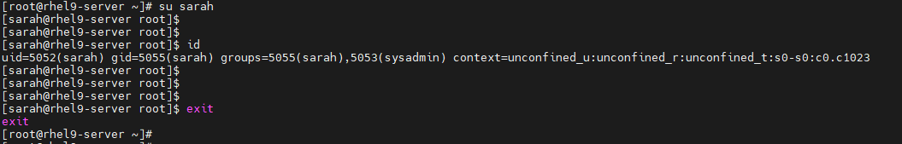

Now adding another user harry who will not have access to an interactive shell on the system & set the password thuctive-

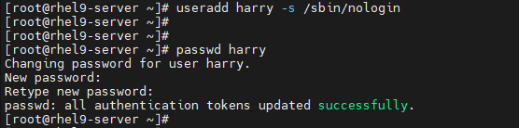

Verify it in /etc/passwd & /etc/group file-

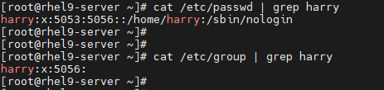

This harry user is not be able to access interactive shell as shown below-



4. Steps: -

Create admin directory inside /common directory-

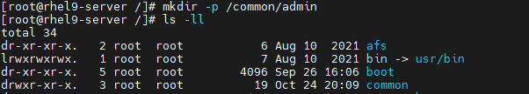

Check admin directory permission as shown below-



Change admin directory permission to 770 as group owner should have read, write & execute permission-

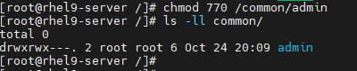

Provide group ownership of this directory to sysadmin group-



Now, verify it using ls -ll common command-



To have files/directory created inside admin directory with sysadmin group membership by default, we will use special permission sgid along with recursive functionality-



Now verify it using ls -ll common command-



Check the members of this sysadmin group-



This shows natasha & sarah are members of this group.

Login with user natasha & create some file/directory-

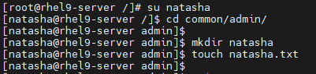

Similarly, login with user sarah & create some file/directory-

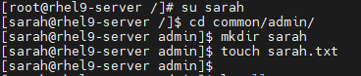

Now verify it using ls -ll command & check whether files/directories created have sysadmin as group owner or not-

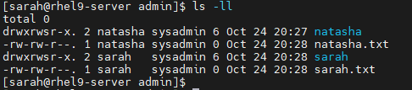

All the files/directories inside /common/admin has sysadmin as group owner.

Now, login with other user & see if it can perform any operation (read, write or execute) on /common/admin directory or not-

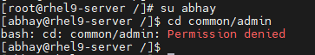

While using execute function with other user, it is showing “Permission denied”.

5. Steps: -

Copy the file /etc/fstab to /var/tmp-



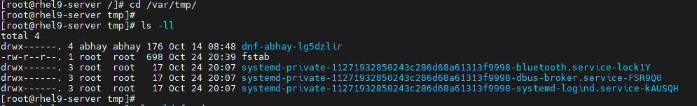

Set read, write permission for user natasha on this file-



Restrict read, write permission for user sarah-



Now check file permission-

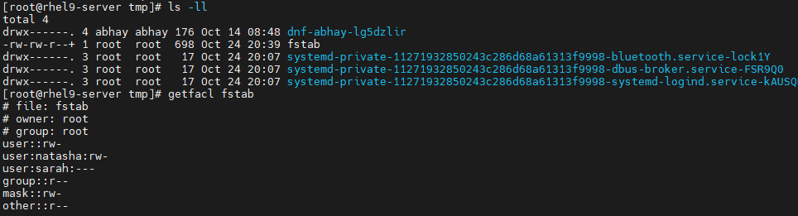

User natasha is able to read & write as shown below-

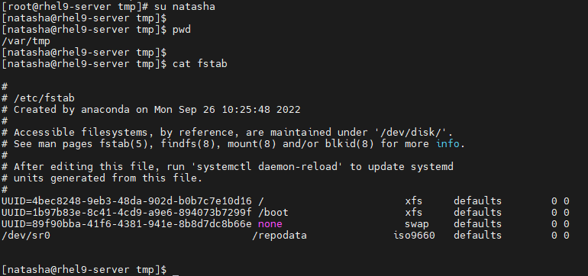

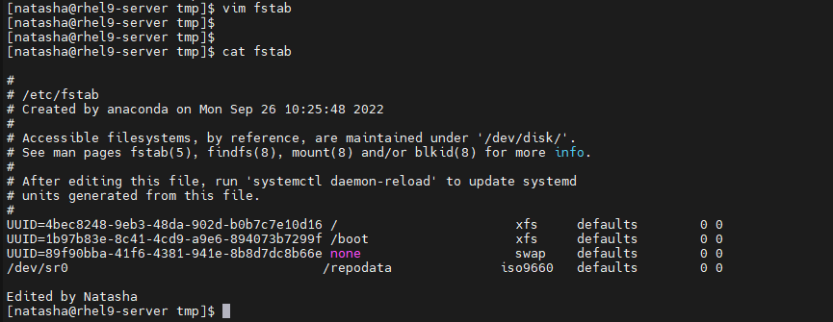

User sarah doesn’t have read, write access as shown below-

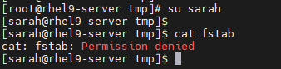

Another user, john is able to read, but not write-

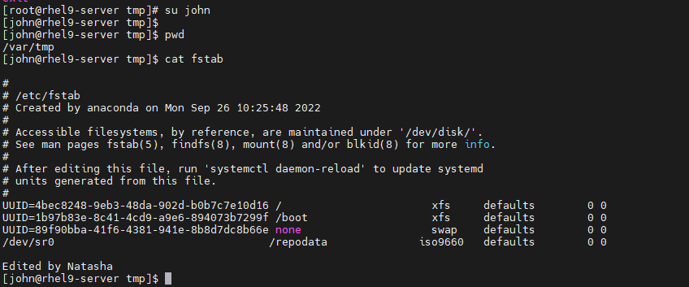

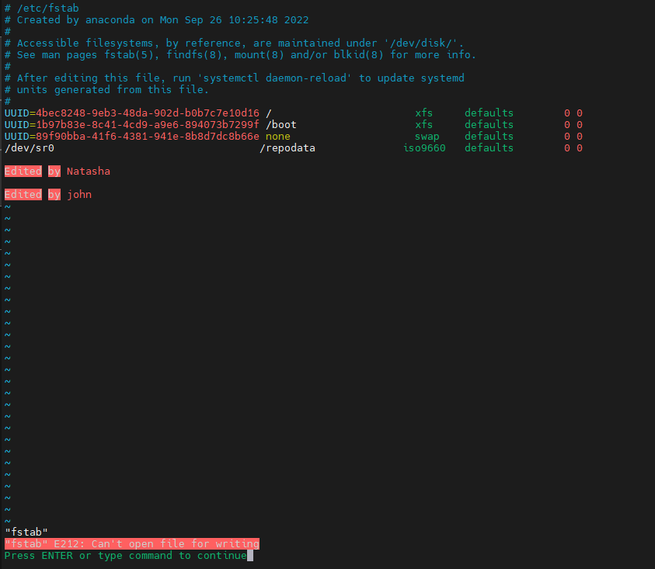

6. Steps: -

Check server IP-

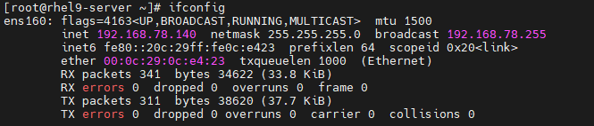

Check client IP-

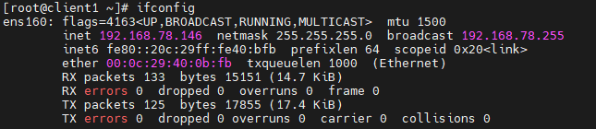

Using one of India NTP server url at server side in /etc/chrony.conf as shown below-

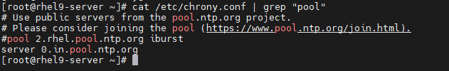

Have allowed 192.168.78.0/24 network for NTP configuration at server side-

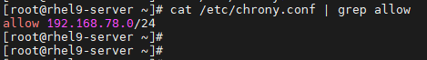

Now restart chronyd service at server side-



Check the chronyd service status as shown below-

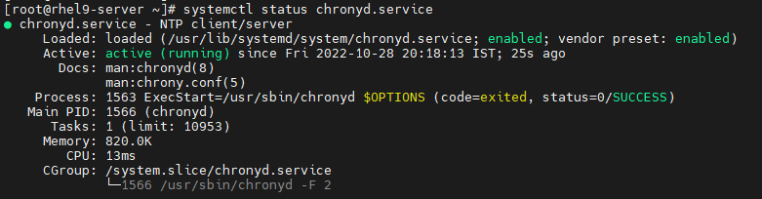

Now add 192.168.78.140 as NTP server in /etc/chrony.conf file at client side as shown below-



Restart chronyd service at client side-



Check the chronyd service status as shown below-

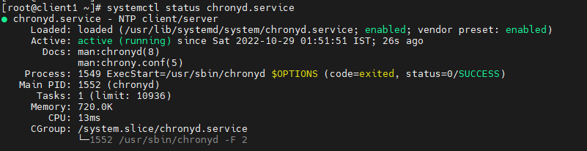

Client will sync its clock with NTP server. We can verify NTP server source at client side as shown below-

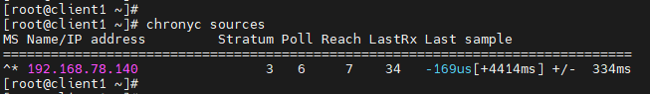

Similarly, for windows machine, we will try to sync it with the NTP server as shown below-

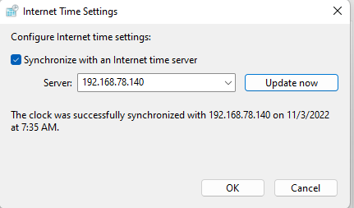

We can verify both the NTP clients at server side-

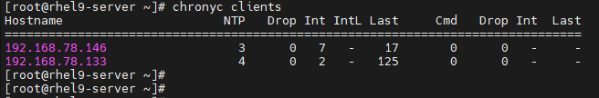

7. Steps: -

Creating user simone & some files inside its home directory-

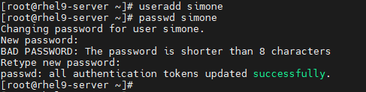

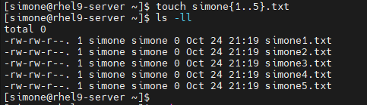

Creating found directory inside /root-



Find the files owned by user simone in this system-

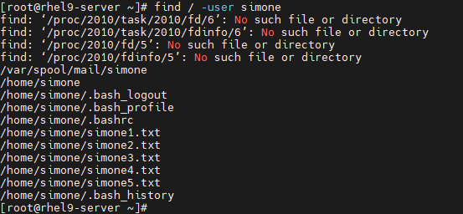

Now copy these files in /root/found directory as below-

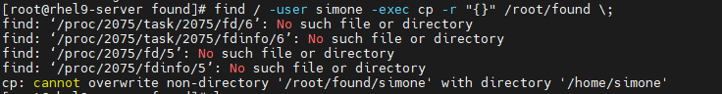

List those files-



8. Steps: -

To find string “strato” inside /usr/share/dict/words-



Copy it in file named /searchfile-

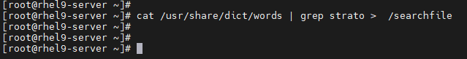

Now check the content in this /searchfile-



12. Steps: -

Create a file backup.tar.bz2 of /etc directory in /home location & list it-



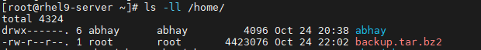

Check the total size of /etc directory as shown below-





Check the total size of /etc after compressing & zipping it using bzip2-



Create a file backup.tar.gz of /etc directory in /home location & list it-



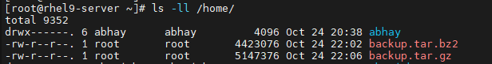

Check the total size of /etc after compressing & zipping it using gzip-

