**AutoFS SAMBA**

**At Server Side:**

1. Check samba server IP-



2. Install required packages-



3. Create samba share & change permission as shown-





4. Create few service accounts for samba share-



5. Set smb password for them in including one local user (abhay)-

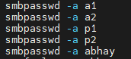

6. Create two groups as shown-



7. Add service account users to the group & verify-



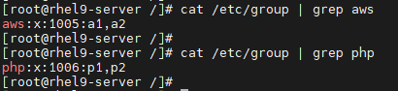

8. Now set ACL permissions for the samba directory as shown-







9. Check ACL permissions over samba directory-

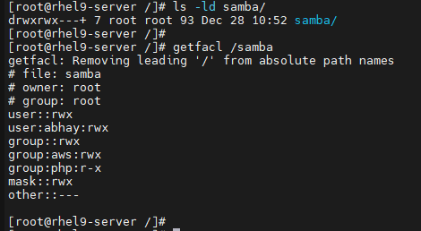

10. Change semange context for samba directory & verify it as shown-





11. Add samba service in firewall-



12. Edit /etc/samba/smb.conf file & add below lines as shown-

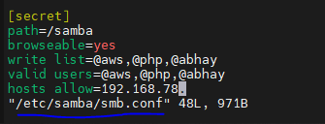

13. Restart samba services-



14. We have few files added in shared directory previously. We can list it as-

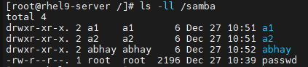

**At Client Side:**

1. Check client IP-



2. Create samba share in parent-child format-





3. Install required packages-





4. Edit /etc/auto.master file & add below line-

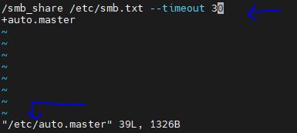

Here, /smb_share is parent directory. We will create smb.txt in next step.

5. Create & edit smb.txt-



Here, ‘share’ is child directory for parent /smb_share. We will create pass.txt in next step for authentication purpose.

6. Create & edit pass.txt-



Here, we used service account a1 & mentioned its smb password.

7. Start & enable AutoFS service-

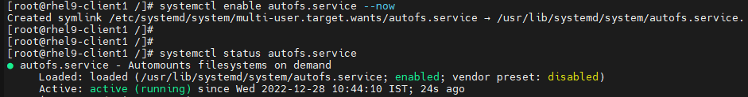

8. Now go to parent directory & list the content-



Here, ‘share’ child directory is not visible. We need to manually go to that directory to list the samba share contents-

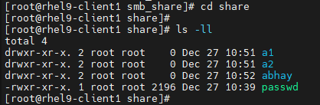

9. Now, shared samba directory is mounted. Verify its mount point-

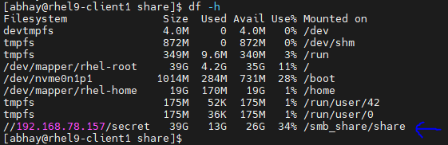

10. Create one directory & verify it at both client & server side-

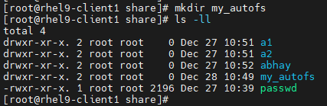

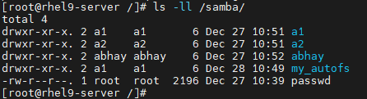

11. If we switch to other local user (For which we already created smb password at server side), we will see permission denied error-

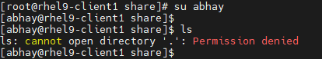

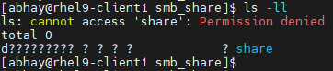

12. To fix this, we will add its smb credential-

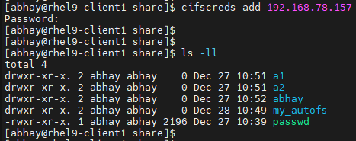

Note: To mount, user should have proper permission defined at server side inside /etc/smb.conf (User or group should be in ‘valid users’ & ‘write list’) & it should have rwx permission on samba shared directory in order to modify content.

13. This user has rwx permission. So, it creates file/dir as shown-

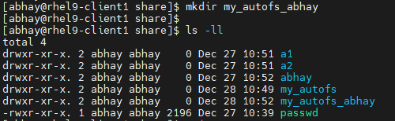

14. Verify it at server side as well-

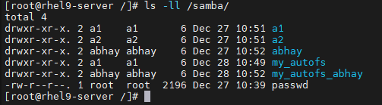

This is it!!!