**Container: Lecture 1**

1. Install container tools-





2. Start & enable podman service-



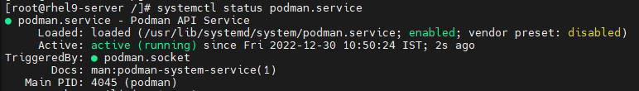

3. Check podman version-

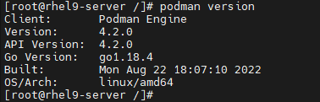

4. Syntax to search container image using podman-



5. For ex, search for Redis container image-

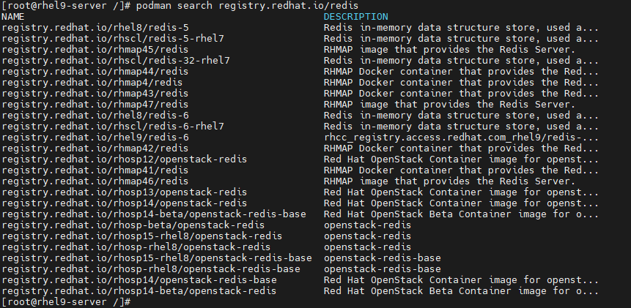

6. Similarly, for MariaDB container image-

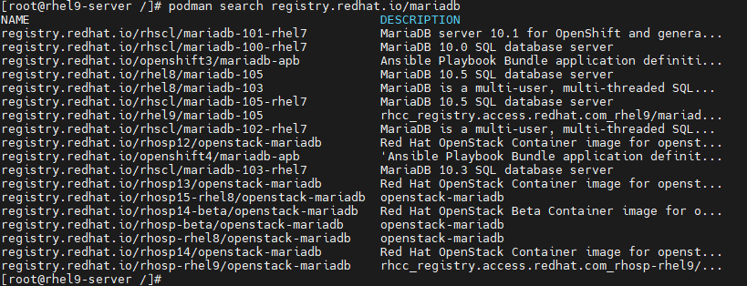

7. To get description of any particular container image-

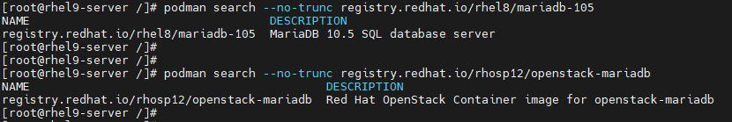

8. Login using Redhat credential-

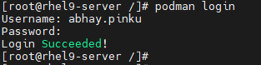

9. Look for centos 8 container image-

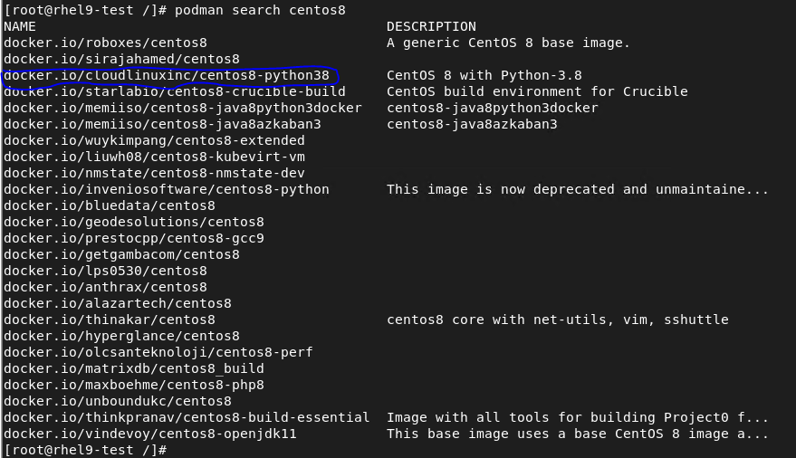

10. Pull centos 8 container image from docker registry shown above-

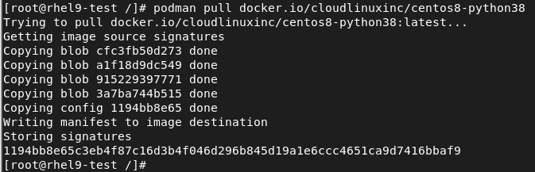

11. Verify all available container images on local machine using podman-

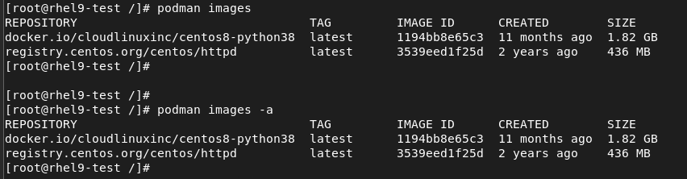

12. To inspect any installed container image to get all details about this container image-



13. To give tag to any installed container image-

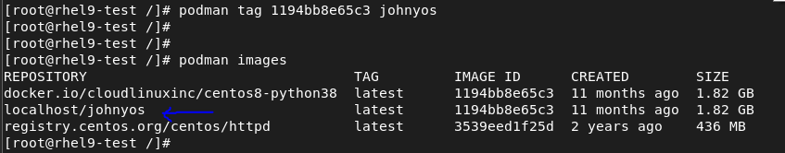

Note: It will create a copy of that original container image with tag.

14. Run container image & verify it-



Note: This will start container image in foreground.



15. To stop the running container image-



16. To run container in background-





17. Stop & verify it-

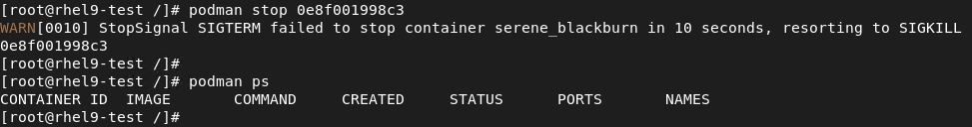

18. List all available container image & run centos8 with interactive terminal using /bin/bash-

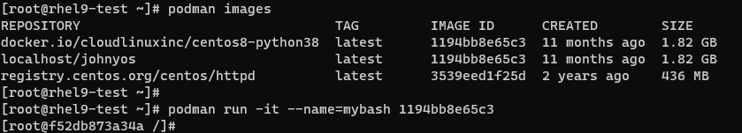

19. Run few commands in it-

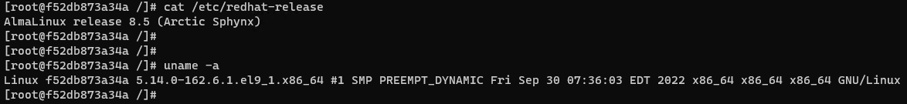

20. Use CTRL+P & CTRL+Q one by one to exit this interactive session without terminating it. Verify the running image from command shown below-



21. Stop this container image-



22. Next, pull Redis container image & verify all the images as shown-



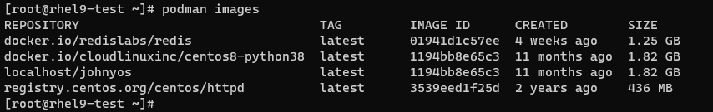

23. Run this Redis container image in background using mentioned port & verify it-





24. To keep any container image running even after server reboot. Go to mentioned directory (For systemd unit)-

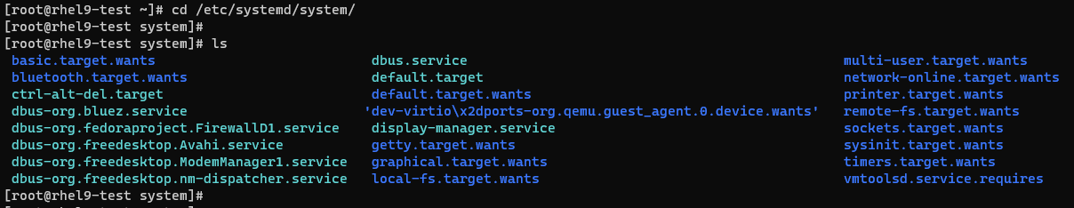

25. Create file for systemd unit-



26. Mentioned below line of codes in it-

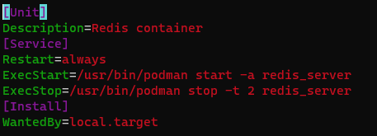

27. Stop the running Redis container-



28. Start & enable the created service for Redis container image using systemd unit to keep it running even after server reboot-

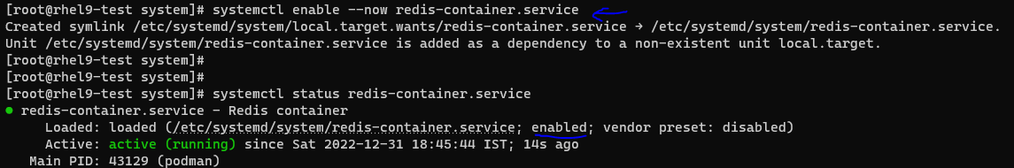

Note: Container will withstand server reboot.

29. Now we will disable & stop the service as well as delete the service file. We are going to create systemd unit automatically-

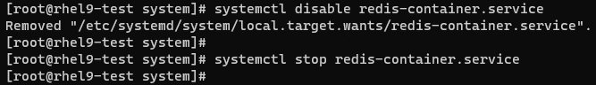



30. First, we need to turn on mentioned Boolean to use this feature-



31. Now we will see the systemd unit file content, which we will generate-



32. To generate systemd unit file, see snapshot below-

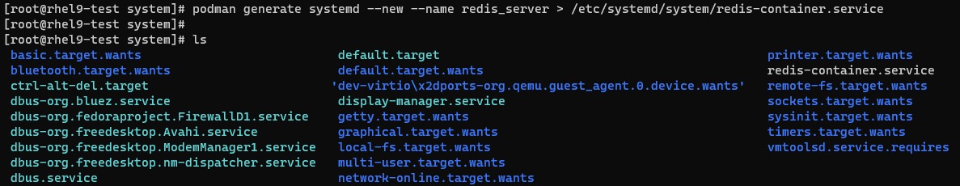

33. Start & enable service again-

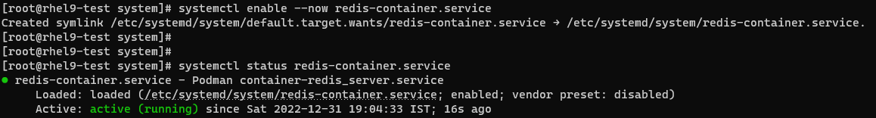

34. Verify the container status whether it is running or not-



35. To test, we will reboot server now-



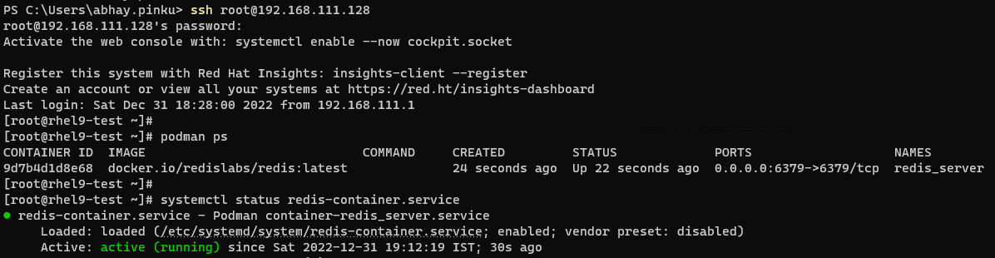

36. Now our Lab is done. We will stop running container & verify it-

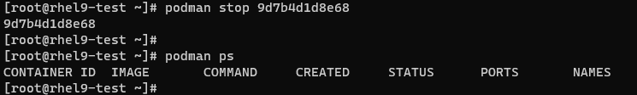

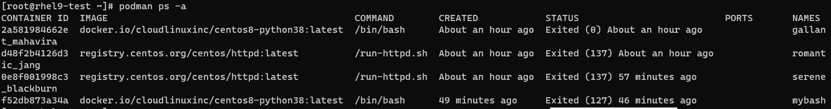

37. Remove the container & verify it-

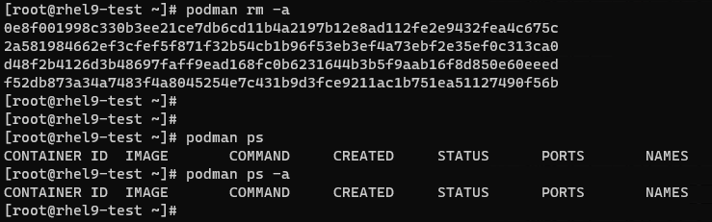

Note: “podman ps -a” will show status of current container as well as container ran in past.

38. Verify the container images & remove all-

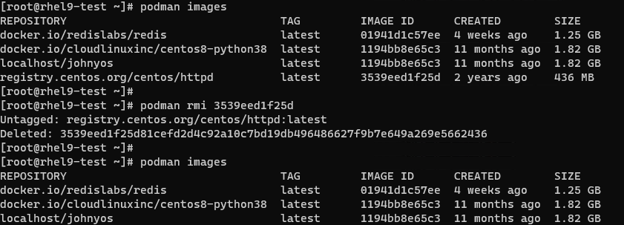

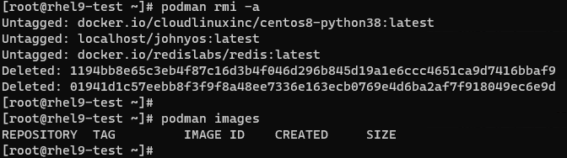

Container Removal Stage -> Stop the container -> Remove the container -> Remove the images.

If any image is not getting remove, we can remove it forcefully using “-f”.

This is it for Lecture 1!!!