**Container: Lecture 2**

1. Install container tools-



2. Check podman version-



3. Check podman info for more detail-



4. Now, pull docker http container image & verify it-

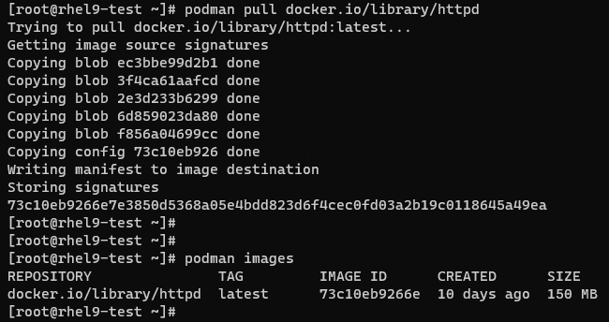

5. We can inspect this downloaded container image-



6. If we want to inspect a container image without downloading or pull, use below skopeo command-



Note: We must have skopeo package installed in our machine. If not, install it using 1st command.

7. If we want to copy one container image to another, we use skopeo for this-



8. We want to pull container image at the location other than the default one. First make one directory as shown-



9. Pull container image using this newly created directory & verify the same-

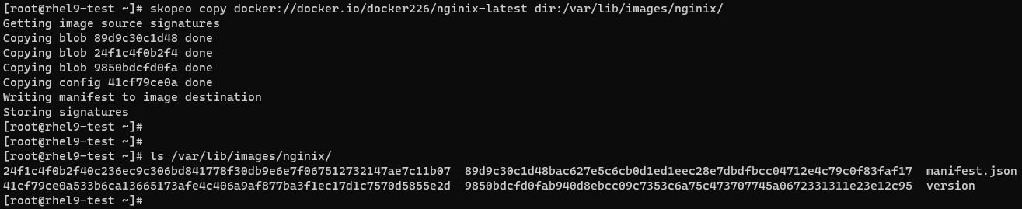

10. If we want to give custom tag to pulled container image, use below snap-

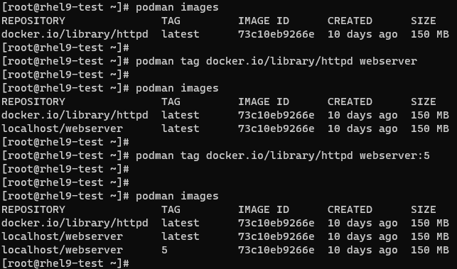

Note: Custom tag just crate a copy of original container image with custom name.

11. If we want to create an archive of container image, use command shown below-

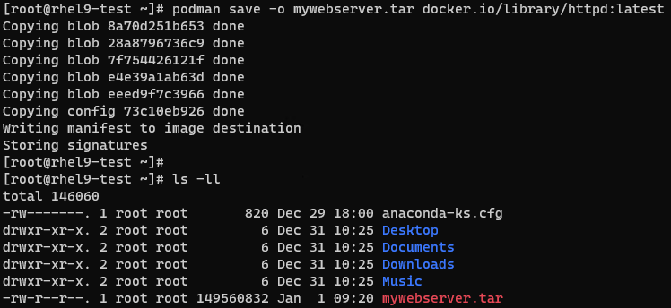

12. Verify its file type-



13. If we want to archive a container image in OCI archive format, use below command-

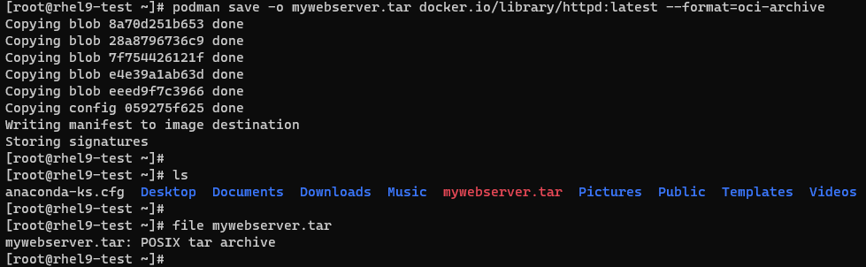

14. We can remove a single container image or all container image at once. Removing all to create a container image using archive-

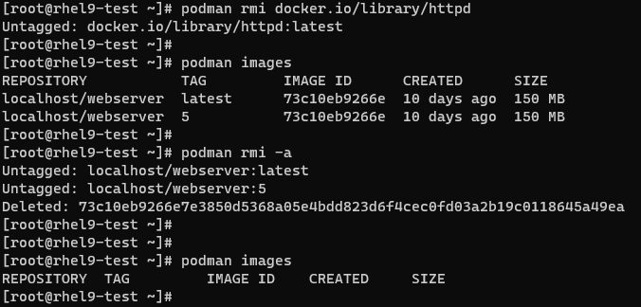

15. Now load the container image from its archive created earlier & give it a tag-

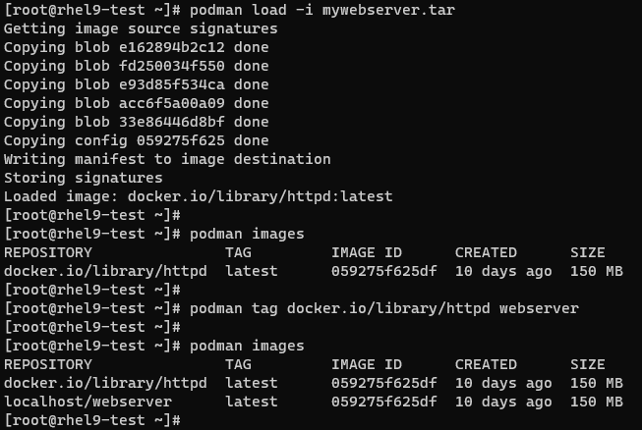

16. Now, we can push our custom container image to Redhat registry if we have proper subscription-



Note: Here we are getting error. We need to login first for this & should have required subscription to push container image. It can’t be done just using developer subscription. Login process was already explained in lecture 1.

17. We can set a trust for the image pulled from different registry using GPG key as shown-



Note: Caution before using this. It may not allow you to download container image as it will check the signature.

18. If we are done with Lab, remove the images as shown-

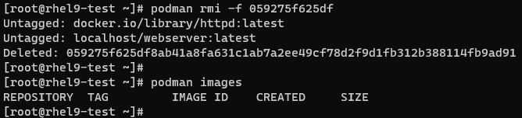

This is it for Lecture 2!!!