**Container: Lecture 3**

1. Install container tools-



2. Get container image detail like os-release without using interactive shell just after download-

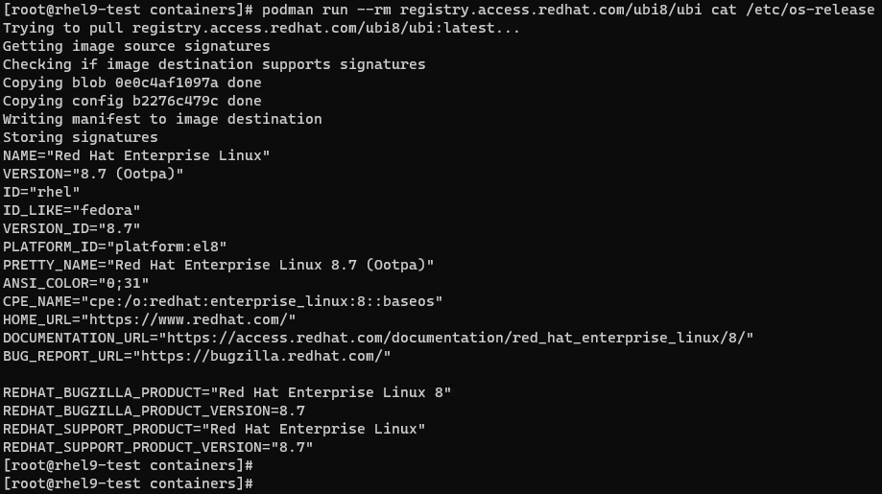

3. Verify it-



4. Now for container image interactive session, use command as shown-



Note: We are in container now.

5. We can verify few commands, like shown below-

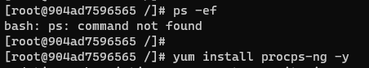

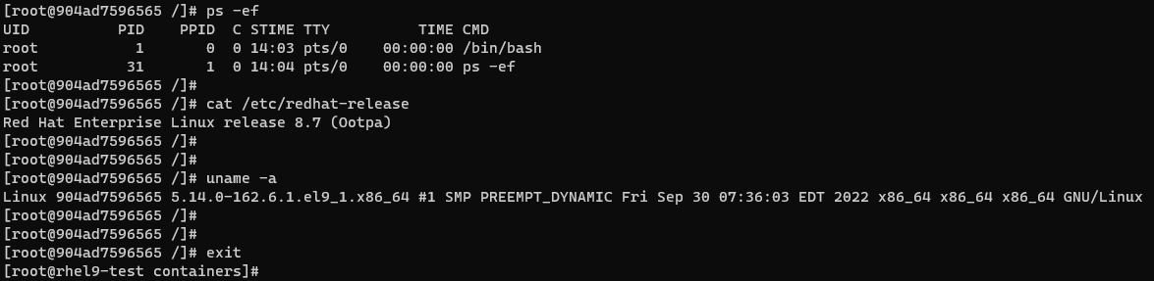

Note: If command not found, install its package first. After verifying few commands, exit from container.

6. To get logs for that image, use command shown-



Note: It will show all task we done there previously like we ran few commands & install packages.

7. If we want to pull container image & run it in background at the same time, use below command-

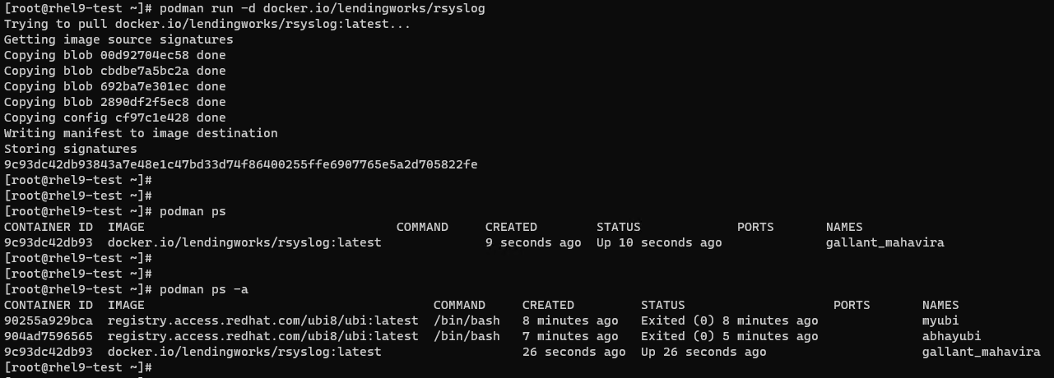

8. To start a stopped image, run below command & verify it-

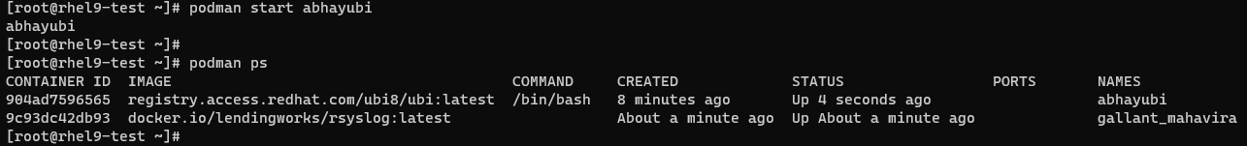

9. To start interactive session-

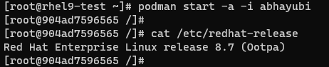

Note: “-a “for attach. “-i” for interactive.

10. Verify images & inspect any one-

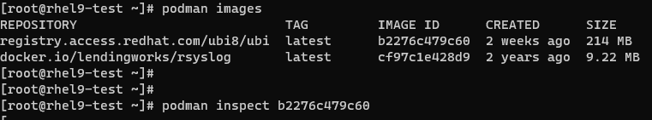

11. If we want to inspect any particular format of that image, use command as shown-



12. We want to mount container’s log directory on host machine to see container logs-

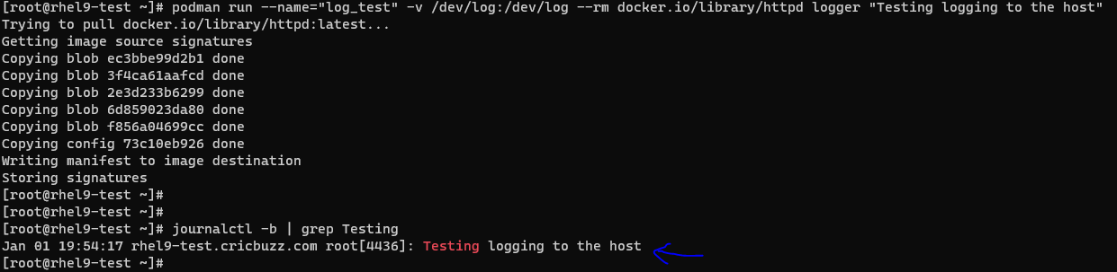

Note: here we can see container logs on host machine.

13. If we want to mount container image file system on host machine--

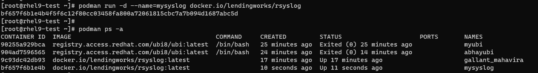

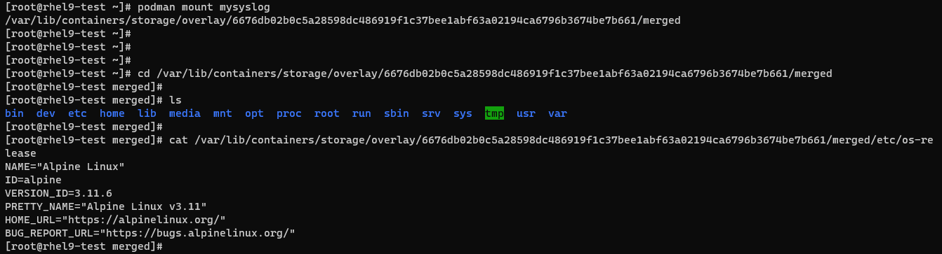

Note: We ran the container in background. Mounted its file system on host machine & verified its os-release file.

14. Now unmount the container file system & stop container image-

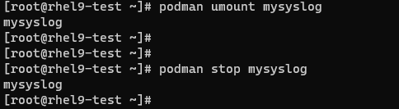

15. Remove container image-

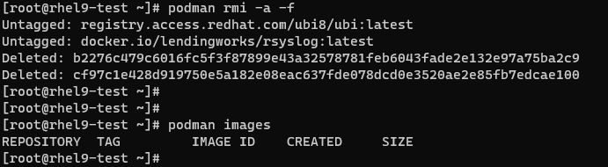

This is it for Lecture 3!!!