**Container: Lecture 4**

1. Install container packages-



2. Pull one container image, start it in background & stop it to verify-

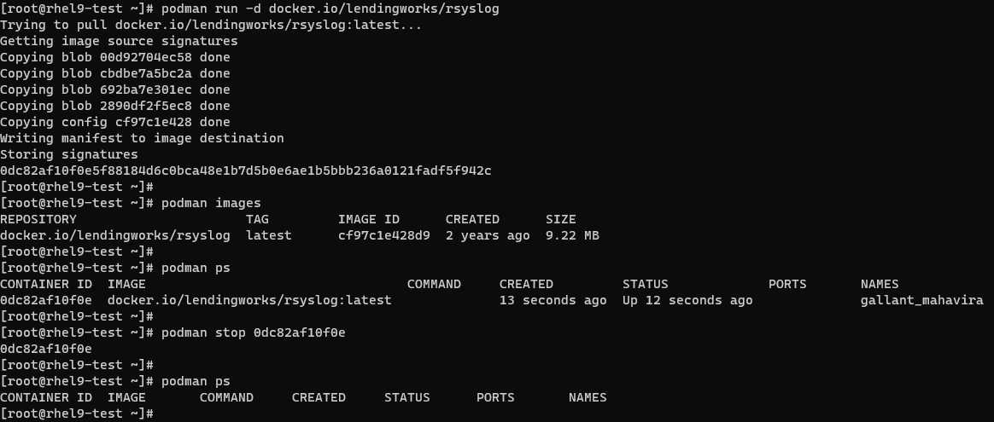

3. To run a container after assigning static IP to it-

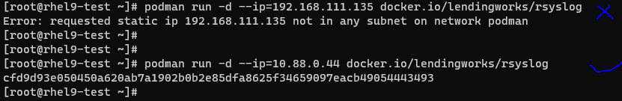

Note: We can’t assign IP from range of host network. Give it from provided range.

4. We can inspect this container image to see the IP address-



5. To execute any command in this container image without going inside it-

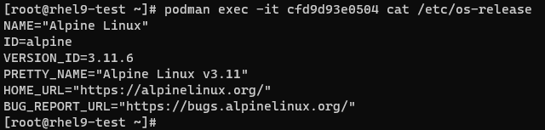

6. Now, to go inside container using interactive session & run few commands-

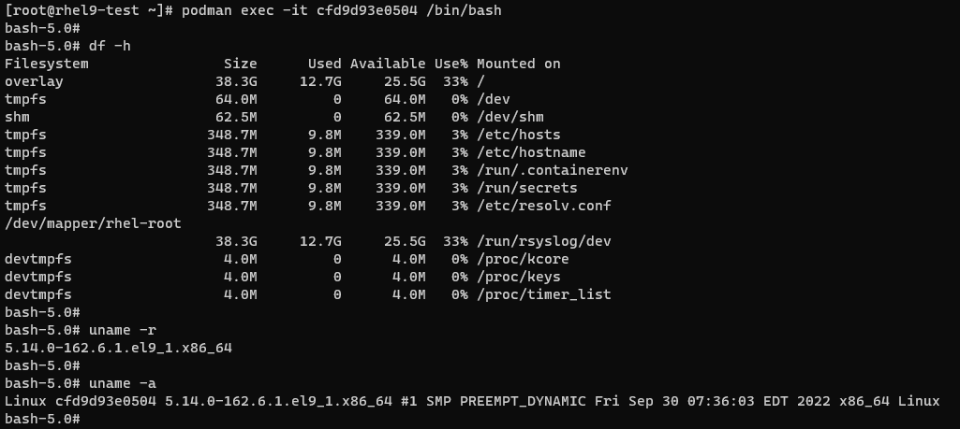

7. To share files between two containers, we will create one volume on host machine & verify it-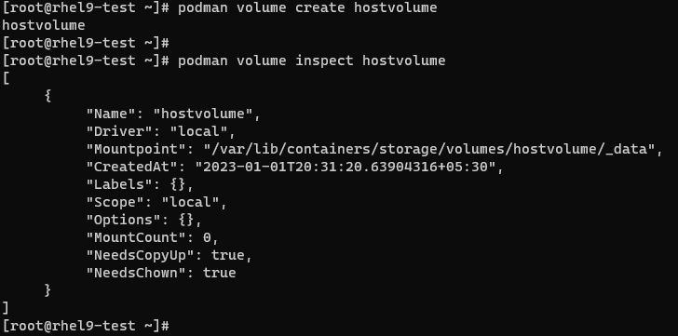

Note: We can see the Mountpoint in this snapshot. _data will be used for this purpose.

8. To avoid writing this path again & again, we will define one variable for it & verify as well. We will create one txt file & write some data into it to share-

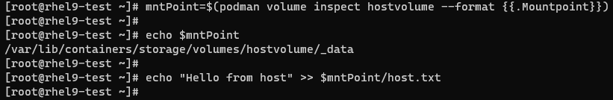

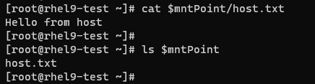

9. Now, we will pull one ubi container image & verify it-

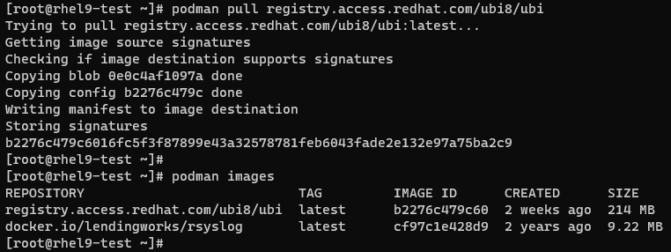

10. We will run its interactive session (myubi) with mounting the volume created on host (hostvolume). Then verify volume & file content & will create one text file with some content in it-

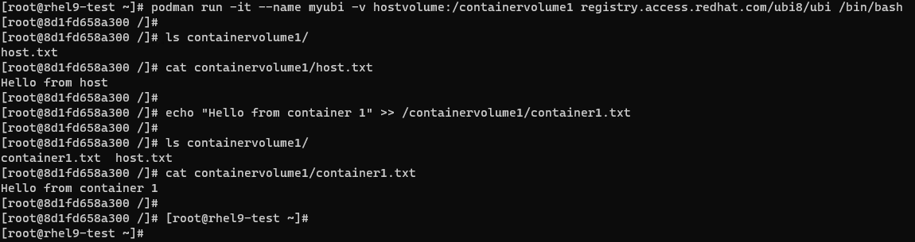

11. To keep this container running & move to host machine, use CTRL+P CTRL+Q one by one-



12. Now verify new content of host volume-





13. Next, we will run its interactive session (abhayubi) with mounting the volume created on host (hostvolume). Then verify volume & file content-

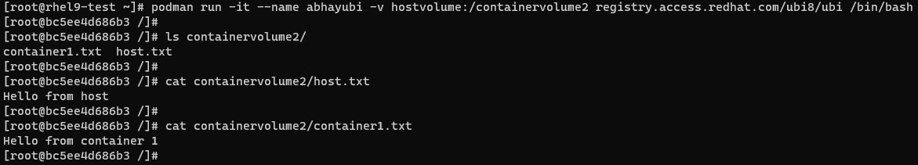

14. We will list this container’s content. Copy one file to its tmp & verify it. Will create one text file with some content in it. Now go to host machine without closing container. CTRL+P CTRL+Q-

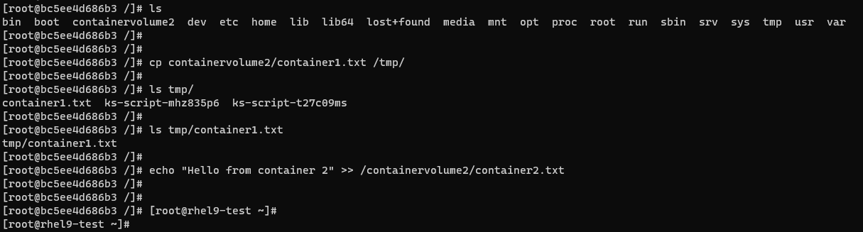

15. Now verify images & host volume new content-

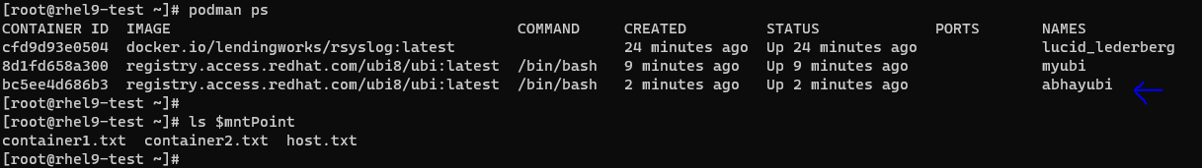



16. To export a running container, we will run a new container in background & verify-

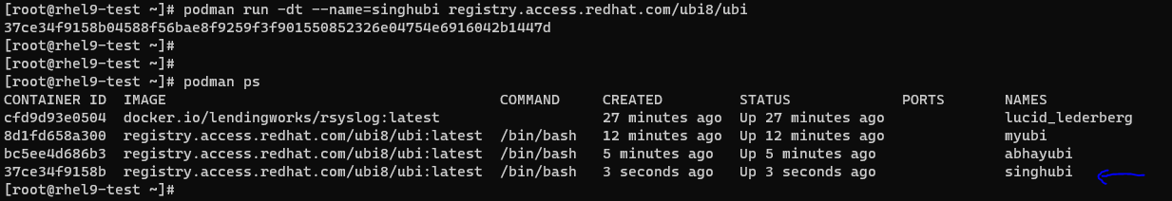

17. To go inside container, use below command-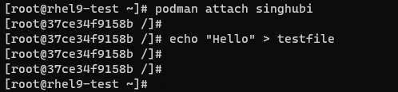

Note: We have created one file with some content in it for verification later on.

18. Now move to host without exiting this session, use CTRL+P, CTRL+Q-

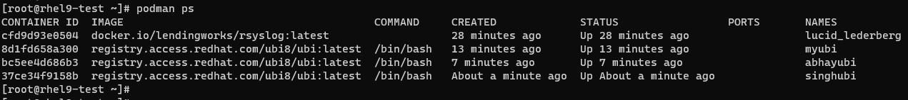

19. Export it in archive form-

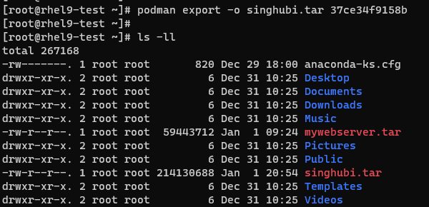

20. Next, create one directory on host machine & extract this archive in order to create new container from it & verify-





21. We can verify its content using tree command-

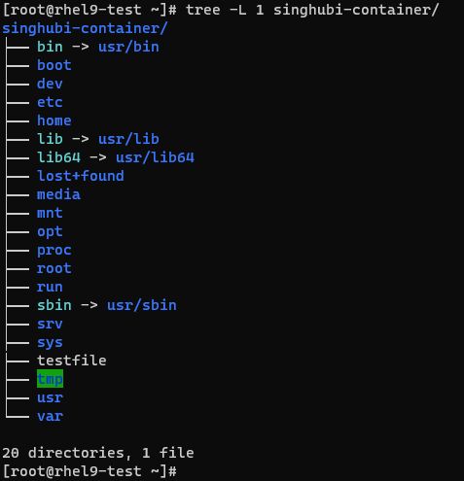

22. To run container using this extracted content, use podman import-

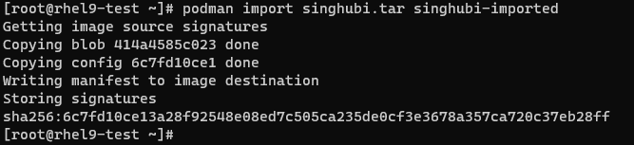

23. We can verify the same-

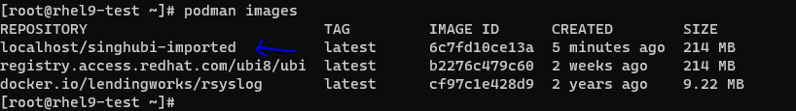

24. We can verify the file content (Created in step 17) of this newly created container without going inside it-



25. Now, we are done with Lab. So, stop all the running containers & verify-

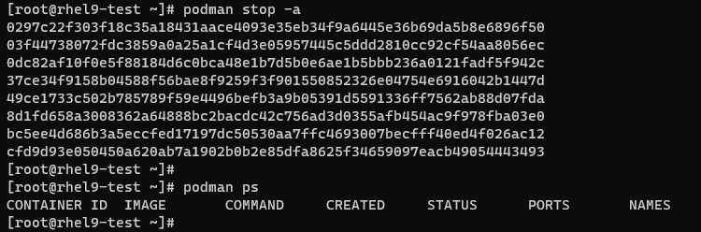

26. Similarly remove all the images from host machine (Use -f to forcefully remove)-

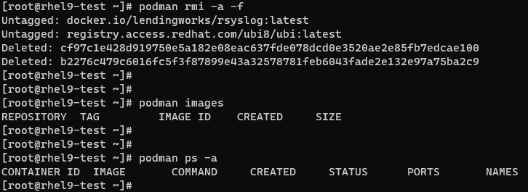

This is it about Lecture 4!!!