**Container: Lecture 6**

1. Install container packages-



2. Check whether required packages is installed or not-



**Root Full Container:**

3. Pull http container image & verify it-

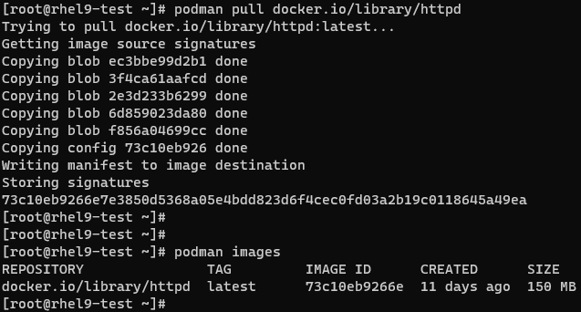

4. Run it in background & use port 8080 for this web server & verify the same using this port-

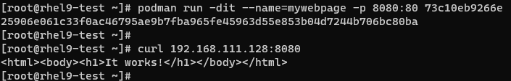

5. Check current status of container (Whether running or not). If we want to check logs, use shown command-



Note: It will show all the logs generated for this container.

6. To check what are the process running for this container image, use command shown-

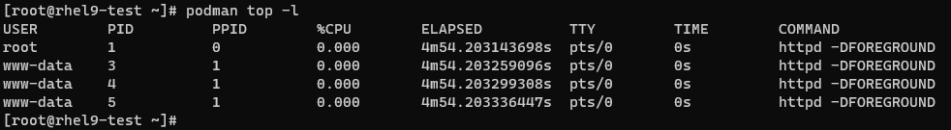

7. Now, go inside this container image using its bash shell & will verify the index file content & then exit out from here-

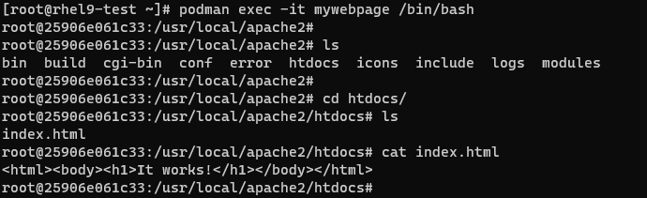



8. We want to use custom webpage (Available on host machine) using persistent storage. For this, follow below steps-

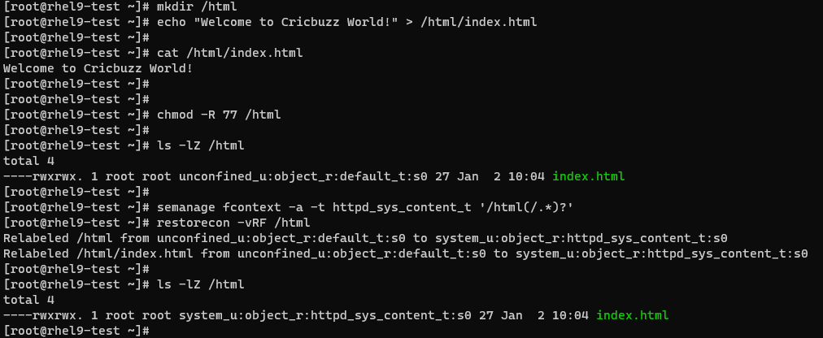

Note: Here we have to set 777 permission to parent directory & subdirectories. Change selinux context.

9. Stop all the running container & remove it-



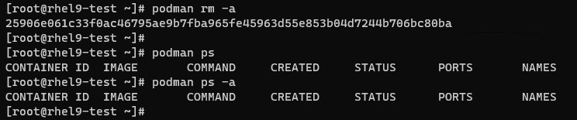

10. Check the available container image-

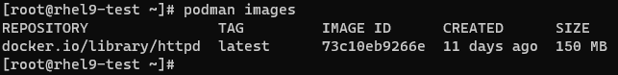

11. We will run container in background & use the path of index.html of host machine to mount it to container. Verify the same-

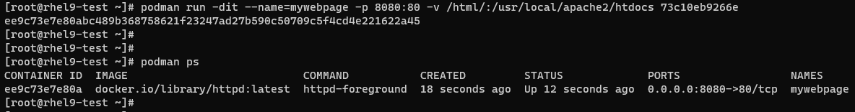

12. Verify it using default & new http port-

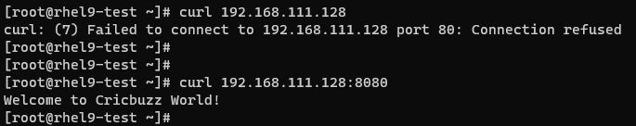

13. Now we will stop the container & verify it-

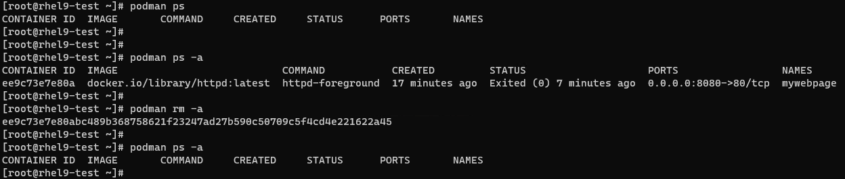

This testing is done.

14. Next, pull MySQL container image & verify the same-

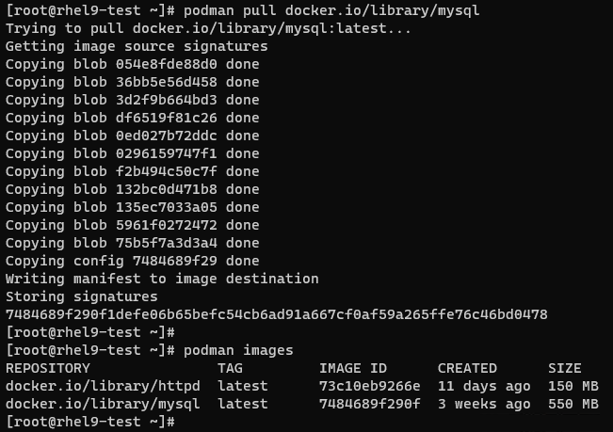

15. Run it in background using default port & set root password. Verify it & then login into container using shell-

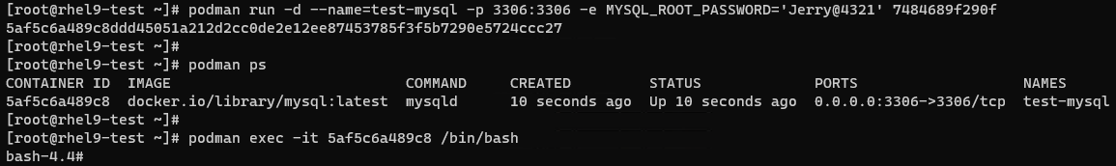

16. Now, login into data base using set credential (In last step)-

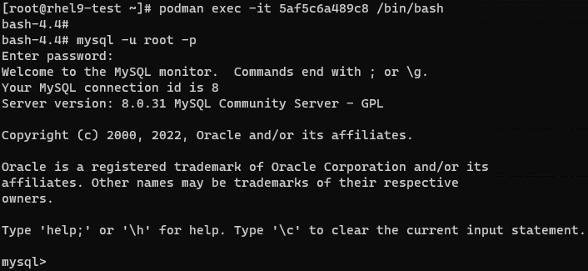

17. Show existing database-

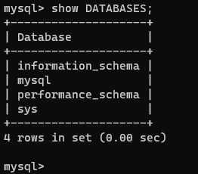

18. Create a new DB & verify it. Check warnings as well & then exit from container-

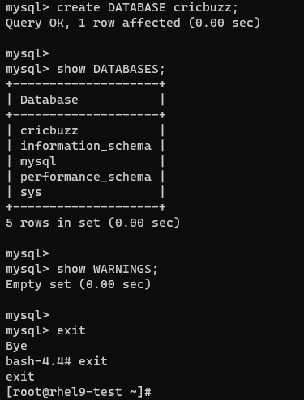

19. Next, stop the container & verify it-

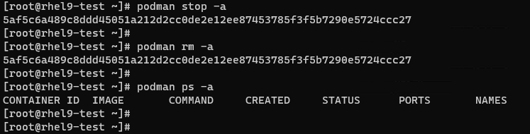

**Root Less Container:**

20. Now we will do container Lab in standard user. Login with it & verify the existing container images if any. For the root less lab, ignore the warnings & focus on blue arrow-

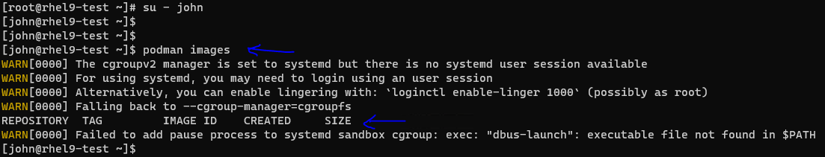

21. Search for a container image-

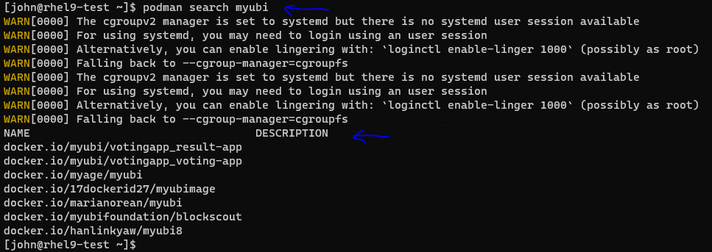

22. Pull the container image-

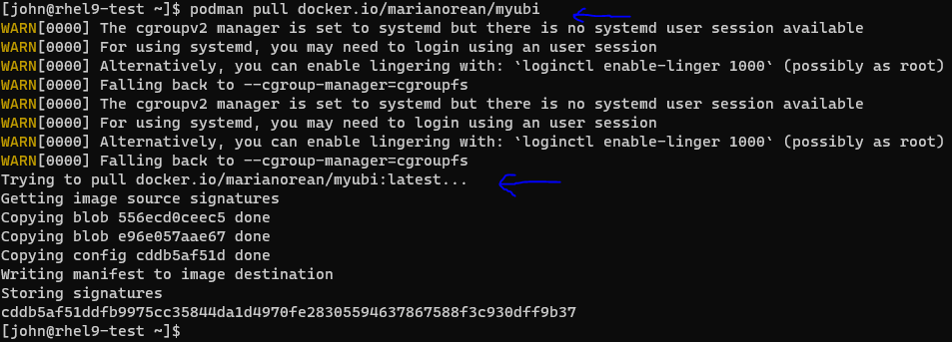

23. Verify it & inspect if require more detail about this container image-

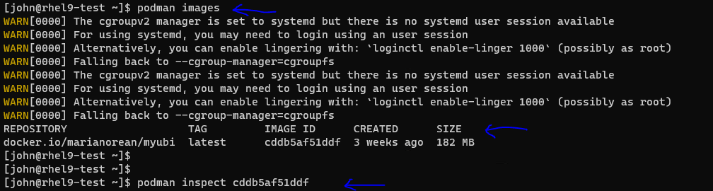

24. To get information about podman, use command as shown-



25. If we want to go to storage location of containers, use path shown after running previous command-



26. Check current container images-

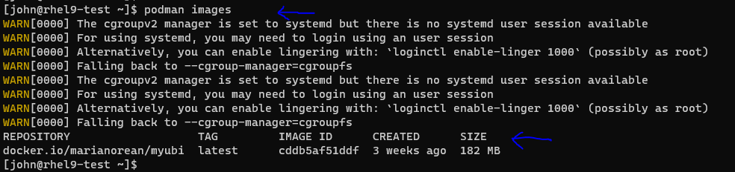

27. Run this container image in background & verify-

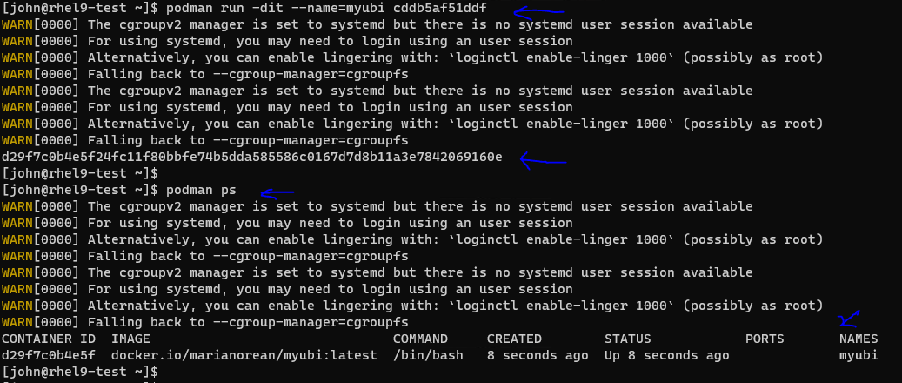

28. Go inside container image using interactive shell-

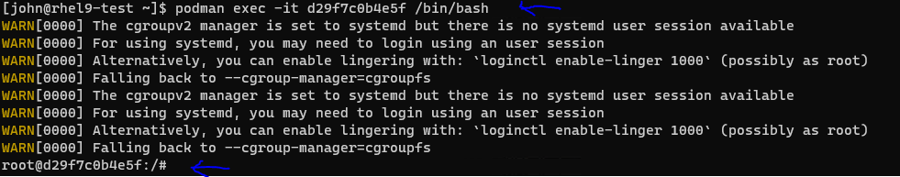

29. Run few commands in this container to get some detail about it-

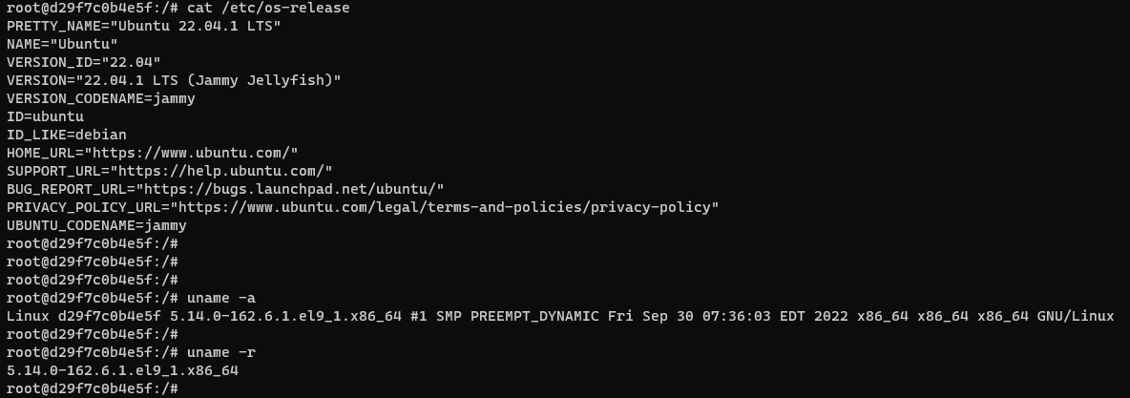

30. Now exit it & check the status. Check if we can mount this container in standard user or not-

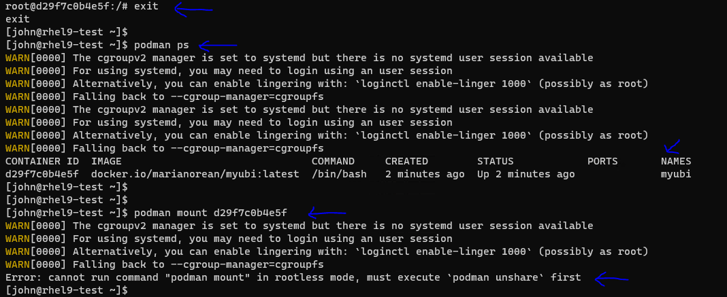

Limitations of root less container:

(i). We are getting error while trying to mount it in root less mode. This is the limitation of root less mode.

(ii). Also we can’t assign any port before 1024 in root less mode. We will verify it in next few snapshots.

31. Pull httpd image & verify it-

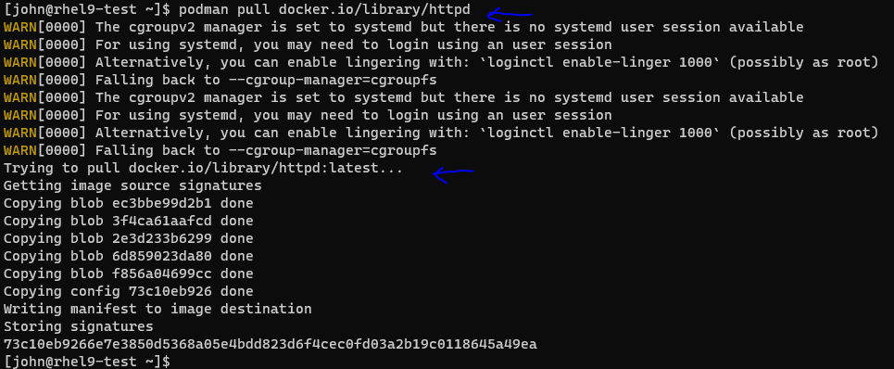

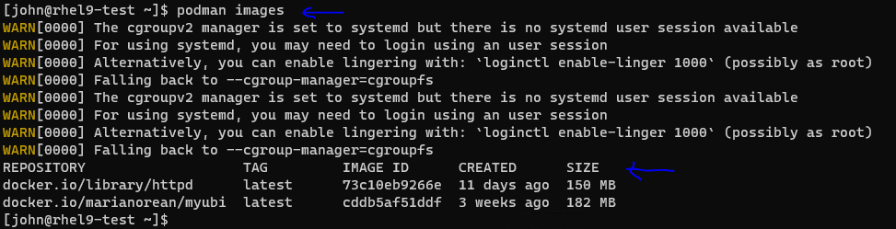

32. Now run it in background & try to use default http port (Which is less than 1024)-

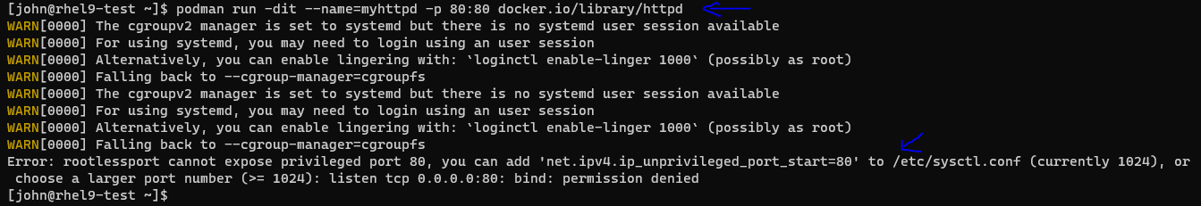

Here, it is not allowing us to use port 80 in root less mode.

33. Remove this container-

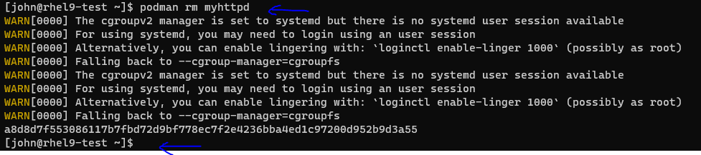

34. Run it in background & this time with port no. greater than 1024 & verify it-

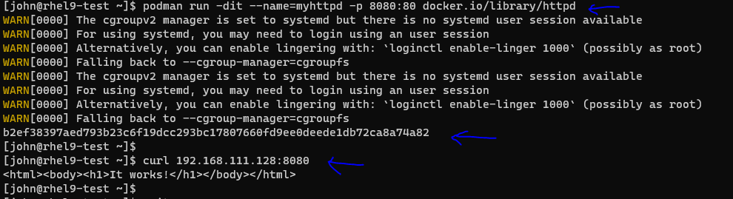

This time we are successful in running this container using custom port & able to see webpage output.

35. Stop & remove all running images-

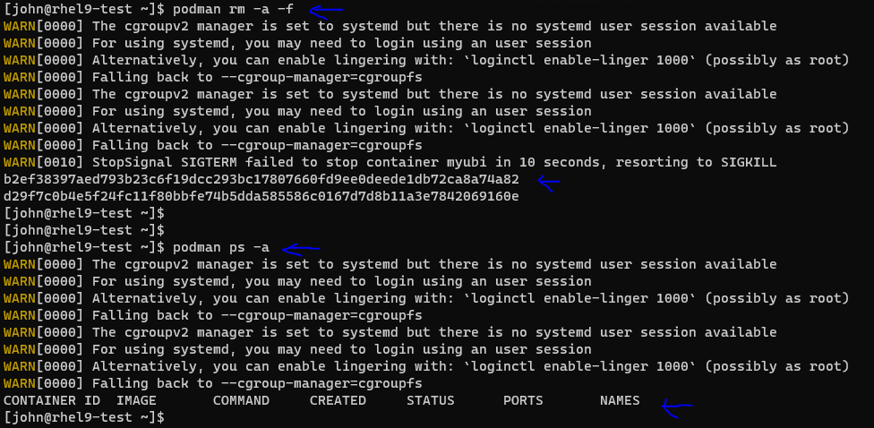

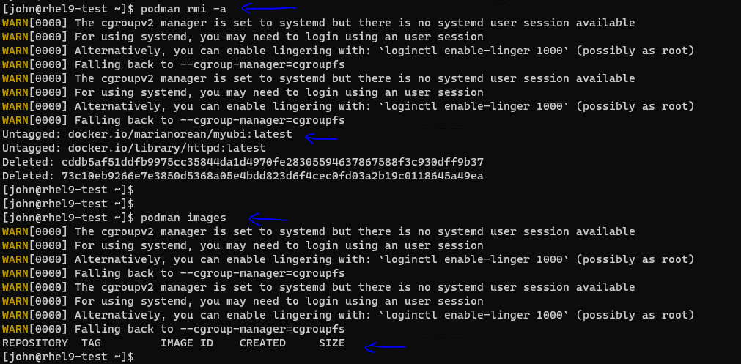

36. Exit from standard user-



37. Remove container images from root user login as well which we pulled at start-

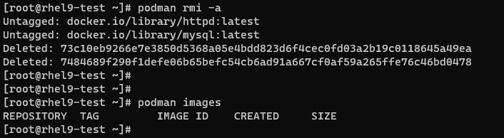

This is it about Lecture 5!!!