**Container: Lecture 6**

**Persistent Container Lab (Even After Server Reboot):**

**Root Full Mode:**

1. Install Container packages-



2. Pull http container image-

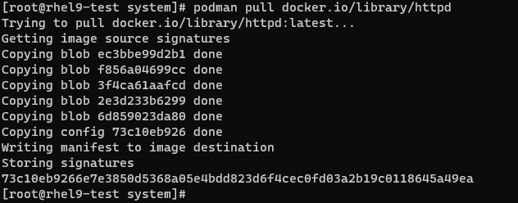

3. Verify image. Run it in background & check web URL-

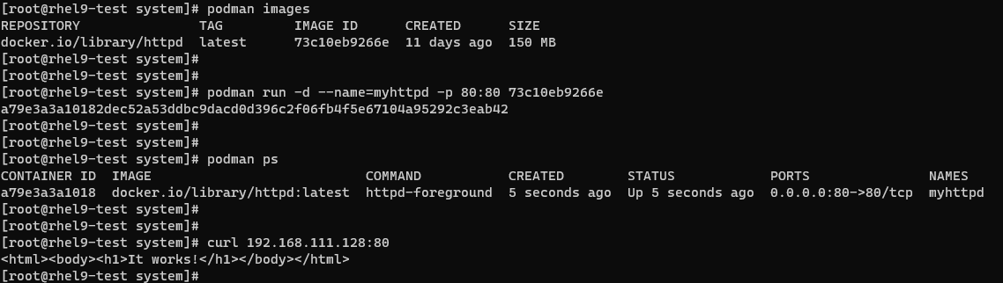

4. Now, we will define this container as a service under systemd-

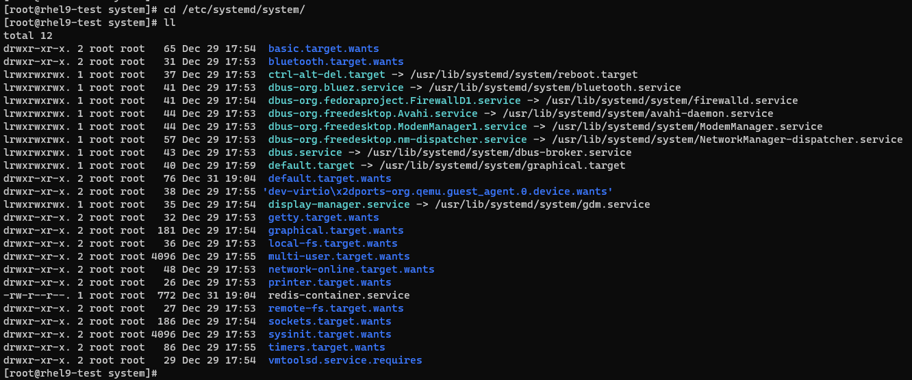

5. If we run below command, it will show unit content, but won’t create file.



6. We will generate container service unit file under systemd & verify it (container-myhttpd.service)-

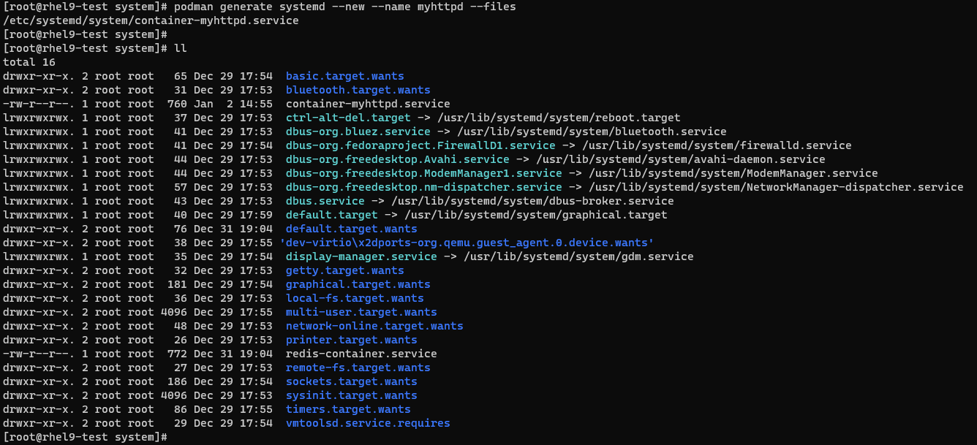

Note: Where ever we run this command, it create file in that location only.

7. We can check this file content & it is same as the output we receive from step 5-



8. Verify current status of httpd container image, stop it & verify again to go further-

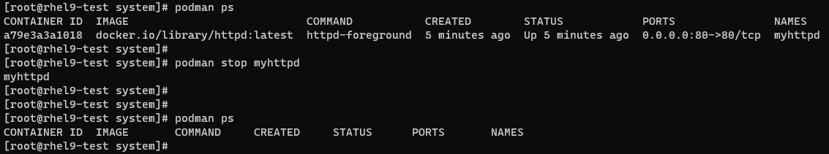

9. Verify service status for newly created container service under systemd-

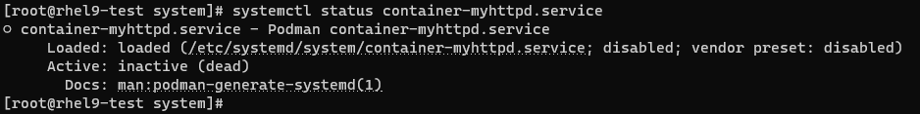

10. Start & enable this service-



11. Now, check the container image status. We stopped it previously. Now it should be up after starting service. After that reboot server to check whether it withstand server reboot or not-

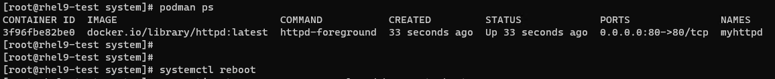

12. After rebooting, check the status of container-

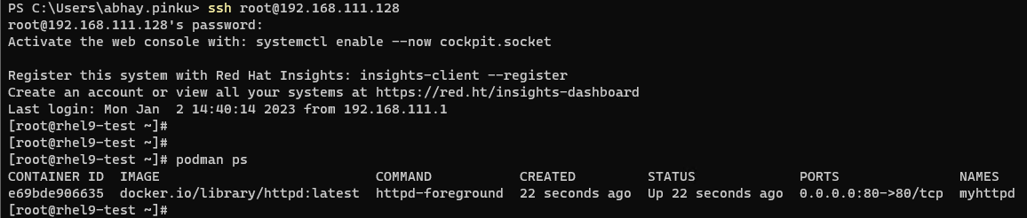

It is started automatically.

13. Verify service status-



14. Our lab is completed. Now we will stop the service, verify container running status-

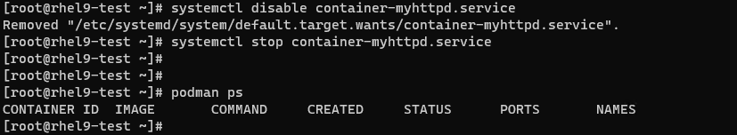

Container is stopped too as we stopped service.

15. Now remove all images & created service for the container. Verify the same-

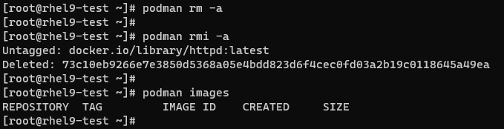



**Root Less Mode:**

16. Login with a standard user-



17. Pull httpd container image-

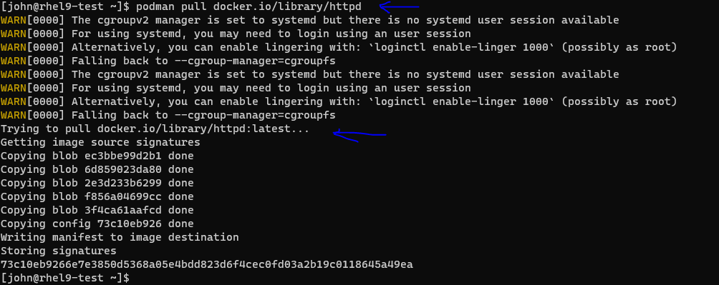

18. Check is any container is running previously-

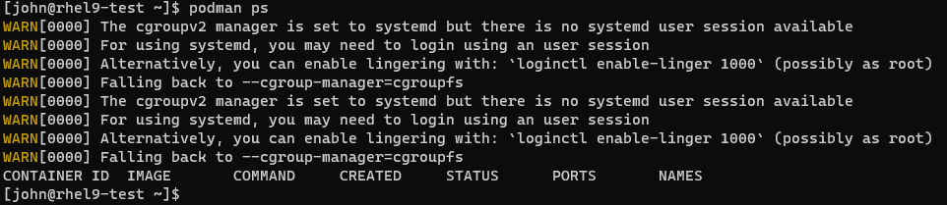

19. Check available container images-

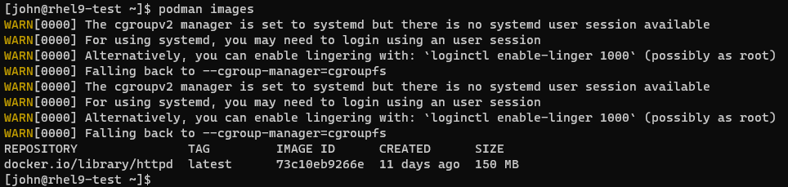

20. Run this container image in background at port greater than 1024-

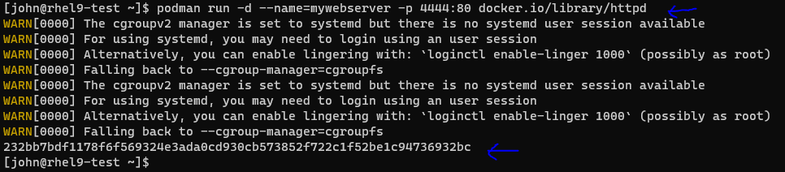

21. Verify the container running status-

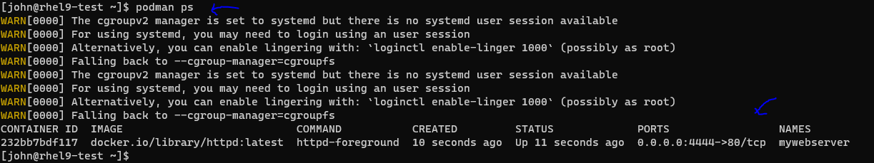

22. Verify web URL-



23. This lab is for keep container image running even after server reboot in root less mode. First look for .config directory under user’s home directory-

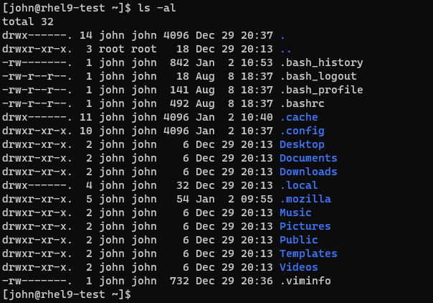

24. We will list its content-

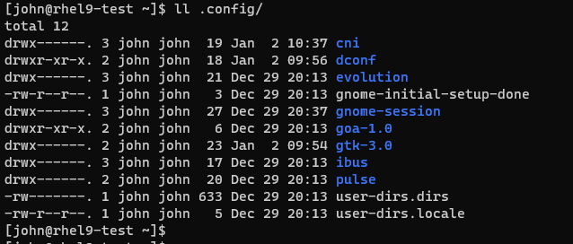

25. Now create one directory in parent-child form-

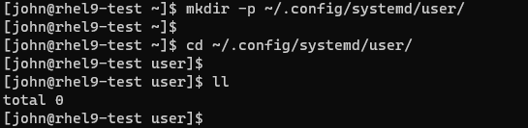

26. We need to generate unit file as we did in root full mode. To just see content of systemd unit file, run below command-



27. Now generate that unit file in newly created child directory & we can check its content as well-

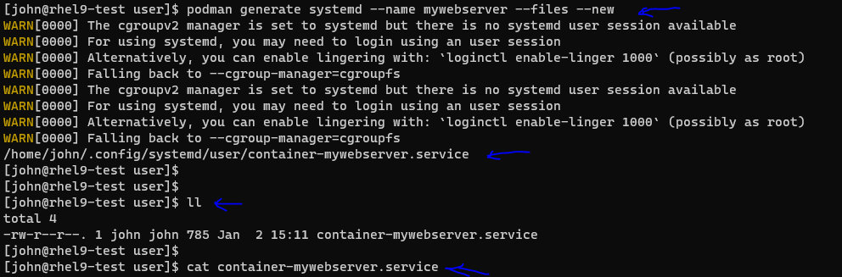

28. Stop the webserver & verify the container status-

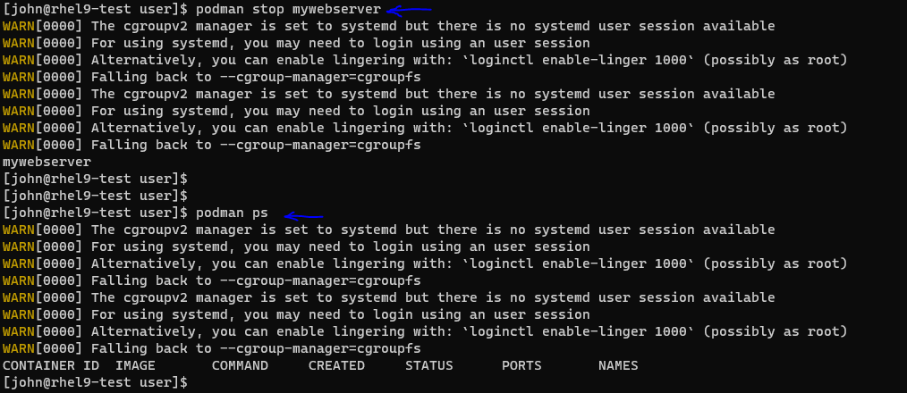

29. To check whether this user is allowed for lingering or not. If not, he will not be able to define systemd unit. We can list linger file content, but it will show empty if no user allowed to define systemd unit. To fix it, we need to enable user for lingering as shown-

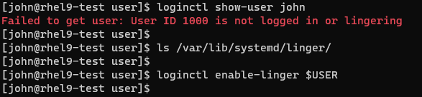

30. Now verify linger file content. It will show this user name i.e this user has permission to define systemd unit. We can also check this user detail which was not showing last time-

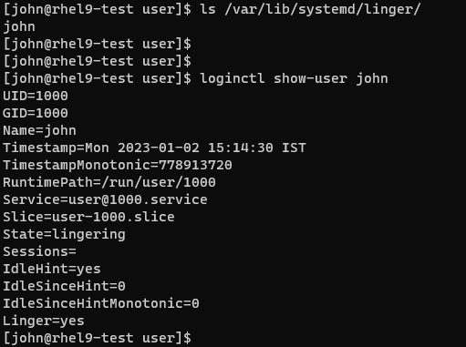

31. Check for any running container. Now we will reload daemon for user-

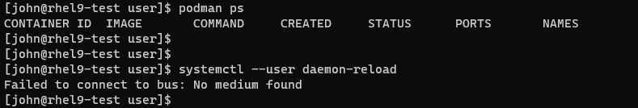

It is failing. This is the method use to define systemd unit in root less mode. This issue arises after RHEL 8.5 version.

32. To solve this, we will define a variable & export it so that it can be available in other shells as well-

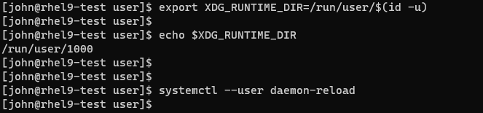

We can see this variable content. It shows user-id for current user i.e john here. Now we will again reload daemon for this user & this time it succeeds.

33. Again check for any running container-

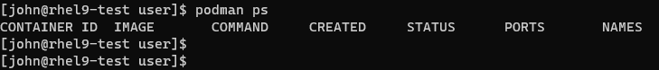

34. Now we will start & enable created systemd unit & check for the container status-

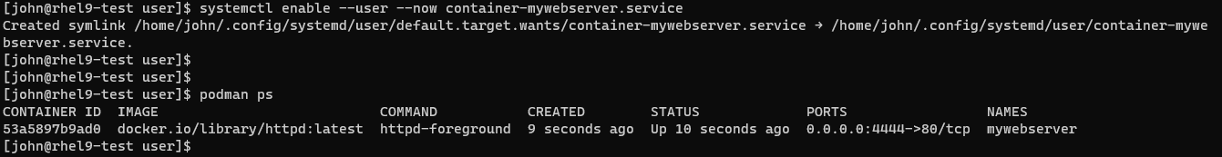

35. Check its service status-



36. Next, we will exit from this user & reboot the server-

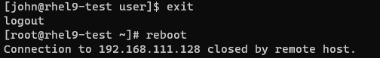

37. We will login back with john user after server reboot-

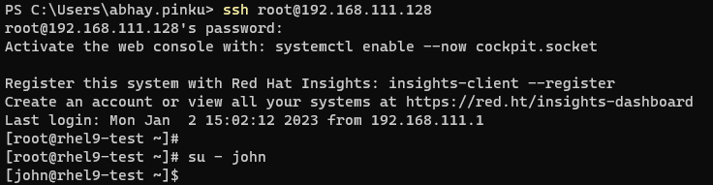

38. Verify the container running status & check the web URL-

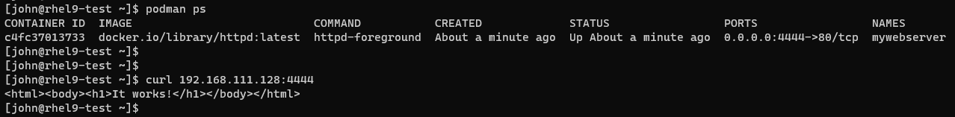

It is up & running even after server reboot. Thus we succeed in setting up root less container which withstand server reboot.

39. Now we will stop running container & remove it as well as remove container images-

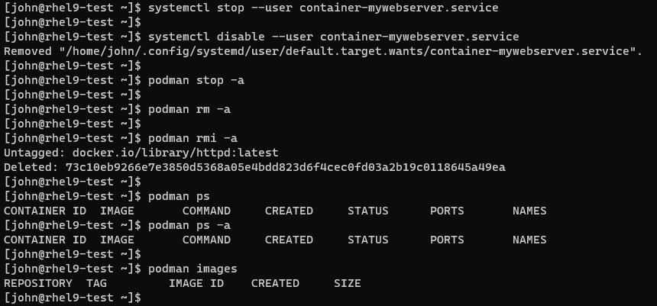

This is it for Lecture 6!!!