**Container: Lecture 7**

**Pod Lab:**

1. Install container packages-



2. To get help, use command shown-



3. We have several options to use with podman-

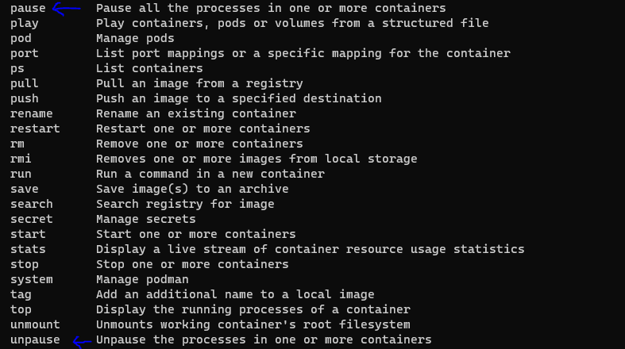

4. To create pod & verify, use command as shown-

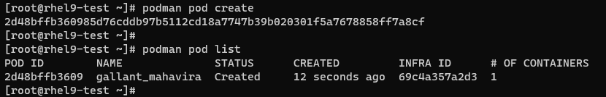

5. Create pod with custom pod name & verify-

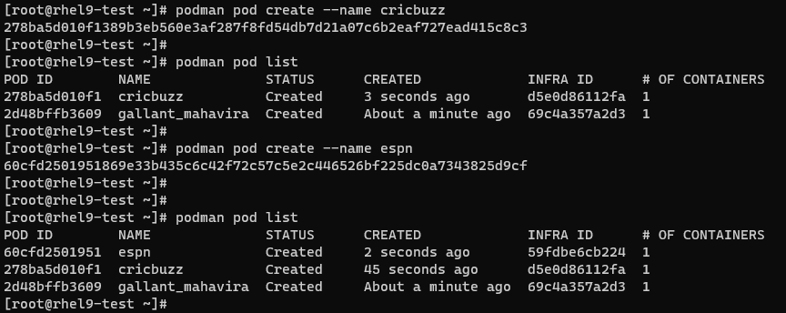

6. To check list of running containers & under which pod they are running-

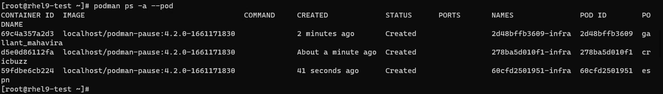

7. To add a container in an existing pod & go inside using terminal using interactive shell-

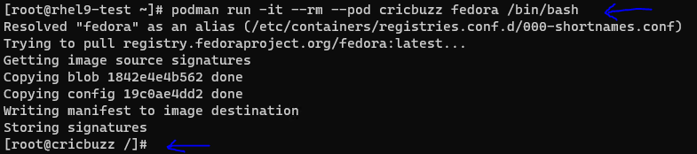

Note: If we have multiple registry from where we can pull same image, it will give us option to select it.

8. Run few commands inside this container & then exit from it-

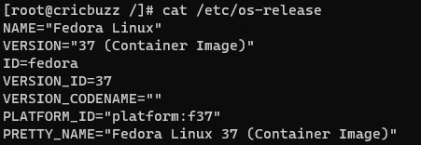

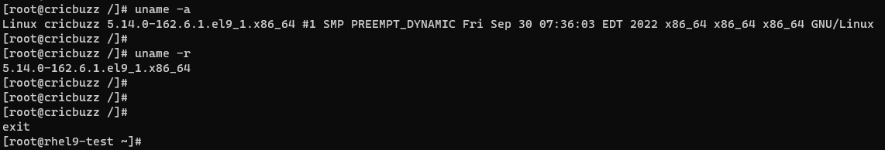

9. Now we can again check list of running containers & under which pod they are running-

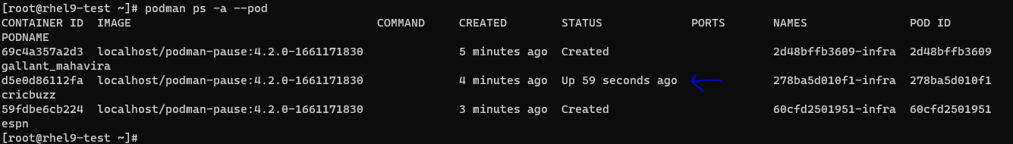

10. We can verify pod list as shown-

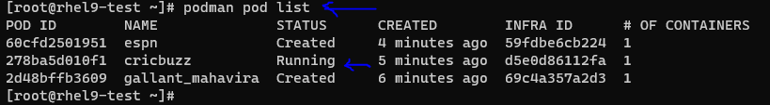

11. Previously, we had created pod first & then pulled image. This time we will create pod & pull image together as shown in image-

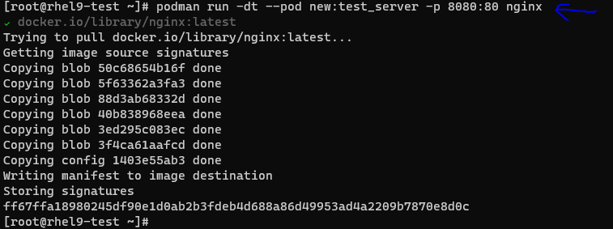

Note: “nginix” was available in multiple registry. We had chosen one of that & green tick is suggesting that selection of registry done & hence image pull started.

12. Again verify the updated pod list-

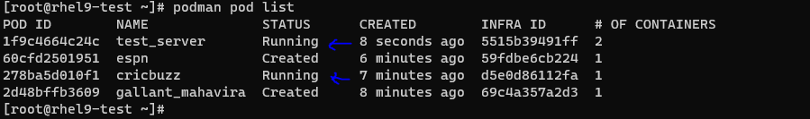

13. To get details of a pod, use inspect option as shown-



14. Now stop test_server pod & verify it-

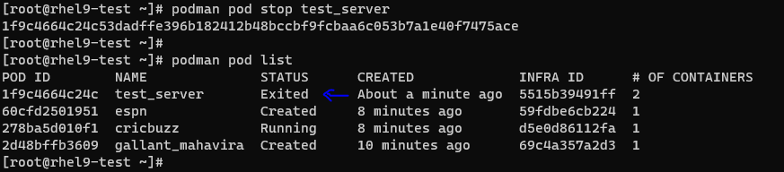

15. Remove this pod & verify again-

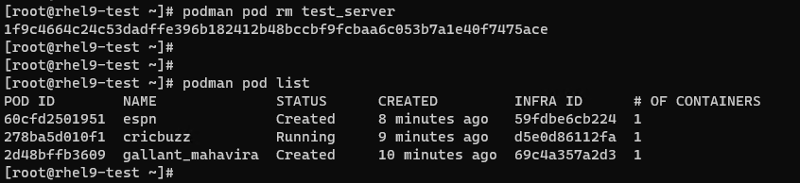

16. Now we will stop all pods & then remove all-

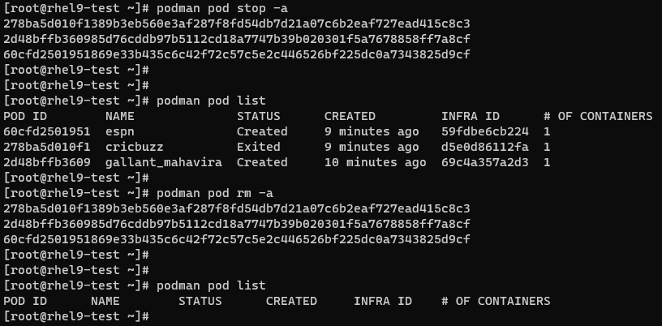

This is it for Lecture 7!!!