**Container: Lecture 8**

**Build Container Image Lab:**

1. Install container packages-



2. To get podman help, run command as shown-



3. Similarly to get podman create help, run below command-



4. For network related help, run below command-

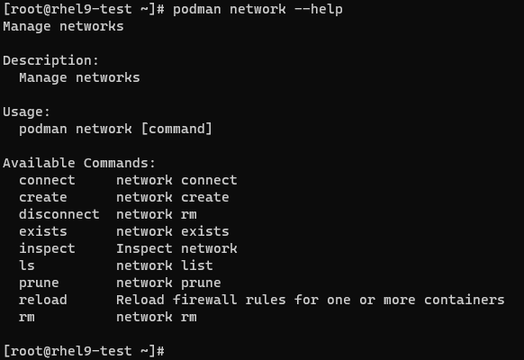

5. For podman build help-

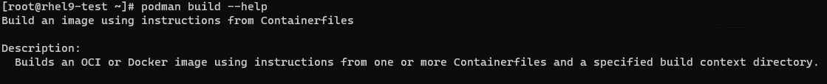

**Create Container using podman (Command Line Method):**

6. Now pull httpd container image, we will have multiple registry to pull from if not specified a registry-

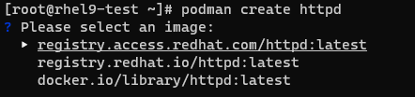

7. We will select docker registry & continue-

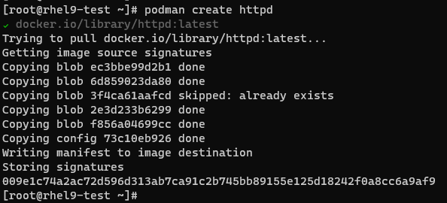

8. To verify images, we can use either of the two commands as shown-

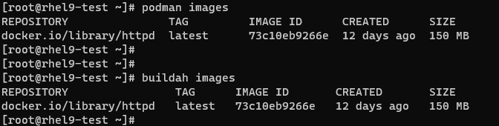

9. Check for running container if any-



**Create Container using podman (Docker File Method):**

10. First, create a Docker File & write some lines of code. Verify it-

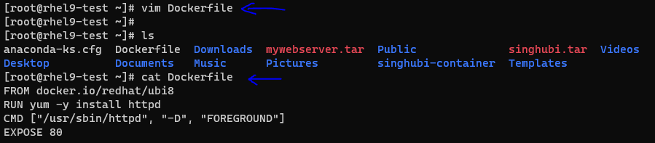

Here, using this file, we will-

* Mention the registry URL to pull base image in order to create a container
* Install httpd packages while creating our own container
* Container will run using httpd binary file
* Expose the http port

11. Next, we will create the image using this file-

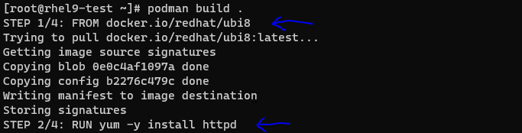

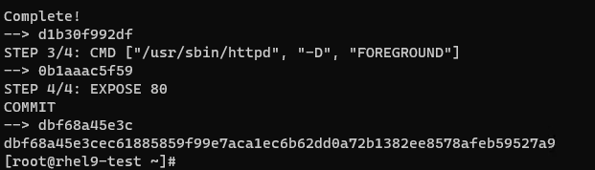

12. Verify using podman images & podman ps-

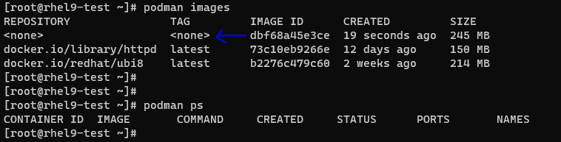

Here third image we have pulled to build our own image. Blue arrow is showing our created image. We haven’t defined any name or tag for this.

13. To modify this image, we will use another method to create image. For this first create one directory & copy that file in it as shown-

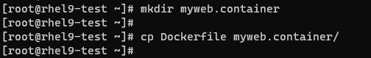

14. Now create the image-

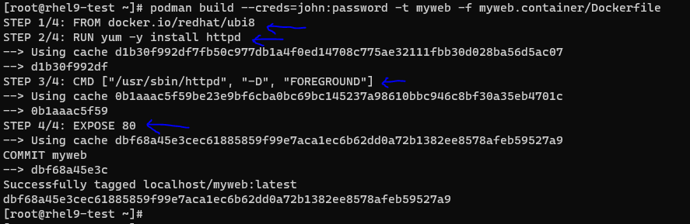

Here, we specified a username & its password along with image name.

15. Verify images now-

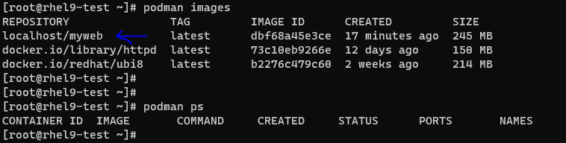

16. Now we will run this container image in background & verify the web content-

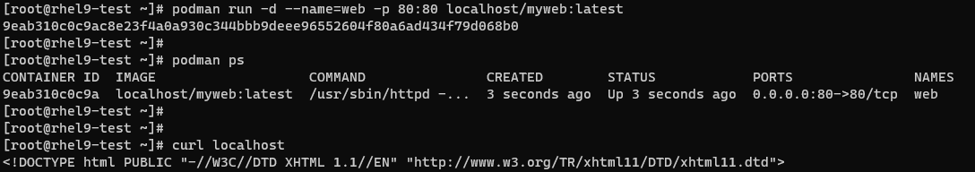

17. This is done using podman. Now we will stop & remove all the images-

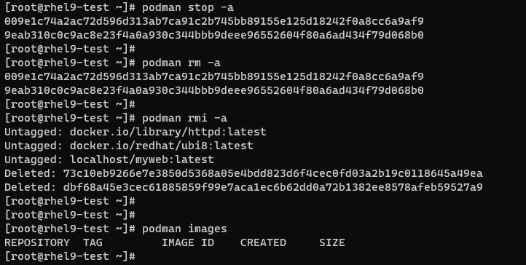

**Create container using buildah (Command Line Method):**

18. First verify whether buildah package is installed or not-



19. Now, we will pull fedora base image using buildah & verify it-

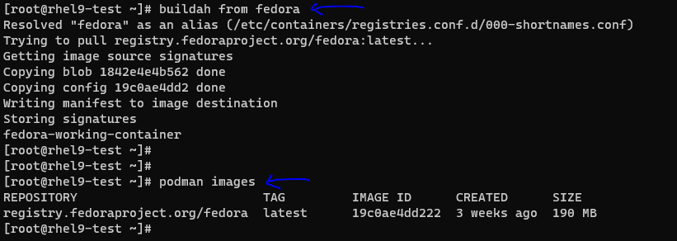

20. To run this container image after giving a name & then will install httpd package in order to setup web server-

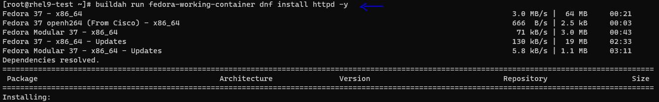

21. We will create a custom web server, for that create index.html file inside newly created directory as shown-

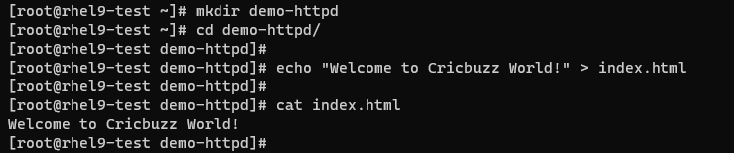

22. We will copy this index.html to running fedora container using buildah & define the binary file in the image-

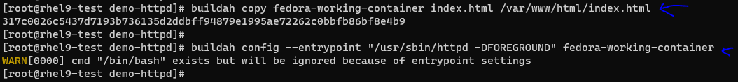

23. Next, we will commit the changes & then verify available images-

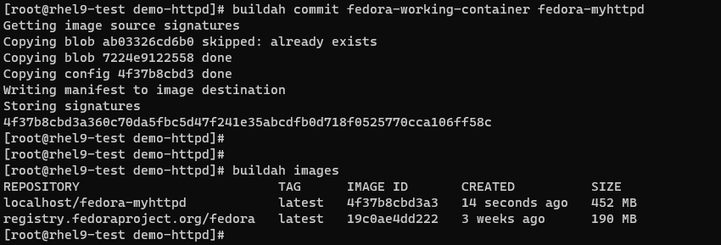

24. Now run it in background & verify the container running status as well as web content-

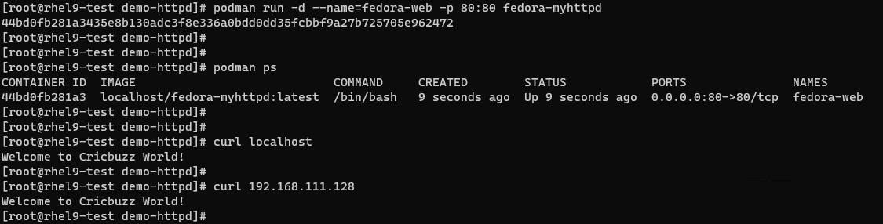

25. Now we will stop running images & remove it-

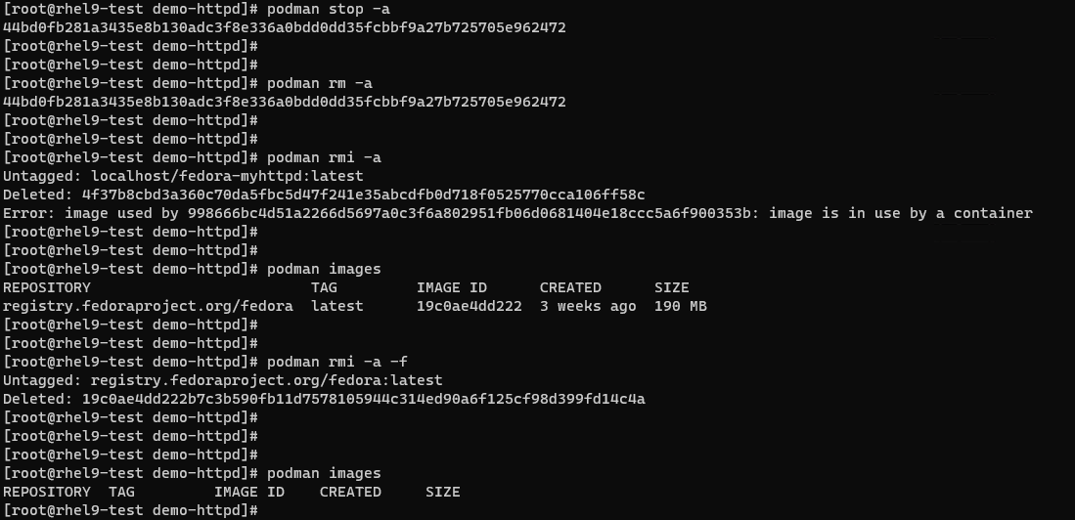

**Create container using buildah (Docker File Method):**

26. We will switch to a standard user-



27. Now, create a Docker File & write some lines of code. Verify it-

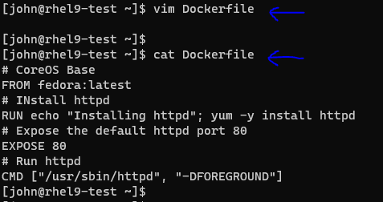

28. We will use bud (build-using-dockerfile) command & give image name-

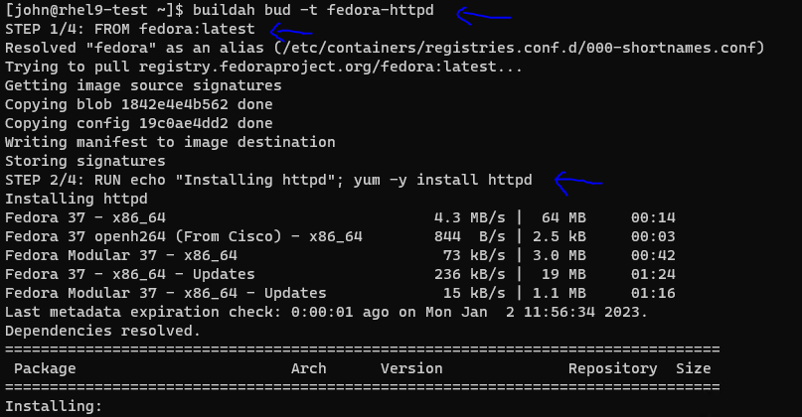

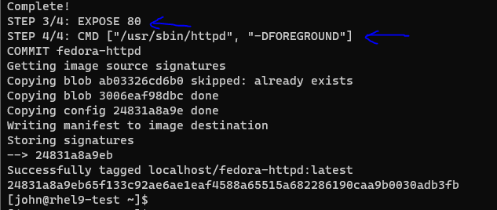

This will –

* Pull fedora base image,
* Install httpd package,
* Expose port 80 & then
* Container will run using httpd binary file.

29. Verify the images using both podman & buildah-

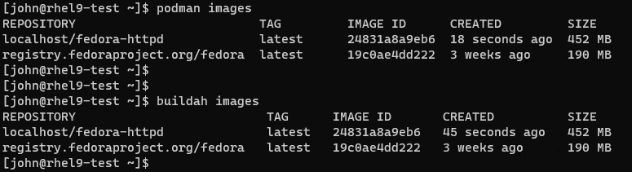

30. Run this in background with port no greater than 1024 (As we are running the container in standard user i.e root less) & verify it-

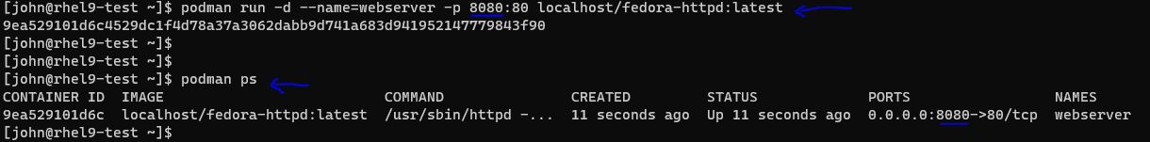

31. Verify web content once image runs-

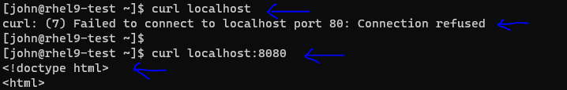

32. Check the container status-



33. At last, stop the container & remove all the images-

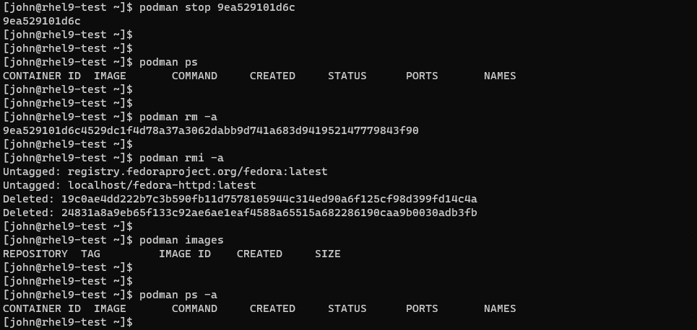

This is it about our last lecture 8!!!