**FTP Server Setup**

1. Setup FTP server & for this check its IP-



2. Install require packages-



3. We will make some changes in FTP config file. So have its backup first-





4. Now, we will setup anonymous user access & for this edit config file-

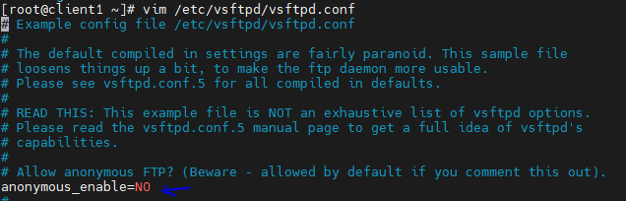

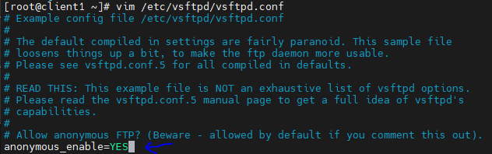

5. After making changes, start & enable FTP service-



6. We can verify its status-

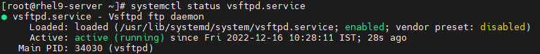

7. We will allow FTP from firewall-

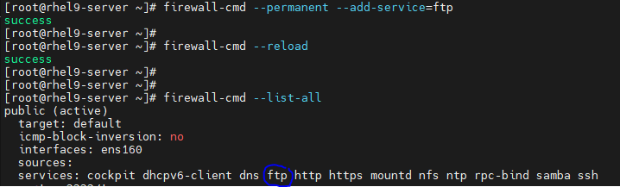

8. We will log into FTP server using local user first, list the content & then sign out from FTP-

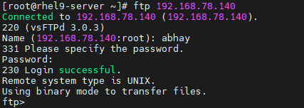

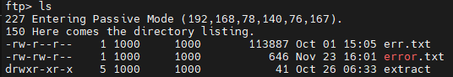



9. Next, we will try to login with anonymous user (As we already allowed it from config file). Specify password in mail id format. We will see content & try to download file (if any) from FTP server pub directory-

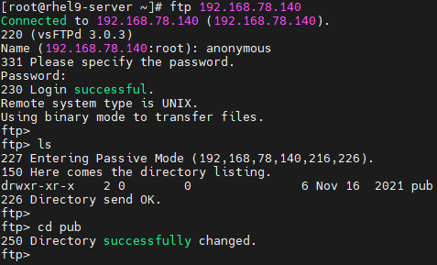

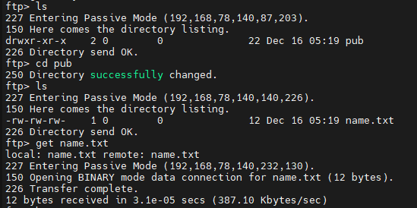

Note: It will get downloaded in same location from where we are logging in from cmd or terminal.



10. If we don’t allow anonymous user access from FTP config file, we will get error during anonymous login-

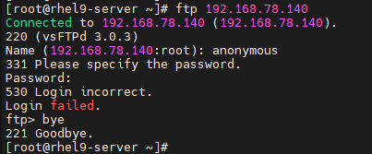

11. In windows machine, if we try to connect FTP server, we will be able to connect, but can’t list directory content. It shows one error as shown here-

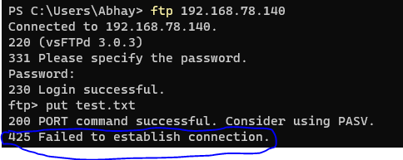

12. To fix this, we will turn on one of FTP Boolean in RHEL server-

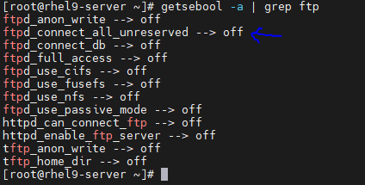

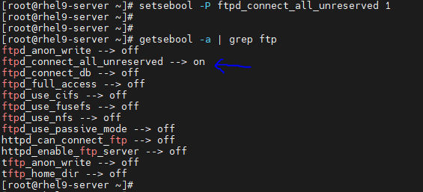

13. Now we will be able to list directory content as well as download & upload file. Few terms are explained as-

* To download a single file: get <file-name>
* To download a multiple file: mget <file1-name><file2-name><file3-name>
* To upload single file: put <file-name>
* To upload multiple file: mput <file1-name><file2-name><file3-name>

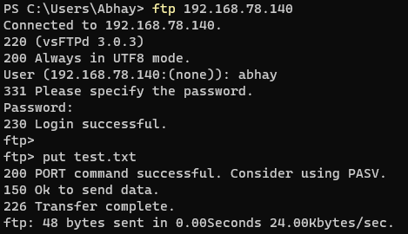

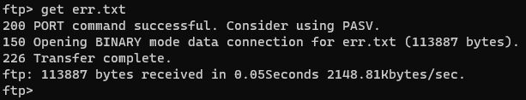

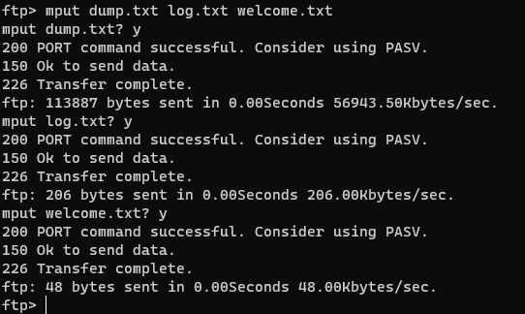

**Allow or deny users from login using FTP:**

1. Go to FTP default config directory & list the content-

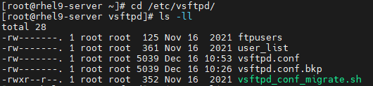

2. Edit user_list file & add user to whom you want to deny the access-

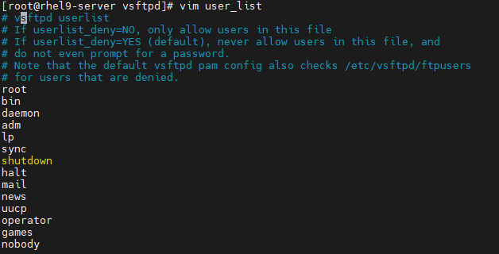

For example, we want to deny “abhay” user from FTP login. We will add its username in above file.

3. Next, go to FTP config file (vim /etc/vsftpd.conf) & add following line & restart FTP service-



systemctl restart vsftpd.service

4. Now check with abhay user login-

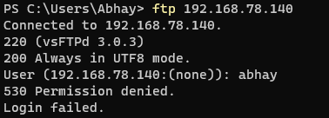

**Change FTP Default Port Number:**

1. Go to FTP config file (vim /etc/vsftpd.conf) & add custom port number other than default one-



2. Restart FTP service-



3. Allow this custom port from firewall-

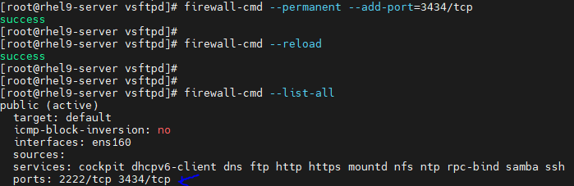

4. Now, test the FTP connection in linux-

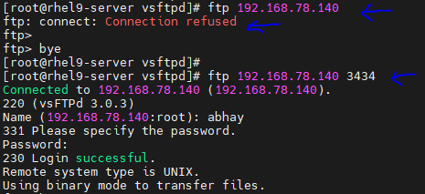

5. Similarly, test the FTP connection in windows-

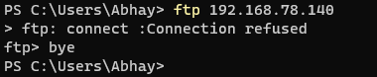

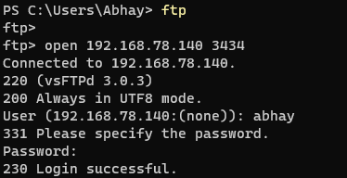

**Change Default Directory for Anonymous User:**

1. Enable anonymous login access from FTP config file-



2. Add following line for new anonymous FTP directory-



3. Restart FTP service-



4. Create custom directory for FTP anonymous access as mentioned in FTP config file. Verify its selinux context-

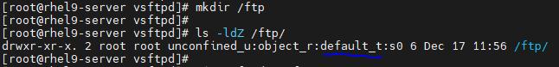

5. If we try to login with anonymous user, we will be able to do that. But we cannot list new FTP directory content-

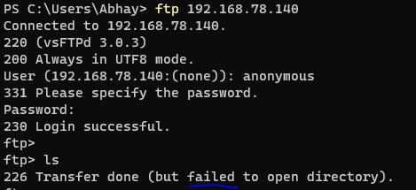

Reason: SELinux context of this new anonymous directory is different from required one.

6. We can verify default FTP directory context & change this new FTP directory context accordingly-



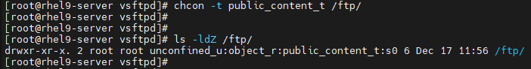

Note: Using chcon, context will get removed if we do autorelabel. To solve this, we use semanage command for changing directory/file context & run restorecon to force it to stay as it is even we run autorelabel.

7. Next, we will create one file in this new directory-



8. Now if we ant to list new anonymous FTP directory content in windows, we can see that & even download the files-

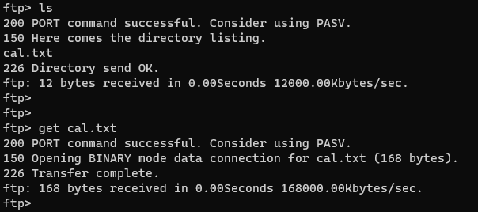

9. If we want to remove this custom anonymous FTP directory & use the default one, We will comment following line in FTP config file & restart FTP service-





10. We can verify the same & will see “pub” as default anonymous FTP directory-

