1. **Introduction**



FlavourFeed is like a cozy kitchen on the internet where food lovers meet. It is super easy – just like sharing recipes with friends. The website looks great and works smoothly, thanks to simple tools like HTML, CSS, and JavaScript. Behind the scenes, we have got Spring Boot, Hibernate, and MySQL making everything run smoothly. FlavourFeed is not just a place for recipes; it is a friendly community where you can discover new flavors, make friends who love food as much as you do, and maybe even learn a thing or two about what is good for you. Join us and let us create a delicious experience together!

This web application offers a user-friendly platform for exploring, sharing, and contributing to a diverse collection of food recipes, while also empowering users to create personalized diet plans, and access valuable nutritional information.

1. **Problem Definition & Scope**
2. **Problem Definition**

Imagine a world where people who love cooking find it a bit tricky to share recipes and connect with others who enjoy food. Regular cooking websites might be a bit too complicated or not as fun. That is where FlavourFeed comes in! We noticed this problem and want to create a simple, easy-to-use place where everyone can share their favorite recipes, find yummy dishes, and make food-loving friends. So, our mission is to make cooking and sharing recipes online a lot more enjoyable and friendly for everyone!

**2. Goals**

* 1. Create a Friendly Food Community
  2. Seamless Recipe Sharing
  3. Recipe Discovery
  4. Enhance Nutritional Awareness
  5. Interactive User Engagement

**3. Objectives**

* 1. User Registration and Onboarding
  2. Recipe Submission
  3. Efficient Recipe Search and Discovery
  4. Nutritional Information Integration
  5. Community Interaction Features
  6. Responsive Design Across Devices
  7. Security and Privacy Measures
  8. Regular User Feedback and Improvement

1. **Major Constraints**
   1. The web application should support common web browsers such as Chrome, Safari, Firefox, etc.
   2. User Device Compatibility
   3. Compliance with relevant data protection regulations.
   4. Content Moderation
   5. Budget Constraints
2. **Outcomes**
   1. Establishment of a Vibrant Food Community
   2. Simplified Recipe Sharing
   3. Diverse Recipe Discovery
   4. Enhanced Nutritional Awareness
3. **Software Requirements Specification (SRS)**
4. **Team Members (Stake Holders):**
   1. Admin
   2. User
5. **Scope:**

FlavourFeed aims to create a user-friendly culinary platform, enabling users to share, discover, and engage in a vibrant community. The scope includes intuitive recipe sharing, robust search functionalities, nutritional information integration, cross-device accessibility, security measures, continuous improvement based on user feedback, and fostering an interactive and supportive user environment. The platform's goal is to inspire culinary exploration, connection, and a positive experience for food enthusiasts.

1. **Functional Requirements:**
   * **Admin**
   1. The admin should be able to login himself.
   2. The admin should be able to create and manage Users.
   3. The admin should be able to create, modify, and deactivate user accounts.
   4. This includes the ability to reset passwords and manage user roles.
   5. The admin should be able to review, approve, or reject recipe submissions from users after checking for inappropriate content and ensuring compliance with guidelines.
   6. The admin should have tools to monitor and moderate user-generated content, including comments and user interactions.
   7. The admin should have access to user activity logs, including login/logout times, recipe submissions, and other significant actions.
   8. The admin should be able to configure and manage automated email notifications, such as account verification, password reset, and system updates.
   9. The admin should be able to adjust system parameters, such as maximum recipe size, image upload limits, and other application settings.
   10. The admin should be able to respond to user queries and issues, providing assistance and resolving problems.
   11. The admin should be able to communicate important information or updates to users through the platform, such as changes in policies or upcoming maintenance.
   * **User**
2. User should be able to create accounts.
3. User should get secure login and authentication mechanisms.
4. User should be able to submit, edit, and delete recipes.
5. Recipes added by user should include details like ingredients, instructions, and serving sizes.
6. User should be able to search functionality to discover recipes based on ingredients, cuisine, and dietary preferences.
7. User should be able to plan meals for the day or for the week.
8. User can generate a shopping list based on selected recipes.
9. User should be able to customize the shopping list.
10. User should get nutritional content such as calaories per serving for each recipe.
11. User should get aggregate nutritional information for the entire meal plan.
12. User should be able to like, comment, and share recipes.
13. User can follow other users and receive updates on their activity.
14. **Non-Functional Requirements:**
15. **Performance**
    1. The web-application should handle a large user base and increasing data traffic.
    2. The web-application should work fast and availability should be 24x7.
16. **Security** 
    1. Implement secure data storage and transmission.
    2. Protection against web malfunctions such as SQL injections, cross-site scripting.
17. **Usability** 
    1. Provide user-friendly interface
    2. Web-application accessibility on various devices.
18. **Scalability**
    1. The system should be scalable to accommodate future growth.
19. **Reliability**
    1. Minimum downtime for maintenance and updates.
    2. Regular data backups to prevent data loss.

1. **Constraints**

1. The web application should support common web browsers such as Chrome, Safari, Firefox, etc.
2. User Device Compatibility
3. Compliance with relevant data protection regulations.
4. Content Moderation
5. Budget Constraints
6. **Assumptions and Dependencies**
7. Users will have a stable internet connection.
8. Users will provide accurate personal information.
9. Users will provide accurate recipes for food items.
10. Users will provide accurate nutritional information for recipes.
11. **System Modules**
12. **User Management:**

Includes user registration, profile creation, and account management.

1. **Recipe Hub:**

Central module for sharing, submitting, and exploring diverse recipes.

1. **Search and Discovery:**

Functionality allowing users to search for recipes based on criteria like cuisine, ingredients, and dietary preferences.

1. **Nutritional Information:**

Module for integrating and displaying nutritional details for each recipe.

1. **Community Engagement:**

Features for user interaction, including likes, comments, and sharing within the FlavourFeed community.

1. **User Interface:**

Development of a user-friendly interface using HTML, CSS, and JavaScript.

1. **Cross-Device Compatibility:**

Ensuring the platform is accessible and responsive across various devices.

1. **Security and Privacy:**

Implementation of security measures to protect user data and ensure privacy.

1. **Feedback and Improvement:**

Mechanisms for users to provide feedback and continuous improvement based on user suggestions.

1. **Community Guidelines and Moderation:**

Establishment of guidelines and content moderation to maintain a positive and safe environment.

1. **Performance Optimization:**

Continuous efforts to optimize platform performance for a smooth user experience.

1. **External API Integration:**

Potential integration with external APIs for real-time updates or additional features.

1. **User Support and Communication:**

Provision of user support and communication channels for addressing queries and providing updates.

These system modules collectively form the backbone of FlavourFeed, ensuring a seamless, interactive, and enriching experience for users passionate about food and culinary exploration.

1. **Performance Requirements**

Performance requirements for a recipe website would include quick loading times for smooth navigation, dependable and secure data storage to protect user data, and capacity to manage many concurrent users looking for recipes. A pleasant user experience depends on mobile compatibility for access while on the go, as well as user-friendly navigation and an intuitive recipe interface. To improve the recipe-sharing platform, it is imperative to track user interaction, recipe popularity, and other relevant indicators using comprehensive reporting and analytics tools.

1. **Software Requirements**

|  |  |  |
| --- | --- | --- |
| **FRONT END** | **BACKEND** | **DATABASE** |
|  |  |  |
| **REACT JS** | **J2EE** | **MySQL** |

1. **Frontend Technologies:**

**React:**

Version: 18.2.0 (Latest stable release)

Description: JavaScript library for building user interfaces.

**HTML, CSS, JavaScript:**

Utilized for structuring web pages, styling, and client-side scripting.

**Bootstrap:**

Version: 5.3.2 (Latest stable release)

Description: Powerful, extensible, and feature-packed frontend toolkit. Build and customize with Sass, utilize prebuilt grid system and components, and bring projects to life with powerful JavaScript plugins.

1. **Backend Technologies:**

**Spring Boot:**

Version: 2.7.14 (Latest stable release)

Description: Java-based framework for building robust and scalable backend applications.

**Hibernate:**

Version: Latest stable release

Description: Object-relational mapping (ORM) tool for data management.

1. **Database technologies:**

**MySQL:**

Version: 8.0 (Latest stable release)

Description: Relational database management system for storing application data.

1. **Development Environment:**

Integrated Development Environment (IDE): Eclipse, VS Code

Description: An IDE for coding, testing, and debugging application components.

1. **Git:**

Version: 2.42.0.windows.2 (Latest stable release)

Description: Distributed version control system for tracking changes in source code.

1. **Web Server:**

**Apache Tomcat:**

Version: 9.0 (Latest stable release)

Description: Web server and servlet container for hosting the Java-based application.

1. **Deployment Platform:**

**Frontend = Vercel**

Vercel builds a frontend-as-a-service product—they make it easy for engineers to deploy and run the user facing parts of their applications.

**Backend = Railway**

Railway is the cloud for building, shipping, and monitoring applications.

1. **Hardware Technologies (Minimum)**

|  |  |  |  |
| --- | --- | --- | --- |
| **Server Side** | | | |
| **Monitor** | **Processor** | **RAM** | **Disk Space** |
| Resolution  1024x768 | Intel or AMD 2GHZ OR HIGHER | 4GB | 10GB |
| **Client Side** | | | |
| **Monitor** | **Processor** | **RAM** | **Disk Space** |
| Resolution: 1024x768 | Intel or AMD 1GHZ DUAL CORE MIN | 2 GB | 128 GB |

1. **Server**

A robust server with sufficient processing power and memory to handle concurrent user requests and ensure smooth application performance.

1. **Storage**

Adequate storage capacity for the database and multimedia content (images, videos) associated with recipes.

1. **Network Infrastructure:**

Reliable internet connectivity and network infrastructure to support data transmission between the frontend and backend components.

1. **UML Diagrams**
2. **Data Flow Diagram**

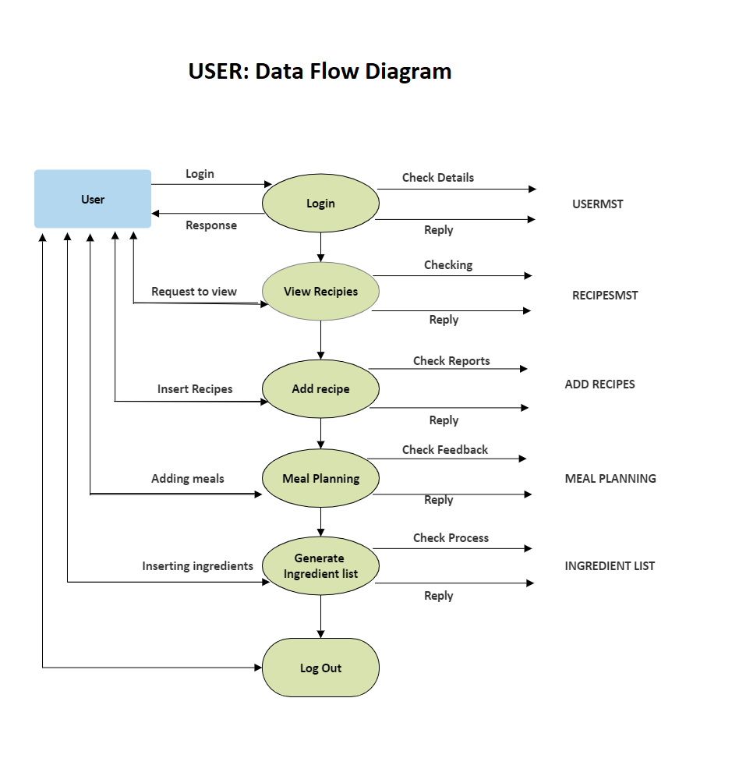

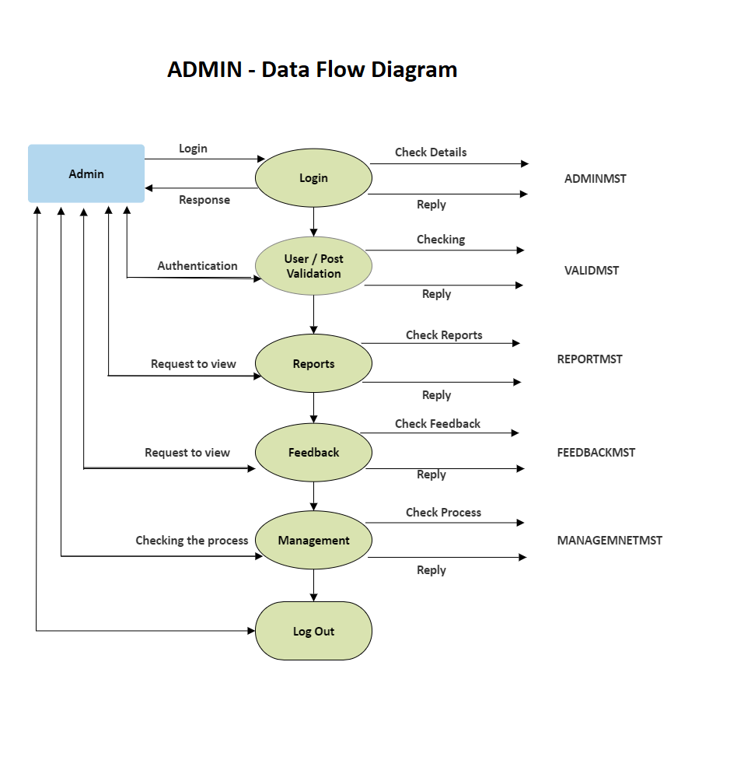

1. **Entity Relation Diagram (ERD)**

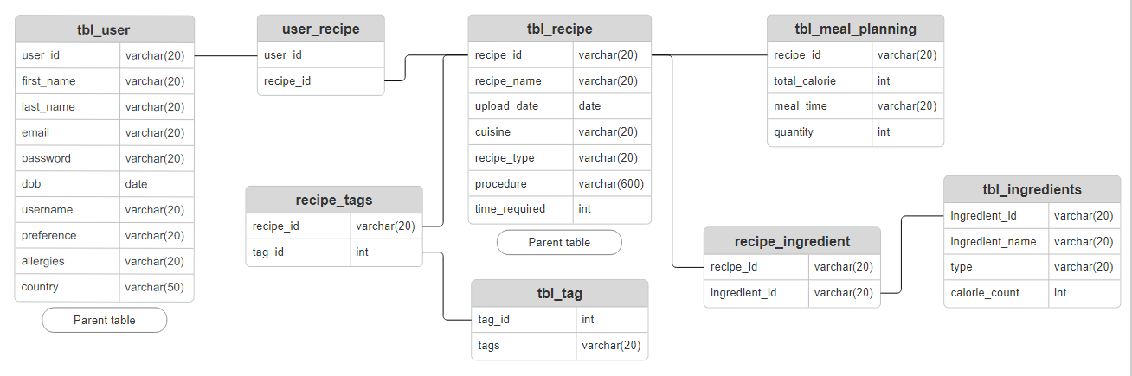

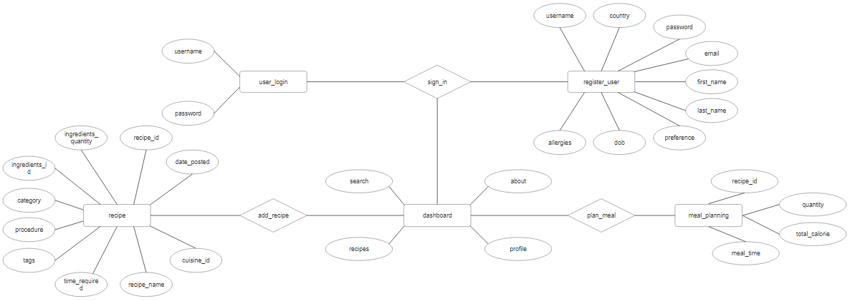

1. **Use Case Diagram**

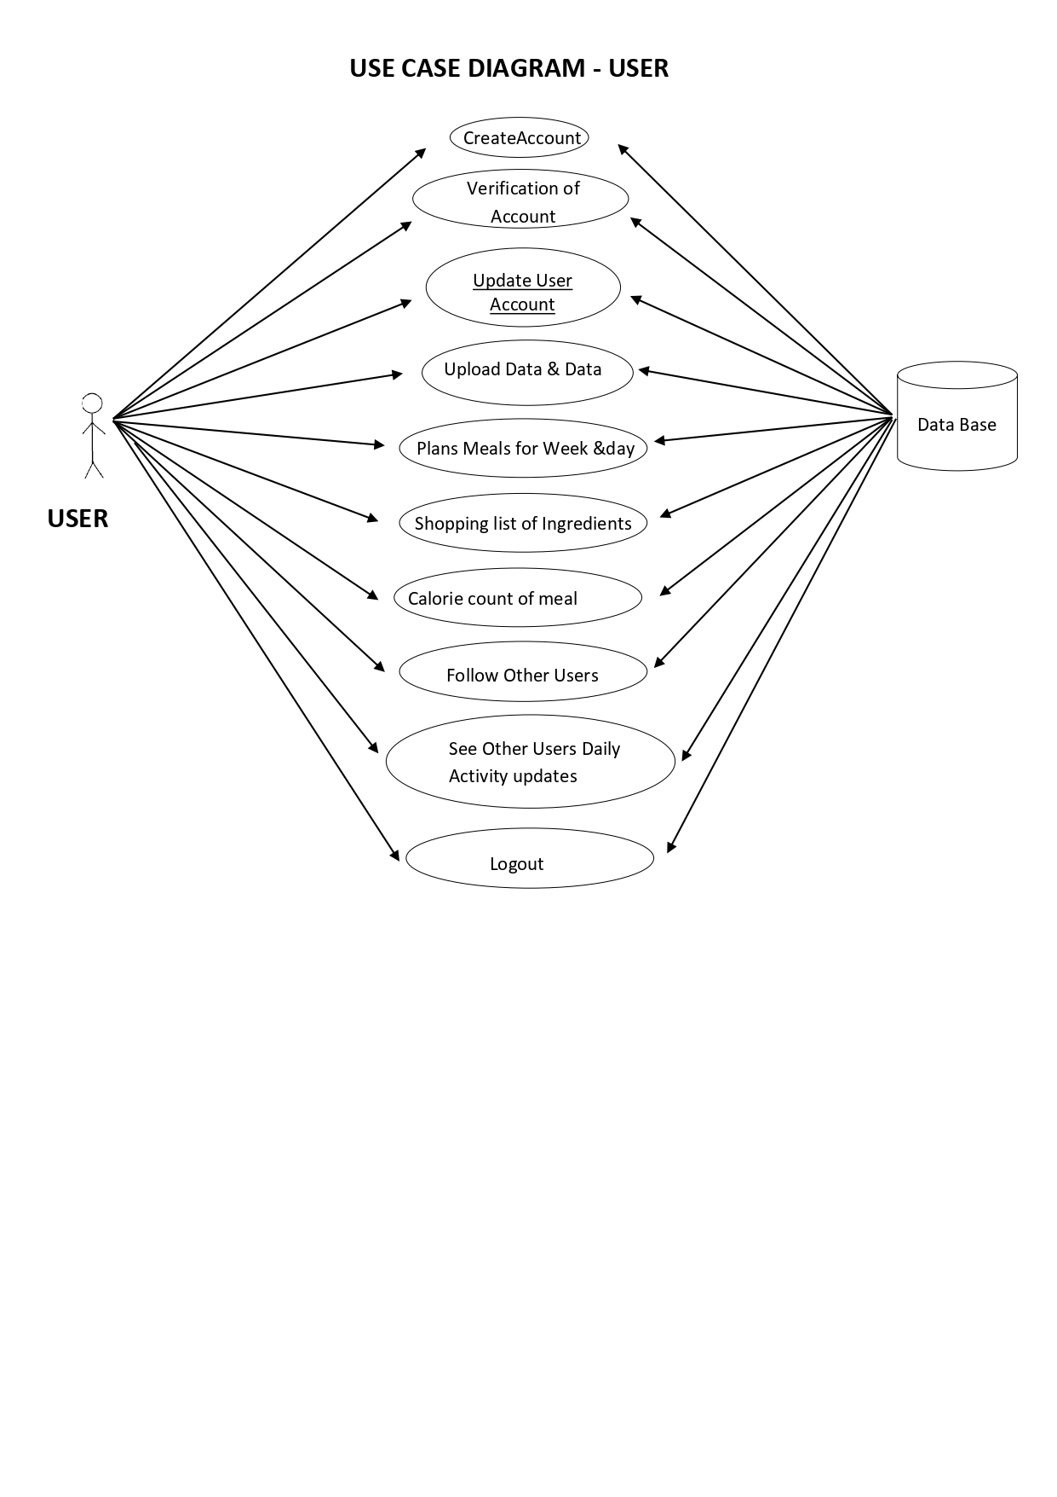

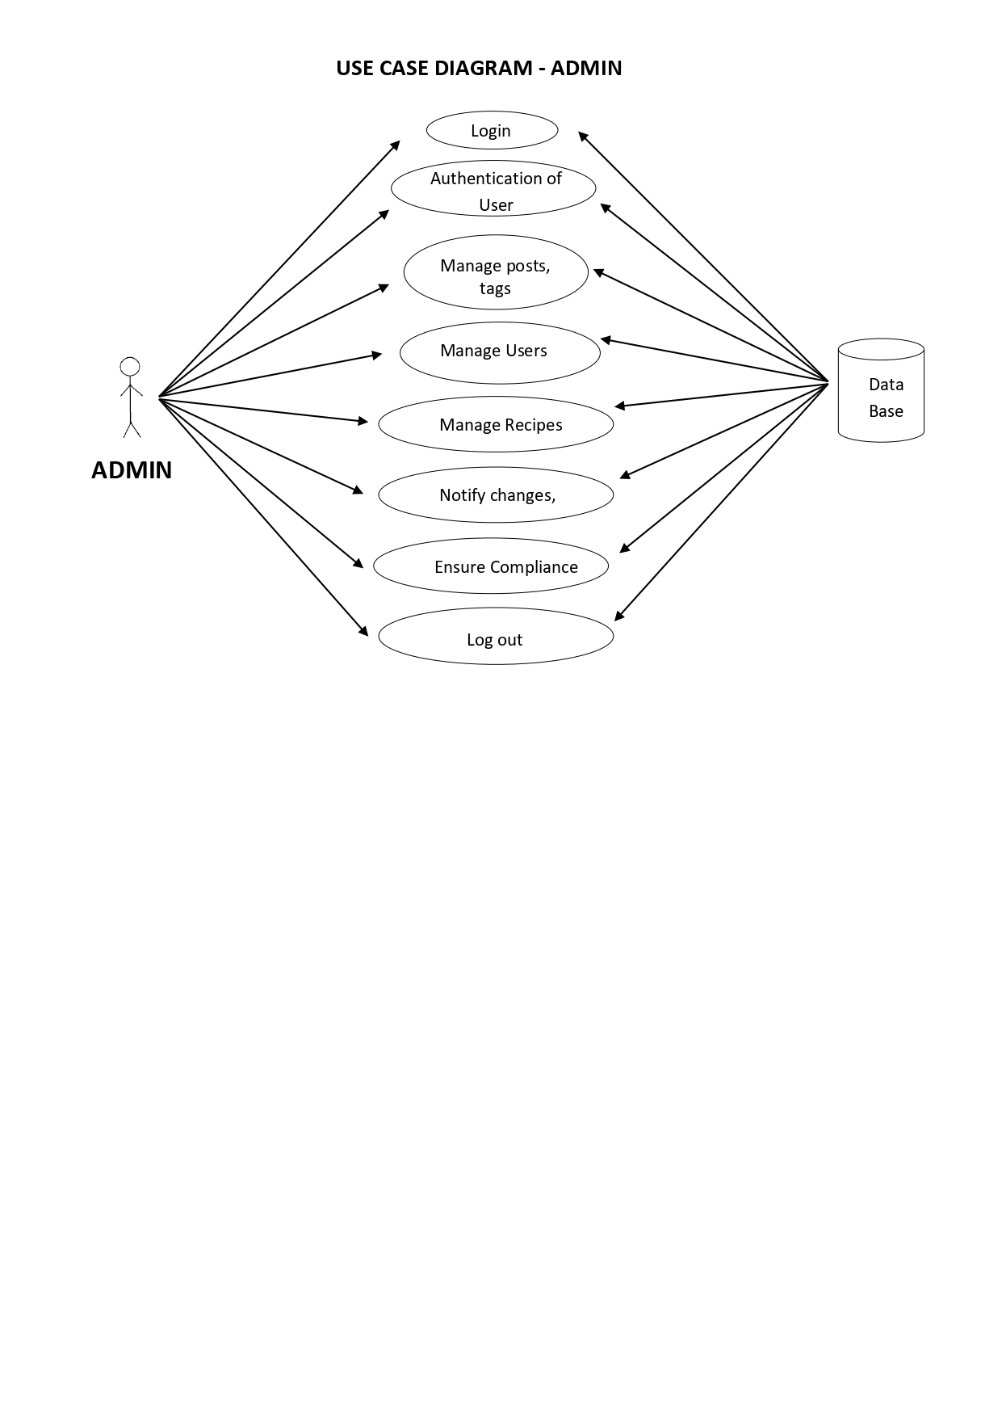

1. **Class Diagram**
2. **Sequence Diagram**
3. **Activity Diagram**
4. 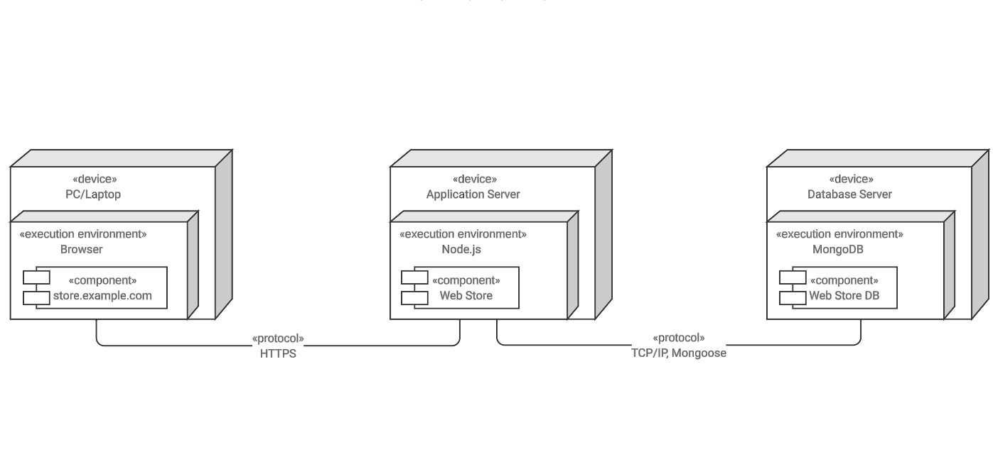**Deployment Diagram**
5. **System Architecture**

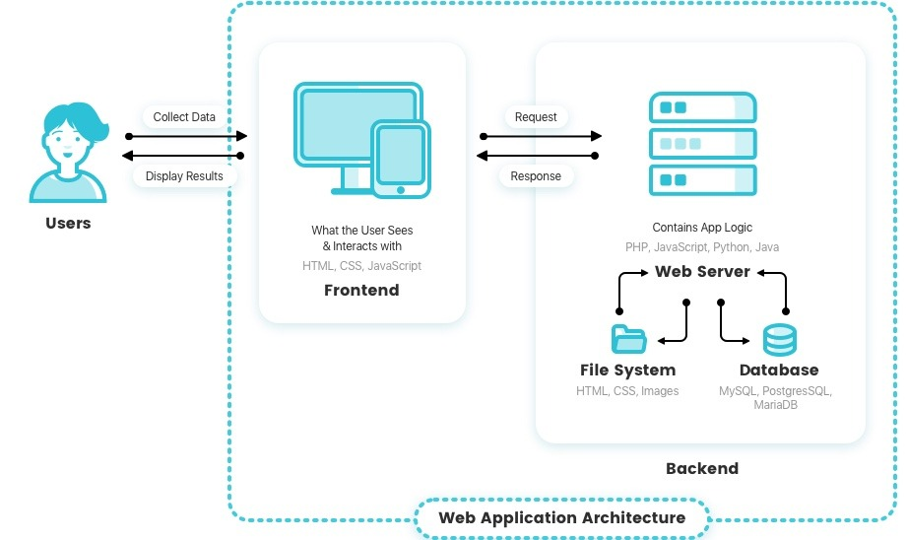

The system architecture for FlavourFeed can follow a typical three-tier architecture, separating the application into three main components: the presentation layer (frontend), the application layer (backend), and the data layer (database). Here is an overview of the system architecture:

1. **Presentation Layer (Frontend):**

Technology: React (HTML, CSS, JavaScript)

Description: The user interface where users interact with the application. React is used for building responsive and dynamic components, allowing for an interactive and engaging user experience.

1. **Application Layer (Backend):**

Technology: Spring Boot (Java)

Description: The backend logic and application processes are managed using the Spring Boot framework. It handles user requests, business logic, and communication with the database.

1. **Data Layer (Database):**

Technology: MySQL

Description: The MySQL database stores user profiles, recipes, and related data. It interacts with the backend to retrieve and update information.

1. **External APIs (Optional):**

Description: Additional external APIs, if integrated, provide services such as nutritional information retrieval. These APIs can be accessed by the backend for enhanced functionality.

1. **Cloud Service (Optional):**

Description: Cloud platforms like AWS, Google Cloud, or Azure can be used for hosting the application, providing scalability, flexibility, and reliable infrastructure.

1. **Development Environment:**

Technology: IntelliJ IDEA, Eclipse (Optional)

Description: Integrated Development Environments (IDEs) are used during the development phase for coding, testing, and debugging application components.

1. **Version Control:**

Technology: Git

Description: Git is employed for version control, allowing multiple developers to collaborate on the codebase, track changes, and manage the development workflow.

1. **Web Server (Optional):**

Technology: Apache Tomcat (or similar)

Description: A web server may be used to host the React frontend files and serve them to users' web browsers.

1. **Test Cases**

Testing for a web application like FlavourFeed involves verifying various aspects of its functionality, usability, and security. Below are examples of test cases covering different scenarios:

**User Registration:**

1. Verify that users can successfully register with valid information.
2. Check for appropriate error messages when invalid or incomplete information is provided.
3. Ensure the uniqueness of usernames and email addresses during registration.

**Login Functionality:**

1. Confirm that registered users can log in with correct credentials.
2. Test the handling of incorrect login attempts, ensuring appropriate error messages are displayed.
3. Check for session management, including proper session expiration and user logout.

**Recipe Submission:**

1. Test the ability to submit a new recipe with all required fields.
2. Verify that users can upload images or multimedia content related to the recipe.
3. Check for appropriate error handling when required fields are left blank or invalid data is entered.

**Recipe Search and Discovery:**

1. Test the search functionality by searching for recipes based on keywords, ingredients, or cuisine types.
2. Verify that search results are relevant and displayed correctly.
3. Check for pagination or infinite scrolling functionality for a large number of search results.

**Nutritional Information:**

1. Verify that nutritional information is displayed accurately for each recipe.
2. Test scenarios where nutritional information is not available or incomplete.
3. Ensure proper units and formatting of nutritional values.

**Community Interaction:**

1. Test the ability to like, comment on, and share recipes.
2. Verify that notifications are triggered for user interactions.
3. Check for proper display of user-generated content within the community.

**Responsive Design:**

1. Test the application's responsiveness on different devices, including desktops, tablets, and smartphones.
2. Verify that the layout adjusts appropriately to various screen sizes.

**Security Testing:**

1. Test for SQL injection vulnerabilities by entering malicious input.
2. Ensure that user authentication and authorization mechanisms are robust.
3. Verify that sensitive information is appropriately protected, especially during data transmission (HTTPS).

**Cross-Browser Compatibility:**

1. Test the application on different browsers (Chrome, Firefox, Safari, Edge) to ensure consistent behavior.
2. Check for compatibility with different browser versions.

**Performance Testing:**

1. Test the application's response time under different levels of user load.
2. Verify that the application performs well in terms of speed and responsiveness.

**Error Handling:**

1. Test how the application handles unexpected errors or exceptions.
2. Verify that users receive clear and helpful error messages.
3. Compatibility with External APIs (if applicable):

If the application integrates with external APIs for features like nutritional information, test the integration for accuracy and reliability.

These test cases cover various functional and non-functional aspects of the FlavourFeed web application, ensuring a thorough evaluation of its performance and user experience. Adapt and expand these test cases based on the specific features and requirements of your project.

1. **Screenshots**

**Home/Landing Page**

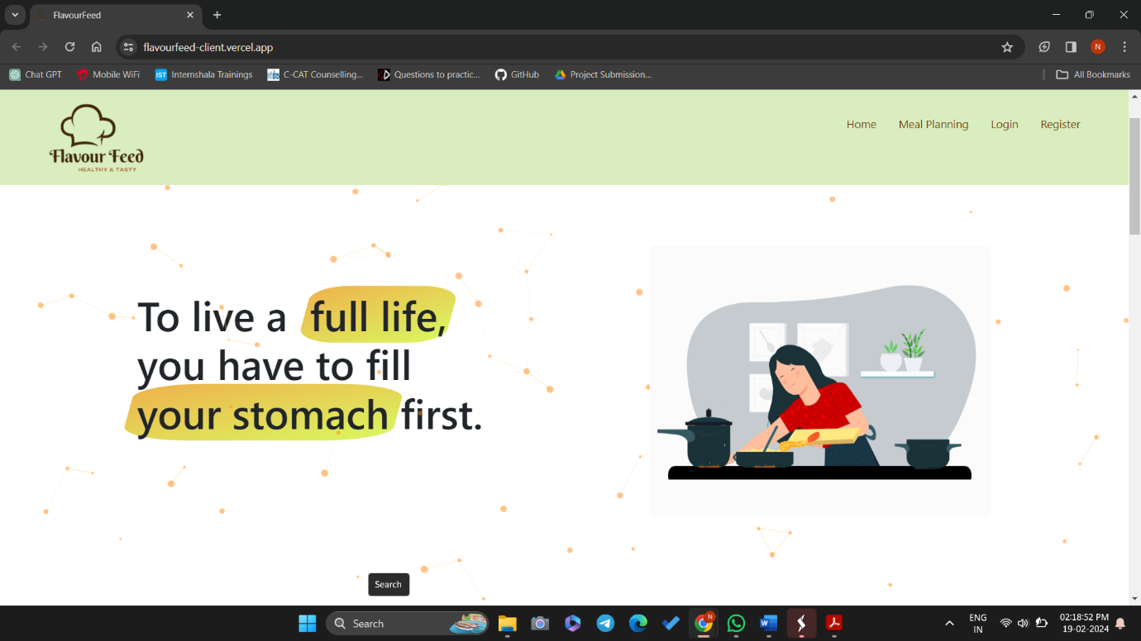

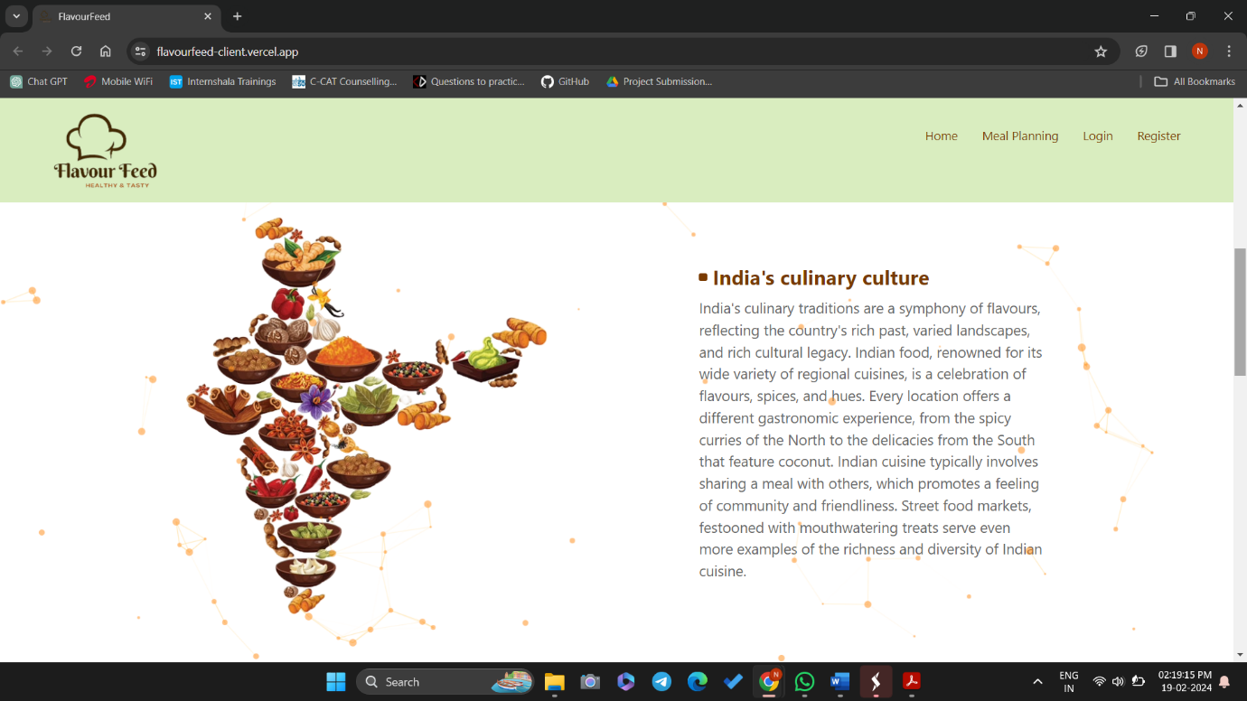

**Add Recipe**

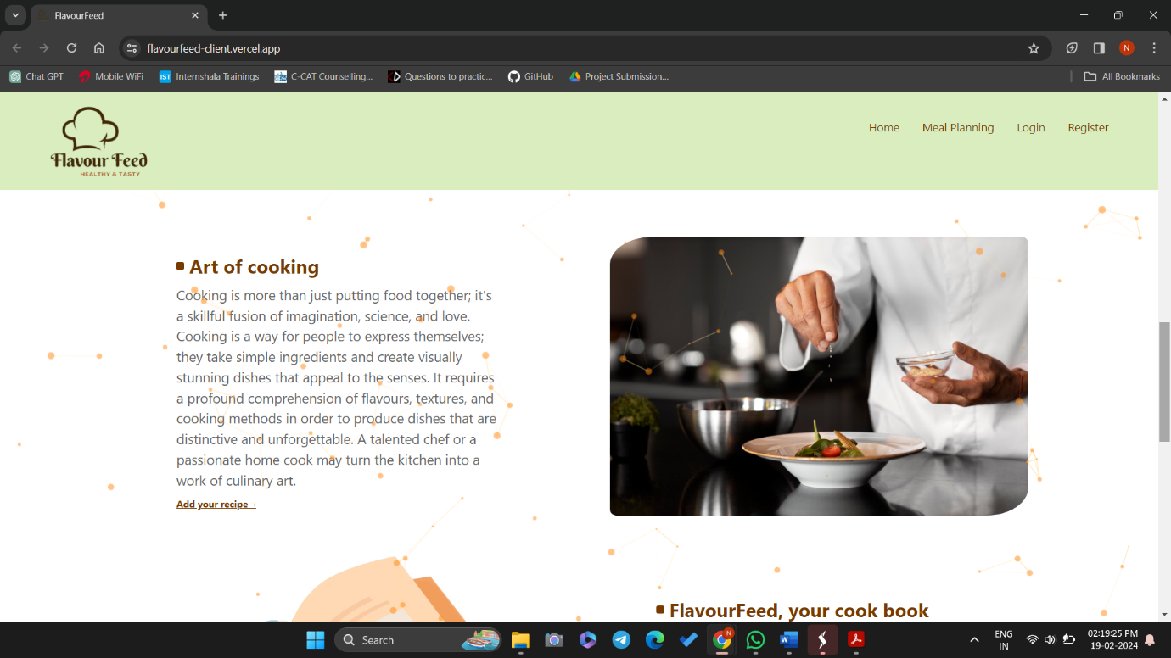

**Discover Recipe**

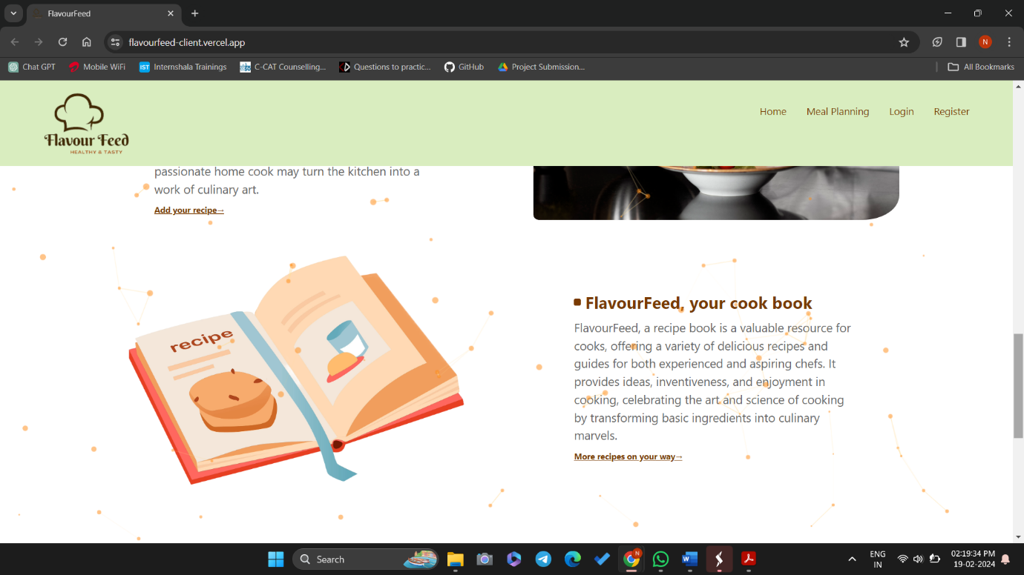

**FAQ**

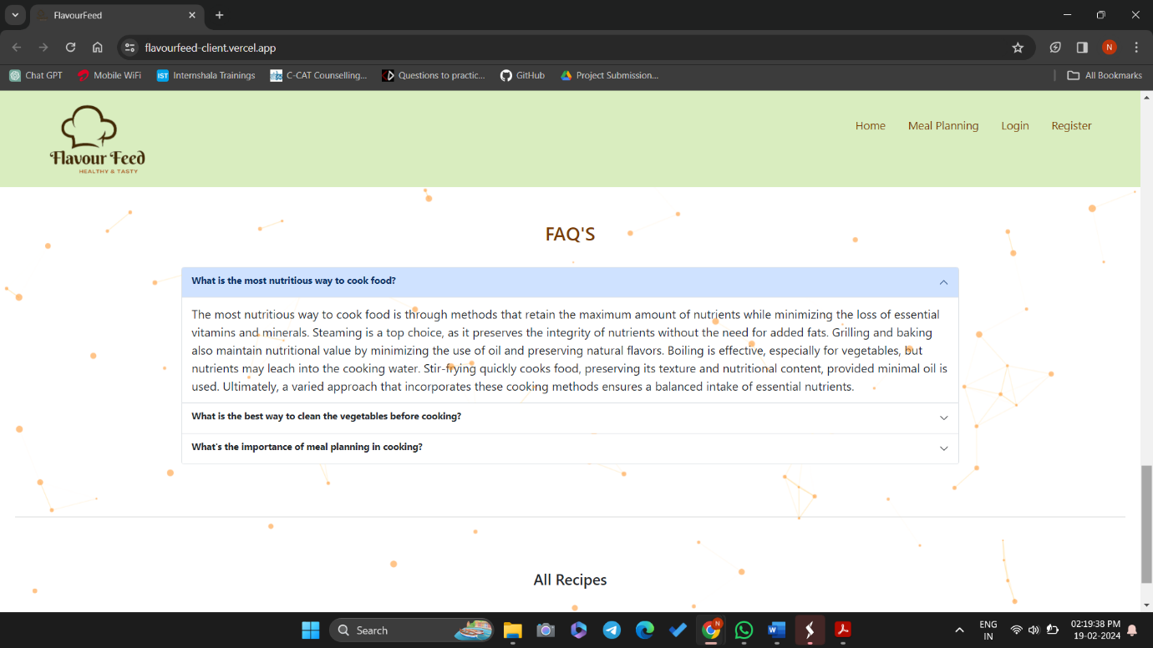

**Login Page**

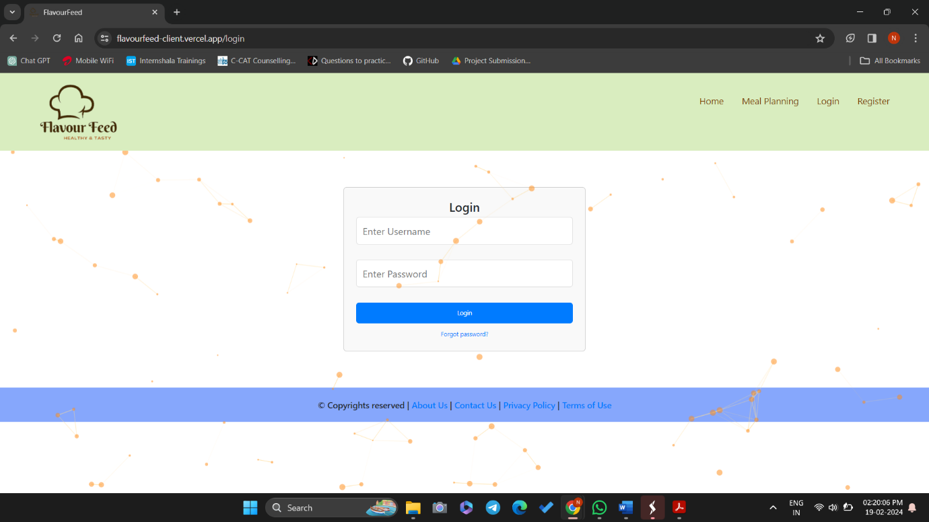

**Forgot Password**

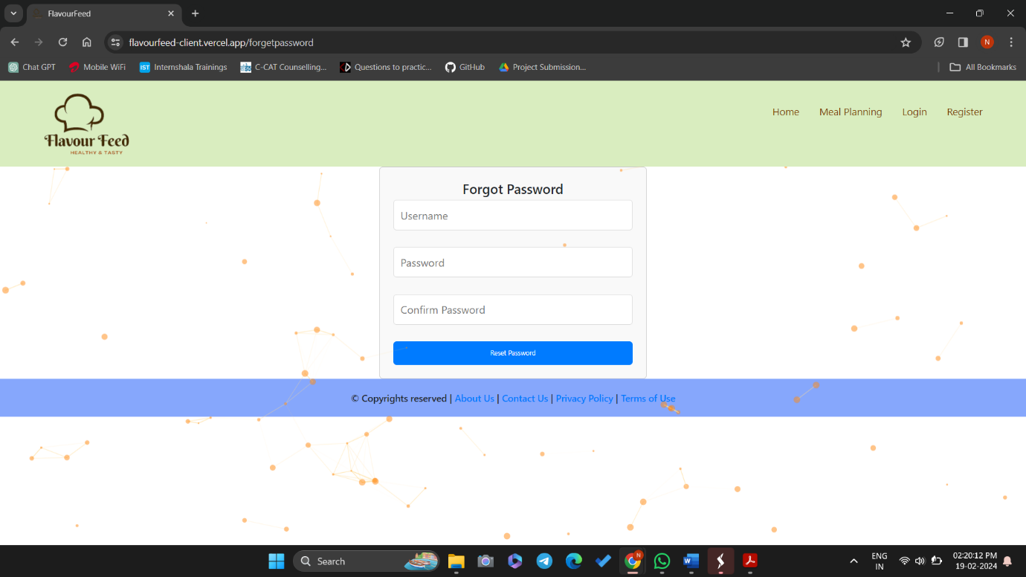

**Register Page**

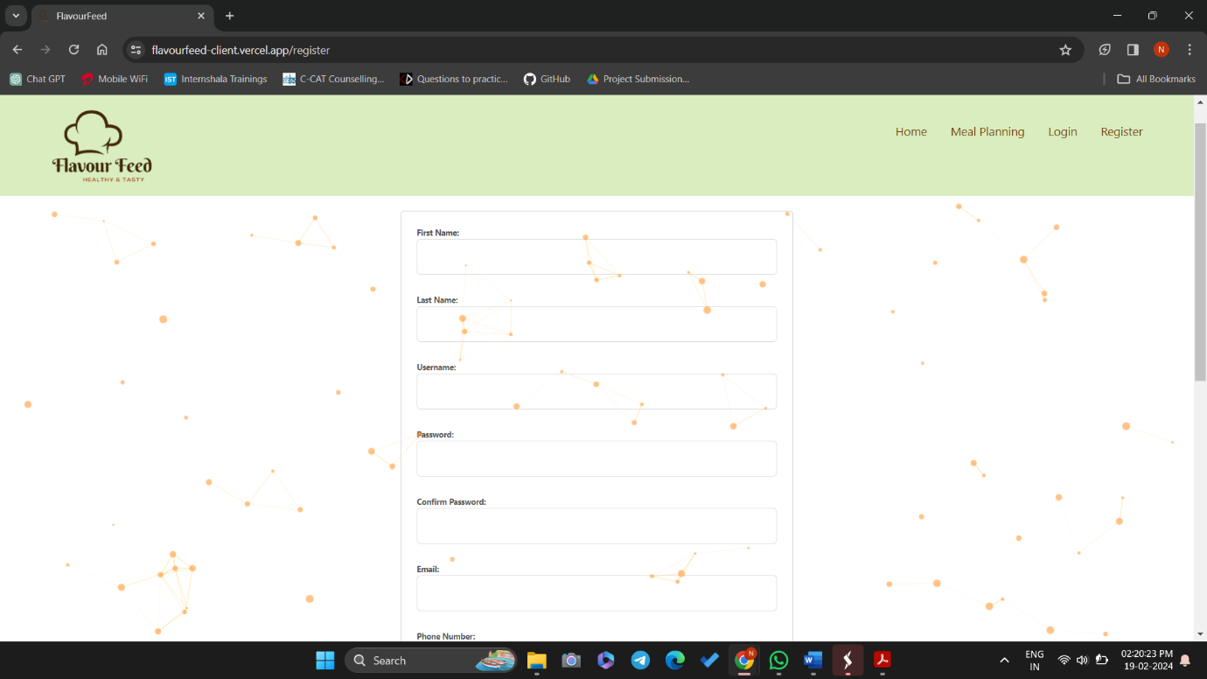

**Register Page**

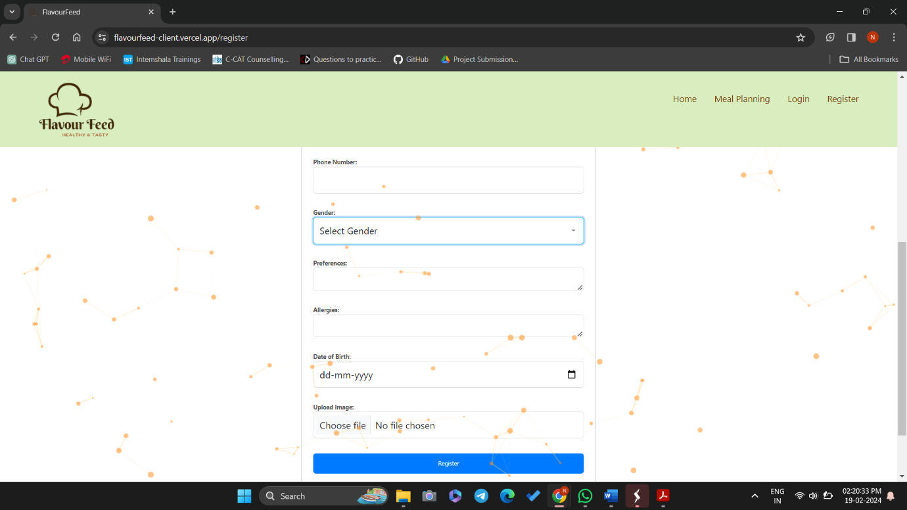

**About Page**

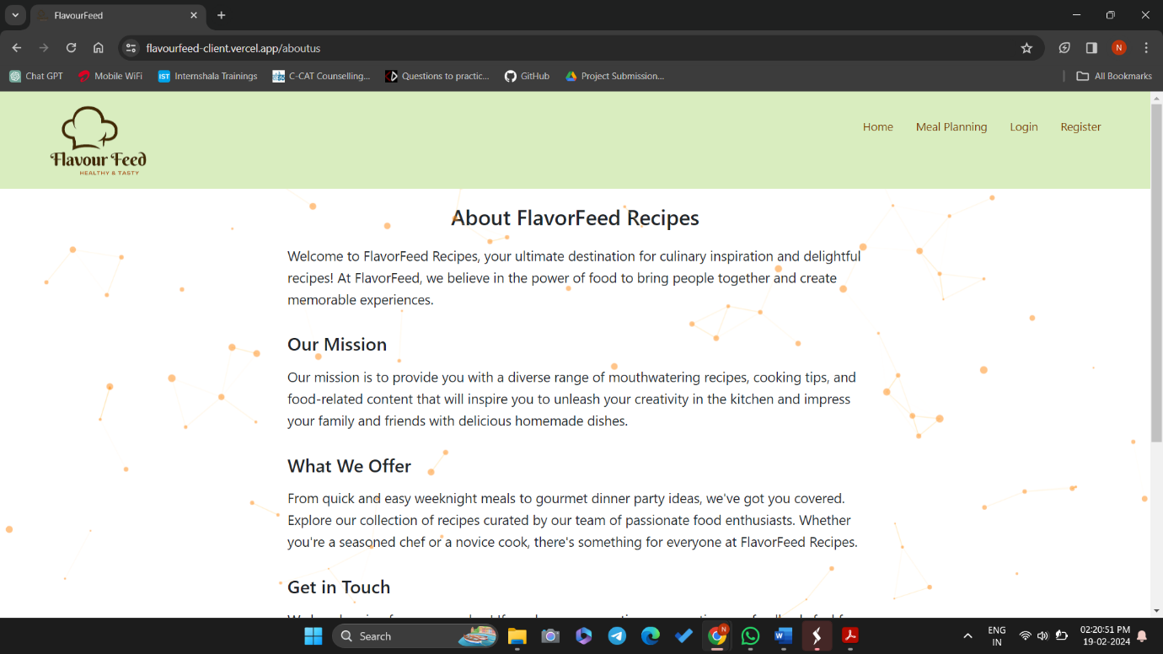

**Contact Us Page**

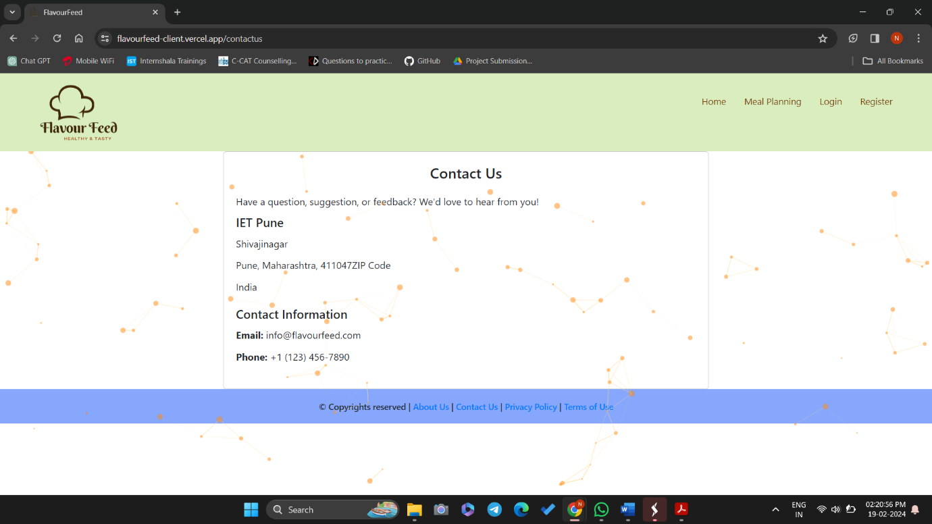

**Privacy Page**

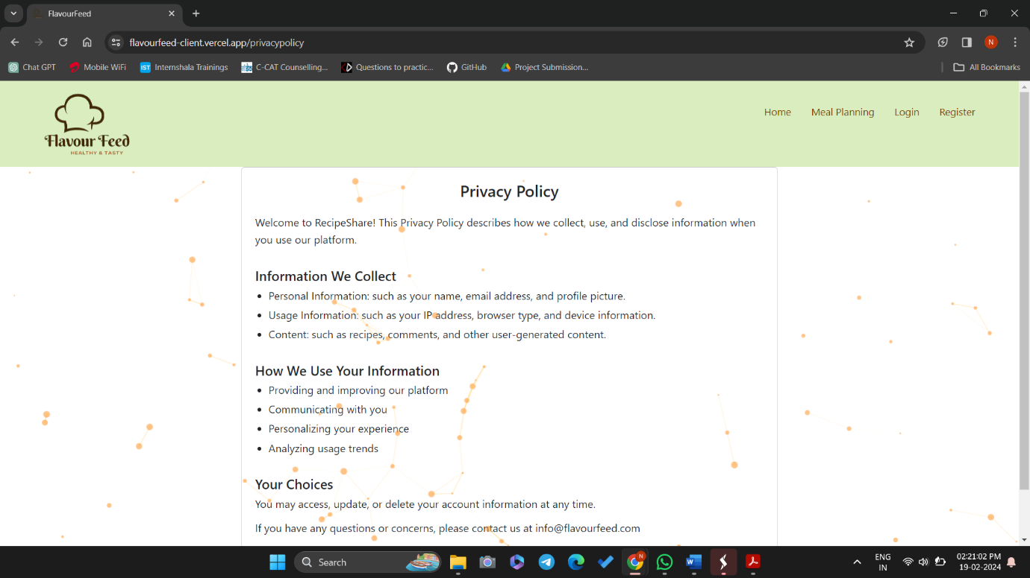

**Terms of Use**

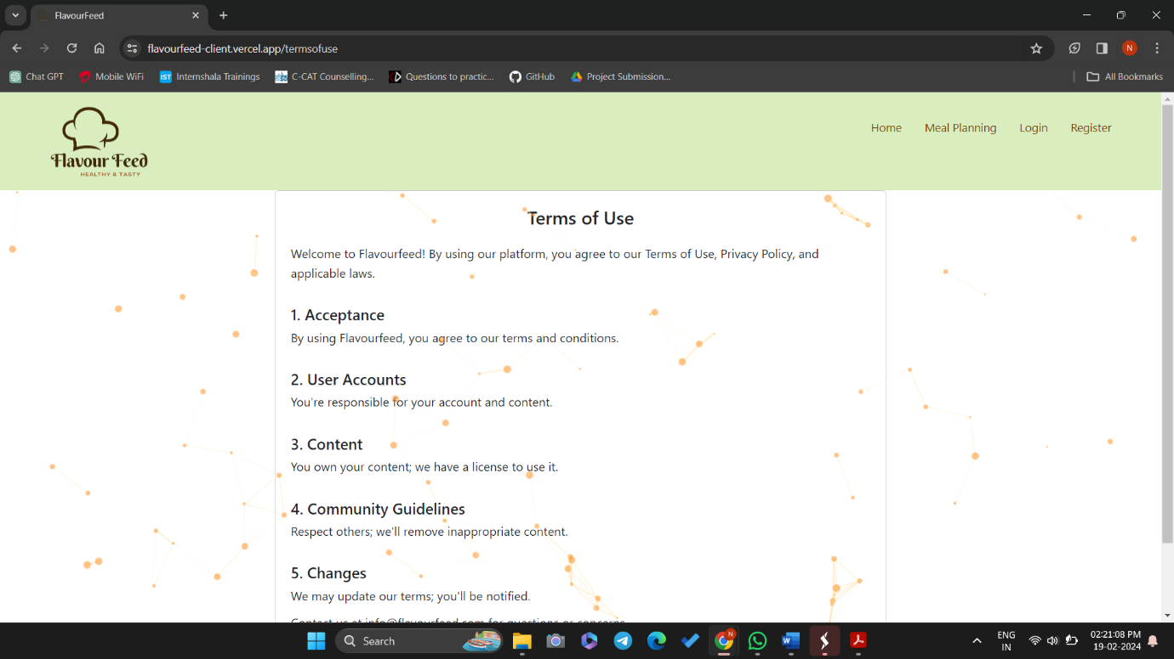

1. **References**

[1] React. (2023). https://reactjs.org/

[2] Spring Framework. (2023). https://spring.io/projects/spring-framework

[3] Hibernate ORM. (2023). https://hibernate.org/orm/

[4] MySQL Database. (2023). https://www.mysql.com/

[5] Apache Tomcat. (2023). http://tomcat.apache.org/

[6] React Testing Library. (2023). https://testing-library.com/docs/react-testing-library/intro/

[7] Git. (2023). https://git-scm.com/