Birla Institute of Technology & Science, Pilani
Work-Integrated Learning Programmes Division
First Semester 2023-2024

Mid-Semester Test
(EC-2 Make-up)

Course No. : AIML ZG565
Course Title : MACHINE LEARNING
Nature of Exam : Closed Book
Weightage : 30%
No. of Pages = 3

No. of Questions = 5
Duration : 2 Hours
Date of Exam :
Note:
- Please follow all the Instructions to Candidates given on the cover page of the answer book.
- All parts of a question should be answered consecutively. Each answer should start from a fresh page.
- Assumptions made if any, should be stated clearly at the beginning of your answer.

Q1. a) For the scenarios given below, answer the following questions:
- Which machine technique(s) is/are suitable for the cases given below? (1 marks)
- Why? Justify your choice. (2 marks)

Scenarios
- A hospital wants to develop a system to assist doctors in diagnosing a specific medical condition based on patient data. [Supervised L, Classification, target variable is discete in this case]
- Given data on how 1000 medical patients respond to an experimental drug (such as effectiveness of the treatment, side effects, etc.), discover whether there are different categories or “types” of patients in terms of how they respond to the drug, and is if so, what these categories are. [ Unsupervised L,Clustering, categories are not given]

Q1. b) If your model performs great on the training data but generalizes poorly to unseen instances, what could be the possible reason for this? Can you suggest any 2 possible solutions to solve this problem? [2]
Overfitting
Solutions: More Training data, Simplifying the model (reducing the number of features used, or regularizing the model), reducing the noise in the training data

Q1.c) A Google machine learning system beat a human Go player in 2015. This complicated game may contain more playable options than there are universe atoms. The first version won by observing hundreds of thousands of hours of human game play; the second version learnt by getting rewards while playing against itself. How would you describe this transition to different machine learning approaches? [2]

Ans - The system went from supervised learning to reinforcement learning. The first version is supervised learning and second is reinforcement learning.

Q2. Consider the following dataset with 4 records. [4+2 = 6]

Input X | Output Y
1 | exp(2)
2 | exp(4)
3 | exp(6.3)
4 | exp(9.2)

Assume output y=e^{(α * x)} . Using linear regression,
- Find the best value of α.
- Find the optimal total sum of square error.
Solution:
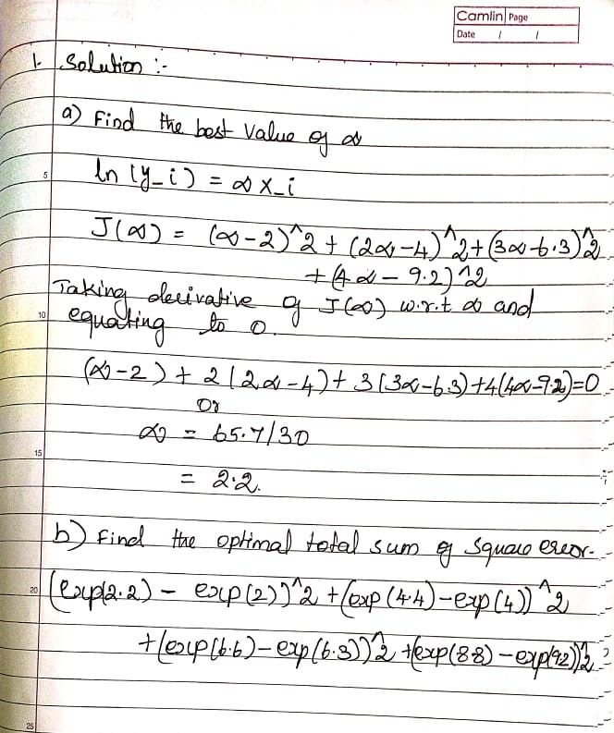

Q3. a) Consider a classification model with logistic regression and L2 regularization. Assuming that model is suffering from the problem of over-fitting, decreasing the value of regularization parameter helps in reduction of over-fitting. Is it True or False? Justify. [2]
False [0.5 marks + 1.5 marks for the explanation]
https://github.com/mGalarnyk/datasciencecoursera/blob/master/Stanford_Machine_Learning/Week6/AdviceQuiz.md
Decreasing the regularization parameter will increase the overfitting, not decrease it.
The gap in errors between training and test suggests a high variance problem in which the algorithm has overfit the training set. Increasing the regularization parameter will reduce overfitting and help with the variance problem.

Q3. b) Which regularization technique can be used for feature selection? Why? [2]
L1 regularisation.

Q3. c) Can the learning rate (in gradient descent algorithms), eta, be any random value? What are the consequences of choosing random value for eta? [2]
- If α is very small, it would take long time to converge and become computationally expensive.
- If α is large, it may fail to converge and overshoot the minimum.
[ 1 mark for each]

Q4. Suppose a model is trained that helps in predicting whether the tumor is benign and malignant. After training the model, we apply it to a test set of 200 instances (also labelled) and the model produces the contingency table below. [5]
 |  | Predicted Class
 |  | Malignant | Benign
True Class | Malignant | 60 | 0
 | Benign | 120 | 20

Compute the precision and recall of this model with respect to the “Malignant” class and with respect to the “Benign” class. List your crisp point-wise observations on the performance of this classifier with supporting justification.

Solution
Metrics with respect to Malignant Class:
 |  | Predicted Class
 |  | Malignant | Benign
True Class | Malignant | 60 (TP) | 0 (FN)
 | Benign | 120 (FP) | 20 (TN)

Precision = TP/(TP+FP) = 60/(60+120) = 60/180 = 33.33%
Recall = Sensitivity = TP/P = TP/(TP+FN) = 60/(60+0) = 100%

Metrics with respect to “Benign” Class:
 |  | Predicted Class
 |  | Malignant | Benign
True Class | Malignant | 60 (TN) | 0 (FP)
 | Benign | 120 (FN) | 20 (TP)

Precision = TP/(TP+FP) = 20/(20+0) = 100%
Recall = TP/P = TP/(TP+FN) = 20/(20+120) = 14.29%

Precision wrt Malignant class = 33.33%
Precision wrt Benign class = 100%
Recall wrt Malignant Class = 100%
Recall wrt Benign class = 14.29%
[Marks - 1 mark for the formula and 1.5 marks each for calculation wrt “Malignant” and “Benign” class, 1 mark for interpretation]

Q5. a) a) Construct the complete decision tree up to depth = 1 for the following data using ID3 algorithm with information gain. Pictorially represent the final decision tree. Show all the calculations and round the values to four decimal scale as appropriate. [4]
Use case: The Glasgow Coma Scale assesses patients according to three aspects of responsiveness: eye-opening, motor, and verbal responses. Reporting each of these separately provides a clear, communicable picture of a patient's state. Quantified values of attributes are discretized in below data. Build a machine learning model to classify if a patient is at “High” or “Low” risk of getting Coma.
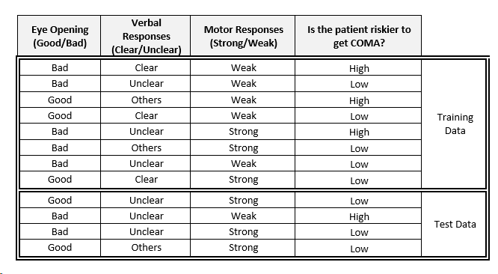

b) Justify the below statement with any plagiarism free example. [2]
"Unless absolutely necessary, the data pre-processing step of converting from categorical features to numerical data type can be omitted, while modelling classifier using decision tree. "
----------------------------------------------------------------------------------------------------------------
a) Answer Key:
Class Entropy : _0.9544_
Entropy of feature “verbal responses”: 0.9387 , Gain : 0.0157
Entropy of feature “eye opening” and “motor responses”: 0.9512, Gain : 0.0032
Inference : “Verbal Responses” has the minimum entropy or maximum info gain and hence it’s the selected root for decision tree building
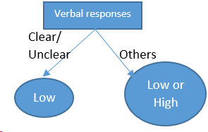
Marking Scheme:
1 mark: Entropy of class attribute
1 mark: Information Gain of the second feature. Info Gain must be calculated!
1 mark: Information Gain of the 1st & 3rd feature. Info Gain must be calculated! Note: No need to recalculate as the distribution is same for both 1st & 3rd feature
0.5 mark: Correct choice of the root
0.5 mark: Final decision tree with leaves (labelled with majority voting) in depth 1, built with chosen root.
Partial Marking: If none of the above are correct but correctly tried to implement the algorithm= 1.5m

b) Answer key
Entropy based classification uses lookup tables with simple frequency based counts, Unlike in logistic regression where the feature vector have to encoded into numerical data type for modelling the hypothesis based on "Weights*Features".
Marking Scheme:
1 mark: Correct Reason
1 mark: Any sample dataset with categorical feature shown for illustration
Partial Marking: -None-

