**PRACTICAL 9:Mongodb**

**1.AIM:**

To understand how to use MongoDB

**2.WRITEUP**:

What is MongoDB?

MongoDB is an open-source document database and leading NoSQL database. MongoDB is written in C++..

**1.The use Command:**

MongoDB use DATABASE_NAME is used to create database. The command will create a new database if it doesn't exist, otherwise it will return the existing database.

Basic syntax of use command is as follows-

use databasename

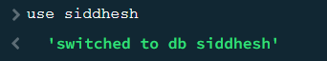

**2.The createCollection() Method**

MongoDB db.createCollection(name, options) is used to create collection.

Basic syntax of createCollection() command is as follows −

db.createCollection(name, options);



**3.The insert() Method**

To insert data into MongoDB collection, you need to use MongoDB's insert() or save() method.

Syntax

The basic syntax of insert() command is as follows −

db.COLLECTION_NAME.insert(document);

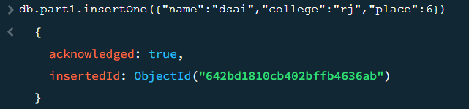

**4.The find() Method**

MongoDB's find() method, explained in MongoDB Query Document accepts second optional parameter that is list of fields that you want to retrieve. In MongoDB, when you execute find() method, then it displays all fields of a document. To limit this, you need to set a list of fields with value 1 or 0. 1 is used to show the field while 0 is used to hide the fields.

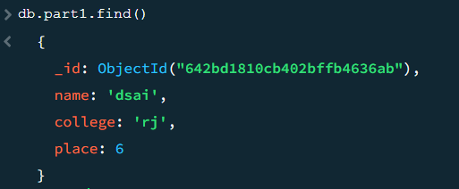

**5. inserMany() Method**

The insertMany() method inserts one or more documents in the collection. It takes array of documents to insert in the collection.

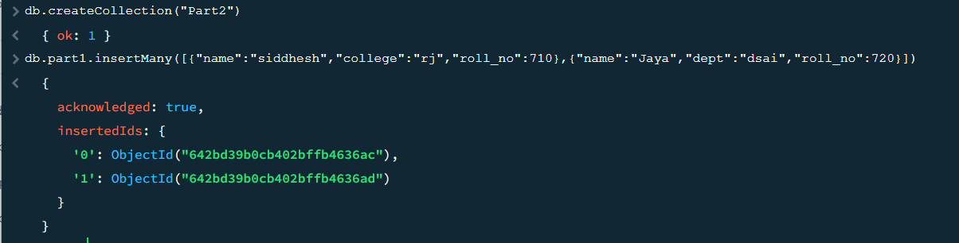

**6. find() method**

In MongoDB, find() method is used to select documents in a collection and return a cursor to the selected documents. Cursor means a pointer that points to a document, when we use find() method it returns a pointer on the selected documents and returns one by one. If we want to return pointer on all documents then use empty() parameter that returns all documents one by one. It takes only some optional parameters. The first optional parameter is the selection criteria on which we want to return a cursor. To return all documents in a collection use empty document({}).

